Nuclear Data Section
International Atomic Energy Agency
P.O.Box 100, A-1400 Vienna, Austria

Memo 4C-3/415 (Rev.)

Date: 22 November 2019
To: Distribution
From: N. Otsuka

Subject: Low energy neutron cross section per hydrogen atom
During recent intensive compilation of the thermal neutron scattering related data, some compilers met “cross section per hydrogen”, which definition has not been clear. After reviewing several examples (see next page), I now interpret that for a compound H_{n}A_{i}B_{j}C_{k}…:
- Total cross section per hydrogen = [σ - (i·σ_{A} + j·σ_{B} + k·σ_{C} + …)]/n
- Scattering cross section per hydrogen = [σ - (i·σ_{A} + j·σ_{B} + k·σ_{C} +…)]/n – σ_{a}
where σ is the total cross section of the compound, σ_{A} is the free atom cross section of the element A, σ_{a} is the hydrogen absorption cross section. As the neutron energy increases, the “cross section per hydrogen” should approaches to the free atom hydrogen cross section (~20.5 barn) at the asymptotic region (~0.5 eV) for which E.Melkonian Phys.Rev.76(1949)1750 EXFOR 11150 mentions that
“At about the energy spacing of vibration energy levels (0.5 eV) there is a sudden, rapid increase in cross section with decreasing neutron energy”.
We propose the following REACTION code for the cross section per hydrogen:
- (1-H-WTR(N,TOT),,SIG,,HYD) for “hydrogen total cross section in the water”
- (1-H-WTR(N,THS)1-H-WTR,,SIG,,HYD) for “hydrogen scattering cross section in the water”
at the neutron energy where the cross sections are different from those for free hydrogen atoms.
See the following pages for examples of this quantity.
Dictionary 34 (Modifiers)
HYD hydrogen part of the quantity
Dictionary 236 (Quantities)
,SIG,,HYD Cross section of hydrogen in hydride molecule
Proposed addition to LEXFOR “Thermal-neutron scattering”:
Cross section of hydrogen in hydride molecule
Cross sections of hydride molecule are often reported as “cross section per hydrogen (proton)”. It means the free atom (gas) cross sections of the elements other than hydrogen are subtracted and then divided by the number of hydrogen atoms in the molecule. The cross section should approach to the free hydrogen cross section (~20.5 b) at the asymptotic region (~1 eV). Above this energy, cross sections should be compiled as those for free hydrogen atoms. The unit code B is used even if the authors give the cross section in b/atom.
REACTION coding: HYD in SF8.
Example 1: EXFOR 30229.005 (Fig.3 of S.B.Herdade et al., R,INDC(BZL)-2,22,1969)

Scattering cross section of water is plotted in Fig.3 and tabulated in Table II.
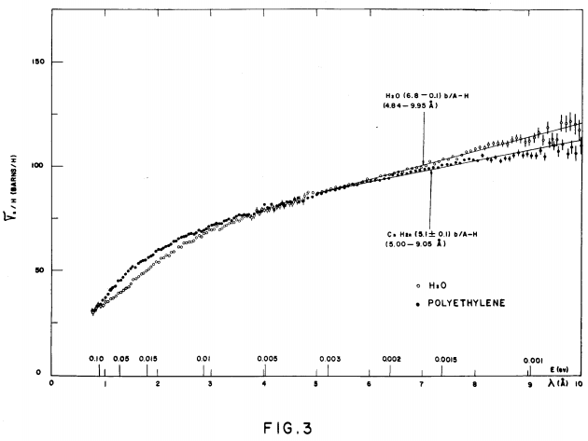
The authors relates σ_{s}/H (“scattering cross section per hydrogen atom”) and total cross section per H₂O (σ_{T}) in Eq.(1) of the report by
σ_{T} = σ_{x} + 2σ_{a} + 2(σ_{s}/H),
where σ_{x} is the free atom total cross section of oxygen (~3.7 b) and σ_{a} is the absorption cross section of hydrogen (~0.3 b at 0.0253 eV). Note that the oxygen absorption cross section is very small (~0.0002 b at 0.0253 eV).

Example 2: EXFOR 11150 (Fig. 16 of E. Melkonian, J,PR,76,1750,1949)

The measured cross sections for various hydrocarbon compounds (which are plotted individually in other figures and must be compiled by NNDC) are collected in Fig.16.

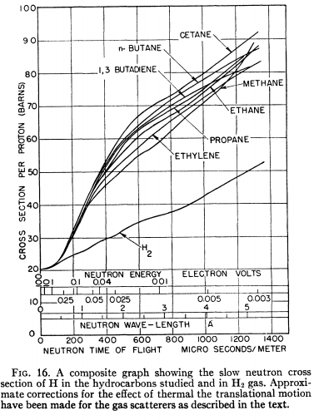

All cross sections reach to the free hydrogen cross section (~20.5 b) at the high energy side. The authors mention “The carbon cross section has been taken as 4.70 barns”. This implies that that the authors subtracted the carbon contribution from the measured cross section of the molecule.

Example 3: EXFOR 23424.005 (Fig.4 bottom of U.Schmidt, J,AKE,12,385,1967)

Total cross section of hydrogen in ZrH_{0.56} is plotted in Fig.5.

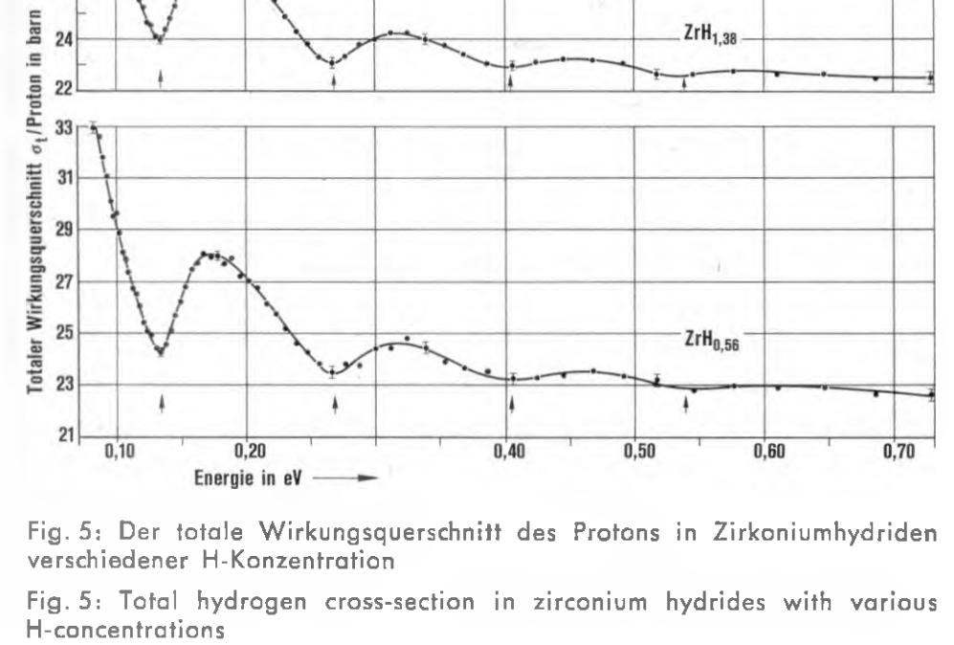

The quantity in Fig.5 would be interpreted as the total cross section of ZrH_{0.56} minus total cross section of zirconium normalized to one hydrogen.

Example 4: EXFOR 21146 (Fig.3 of B.Broecker., P,EANDC(E)-66,52,1966)

Total cross sections of various hydrides (organic compounds, ammonium saltes, metal hydrides) are compiled.

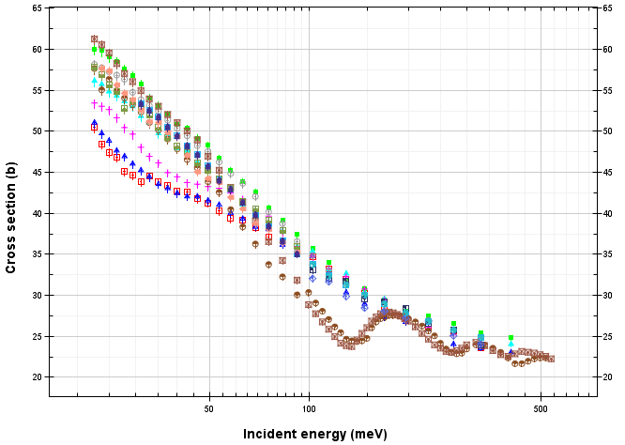

These data sets are compiled from a progress report without detailed description. But the asymptotic value is similar to Example 3 case (~22.5 b).

Distribution:
a.koning@iaea.org
abhihere@gmail.com
aloks279@gmail.com
dbrown@bnl.gov
draj@barc.gov.in
fukahori.tokio@jaea.go.jp
ganesan555@gmail.com
gezg@ciae.ac.cn
iwamoto.osamu@jaea.go.jp
j.c.sublet@iaea.org
jmwang@ciae.ac.cn
kaltchenko@kinr.kiev.ua
kenya.suyama@oecd-nea.org
kimura.atsushi04@jaea.go.jp
l.vrapcenjak@iaea.org
manuel.bossant@oecd-nea.org
masaaki@nucl.sci.hokudai.ac.jp
michael.fleming@oecd-nea.org
mmarina@ippe.ru
nicolas.soppera@oecd-nea.org
n.otsuka@iaea.org
nrdc@jcprg.org
odsurenn@gmail.com
ogritzay@kinr.kiev.ua
ogrudzevich@ippe.ru
otto.schwerer@aon.at
pikulina@expd.vniief.ru
pritychenko@bnl.gov
s.okumura@iaea.org
samaev@obninsk.ru
sbabykina@yandex.ru
scyang@kaeri.re.kr
selyankina@expd.vniief.ru
sonzogni@bnl.gov
stakacs@atomki.mta.hu
stanislav.hlavac@savba.sk
sv.dunaeva@gmail.com
tada@nucl.sci.hokudai.ac.jp
taova@expd.vniief.ru
tarkanyi@atomki.hu
vvvarlamov@gmail.com
v.zerkin@iaea.org
vidyathakur@yahoo.co.in
vsemkova@inrne.bas.bg
yolee@kaeri.re.kr
zholdybayev@inp.kz

cc:
baxterd@indiana.edu
cantargi@cab.cnea.gov.ar
farhi@ill.fr
kiyanagi@phi.phys.nagoya-u.ac.jp
liue@rpi.edu
marquezj@cab.cnea.gov.ar

