Nuclear Data Section
International Atomic Energy Agency
P.O.Box 100, A-1400 Vienna, Austria

Memo 4C-3/423

Date: 2023-11-13
To: Distribution
From: N. Otsuka, J.M.Wang
Subject: Gamma production cross sections from GEANIE spectrometer
It has been known the “gamma production cross sections” measured with the GEANIE spectrometer and compiled in EXFOR are often “transition cross sections” (i.e., gamma production cross section multiplied by 1+α, where α is the internal conversion coefficient).

Example: ²³⁸U(n,n’)²³⁸U 159 keV γ production cross section
The two datasets (13901.003, 14240.002) from GEANIE are gamma production cross sections multiplied by 1+α~2.8, and therefore systematically higher than the dataset from GELINA (22795.002).
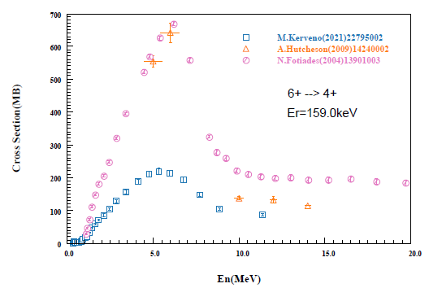
The next table summarizes the situation of all absolute gamma production cross sections from GEANIE and in EXFOR. We would like to ask NNDC to check if corrections of the EXFOR entries are required. (We may think replacement of FCT or MSC with a new modifier indicating multiplication by 1+α.)

X4# | (1+α) multiplied? | Evidence | Comment
13786 | Y | Eq. (3.1) of J,PR/C,64,054613,2001
13787 | Y |  | SF8=FCT coded except for 002 which Egamma is high
13788 | Y | "An excitation function for each g-ray transition ... was generated ... taking into account internal conversion and …"
13885 | Y | Eq. (1) of J,PR/C,68,024312,2003
13901 | Y | Eq. (1) of J,PR/C,69,024601,2004 | SF8=MSC coded in 002-003. Must be added in 004-006?
13910 | ?
13949 | ? |  | Add SF7=G
13996 | Y | Eq. (1) of R,UCRL-TR-205760,,2004
13997 | Y | Eq. (7) of R,UCRL-TR-209474,,2005
14041 | ?
14118 | Y | "Corrections to the ratio include: …, and internal conversion."
14144 | Y | Eq. (8) of R,UCRL-ID-140313,2000
14148 | Y | Eq. (1) of R,AIP-1342,9,2011
14162 | Y | Eq. (1) of J,NSE,157,65,2007
14231 | Y | Eq. (1) of J,PR/C,79,054604,2009
14240 | Y | Eq. (1) of J,PR/C,80,014603,2009
14255 | Y | "Systematic uncertainties for the data reported here include: … internal conversion corrections (∼0.1%); …"
14266 | Y | Eq. (1) of J,NIM/B,268,114,2010
14341 | Y | Eq. (1) of J,PR/C,85,064614,2012
14352 | ?
14359 | ?
14368 | ?
14370 | ?
14461 | Y | "Systematic uncertainties originate from ... γ-ray internal conversion corrections, ... "
14515 | Y | "The influence of internal conversion is very weak (much smaller than measurement uncertainties) for all measured γ rays."
14522 | ?
14588 | Y | Eq. (3.1) of T,CASOLI,2003
14658 | Y | The cross sections reported in the present work were corrected for ...,internal conversion, ..." | SF8=FCT coded

Distribution:

a.koning@iaea.org
abhihere@gmail.com
aloks279@gmail.com
daniela.foligno@oecd-nea.org
dbrown@bnl.gov
dgremyachkin@ippe.ru
draj@barc.gov.in
exfor@oecd-nea.org
fukahori.tokio@jaea.go.jp
ganesan555@gmail.com
gezg@ciae.ac.cn
iwamoto.osamu@jaea.go.jp
jmwang@ciae.ac.cn
kaltchen@ukr.net
kimdh@kaeri.re.kr
kimura.atsushi04@jaea.go.jp
l.vrapcenjak@iaea.org
manuel.bossant@oecd-nea.org
marina-03-08@yandex.ru
michael.fleming@oecd-nea.org
mvmikhaylyukova@ippe.ru
nicolas.soppera@oecd-nea.org
nomura@nucl.sci.hokudai.ac.jp
n.otsuka@iaea.org
nrdc@jcprg.org
nshu@ciae.ac.cn
odsurenn@gmail.com
ogritzay@ukr.net
otto.schwerer@aon.at
pikulina@expd.vniief.ru
pritychenko@bnl.gov
scyang@kaeri.re.kr
selyankina@expd.vniief.ru
sonzogni@bnl.gov
stakacs@atomki.mta.hu
stanislav.hlavac@savba.sk
sv.dunaeva@gmail.com
tada@nucl.sci.hokudai.ac.jp
taova@expd.vniief.ru
tarkanyi@atomki.hu
v.devi@iaea.org
v.zerkin@gmail.com
vidyathakur@yahoo.co.in
vsemkova@inrne.bas.bg
vvvarlamov@gmail.com
yolee@kaeri.re.kr
zholdybayev@inp.kz

cc:
fotia@lanl.gov
labernstein@lbl.gov
rnelson@lanl.gov
roberto.capotenoy@iaea.org

