Nuclear Data Section
International Atomic Energy Agency
P.O.Box 100, A-1400 Vienna, Austria

Memo CP-D/926

Date: 24 March 2017
To: Distribution
From: N. Otsuka. E. Dupont

Subject: Outliers in JANIS Books for gamma and charged particle cross sections

One of us (ED) went through the online JANIS Books (produced in March 2017) for gamma and light charged-particle (p, d, t, ³He, α) induced reactions and checked the source articles (when available) for the most obvious outliers. The summary on outliers was then checked against the source articles at NDS. The result is appended to this memo.

The necessary corrections have been registered to the EXFOR Feedback List.

Distribution:
a.koning@iaea.org
abhihere@gmail.com
aloks279@gmail.com
cgc@ciae.ac.cn
dbrown@bnl.gov
draj@barc.gov.in
dvoytenkov@ippe.ru
ebata@nucl.sci.hokudai.ac.jp
fukahori.tokio@jaea.go.jp
ganesan555@gmail.com
gezg@ciae.ac.cn
iwamoto.osamu@jaea.go.jp
j.c.sublet@iaea.org
jhchang@kaeri.re.kr
jmwang@ciae.ac.cn
kaltchenko@kinr.kiev.ua
jim.gulliford@oecd.org
manuel.bossant@oecd.org
marema08@gmail.com
masaaki@nucl.sci.hokudai.ac.jp
mmarina@ippe.ru
mwherman@bnl.gov
nicolas.soppera@oecd.org
n.otsuka@iaea.org
nrdc@jcprg.org
nurzat.kenzhebaev@gmail.com
ogritzay@kinr.kiev.ua
oscar.cabellos@oecd.org
otto.schwerer@aon.at
pikulina@expd.vniief.ru
pritychenko@bnl.gov
samaev@obninsk.ru
sbabykina@yandex.ru
scyang@kaeri.re.kr
selyankina@expd.vniief.ru
sonzogni@bnl.gov
stakacs@atomki.hu
stanislav.hlavac@savba.sk
s.a.dunaeva@yandex.ru
sv.dunaeva@gmail.com
taova@expd.vniief.ru
tarkanyi@atomki.hu
vvvarlamov@gmail.com
v.semkova@iaea.org
v.zerkin@iaea.org
yolee@kaeri.re.kr
zholdybayev@inp.kz
zhuangyx@ciae.ac.cn

cc:
emmeric.dupont@cea.fr

Outliers in gamma and light charged-particles (p,d,t,h,α) induced reaction cross sections on JANIS Book summarized by Emmeric Dupont (14 March 2017)

EXFOR # | E.D. Comments | O.N. Comments | Action to the originating centre
A0271.002  to  A0271.011 | The data is rather suspicious (see attached plot), but I cannot check this reference. | These are not directly measured cross sections, but derived by separation of the measured neutron spectra by using the statistical model with adjusted level density parameters of the Fermi gas model. The definitions of each cross section in Table II of J,SNP,39,164,1984is bit complicated, for example,  - (1n) - cross section of neutron emission in (p,xn) reaction in the first step of neutron emission.  - (2n) - cross section of neutron emission in (p,xn) reaction in the second step of neutron emission.  - (p,nγ) - cross section of gamma emission in (p,xn) reaction in the second step of emission.  (Boris, Zhuravlev, 2017-03-23), and not suitable for EXFOR compilation | Delete this entry.
A0448.012 | The DATA line “21.4 20.9” must be deleted as it belongs to another reaction in Table 3(a) of J,RCA,46,5,1989. | Yes! | Data: Move 20.9 mb at 21.4 MeV from 012 to 013 (cf. Table 3(a) of J,RCA,46,5,1989).
A0667.002 | The data in A0667.002 are likely off scale by ~10⁶ since there are supposed to be in agreement with B0099.004, the latter being consistent with other measurements and evaluations. Sorry, I cannot check in the reference. | Yes! | Unit: DATA: NB → MB
C0471.002  C0471.003 | The data (compiled from T,BOUKHAROUBA,1991) are not consistent with other measurements, and not even consistent with the values given in the final publication (Table IV of PR/C,46,2375,1992), which seem correct (and apparently not compiled). | Yes!  Probably the digitized ⁵⁴Fe and ⁵⁶Fe(p,γ) data sets are wrongly compiled in 003 and 002 (instead of 002 and 003), respectively. | Data: Replace digitized values with those tabulated in Table III (003) and Table IV (002) of J,PR/C,46,2375,1992.
C0739.004 | I cannot check the reference (T,QIANG,1990), but there is most probably a problem with the data at 2.1916 MeV (see attached plot). | This value (48.9660 µb± 7.2161%) is printed in Table 5 of thesis. | Add flag explaining that the value at 2.1916 MeV is compiled as printed in Table 5 of the thesis but probably wrong.
C0774.002 | The data (from the CPX file) are a factor 10 too low compared to the data in Fig. 1 of NP/A,107,21,1968 (which are apparently not compiled). | Multiplication of a factor 10 does not solve the disagreement with Fig.1 of J,NP/A,107,21,1968. The numerical data set (originally in P0025.002) is omitted in Physik Daten Nr. 15-5 which prints all CPX data sets but except for doubtful CPX data sets. | Data: Replace the CPX data set with the data set digitized from Figs.1+3 of J,NP/A,107,21,1968
C2004.004 | The digitization of data is very suspicious. From my understanding of the publication, the data in the range 15-20 MeV are a factor 10 too low compared to the symbol of Fig. 3 curve I, whereas the data in the range 10-190 MeV are a factor 100 too low compared to the symbols of Fig. 3 curve II. Well, if I’m not mistaken myself. | The numbers printed on the y-axis of Fig.3 of J,PR,84,463,1951 is not readable well. To obtain matching between CURVE I and CURVE II of the figure, I think we should read the y-tics of CURVE I as 10, 20, 30 and 40 mb, whereas the y-tics of CURVE II as 20, 40 and 60 mb. If this interpretation is correct, we need to multiply a factor 10 to all data points. If we compare the EXFOR data set with TENDL-2015 multiplied by 0.1, we see better agreement. | Explain that the absolute scale is not clear from the y-axis under COMMENT. Multiply a factor 10 to the digitized cross section values if appropriate.
D4025.004.1 | The data at 22.66 MeV must be 627+/-64 mb (and not +/-664). | Yes! | DATA-ERR: 664 mb → 64 mb at 22.66 MeV (cf. Table 3 of C,94GATLIN,,393,1994).
D6206.002 | The value at 33.25 MeV cannot be correct. I checked in table II of the publication and this is what is tabulated, but this cannot be true and this energy (33.25 MeV) is not even displayed in Fig. 1 (for (a,n)) and Fig. 2 (for (a,2n)). In my opinion, both values are suspicious and the one at 75 mb for the (a,n) xs is definitely wrong (7.5 mb would make more sense and would be consistent with a relative uncertainty of 10% (0.8/7.5) similar to the neighbouring energy, but this is no proof of course). | Yes!  Comparison with Fig.1 of J,JPJ,63,84,1994 on GSYS shows that 75 mb should read 7.5 mb.  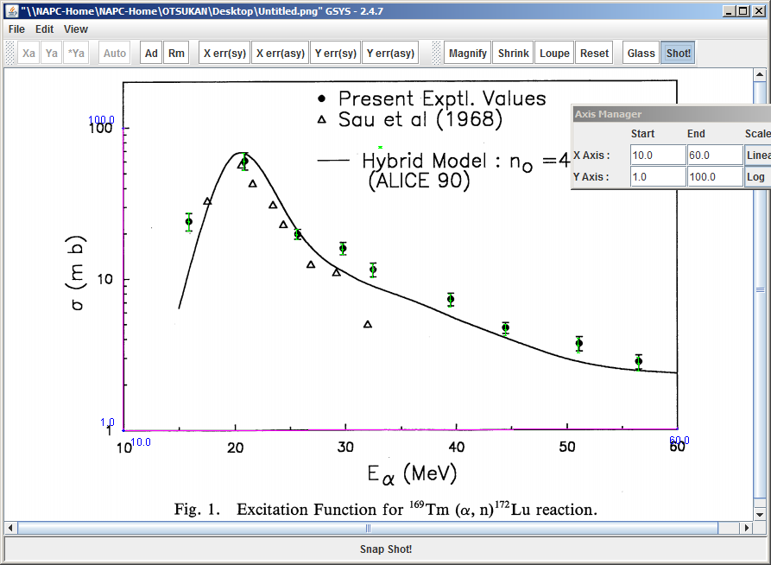 | DATA: 75 mb →7.5 mb at 33.25 MeV (cf. Fig.1 of J,JPJ,63,84,1994).
F0023.005 | The data are off scale by a factor 1000 following a probable compilation mistake. | Yes! | Unit: DATA, ERR-S: MB →B.
G3001.003  G3001.004  G3001.006  G3001.007 | The data/reaction in G3001.003 are wrong as inconsistent with the ⁶³Cu(γ,2n) cross section plotted as histogram in Fig. 1 and Fig. 3 of J,PR/C,52,1484,1995. Idem for G3001.006. | Yes!  - 002+005: (e,2n/2p) cross sections, corresponding to squares of Figs.1+2 of J,PR/C,52,1484,1995 (ok).  - 003+006: (e,2n/2p)+Bremsstrahlung spectrum averaged (γ,2n/2p) cross sections, corresponding to circles of Figs.1+2 of J,PR/C,52,1484,1995.  - (γ,2n/2p) cross section obtained by unfolding 004+007, corresponding to histgrams of Figs.1+2 of J,PR/C,52,1484,1995.  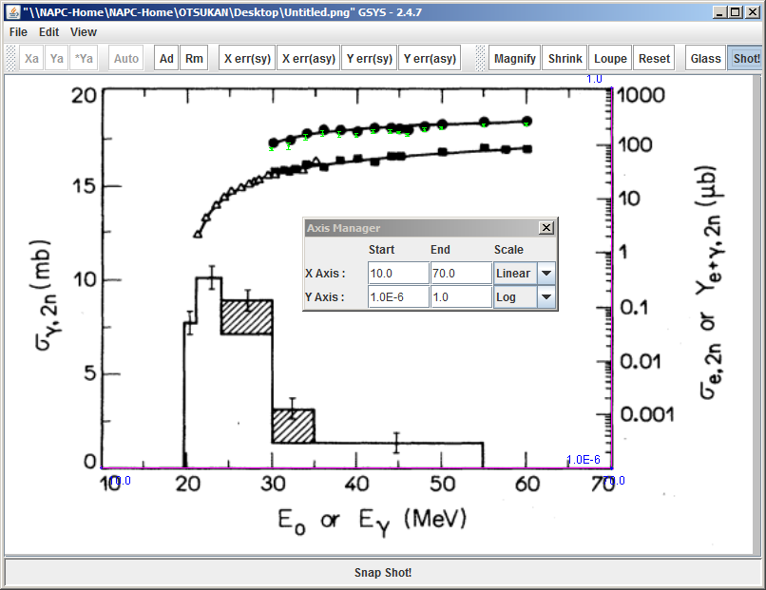  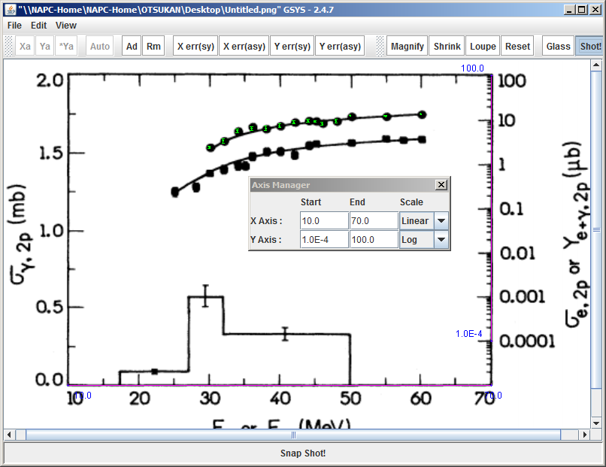 | - 003+006: REACTION  SF2: G → E with MSC in SF7.  - 004+007: REACTION  EP,SIG,,,DERIV → ,SIG,,BRS
M0894.002 | I cannot check the original references, but this is very suspicious to see two ⁶⁵Cu(γ,n) datasets (M0892.008 & M0894.002) published by the same authors (in 1990 and 1991) differing by two order of magnitude, especially when the most recent data (M0894.002) are also the most discrepant when compared to other experimental and evaluated data. | Yes! | REACTION: SF3: N → A; SF4: 29-CU-64 → 27-CO-61 (cf. Fig.1 of J,BAS,55,176,1991).
O1317.003 | Looking at Fig. 12 in PRC 69 (2004) 055806, the asymptotic value of the data at about 1 MeV in O1317.003 should be about 10mb (i.e. a factor 10 larger compared to the current value). This is confirmed by the data stored in A0413.004.S, which are flagged in O1317.003 as being in agreement (and which are not without this factor 10). See attached plots. | Yes!  The digitized cross section values must be multiplied by a factor 10. (The positions of the numbers printed on the y-axis of Fig.12 are actually misleading.) 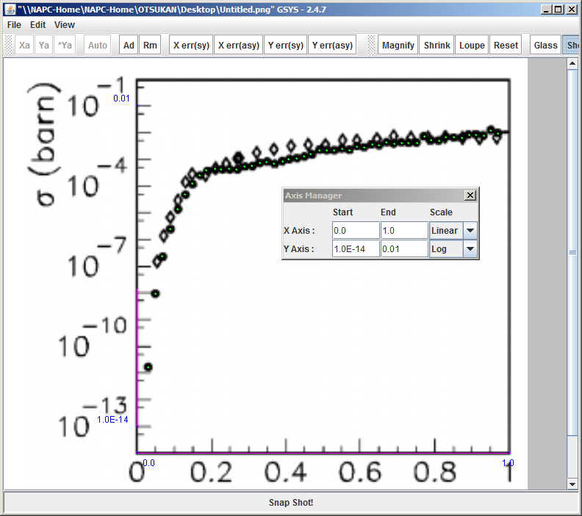 | DATA: Multiply all values by a factor 10. (c.f. Fig.12 of J,PR/C,69,055806,2004).
O2034.002  O2034.003  O2034.004 | The data are not total fission cross section, but partial cross section for the formation of fission isomers. | Yes! | 002: REACITON: (92-U-235(D,P)92-U-236-L,,SIG) with T_{1/2}=70 nsec in DECAY-DATA.  003: REACTION: (92-U-236(D,X)92-U-236-L,,SIG) with T_{1/2}=70 nsec in DECAY-DATA.  004: REACTION: (92-U-238(D,X)92-U-238-L,,SIG) with T_{1/2}=110 nsec in DECAY-DATA.
P0047.002  P0047.003  P0047.004  P0047.005  P0047.006  P0047.007  P0047.008 | The data are completely wrong… but as published in JIN,3,69,1956. ;-) However, a comment by the author in the same paper may be cited: “… Thus the peaks in Figs. 1-4 should be shifted to lower energies.” (see text below Fig. 4) | Yes! | 002-008:  CRITIQUE: Add “By the authors: The peak should be shifted to a lower energy so that the ²³²Th(p,3n)²³⁰Pa excitation function peak position agree with the peak observed by Tewes’s work where proton energy is known accurately.” (cf. the last sentence of Sect.3.a.2 of J,JIN,3,69,1956).  004-005:  REL-REF: Add (D,O0029004,H.A.Tewes,J,PR,98,25,1955) The author consider the peak position in Tewes’s article is more accurate.

