Nuclear Data Section
International Atomic Energy Agency
P.O.Box 100, A-1400 Vienna, Austria

Memo CP-D/932

Date: 16 May 2017
To: Distribution
From: N. Otsuka, V. Semkova

Subject: Headings for incident projectile energy resolution (EN-RSL etc.)

LEXFOR “Resolution” explains the coding of the incident projectile energy resolution as follows:
The energy resolution describes the distribution curve of the energy spread. It is usually defined as full-width at half-maximum (FWHM), but may be given in other representations. The shape and definition of the resolution function should be given in free text under INC-SPECT, if known. Resolution is coded using the following data headings:
- EN-RSL-FW Incident-particle energy resolution (FWHM)
- EN-RSL-HW Incident-particle energy resolution (±HWHM)
- EN-RSL Incident-particle energy resolution (unspecified)
Accordingly, an energy spread value following ± without further specification (e.g., ± 1 MeV) has to be under EN-RSL. However, a value under this heading (EN-RSL) may have another meaning (e.g., full bin width such as 12924.002). Under this situation, we cannot explain users and tools the meaning of the number properly (See Appendix 1 for two different interpretations of the values under EN-RSL).
I checked the usage of EN-RSL-HW in EXFOR entries compiled from the articles published in 2000 or later, and found three usages:
- To provide HWHM values
- To provide values followed by ±
- To provide FWHM values (!, This must be under EN-RSL-FW).
Sometimes compilers try to explain the details about the heading in free text, but the following two examples would show we need a better coding rule for it:
Example – 22923.001
INC-SPECT *EN-RSL-FW*.The full width at half-maximum energy
resolution. Low-energy tail includes 13% of neutrons
Neutron flux is given on Fig.1 of J,PR/C,73,034611,2006
-the peak -95.6 MeV, median -95.1 MeV, average 94.0MeV.
Example – 40642.001
ERR-ANALYS EN-RSL-FW Width at the bottom of triangular energy
distribution
Proposals
(1) Two change in the expansions of EN-RSL-FW and EN-RSL-HW as follows:
- EN-RSL-FW Incident-particle energy resolution (FWHM full width)
- EN-RSL-HW Incident-particle energy resolution (±HWHM half width)
- EN-RSL Incident-particle energy resolution (unspecified)
(2) Change of the format rule to allow free text explanation of the heading followed by the parenthesized heading under INC-SPECT, for example

INC-SPECT (EN-RSL-FW) Energy resolution (Full width at half-maximum)
INC-SPECT (EN-RSL-FW) Width of energy bin
INC-SPECT (EN-RSL-HW) Energy resolution (Half width at half-maximum)
INC-SPECT (EN-RSL-HW) Energy resolution (standard deviation)

Examples of energy distributions
- Standard deviation, HWHM and FWHM in normal distribution
standard deviation (σ)
HWHM~1.2σ)
FWHM (=2HWHM)

- Full bin width in uniform distribution

Uncertainty? Resolution?
We would like to remind compilers to distinguish the uncertainty (e.g., EN-ERR) and resolution (e.g., EN-RSL) when possible.

- The uncertainty in the charge particle beam energy is very small. The uncertainty in the neutron beam energy, which is usually much smaller that the energy resolution, depends on the uncertainties in the parameters for neutron production reactions (e.g., cross section, charged-particle beam energy and its loss in the neutron production target). The neutron energy resolution depends on spectral flux distribution of the neutron beam for the actual irradiation geometry (e.g., shape and size of the sample irradiated by the neutron beam).
- The uncertainty can be reduced by repeating measurement of the incident energy, but resolution does not depend on such statistics. For example, the thickness of foils in the stacked foil charged-particle activation determines the incident energy resolution (not uncertainty), and we cannot reduce it by measuring the thickness many times.

Example: Table XIII of A.Fessler et al., Nucl.Sci.Eng.134(2000)171 (EXFOR 22414)

The uncertainty and energy spread (HWHM) for D-T neutron energy distribution are tabulated separately. EN-RSL is wrongly used for HWHM in the current EXFOR Master.

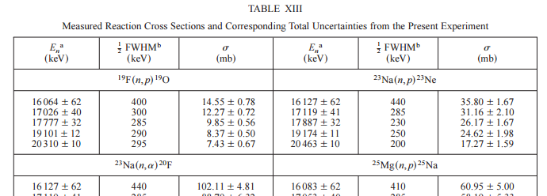

Appendix 1
EXFOR 12924.002 plotted by the NDS EXFOR web retrieval system

Quick plot (as intended by the author)
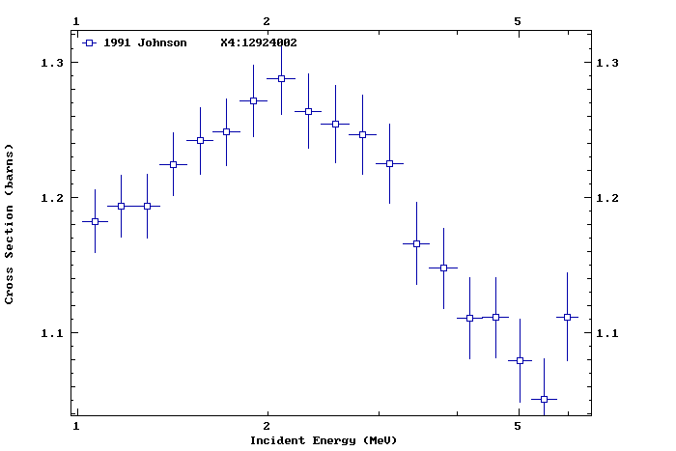

Advanced plot (according to the plotting flag of EN-RSL in Dict.24?)
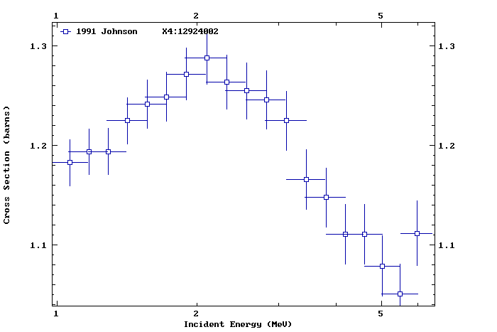
Extraction from EXFOR 12924.002
EN EN-RSL DATA ERR-S ERR-T ERR-9
KEV KEV B PER-CENT PER-CENT PER-CENT
5985.9 468.4 1.1118 2.39 2.91 0.35
5504.1 495.2 1.0510 2.26 2.82 0.36
5039.6 433.8 1.0794 2.27 2.82 0.35
…
Appendix 2
Usage of EN-RSL-HW in EXFOR entries from articles published in 2000 or later

Entry | Explanation by authors | Remark | Half width?
22666 | FWHM | Must be EN-RSL-FW. | No
22691 | Half-width of the peak in the neutron spectrum | Uncertain if HWHM | Yes
22723 | ? | No such a value in the article | ?
22806 | FWHM | Must be EN-RSL-FW. | No
22821 | 95.8 ±0.5 MeV neutrons | Uncertain if HWHM | Yes
22910 | Difference between maximum and mean neutron energy | Not HWHM. | Yes
22949 | The spread of the neutron energy is estimated to be ±130 keV | Uncertain if HWHM | Yes
23159 | Difference between maximum and mean neutron energy | Not HWHM. | Yes
23233 | FWHM (V. Semkova, 2017-05-08) | Must be EN-RSL-FW. | No
23288 | ? | Values received from authors | ?
23295 | With an energy spread of ±30 keV | Uncertain if HWHM | Yes
31714 | FWHM of the monoenergetic peaks | Must be EN-RSL-FW. | No
32205 | The estimated energy resolution, 0.5FWHM (MeV) | Ok | Yes
E1831 | Beam energy stability was less than ±2.5 keV at 6 MeV | Must be EN-ERR? | ?

Distribution:

a.koning@iaea.org
abhihere@gmail.com
aloks279@gmail.com
cgc@ciae.ac.cn
dbrown@bnl.gov
draj@barc.gov.in
dvoytenkov@ippe.ru
ebata@nucl.sci.hokudai.ac.jp
fukahori.tokio@jaea.go.jp
ganesan555@gmail.com
gezg@ciae.ac.cn
iwamoto.osamu@jaea.go.jp
j.c.sublet@iaea.org
jhchang@kaeri.re.kr
jmwang@ciae.ac.cn
kaltchenko@kinr.kiev.ua
jim.gulliford@oecd.org
manuel.bossant@oecd.org
marema08@gmail.com
masaaki@nucl.sci.hokudai.ac.jp
mmarina@ippe.ru
mwherman@bnl.gov
nicolas.soppera@oecd.org
n.otsuka@iaea.org
nrdc@jcprg.org
nurzat.kenzhebaev@gmail.com
ogritzay@kinr.kiev.ua
oscar.cabellos@oecd.org
otto.schwerer@aon.at
pikulina@expd.vniief.ru
pritychenko@bnl.gov
samaev@obninsk.ru
sbabykina@yandex.ru
scyang@kaeri.re.kr
selyankina@expd.vniief.ru
sonzogni@bnl.gov
stakacs@atomki.hu
stanislav.hlavac@savba.sk
s.a.dunaeva@yandex.ru
sv.dunaeva@gmail.com
taova@expd.vniief.ru
tarkanyi@atomki.hu
vvvarlamov@gmail.com
v.semkova@iaea.org
v.zerkin@iaea.org
yolee@kaeri.re.kr
zholdybayev@inp.kz
zhuangyx@ciae.ac.cn

