Nuclear Data Section
International Atomic Energy Agency
P.O.Box 100, A-1400 Vienna, Austria

Memo CP-D/958

Date: 26 April 2018
To: Distribution
From: N. Otsuka

Subject: Coding of fragment separator (FRS, PRJFS)

The LEXFOR “Measurement Techniques” explains that
FACILITY is used to identify the main apparatus or machine used in the experiment, e.g., reactor or cyclotron.
A fragment separator may be used to analyze (1) secondary beam (REACTION SF2), or (2) reaction products (REACTION SF4), and two codes FRS (fragment separator) and PRJFS (Secondary beam from projectile fragment separator) are currently defined in Dict. 18 (Facility). I observe some problems in their actual usages:
Example 1 (EXFOR A0920): Separation of fragment produced by the reaction of interest
FACILITY (CYCLO,4ZZZDUB) Experiments were Carried Out at the A085600100020
U-400 Cyclotron A085600100021
(FRS,4ZZZDUB) the Dubna gas-filled recoil separator A085600100022
METHOD (TOF) A085600100023
…
DETECTOR (MCPLT) a 4-cm*12-cm semiconductor detector array withA085600100031
…
REACTION (98-CF-249(20-CA-48,3N)118-OG-294,,SIG) A085600200003

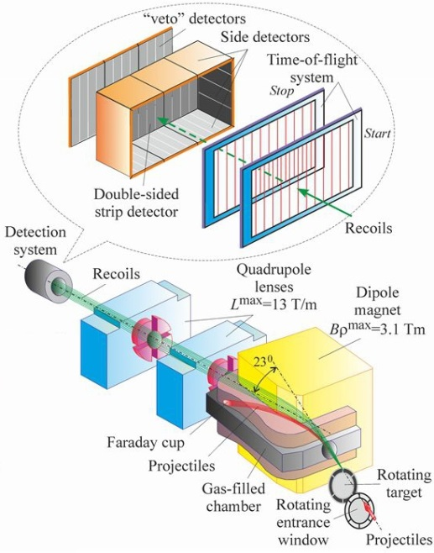
⁴⁸Ca accelerated by a JINR cyclotron induced ²⁴⁹Cf(⁴⁸Ca,3n)²⁹⁴Og reaction. The produced ²⁹⁴Og was analyzed by a recoil separator (Dubna Gas Filled Recoil Separator DGFRS, see the image downloaded from a JINR website), and its decay αs were detected by a semiconductor detector.
The recoil separator is one of the major instruments of this experiment. However it is a part of the detection system, and must be coded by MAGSP under DETECTOR.

Example 2 (EXFOR A0493): Separation of fragment producing secondary beam
INC-SOURCE (SPALL) The helium ions produced by fragmentation of A049300100039
18-O entered FRS and were separated according to theirA049300100040
magnetic rigidity. The beam intensities were 1000 A049300100041
1/sec, with the duty factor between 25% and 50%. A049300100042
…
FACILITY (FRS,2GERGSI) A049300100046
ERR-ANALYS (ERR-1).The uncertainty in the data normalization. A049300100047
…
REACTION ((1-H-1(2-HE-6,EL)1-H-1,,DT)=(2-HE-6(P,EL)2-HE-6,,DT)) A049300600003

¹⁸O accelerated by a GSI synchrotron on Be target produced ⁴He, ⁶He and 8He secondary beams, and they irradiated a hydrogen target after separation by a fragment separator (FRS):
The fragment separator one major instruments of the experiment. However the synchrotron is the apparatus to be coded under FACILITY. The role of the fragmentation Be(¹⁸O,⁶He) etc. is an incident source reaction similar to D-T neutron production by ³H(d,n)⁴He. Some entries actually use INC-SOURCE to indicate the secondary beam production under INC-SOURCE:
TITLE Quasielastic scattering of 9Li on 12C C016100100008
INC-SOURCE A1200 fragment separator at Michigan State University. C016100100009
FACILITY (CYCLO,1USAMSU) C016100100010
…
Proposals
I suggest to
- indicate separation of reaction product MAGSP under DETECTOR
- indicate use of fragmentation for secondary beam production by FRAGM (fragmentation) under INC-SOURCE. This new code is similar to SPALL (spallation) for high energy neutron production.
- make PRJFS and FRS obsolete (which have not been distinguished in a consistent manner.)
There are a number of entries coded with FRS or PRJFS, and I do not suggest retransmission of affected entries only for this change.

Revision of LEXFOR “Measurement Techniques”
Below is an explanation on INC-SOURCE existed in the same LEXFOR “Measurement Techniques” extracted from an old LEXFOR (IAEA-NDS-3, Rev.96/11):
This keyword is used exclusively for the nuclear reaction used as an incident projectile source. The apparatus in which this reaction took place is entered under FACILITY, and the quality of the resulting particle beam is entered under INC-SPECT (see under Incident-Projectile Energy).
This explains the proper use of FACILITY, INC-SOURCE and INC-SPECT very well, and I propose to restore this paragraph in LEXFOR.
Dictionary 5 (Facility)
FRS (Obsolete)
PRJFS (Obsolete)

Dictionary 19 (Incident sources)
FRAGM Fragmentation

Distribution:

a.koning@iaea.org
abhihere@gmail.com
aloks279@gmail.com
cgc@ciae.ac.cn
dbrown@bnl.gov
draj@barc.gov.in
ebata@nucl.sci.hokudai.ac.jp
fukahori.tokio@jaea.go.jp
ganesan555@gmail.com
gezg@ciae.ac.cn
iwamoto.osamu@jaea.go.jp
j.c.sublet@iaea.org
jhchang@kaeri.re.kr
jmwang@ciae.ac.cn
kaltchenko@kinr.kiev.ua
jim.gulliford@oecd.org
l.vrapcenjak@iaea.org
manuel.bossant@oecd.org
masaaki@nucl.sci.hokudai.ac.jp
mmarina@ippe.ru
mwherman@bnl.gov
nicolas.soppera@oecd.org
n.otsuka@iaea.org
nrdc@jcprg.org
nurzat.kenzhebaev@gmail.com
odsuren@gmail.com
ogritzay@kinr.kiev.ua
ogrudzevich@ippe.ru
otto.schwerer@aon.at
pikulina@expd.vniief.ru
pritychenko@bnl.gov
s.a.dunaeva@yandex.ru
s.selyankina@iaea.org
samaev@obninsk.ru
sbabykina@yandex.ru
scyang@kaeri.re.kr
selyankina@expd.vniief.ru
sonzogni@bnl.gov
stakacs@atomki.hu
stanislav.hlavac@savba.sk
sv.dunaeva@gmail.com
taova@expd.vniief.ru
tarkanyi@atomki.hu
vvvarlamov@gmail.com
v.zerkin@iaea.org
vidyathakur@yahoo.co.in
yolee@kaeri.re.kr
zholdybayev@inp.kz
zhuangyx@ciae.ac.cn

