Nuclear Data Section
International Atomic Energy Agency
P.O.Box 100, A-1400 Vienna, Austria

Memo CP-D/995

Date: 3 June 2020
To: Distribution
From: N. Otsuka
Subject: Coding of carbon-12 break up by neutron (Antolković’s experiments)
Reference: Memo CP-D/646
B. Antolković performed “kinematical complete measurements” of ¹²C(n,n+3α) twice by detection of three alpha particles by emulsions (EXFOR 22231 and 30635). During review of EXFOR 40359 retransmitted in PRELIM.4187, I found their data sets are useful to check whether our REACTION coding rule works well for breakup reactions (c.f. Memo CP-D/646), and I reviewed the REACTION strings of these entries.
Various ¹²C+n reactions leaving n+3α as the final products
(¹²C*: Carbon-12 in an excitation state other than ¹²C_{4.4}. ⁹Be*: Bellyrium-9 in an excitation state. SB: simultaneous breakup.).
# | Reaction | Product | 1st decay | 2nd decay | Remark
1 | ¹²C(n,n’) | ¹²C*
 |  | ¹²C* | →α+⁸Be
 |  |  | ⁸Be | →α+α
2 | ¹²C(n,n’) | ¹²C*
 |  | ¹²C* | →α+α+α
3 | ¹²C(n,α) | ⁹Be*
 |  | ⁹Be* | →n+⁸Be
 |  |  | ⁸Be | →α+α
4 | ¹²C(n,α) | ⁹Be*
 |  | ⁹Be* | →α+⁵He
 |  |  | ⁵He | →n+α
5 | ¹²C(n,n+α) | ⁸Be |  |  | Three-body SB
 |  | ⁸Be | →α+α
6 | ¹²C(n,α+α) | ⁵He |  |  | Three-body SB
 |  | ⁵He | →n+α
7 | ¹²C(n,n+α+α+α) |  |  |  | Four-body SB

Below are the outgoing alpha and neutron spectra for 14 MeV neutrons (K. Kondo et al., ND2007 Conf. Proc. p.407), which show the contribution of various sequential decay channels following the (n,n’) and (n,α) reactions.

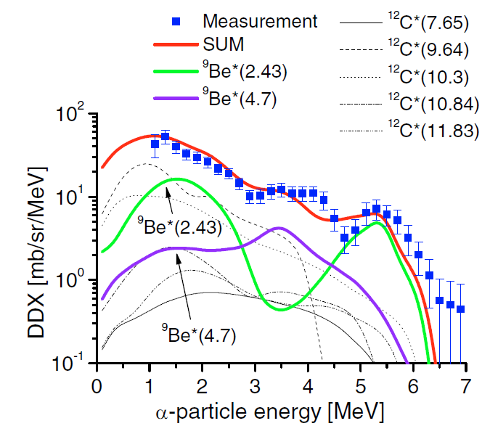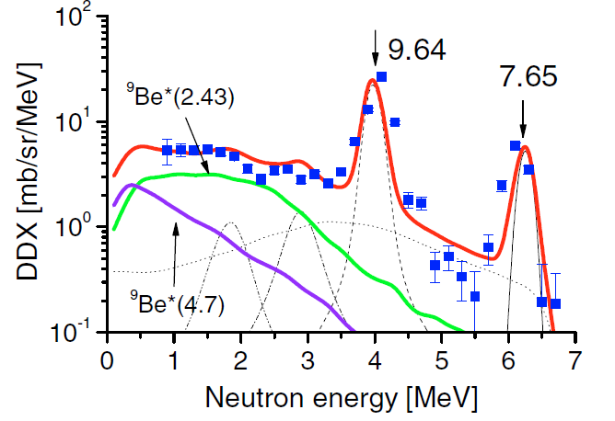

EXFOR 22231 (B. Antolković et al., Nucl. Sci. Eng.107(1991)1. PTB D-T neutron source)
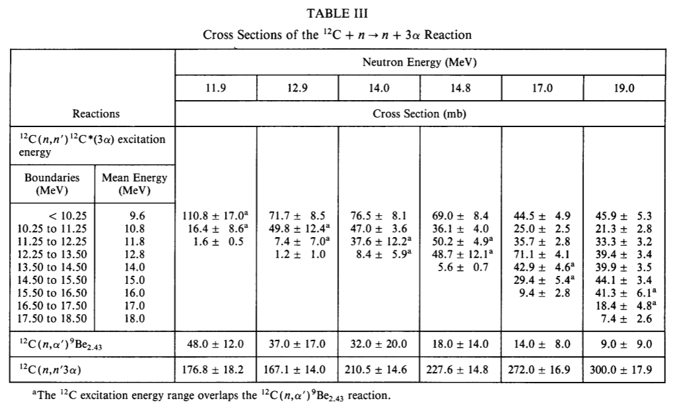

22231.005 (Last line of Table III – “¹²C(n,n’3α)”)
It gives the cross section for the all (#1 to #7) paths resulting n+3α as the final products (but excluding #1+#2 via ¹²C_{7.6}, which was undetectable due to too low α energies). It is currently compiled with
REACTION (6-C-12(N,N+2A)2-HE-4,,SIG,,MSC)
12C(n,n+3a) cross section excluding 12C(n,n2)12C
contribution
where MSC is needed because of exclusion of #1+#2 via ¹²C_{7.6}.
This code reminds us the following basic rule for break upcoding in Memo CP-D/646:
When a reaction proceeds through an intermediate nucleus that is unstable and breaks up with the emission of particles (e.g. n, p, α), the reaction is coded with the products of the breakup as the output particles.
22231.004 (Second line from the bottom of Table III – “¹²C(n,α’)⁹Be_{2.43}”, also in Fig.8)
It gives the cross section for #3+#4 vith ⁹Be* = ⁹Be_{2.43}. It is currently compiled with
REACTION (6-C-12(N,A)4-BE-9,PAR,SIG)
with E-LVL=2.43 MeV, and it is correct.

22231.002 (Lines with ¹²C(n,n’)¹²C*(3α) excitation energy in Table III and in Fig.8.)
It gives 005 minus 004, namely for the paths #1+#2 (excluding the path via ¹²C_{7.6}), #3+#4 (excluding paths via ⁹Be_{2.43}), and #5 to #7. The data set is divided by the ¹²C excitation energy group, and I proposed
REACTION (6-C-12(N,N+2A)2-HE-4,ISP,SIG)
EN-SEC (E-EXC,6-C-12)
during the last retransmission. This RECTION code is questionable since some paths (#3 to #7) do not go through ¹²C as an actual intermediate state (N.B. We can define the ¹²C excitation energy for any 3α system). The article mentions that the simultaneous breakup contribution (#5 to #7) is less than 10% of the ¹²C_{9.64} but becomes considerable for higher ¹²C states, and therefore the paths other than #1+#2 are not negligible. On the other hand the authors plot the 22231.002 data as inelastic scattering cross sections in Fig. 8, and especially assign the three ¹²C levels 9.64, 10.8 and 11.8 MeV to the first three energy groups in Table III – [.10.25 MeV], [10.25 MeV to 11.25 MeV] and [11.25 to 12.25 MeV]. Under this situation, now I consider
REACTION (6-C-12(N,INL)6-C-12,PAR,SIG,,MSC)
EN-SEC (E-EXC,6-C-12)
with free text explanation like “cross section for all (n,n3a) reactions characterized by the three-alpha energy excluding (n,n2) and (n,a1)” could reflect author’s intention better than the current REACTION code.

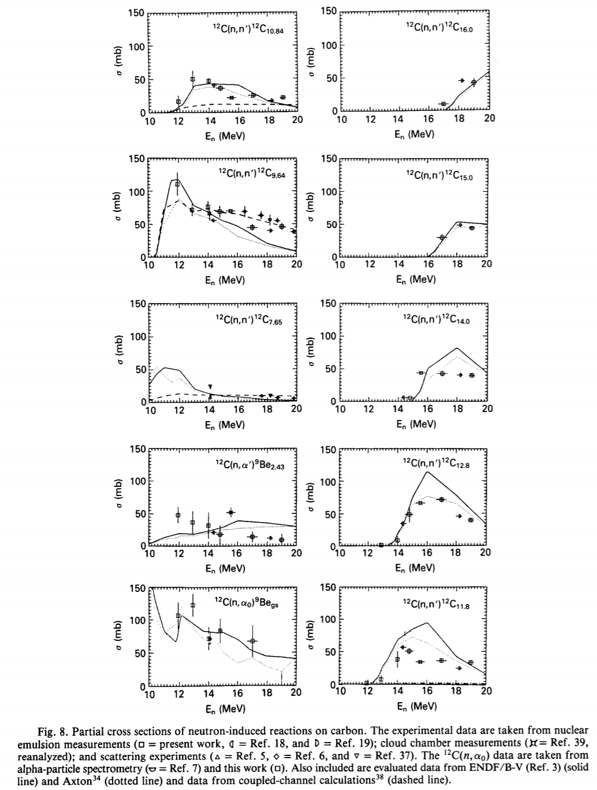

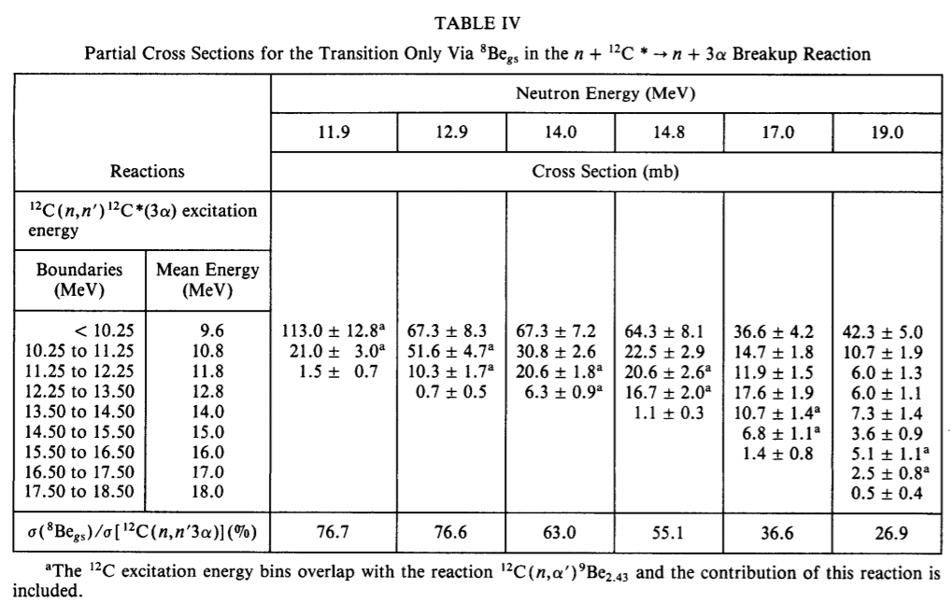

22231.006 (Table IV with ¹²C(n,n’)¹²C*(3α) excitation energy)
It gives the cross section for the path #1+#3+#5 with ⁸Be_{g.s.} characterized by the 3α energies but excluding #1 via ¹²C_{7.6} (undetectable in this experiment). I proposed
REACTION (6-C-12(N,N+A)4-BE-8,ISP/PAR,SIG)
EN-SEC (E-EXC,6-C-12)
(E-LVL,4-BE-8)
with E-LVL=0 MeV in the last retransmission. However, #3 and #5 do not go through ¹²C as an intermediate state, and now I consider
REACTION (6-C-12(N,N+A)4-BE-8,ISP/PAR,SIG,,MSC)
EN-SEC (E-EXC,6-C-12)
(E-LVL,4-BE-8)
with free text explanation like “cross section for all (n,n3a) reactions via 8Be(g.s.) and characterized by the three-alpha energy” could be better.
The authors superseded this data set by 22231.009 (=Table 1 of B. Antolković et al., Radiat. Prot. Dosim.44(1992)31). The Table 2 of this 1992 article gives the same quantity for ⁸Be_{3.03}, and it is compiled in 22231.010 by the same manner.
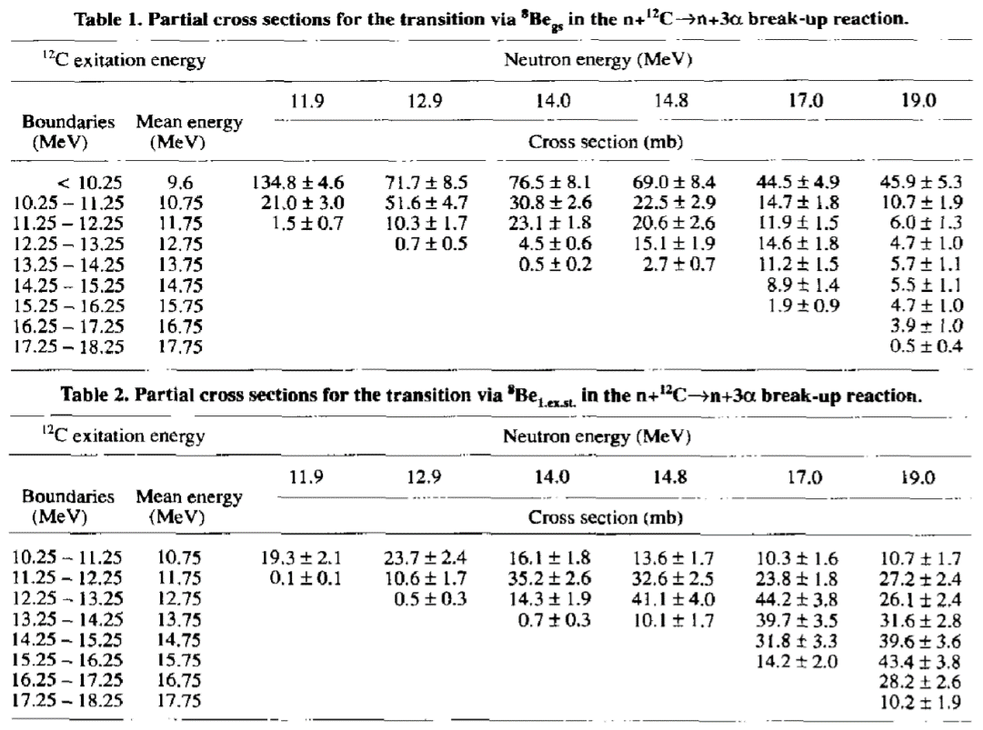
22231.008 (Table V)
This is not from the emulsion experiment but from another measurement with a NE213 liquid scintillator as the target material. The pulse-height spectrum in the smooth line in Fig.4 is calculated with n-p scattering and ¹²C(n,n₀+n₁)¹²C as the first interaction in the scintillator. Then its difference from the measured pulse-height spectrum (histogram in Fig.4) was attributed to the “neutron-induced reaction cross section” by the authors. The cross section in Table V is for the paths #1 to #7 (but excluding #1+#2 via ¹²C_{7.6} due to the detection limit.), ¹²C(n,α₀)⁹Be_{g.s.}, ¹²C(n,p)¹²N (E_{thr}=13.6 MeV) and ¹²C(n,d)¹¹C (E_{thr}=14.9 MeV). It is currently coded by

REACTION (6-C-12(N,N+2A)2-HE-4,,SIG,,MSC)
Three-alpha break up cross section (excluding
12C(n,n'2)12C(7.65MeV)(3alpha) contribution) plus
12C(n,alpha0)9Be cross section.
and it looks fine.
As the free text explains, this approximates the cross section for the all (n,3a) breakup paths observed in the emulsion measurement plus ¹²C(n,α₀)⁹Be_{g.s.,}, but also includes the (n,p) and (n,d) contribution above E_{n}~14.0 MeV. (Indeed the authors derive the ¹²C(n,α₀)⁹Be_{g.s.} cross section by subtraction of 22231.005 plus evaluated (n,p) and (n,d) cross sections from this data set. The derived (n,α₀) cross section is in Fig.8 but not tabulated and not in the EXFOR entry.

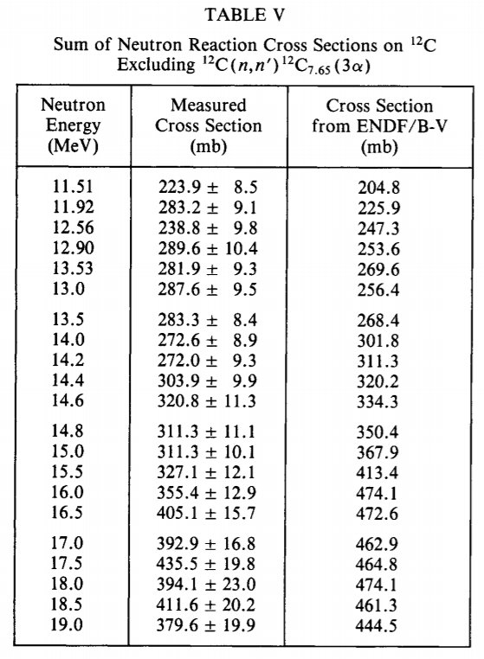

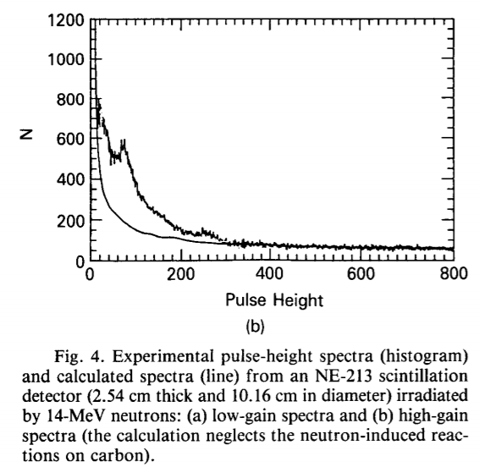

EXFOR 30635 (B. Antolković et al., Nucl. Phys.A394(1983)87. Louvain Be(d,n) source)
This is a similar kinematically complete emulsion experiment performed by the same author but published 8 years before. The breakup via ¹²C_{7.65} was not detectable in this experiment, too.

30635.002 (Table 1)
This gives the quantity compiled in 22231.005. It is coded by
REACTION (6-C-12(N,N+2A)2-HE-4,,SIG)
Currently exclusion of the breakup via ¹²C_{7.65} is mentioned in free text under COMMENT. But it would be better to be mentioned under REACTION with addition of SF8=MSC to be consistent with 22231.005.
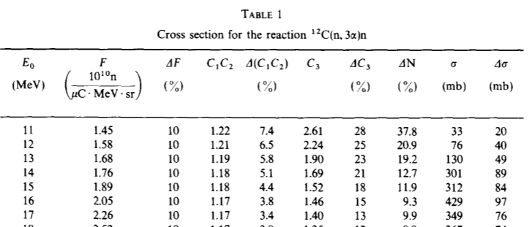

30653.003 (Table 2)
It gives the cross section is for the paths #1, #3 and #5 with ⁸Be_{g.s.} but excluding #1 via ¹²C_{7.6} (undetectable in this experiment). It is very similar to 22231.006 but the cross section is not divided to the 3α energy groups. It is coded by
REACTION (6-C-12(N,N+A)4-BE-8,PAR,SIG)
EN-SEC (E-LVL,4-BE-8)
and it looks fine.
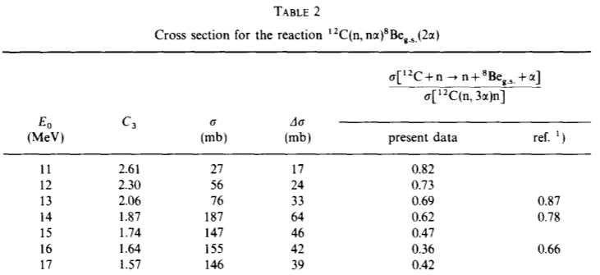

30653.004 (Table 3)
It gives the cross section for the paths #1 and #2 via ¹²C_{9.63}. It is just the ¹²C(n,n₃)¹²C cross section, and compiled by
REACTION (6-C-12(N,INL)6-12-C,PAR,SIG)
EN-SEC (E-LVL,6-C-12)
with E-LVL=9.63 MeV. This data set agrees very well with other data sets from the standard technique (neutron detection with TOF).
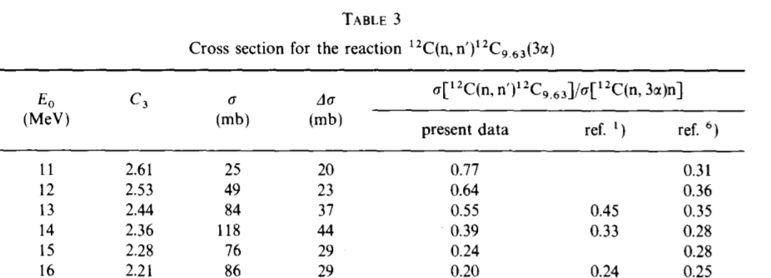

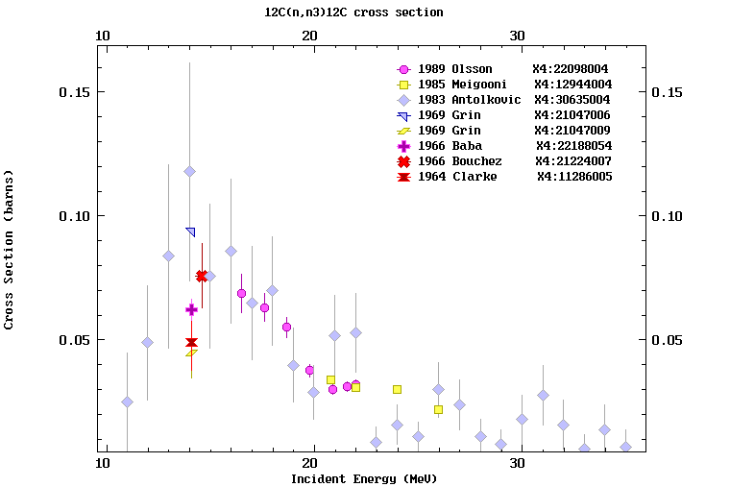
Additional remarks:
- I found the rules formulated in Memo CP-D/646 (=WP2011-29), are very practical for breakup compilation, and all important statements of this Memo should be kept in our manuals.
- I discussed EXFOR 40359.002 and 003 with Stanislav Simakov further after their retransmission in TRANS.4186, and we concluded that the cross sections are for any reaction leaving a neutron slower than the (n,n₃) neutron. The upper boundary energies at four outgoing angles in the laboratory system are in Table 1 of the source article, and the corresponding energy in the centre-of-mass system was estimated to 3.37 MeV by Stanislav. This is similar to 22231.002, and I propose addition of SF8=MSC to the REACTION codes of these subentries to indicate that the channels other than the inelastic scattering also contribute.

Distribution:

a.koning@iaea.org
abhihere@gmail.com
aloks279@gmail.com
daniela.foligno@oecd-nea.org
dbrown@bnl.gov
draj@barc.gov.in
fukahori.tokio@jaea.go.jp
ganesan555@gmail.com
gezg@ciae.ac.cn
iwamoto.osamu@jaea.go.jp
j.c.sublet@iaea.org
jmwang@ciae.ac.cn
kaltchenko@kinr.kiev.ua
kenya.suyama@oecd-nea.org
kimura.atsushi04@jaea.go.jp
l.vrapcenjak@iaea.org
manuel.bossant@oecd-nea.org
masaaki@nucl.sci.hokudai.ac.jp
michael.fleming@oecd-nea.org
mmarina@ippe.ru
nicolas.soppera@oecd-nea.org
n.otsuka@iaea.org
nrdc@jcprg.org
odsurenn@gmail.com
ogritzay@kinr.kiev.ua
ogrudzevich@ippe.ru
otto.schwerer@aon.at
pikulina@expd.vniief.ru
pritychenko@bnl.gov
s.okumura@iaea.org
samaev@obninsk.ru
sbabykina@yandex.ru
scyang@kaeri.re.kr
selyankina@expd.vniief.ru
sonzogni@bnl.gov
stakacs@atomki.mta.hu
stanislav.hlavac@savba.sk
sv.dunaeva@gmail.com
tada@nucl.sci.hokudai.ac.jp
taova@expd.vniief.ru
tarkanyi@atomki.hu
vvvarlamov@gmail.com
v.zerkin@iaea.org
vidyathakur@yahoo.co.in
vsemkova@inrne.bas.bg
yolee@kaeri.re.kr
zholdybayev@inp.kz

cc:
kondo.keitaro@qst.go.jp
murata@see.eng.osaka-u.ac.jp
stanislav.simakov@partner.kit.edu

