Nuclear Data Section
International Atomic Energy Agency
P.O.Box 100, A-1400 Vienna, Austria

Memo CP-D/996

Date: 16 June 2020
To: Distribution
From: N. Otsuka
Subject: Fission product yield measured by Coulomb excitation of heavy-ion beam

I found three articles reporting fission product yields from Coulomb excitation of heavy-ion beam measured at the GSI FRS facility [1-3] and their preceding article published 20 years ago [4]. We discussed this experimental technique briefly in the 2018 EXFOR compilation workshop but without further discussion. There is no data centre responsible for compilation of these fission product yields.
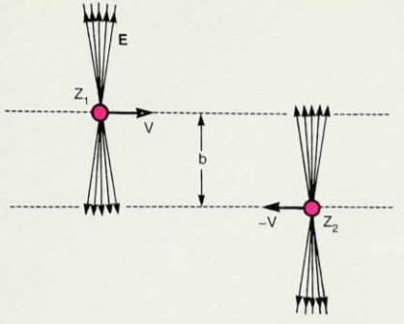
The Coulomb field originated by a heavy (Z) target (e.g., Pb) is enhanced to E~γZe/b² due to Lorentz contraction (b: impact parameter, see the figure taken from Fig.2 of Ref.[5]), and it can be sufficiently energetic to excite giant resonance in the nucleus [6]. In these GSI experiments [1-4], a projectile (At, Rn, Fr, Ra, Ac, Th, Pa or U) was excited by interaction with an “active target” (e.g., Pb, U), and the fission fragments were detected in coincidence.
There are some entries compiling production cross sections for heavy ion (e.g., ²³⁸U) induced fission from its interaction with a heavy (e.g., ²⁰⁸Pb) target measured at the GSI FRS facility (e.g., [7]). They are compiled with a REACTION code such as
(82-PB-208(92-U-238,F)ELEM/MASS,,SIG)
etc. The fission product yields reported in Refs. [1-4] is for the electromagnetic induced fission. As the nuclear induced fission contribution is eliminated (see Appendix), the fission product yields cannot be spelled like
(82-PB-208(92-U-238,F)ELEM,CHG,FY)
etc.
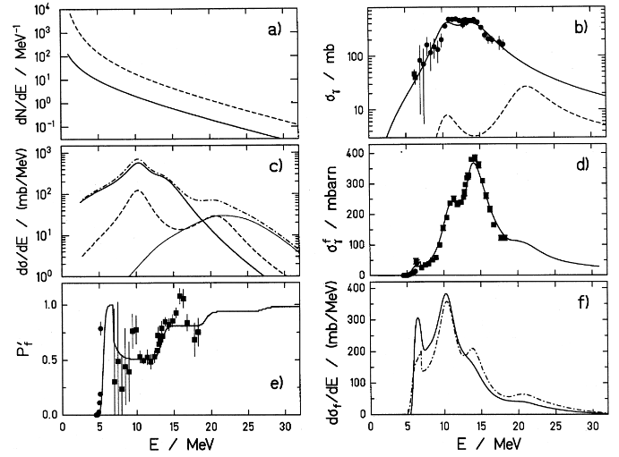
Refs. [1-4] report their fission product yields as yields from fissions induced by virtual (equivalent) photons. The virtual photon spectrum (c.f. Fig. 15 (a) of Ref. [4]) is not monoenergetic, and the fission product yields in the four articles are characterized by the mean excitation energy of the projectile for gamma-induced fission (γ,f) (c.f. Fig. 15 (f) dashed line of Ref. [4], E_{x}~14 MeV). It would be appropriate to spell the yield by
(92-U-238(G,F)ELEM,CHG,FY,,SPA)
etc.
The mean excitation energy (photon incident energy) coded in the four EXFOR entries made from Refs. [1-4] is
<E> = ∫ dE E σ_{f}(E) φ(E) / ∫ dE σ_{f}(E) φ(E)
where σ_{f}(E) is the fission cross section (including second, third,.. chance fissions) for a monoenergetic photon at E, and φ(E) is the energy distribution of the equivalent photons (averaged over the impact parameter b).

Coding sample
(EXFOR G0075.001+002 with minor revisions for better readability)
REACTION (92-U-234(G,F)ELEM,CHG,FY,,SPA)
INC-SOURCE (FRAGM) 238U (1 A GeV) on Be (657 mg/cm2 thick) for
secondary beam production
(COULX) Coulomb excitation of At, Rn, Fr, Ra, Ac, Th,
Pa and U secondary beam (420 A MeV) by a Pb target
(active target)
INC-SPECT Excitation energy distribution with
~14 MeV average initial excitation energy and a tail
up to 30 MeV.
Due to contributions of fission events after
emission of a few neutrons before fission, the
average excitation energy at fission becomes ~11 MeV.
CORRECTION Nuclear-induced fission in the Pb target were removed
by using the ratio of the charge-sum (sum of the
fission fragment charges) spectra of fission events
in the Pb target and (CH2)n target.
MISC-COL (MISC1) Fission yield for all fissions
(MISC2) Fission yield for nuclear-induced fissions
ENDBIB 31 0
COMMON 1 3
EN-APRX
MEV
14.
ENDCOMMON 3 0
DATA 7 41
ELEMENT DATA ERR-S MISC1 MISC1-ERR MISC2 MISC2-ERR
NO-DIM PC/FIS PC/FIS PC/FIS PC/FIS PC/FIS PC/FIS
25. 0. 0. 0. 0. 0. 0.
26. 0. 0. 0. 0. 0. 0.
27. -0.02 0. 0. 0. 0.09 0.04
28. -0.01 0.01 0. 0. 0.04 0.03
29. 0.01 0.04 0.06 0.03 0.29 0.08
...

For INC-SOURCE, the code VPH (virtual photons) has been used for photonuclear data derived from electron beam irradiation, and another incident particle source code COULX (coulomb excitation, for photonuclear data only) could be used for photonuclear data from Coulomb excitation by virtual (equivalent) photons.
The ^{20,22}O(γ,n+x) cross sections [8] compiled in M0662 and M0735 (duplication of M0662) are measured by the same technique at GSI. In this EXFOR entry, COULX and SPA will replace BRST and BRS once the proposals of this memo is accepted.
Dictionary 19 (Incident sources)
COULX Coulomb excitation (photonuclear data only)

I am grateful to Karl-Heinz Schmidt for submission of the numerical data and extensive discussion on their compilation including comments on this memo. Audrey Chatillon also kindly shared the numerical data and checked the EXFOR entry drafts, and it is also appreciated very much. The four entries will be transmitted in PRELIM.G045.

References
[1] A. Chatillon et al., Phys.Rev.C99 (2019) 054628 (EXFOR G0074).
[2] A. Chatillon et al., Phys. Rev. Lett. 124 (2020) 202502 (EXFOR G0076).
[3] E. Pellereau et al., Phys. Rev. C 95 (2017) 054603 (EXFOR G0077).
[4] K.-H. Schmidt et al., Nucl. Phys. A 665 (2000) 221 (EXFOR G0075).
[5] C. Bertulani and G. Baur, Physics Today 47, 3, 22 (1994).
[6] C. Bertulani and G. Baur, Phys. Rep. 163 (1988) 299.
[7] T. Enqvist et al., Nucl. Phys. A 658 (1999) 47 (EXFOR A0099).
[8] A. Leistenschneider et al., Phys. Rev. Lett. 86 (2001) 5442 (EXFOR M0662).

Appendix: Extraction of the electromagnetic induced fission events
First of all, all fission events in the Pb target with a charge sum Zcn (=sum of the two fission fragment charges Z₁ and Z₂) below Z of the projectile are attributed to nuclear induced fission event-by-event.
The fission events with Z_{cn}=Z are from both electromagnetic and nuclear induced fissions, and its nuclear induced fission portion must be subtracted further. Fig.9 of Ref. [4] (below) demonstrates subtraction of the nuclear induced fission events for ²²⁶Th (Z=90).
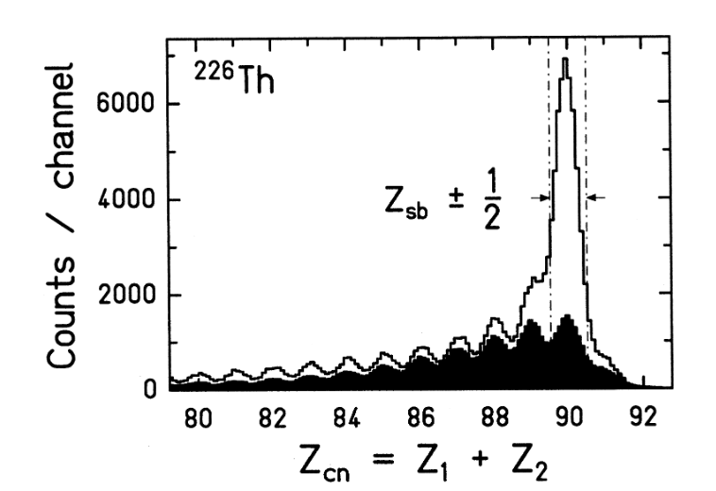

- The charge-sum spectrum (hereafter “spectrum”) for the Pb target (open histogram) is from both electromagnetic and nuclear induced Pb+²²⁶Th fissions.
- The spectrum for the scintillation target ((CH₂)_{n}) target is from nuclear induced fissions only (electromagnetic fission is negligible). We assume this spectrum shape does not depend on the target.
- The spectrum for the scintillation target was normalized (solid histogram) so that it represents the nuclear fission fraction of the spectrum for the Pb target. This normalization was done by adjusting the heights of the peaks in the Z_{cn} distribution for Z₁+Z₂<90 to be equal.
- The difference between the open and solid histogram is assigned to the spectrum from the electromagnetic induced Pb+²²⁶Th fissions.

Distribution:

a.koning@iaea.org
abhihere@gmail.com
aloks279@gmail.com
daniela.foligno@oecd-nea.org
dbrown@bnl.gov
draj@barc.gov.in
fukahori.tokio@jaea.go.jp
ganesan555@gmail.com
gezg@ciae.ac.cn
iwamoto.osamu@jaea.go.jp
j.c.sublet@iaea.org
jmwang@ciae.ac.cn
kaltchenko@kinr.kiev.ua
kenya.suyama@oecd-nea.org
kimura.atsushi04@jaea.go.jp
l.vrapcenjak@iaea.org
manuel.bossant@oecd-nea.org
masaaki@nucl.sci.hokudai.ac.jp
michael.fleming@oecd-nea.org
mmarina@ippe.ru
nicolas.soppera@oecd-nea.org
n.otsuka@iaea.org
nrdc@jcprg.org
odsurenn@gmail.com
ogritzay@kinr.kiev.ua
ogrudzevich@ippe.ru
otto.schwerer@aon.at
pikulina@expd.vniief.ru
pritychenko@bnl.gov
s.okumura@iaea.org
samaev@obninsk.ru
sbabykina@yandex.ru
scyang@kaeri.re.kr
selyankina@expd.vniief.ru
sonzogni@bnl.gov
stakacs@atomki.mta.hu
stanislav.hlavac@savba.sk
sv.dunaeva@gmail.com
tada@nucl.sci.hokudai.ac.jp
taova@expd.vniief.ru
tarkanyi@atomki.hu
vvvarlamov@gmail.com
v.zerkin@iaea.org
vidyathakur@yahoo.co.in
vsemkova@inrne.bas.bg
yolee@kaeri.re.kr
zholdybayev@inp.kz

cc:
andreas.heinz@chalmers.se
audrey.chatillon@cea.fr
julien.taieb@cea.fr
schmidt-erzhausen@t-online.de

