Nuclear Data Section
International Atomic Energy Agency
P.O.Box 100, A-1400 Vienna, Austria

Memo CP-D/1007

Date: 24 December 2020
To: Distribution
From: N. Otsuka
Subject: LEXFOR “Fitting Coefficients” – LEG/RS0 and LEG/RSD

LEXFOR “Fitting Coefficients” defines DA,,LEG/RS0 and DA,,LEG/RSD as follows:

DA,,LEG/RS0 = B_{l} (units NO-DIM) where:
$$\frac{dσ}{dΩ}\left(E,θ\right)=\frac{dσ}{dΩ}\left(E,0°\right)\sum_{l=1}^{n}{a_{l}\left(E\right)P_{l}\left(\cos{θ}\right)}$$
DA,,LEG/RSD = B_{l} (units NO-DIM) where:
$$\frac{dσ}{dΩ}\left(E,θ\right)=\frac{dσ}{dΩ}\left(E,90°\right)\sum_{l=1}^{n}{a_{l}\left(E\right)P_{l}\left(\cos{θ}\right)}$$
Due to absence of the l=0 term, the integration of the right-hand side over the whole solid angle gives zero. This is strange! I found they were defined differently in an old LEXFOR entry (IAEA-NDS-3 Rev.96/11):
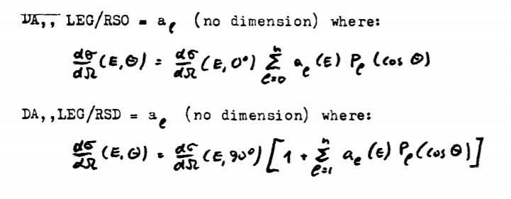
For DA,,LEG/RSD, however, I do not see a reason to fix the 0th order term to 1 (i.e., the angular integrated cross section is not necessary to be 4π times the 90 deg angular differential cross section in general.). I propose the following definitions:

DA,,LEG/RS0 = a_{l} (units NO-DIM) where:
$$\frac{dσ}{dΩ}\left(E,θ\right)=\frac{dσ}{dΩ}\left(E,0°\right)\left[a_{0}+\sum_{l=1}^{n}{a_{l}\left(E\right)P_{l}\left(\cos{θ}\right)}\right]$$

DA,,LEG/RSD = a_{l} (units NO-DIM) where:
$$\frac{dσ}{dΩ}\left(E,θ\right)=\frac{dσ}{dΩ}\left(E,90°\right)\left[a_{0}+\sum_{l=1}^{n}{a_{l}\left(E\right)P_{l}\left(\cos{θ}\right)}\right]$$

There are many data sets compiled with one of these quantities without the 0th order coefficient, and they are suspicious. I checked such questionable entries and found that LEG/RS0 or LEG/RSD are often wrongly used for the coefficients for the expansion W(θ)=1+a₁P₁+a₂P₂+…which must be coded with LEG/RS. Below is a summary from my quick review, and the originating centre is asked to check each case against the source article before correction and retransmission.

SF8 must be LEG/RS.
41027.003, 41136.003, 41140.004, 41615.004, 41660.002+004, 41684.002-003, 41685.005+006, A1156.008+009, A1358.004, C1361.004, C1499.0004-005, F0216.004, F0360.005, F0397.003+005, F0475.002, M0283.013-022, O1347.004.

SF8 must be probably LEG/RS (though the expansion formula is not given in the article or wrong).
40354.003, A1357.004, M0879.003-004

SF8 must be RSD.
41616.008-011

SF8 must be COS/RS.
F0013.004

Not clear
23411.002-003, 30455.003, 40449.002, O1195.004

Distribution:

a.koning@iaea.org
abhihere@gmail.com
aloks279@gmail.com
bknayak@barc.gov.in
daniela.foligno@oecd-nea.org
dbrown@bnl.gov
draj@barc.gov.in
fukahori.tokio@jaea.go.jp
ganesan555@gmail.com
gezg@ciae.ac.cn
iwamoto.osamu@jaea.go.jp
j.c.sublet@iaea.org
jmwang@ciae.ac.cn
kaltchenko@kinr.kiev.ua
kenya.suyama@oecd-nea.org
kimdh@kaeri.re.kr
kimura.atsushi04@jaea.go.jp
l.vrapcenjak@iaea.org
manuel.bossant@oecd-nea.org
masaaki@nucl.sci.hokudai.ac.jp
michael.fleming@oecd-nea.org
mmarina@ippe.ru
nicolas.soppera@oecd-nea.org
n.otsuka@iaea.org
nrdc@jcprg.org
odsurenn@gmail.com
ogritzay@ukr.net
ogrudzevich@ippe.ru
otto.schwerer@aon.at
pikulina@expd.vniief.ru
pritychenko@bnl.gov
s.okumura@iaea.org
samaev@obninsk.ru
sbabykina@yandex.ru
scyang@kaeri.re.kr
selyankina@expd.vniief.ru
sonzogni@bnl.gov
stakacs@atomki.mta.hu
stanislav.hlavac@savba.sk
sv.dunaeva@gmail.com
tada@nucl.sci.hokudai.ac.jp
taova@expd.vniief.ru
tarkanyi@atomki.hu
vvvarlamov@gmail.com
v.zerkin@iaea.org
vidyathakur@yahoo.co.in
vsemkova@inrne.bas.bg
yolee@kaeri.re.kr
zholdybayev@inp.kz

