Nuclear Data Section
International Atomic Energy Agency
P.O.Box 100, A-1400 Vienna, Austria

Memo CP-D/1012

Date: 19 April 2021
To: Distribution
From: N. Otsuka

Subject: Multiple appearance of MASS, ELEMENT, and ISOMER

Multiple appearance of an independent variable heading is allowed when the dataset is for the sum of two independent variable value. However, some repetitions are originated from coding errors.

Example:
MASS in the COMMON section must be MASS-NRM. “(MONIT)” must be added to the second code string under the keyword MONITOR.

SUBENT 22073002 880805
BIB 5 12
REACTION (95-AM-241(N,F)MASS,CHN,FY,,SPA)
MONITOR (92-U-235(N,F)MASS,CHN,FY,,SPA) USED FOR RELATIVE
DETERMINATION OF FISSION YIELDS.
(95-AM-241(N,F)MASS,CHN,FY,,SPA) USED FOR ABSOLUTE
NORMALIZATION OF FISSION YIELDS.
…
ENDBIB 12
COMMON 2 3
MASS MONIT
NO-DIM PC/FIS
1.4000E+02 6.0000E+00
ENDCOMMON 3
DATA 3 35
MASS DATA DATA-ERR
NO-DIM PC/FIS PC/FIS
8.8000E+01 7.5000E-01 9.0000E-02
8.9000E+01 1.0000E+00 2.0000E-01
9.1000E+01 1.7200E+00 2.1000E-01
…
1.3900E+02 6.2100E+00 2.9000E-01
1.4000E+02 6.0000E+00 1.5000E-01
1.4100E+02 5.1500E+00 3.1000E-01
…

I checked multiple appearance of MASS, ELEMENT and ISOMER in EXFOR Master (Ver.2021-04-06), and the result is appended to this memo.

Repetition of both ELEMENT and MASS (41300.002)
During this review, I found it is not trivial to express the quantity summed over several nuclides in the ELEM/MASS formalism (41300.002):
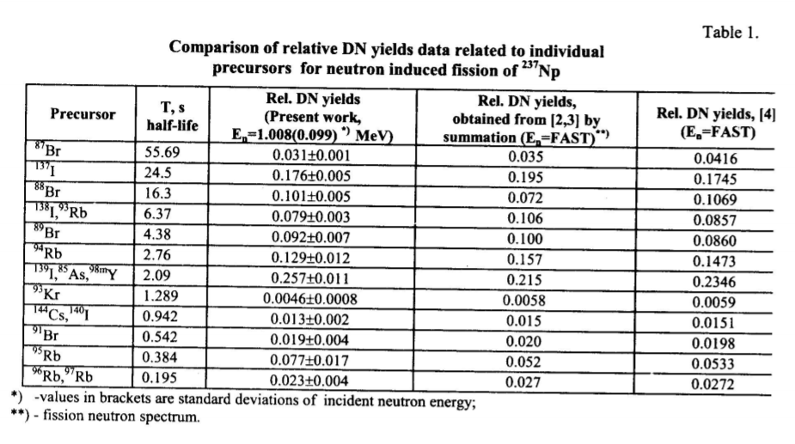
SUBENT 41300002 20191112
BIB 6 38
REACTION ((93-NP-237(N,F)ELEM/MASS,DL,NU)/
(93-NP-237(N,F),DL/IND,NU))
…
ENDBIB 38
NOCOMMON 0 0
DATA 11 60
EN EN-ERR ELEMENT MASS ELEMENT MASS
ISOMER ELEMENT MASS DATA ERR-T
MEV MEV NO-DIM NO-DIM NO-DIM NO-DIM
NO-DIM NO-DIM NO-DIM NO-DIM NO-DIM
0.586 0.078 33. 85. 39. 98.
1. 53. 139. 0.257 0.012
…

The compiler tried to express the delayed neutron fraction for the 2.09 sec group by using three pairs of (ELEMENT,MASS) of precursor nuclides (33-AS-85, 39-Y-98-M1, 53-I-139) instead of the half-life (HALF-LIFE). But the above coding would be interpreted as the direct product of ELEMENT and MASS, i.e.,
(ELEMENT,MASS) = (33,39,53)×(85,98,139) = (33,85) + (33,98)+(33,139)+(39,85)+…
As an-hoc solution, I suggest replacement of (ELEMENT, MASS) with HALF-LIFE in 41300.002.

Repetition of ELEMENT – Chain yield? (13332.002, 13969.002, 22064.003, M0202.002-003)
In the tables of these articles, some fission yields are reported with two nuclides (mother and daughter) on the same mass chain. The mother nuclide often has longer half-life. It could be author’s intention to report the chain yield instead of the cumulative yield. These cases must be further investigated by the originating centres.

Appendix: Multiple appearance of MASS, ELEMENT and ISOMER in EXFOR Master

MASS
22073.002 | MASS -> MASS-NRM in COMMON. Add (MONIT) to the second MONITOR code string.
41300.002 | ELEM/MASS,DL,NU -> ,DL/GRP,NU.  Replace (ELEMENT,MASS) with HALF-LIFE.  (Unresolved precursors of the group-wise delayed neutron fraction.)
41308.003,  41308.004 | (Ok)
C2498.003 | Delete the fourth column of the DATA section under MASS.  (Digitized masses before rounding?)
ELEMENT
13332.002 | Chain yield? (Delete ELEMENT?) ¹¹¹Pd+¹¹¹Ag, ^{129m}Sb-¹²⁹Te, ¹³²Te+¹³²I, ¹⁴¹Ce+¹⁴¹La. The same notation of the sum is used in 13969.002 measured by Kuroda’s group. The two nuclides were isolated and counted separately?
13969.002 | Chain yield? (Delete ELEMENT?) ¹⁴³Ce+¹⁴³Pr, ¹⁵⁶Sm+¹⁵⁶Eu. The authors mention the two nuclides were isolated and counted separately.
22064.003 | Chain yield? The activity of the short-lived daughter is measured. ⁹⁷Zr+⁹⁷Nb, ⁹⁹Mo+^{99m}Tc. The authors explain their yields as “mass yield” in Table 2.
30787.003.1,  30787.003.2,  30787.004.1,  30787.004.2,  30787.005.1,  30787.005.2 | ELEMENT=43 in the common subentry (001) must be deleted.
41300.002 | (See above)
M0202.002,  M0202.003 | Chain yield? (Delete ELEMENT?) Yields are given for ⁸⁸Kr+⁸⁸Rb, ⁹²Sr+⁹²Y, ⁹⁵Zr+⁹⁵Nb, ⁹⁷Zr+⁹⁷Nb, ⁹⁹Mo+⁹⁹Tc (^{99m}Tc?), ¹³²Te+¹³²I, ¹⁴⁰Ba+¹⁴⁰La.
ISOMER
F1217.004 | (Ok)
F1299.002 | (Ok)
G0065.002 | (Ok)
L0214.003,  L0214.004 | (Ok)
O0989.002 | (Ok)

Distribution:

a.koning@iaea.org
abhihere@gmail.com
aloks279@gmail.com
bknayak@barc.gov.in
daniela.foligno@oecd-nea.org
dbrown@bnl.gov
draj@barc.gov.in
exfor@oecd-nea.org
franco.michel-sendis@oecd-nea.org
fukahori.tokio@jaea.go.jp
ganesan555@gmail.com
gezg@ciae.ac.cn
iwamoto.osamu@jaea.go.jp
j.c.sublet@iaea.org
jmwang@ciae.ac.cn
kaltchenko@kinr.kiev.ua
kenya.suyama@oecd-nea.org
kimdh@kaeri.re.kr
kimura.atsushi04@jaea.go.jp
l.vrapcenjak@iaea.org
manuel.bossant@oecd-nea.org
masaaki@nucl.sci.hokudai.ac.jp
michael.fleming@oecd-nea.org
mmarina@ippe.ru
nicolas.soppera@oecd-nea.org
n.otsuka@iaea.org
nrdc@jcprg.org
odsurenn@gmail.com
ogritzay@ukr.net
ogrudzevich@ippe.ru
otto.schwerer@aon.at
pikulina@expd.vniief.ru
pritychenko@bnl.gov
scyang@kaeri.re.kr
selyankina@expd.vniief.ru
sonzogni@bnl.gov
stakacs@atomki.mta.hu
stanislav.hlavac@savba.sk
sv.dunaeva@gmail.com
tada@nucl.sci.hokudai.ac.jp
taova@expd.vniief.ru
tarkanyi@atomki.hu
vvvarlamov@gmail.com
v.zerkin@iaea.org
vidyathakur@yahoo.co.in
vsemkova@inrne.bas.bg
yolee@kaeri.re.kr
zholdybayev@inp.kz

