Nuclear Data Section
International Atomic Energy Agency
P.O.Box 100, A-1400 Vienna, Austria

Memo CP-D/1024

Date: 27 September 2021
To: Distribution
From: N. Otsuka

Subject: Cumulative fission product yield of shielded nuclide – IND/M+,FY?

Fission product yields reported as independent yields may include contribution of isomeric transition from its metastable state:

Example: ¹²⁶Sb (12 d) independent yield
This nuclide does not have a possible precursor nuclide. The 721 keV decay gamma line is emitted only from the ground state (54%), and the fission product yield determined with this gamma line is the yield of the ground state plus a part (IT=14%) of the metastable state (19 min) yield.

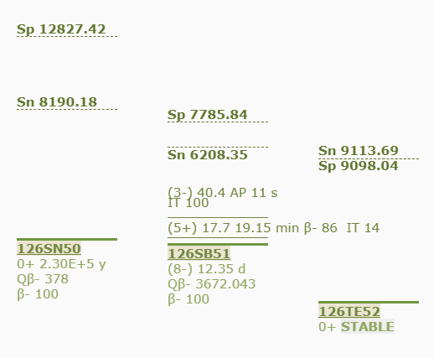

I believe many such independent fission product yields are in EXFOR, but the quantity code IND/M+,FY has been used very seldom in the current EXFOR Master (Ver. 2021-09-21).

Subentry | REACTION
21592.010 | ((98-CF-252(0,F)51-SB-129-G,IND/M+,FY)/  (98-CF-252(0,F)51-SB-127,CUM,FY))
21592.011 | ((98-CF-252(0,F)47-AG-113-G,IND/M+,FY)/  (98-CF-252(0,F)47-AG-111,CUM,FY))
32789.005 | (93-NP-237(N,F)55-CS-138-G,IND/M+,FY)
B0153.003 | (83-BI-209(6-C-12,F)ELEM/MASS,IND/M+,FY,,REL,EXP)

This quantity code is introduced in B0153 in 1980 while it is introduced rather recently in two other entries (2015 and 2019 for 21592 and 32789, respectively). I believe these must be compiled with SF4=-G (or ISOMER=0) with SF5=CUM to be consistent with the other entries. The following revisions of LEXFOR Fission Yields are suggested.

Cumulative Fission-Product Yield
The cumulative yield per fission of a secondary fission product specified by Z and A, i.e., after prompt-neutron emission, and including the independent yield plus the yield from decay of other fission products.

REACTION coding: CUM in SF5.

Example: (…(N,F)ELEM/MASS,CUM,FY)

Sum rule: CUM,FY for the β-decaying product (Z-1,A) + IND,FY for product (Z,A) =
CUM,FY for product (Z,A), if the products (Z-1,A) and (Z,A+1) are not delayed-neutron emitters.

The following events may add to the cumulative yield of the fission-product (Z,A) in its ground state:

- independent yield from fission
- β decay from product (Z-1,A) in ground state
- β decay from product (Z-1,A) in a metastable state
- delayed-neutron emission from product (Z,A+1)
- internal isomeric transition from a metastable state of product (Z,A)

In addition, the product Z,A may be formed from neutron capture in the product (Z,A-1); this product is not included in the "cumulative yield".

Unlike cross sections, the fission product yield excluding feeding via decay of another nuclide but including partial feeding via isomeric transition is coded not with M+ but with CUM in REACTION SF5.

Example:
(92-U-235(N,F)51-SB-126-G,CUM,FY) if the yield is reported in products/fission.
(92-U-235(N,F)51-SB-126-G,IND/M+,SIG) if the yield is reported in barn.

The cumulative yield is often given for an isomeric state of a fission-product (Z,A); the isomer is entered in EXFOR as a separate data field, see EXFOR Formats Manual Chapter 6: Variable Nucleus.

Dictionary 236 (Quantities)
IND/M+,FY (Obsolete)

Distribution:

a.koning@iaea.org
abhihere@gmail.com
aloks279@gmail.com
bknayak@barc.gov.in
daniela.foligno@oecd-nea.org
dbrown@bnl.gov
draj@barc.gov.in
exfor@oecd-nea.org
fukahori.tokio@jaea.go.jp
ganesan555@gmail.com
gezg@ciae.ac.cn
iwamoto.osamu@jaea.go.jp
jmwang@ciae.ac.cn
kaltchenko@kinr.kiev.ua
kimdh@kaeri.re.kr
kimura.atsushi04@jaea.go.jp
l.vrapcenjak@iaea.org
manuel.bossant@oecd-nea.org
masaaki@nucl.sci.hokudai.ac.jp
michael.fleming@oecd-nea.org
mmarina@ippe.ru
nicolas.soppera@oecd-nea.org
n.otsuka@iaea.org
nrdc@jcprg.org
odsurenn@gmail.com
ogritzay@ukr.net
ogrudzevich@ippe.ru
otto.schwerer@aon.at
pikulina@expd.vniief.ru
pritychenko@bnl.gov
scyang@kaeri.re.kr
selyankina@expd.vniief.ru
sonzogni@bnl.gov
stakacs@atomki.mta.hu
stanislav.hlavac@savba.sk
sv.dunaeva@gmail.com
tada@nucl.sci.hokudai.ac.jp
taova@expd.vniief.ru
tarkanyi@atomki.hu
vvvarlamov@gmail.com
v.zerkin@iaea.org
vidyathakur@yahoo.co.in
vsemkova@inrne.bas.bg
yolee@kaeri.re.kr
zholdybayev@inp.kz

