Nuclear Data Section
International Atomic Energy Agency
P.O.Box 100, A-1400 Vienna, Austria

Memo CP-D/1031

Date: 6 December 2021
To: Distribution
From: N. Otsuka, S. Dunaeva

Subject: Compilation of alternative results
Reference: CP-D/714

During update of EXFOR entries compiling kT~25 keV quasi-Maxwellian spectrum averaged cross sections measured at the Karlsruhe Van de Graaf with INDC(GER)-0053, we revised subentries compiling alternative results (e.g., from different samples, different gamma-lines), and propose some revisions in our coding rules based on our experience.
1. Use of flags for alternative results
LEXFOR “Flags” mentions
Flags must not be used to distinguish two distinct data sets for the same quantity, obtained in the same experimental work by different methods. For such cases, the multiple reaction formalism should be used, so that the two data sets can be recognized as distinct sets by processing software. See Multiple Reaction Formalism.
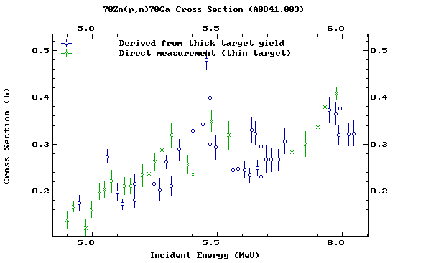
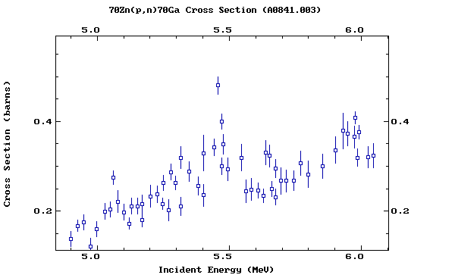
First, we believe the rule is not limited to two datasets from two methods but applied to any alternative results (e.g., two datasets from two samples). Two plots taken from Memo CP-D/714 (cross sections from thick and thin targets compiled with flags [left] and with the multiple reaction formalism [right]) show an advantage of compilation with this rule.

We agree that the multiple reaction formalism is useful when (1) each dataset has several data points, or (2) use of a pointer helps processing of data (e.g., two datasets determined with two different monitor reactions). But we think it rather introduces unnecessary complication in the coding structure when each dataset has a single data point and not distinguished by coded information in the BIB section.

Example (23035.004-006)
The source article reports ⁸¹Br(n,γ)⁸²Br cross sections at kT~25 keV measured with 10 combinations of sample and gamma-line.
SUBENT 23035004 20200806
BIB 8 29
REACTION 1(35-BR-81(N,G)35-BR-82,,SIG,,MXW)
2(35-BR-81(N,G)35-BR-82,,SIG,,MXW)
3(35-BR-81(N,G)35-BR-82,,SIG,,MXW)
…
SAMPLE 1.Activation #4, salt K-Br, mass 98.70 mg, diameter
6 mm, irradiation time 156 min, integrated neutron
flux 2.68E+13, gamma-ray energy 554.35 keV
2.Activation #4, salt K-Br, mass 98.70 mg, diameter
6 mm, irradiation time 156 min, integrated neutron
flux 2.68E+13, gamma-ray energy 776.52 keV
3.Activation #1, salt Rb-Br, mass 72.58 mg, diameter
6 mm, irradiation time 249 min, integrated neutron
flux 4.41E+13, gamma-ray energy 554.35 keV
…
ENDBIB 29
COMMON 6 3
KT ERR-T ERR-HL ERR-6 ERR-7 MISC
KEV PER-CENT HR PER-CENT PER-CENT NO-DIM
25. 3.7 0.007 0.1 2.4 0.99
ENDCOMMON 3
DATA 12 1
DATA 1ERR-S 1ERR-SYS 1ERR-IDD 1DATA 2ERR-S 2
ERR-SYS 2ERR-IDD 2DATA 3ERR-S 3ERR-SYS 3ERR-IDD 3
MB MB MB NO-DIM MB MB
MB NO-DIM MB MB MB NO-DIM
242. 2. 9. 0.0085 236. 3.
9. 0.012 254. 1. 9. 0.0085
ENDDATA 6
Not all 10 cross sections can be in a single subentry due to format restriction, and the compiler had to use 3 subentries to accommodate all alternative results. Each dataset has a single data point, and they are distinguished by free text only. Hence, we believe use of FLAG simplifies the subentry structure without losing processing ability.

SUBENT 23035004 20200806
BIB 8 29
REACTION (35-BR-81(N,G)35-BR-82,,SIG,,MXW)
...
SAMPLE 1.Activation #4, salt K-Br, mass 98.70 mg, diameter
6 mm, irradiation time 156 min, integrated neutron
flux 2.68E+13, gamma-ray energy 554.35 keV
2.Activation #4, salt K-Br, mass 98.70 mg, diameter
6 mm, irradiation time 156 min, integrated neutron
flux 2.68E+13, gamma-ray energy 776.52 keV
3.Activation #1, salt Rb-Br, mass 72.58 mg, diameter
6 mm, irradiation time 249 min, integrated neutron
flux 4.41E+13, gamma-ray energy 554.35 keV
FLAG (1.) Data measured with sample 1
(2.) Data measured with sample 2
(3.) Data measured with sample 3
...
ENDBIB 29
COMMON 6 3
KT ERR-T ERR-HL ERR-6 ERR-7 MISC
KEV PER-CENT HR PER-CENT PER-CENT NO-DIM
25. 3.7 0.007 0.1 2.4 0.99
ENDCOMMON 3
DATA 12 1
DATA ERR-S ERR-SYS ERR-IDD FLAG
MB MB MB NO-DIM NO-DIM
242. 2. 9. 0.0085 1.
236. 3. 9. 0.012 2.
254. 1. 9. 0.0085 3.
ENDDATA 6

We suggest revision of the LEXFOR text as follows:
Flags must not be used to distinguish two distinct alternative results data sets for the same quantity, obtained in the same experimental work by different methods. For such cases, the multiple reaction formalism should be used, so that the two data sets can be recognized as distinct sets by processing software. An exception is compilation of alternative results where each data set has only one data point and use of flags does not lose processing ability (e.g., two data points distinguished by two sample foils having different chemical composition). See Multiple Reaction Formalism.

2. Compilation of alternative results and their average
When the authors report data from several measurements with their average, both individual values and their average may be compiled. But they must be compiled separately otherwise users could treat the individual values and the average value in the same manner. To avoid such double counting, we suggest (1) compilation of the individual values and average value in different subentries, and (2) use of REACTION SF8=AV to indicate that the value is average of the individual values compiled in another subentry.
Example:
REACTION 1(29-CU-63(N,G)29-CU-64,,SIG,,SPA) Run I
2(29-CU-63(N,G)29-CU-64,,SIG,,SPA) Run II
3(29-CU-63(N,G)29-CU-64,,SIG,,SPA) Weighted average
…
DATA 1ERR-S 1DATA 2ERR-S 2DATA 3ERR-S 3
MB MB MB MB MB MB
85.2 1.3 88.6 0.9 87.4 1.1
ENDDATA
…
must be
REACTION 1(29-CU-63(N,G)29-CU-64,,SIG,,SPA) Run I
2(29-CU-63(N,G)29-CU-64,,SIG,,SPA) Run II
…
DATA 1ERR-S 1DATA 2ERR-S 2
MB MB MB MB
85.2 1.3 88.6 0.9
ENDDATA
…
REACTION (29-CU-63(N,G)29-CU-64,,SIG,,SPA/AV)
ANALYSIS Weighted mean of values from Runs I and II
STATUS (DEP,23326002) Values from Runs I and II
…
DATA ERR-S
MB MB
87.4 1.1
ENDDATA
…
Alternatively, the first subentry may be arranged with flags if the first proposal of this memo is approved:
REACTION (29-CU-63(N,G)29-CU-64,,SIG,,SPA)
FLAG (1.) Run I
(2.) Run II
…
DATA ERR-S FLAG
MB MB NO-DIM
85.2 1.3 1.
88.6 0.9 2.

We suggest following addition to the explanation of the AV modifier in the LEXFOR “General quantity modifiers”:
AV-modifier
Used for data measured as a function of energy or angle and averaged over a given energy interval or angular range.
This modifier is also used for an averaged dataset compiled with the individual datasets before averaging. This distinction is important to avoid double counting due to use of averaged and individual datasets. They must not be compiled together as a single dataset.

3. Usage of COREL (LEXFOR “Status”)
LEXFOR “Status” explains usage of COREL as follows:
Interdependent Data
Different results for the same quantity obtained in the same experiment by two different methods of analysis may be coded in the same subentry, see EXFOR Formats Manual Chapter 5. Such data may also be entered in separate subentries, in which case, the subentries should be linked to each other using STATUS code COREL. (See EXFOR Formats Manual Chapter 7: STATUS, for coding details).
The title of the paragraph is “Interdependent data”, but its first sentence is about the alternative results. We see good examples of interdependent data in other pages of LEXFOR, for example,
- Absorption and capture cross sections, and alpha derived from a common set of raw data. (LEXFOR “Dependent Data”)
- Cross section (=0th order coefficient) and higher order coefficients derived from a common angular distribution data (LEXFOR “Fitting Coefficients”).
We believe COREL may be used for both interdependent data and alternative results, and suggest following revision of the paragraph:
Interdependent Data and Alternative Results
Different results for the same quantity obtained in the same experiment by two different methods of analysis Interdependent data (e.g., cross section and Legendre coefficients derived from the same angular distribution data) and alternative results (e.g., two activation cross sections from detection of two radiations) may be coded in the same subentry, see EXFOR Formats Manual Chapter 5. Such data may also be entered in separate subentries, in which case, the subentries should be linked to each other using STATUS code COREL. (See EXFOR Formats Manual Chapter 7: STATUS, for coding details).

Distribution:

a.koning@iaea.org
abhihere@gmail.com
aloks279@gmail.com
bknayak@barc.gov.in
daniela.foligno@oecd-nea.org
dbrown@bnl.gov
draj@barc.gov.in
exfor@oecd-nea.org
fukahori.tokio@jaea.go.jp
ganesan555@gmail.com
gezg@ciae.ac.cn
iwamoto.osamu@jaea.go.jp
jmwang@ciae.ac.cn
kaltchenko@kinr.kiev.ua
kimdh@kaeri.re.kr
kimura.atsushi04@jaea.go.jp
l.vrapcenjak@iaea.org
manuel.bossant@oecd-nea.org
masaaki@nucl.sci.hokudai.ac.jp
michael.fleming@oecd-nea.org
mmarina@ippe.ru
nicolas.soppera@oecd-nea.org
n.otsuka@iaea.org
nrdc@jcprg.org
odsurenn@gmail.com
ogritzay@ukr.net
ogrudzevich@ippe.ru
otto.schwerer@aon.at
pikulina@expd.vniief.ru
pritychenko@bnl.gov
scyang@kaeri.re.kr
selyankina@expd.vniief.ru
sonzogni@bnl.gov
stakacs@atomki.mta.hu
stanislav.hlavac@savba.sk
sv.dunaeva@gmail.com
tada@nucl.sci.hokudai.ac.jp
taova@expd.vniief.ru
tarkanyi@atomki.hu
vvvarlamov@gmail.com
v.zerkin@iaea.org
vidyathakur@yahoo.co.in
vsemkova@inrne.bas.bg
yolee@kaeri.re.kr
zholdybayev@inp.kz

