Nuclear Data Section
International Atomic Energy Agency
P.O.Box 100, A-1400 Vienna, Austria

Memo CP-D/1048

Date: 25 May 2022
To: Distribution
From: N. Otsuka

Subject: LEXFOR “Multiple Reaction Formalism”
LEXFOR “Multiple Reaction Formalism” gives the following example as a legal use of the formalism:
Multiple Reaction Formalism
At present, the following classes of data may be coded using Multiple Reaction Formalism8 (compare EXFOR Formats Manual Chapter 6). In all cases, SF1 and SF2 of the REACTION string must be the same. See Example on following page.
…
4. Data measured simultaneously for the production of specific particles or nuclides where the author has assigned values to given reactions based on systematics or theoretical considerations.

Examples:
REACTION 1(…(P,2N)…)
2(…(P,3N)…)
3(…(P,4N)…)

REACTION 1(…(N,A)…)
2(…(N,NA)…)

I think the underlined part is routinely forgotten by us.

Example of legal use (EXFOR A0068.064)

SUBENT A0068064 20210628
BIB 4 11
REACTION 1(24-CR-52(P,N)25-MN-52,,SIG,,,DERIV)
2(24-CR-52(P,2N)25-MN-51,,SIG,,,DERIV)
P(24-CR-52(P,X)24-CR-51,,SIG)
ANALYSIS Cr.section was derived by separation of the measured
neutron spectra by using the statistical model with
adjusted level density parameters of the
Fermi gas model.
STATUS (TABLE) Tbl. II from Yad.Fiz.,39(1984)264
(DEP,A0068009)
HISTORY (20200331T) SD: From A0271.003.
(20210628A) SD: SF3=X -> N in REACTION (1) code.
ENDBIB 11
NOCOMMON 0 0
DATA 3 1
DATA 1DATA 2DATA P
MB MB MB
431. 188. 352.
ENDDATA 3
ENDSUBENT 19

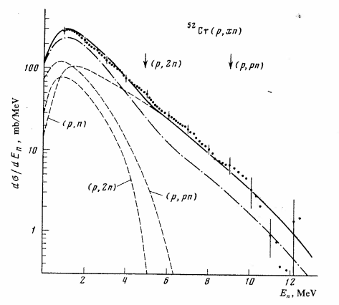
Fig.2 of B.V. Zhuravlev et al., Sov.J.Nucl.Phys.39(1984)164 shows these cross sections were derived by decomposition of the (p,xn) neutron spectrum, and we see a reason to compile the set of the cross sections in the multiple reaction formalism.

I would like to remind the condition when we can use the multiple reaction formalism, and propose the following revision of the example:
Multiple Reaction Formalism
…
4. Data measured simultaneously for the production of specific particles or nuclides where the author has assigned values to given reactions based on systematics or theoretical considerations.

Examples:
REACTION 1(24-CR-52(P,2N)25-MN-52,,SIG,,,DERIV)
2(24-CR-52(P,3N)25-MN-51,,SIG,,,DERIV)
ANALYSIS Derived by decomposition of the measured (p,xn) spectra
by using the statistical model

REACTION 1(…(N,A)…)
2(…(N,NA)…)

Distribution:

a.koning@iaea.org
abhihere@gmail.com
aloks279@gmail.com
daniela.foligno@oecd-nea.org
dbrown@bnl.gov
draj@barc.gov.in
exfor@oecd-nea.org
fukahori.tokio@jaea.go.jp
ganesan555@gmail.com
gezg@ciae.ac.cn
iwamoto.osamu@jaea.go.jp
jmwang@ciae.ac.cn
kaltchen@ukr.net
kimdh@kaeri.re.kr
kimura.atsushi04@jaea.go.jp
l.vrapcenjak@iaea.org
manuel.bossant@oecd-nea.org
masaaki@nucl.sci.hokudai.ac.jp
marina-03-08@yandex.ru
michael.fleming@oecd-nea.org
mmarina@ippe.ru
nicolas.soppera@oecd-nea.org
n.otsuka@iaea.org
nrdc@jcprg.org
odsurenn@gmail.com
ogritzay@ukr.net
ogrudzevich@ippe.ru
otto.schwerer@aon.at
pikulina@expd.vniief.ru
pritychenko@bnl.gov
s.okumura@iaea.org
scyang@kaeri.re.kr
selyankina@expd.vniief.ru
sonzogni@bnl.gov
stakacs@atomki.mta.hu
stanislav.hlavac@savba.sk
sv.dunaeva@gmail.com
tada@nucl.sci.hokudai.ac.jp
taova@expd.vniief.ru
tarkanyi@atomki.hu
v.devi@iaea.org
v.zerkin@iaea.org
vidyathakur@yahoo.co.in
vsemkova@inrne.bas.bg
vvvarlamov@gmail.com
yolee@kaeri.re.kr
zholdybayev@inp.kz

