Nuclear Data Section
International Atomic Energy Agency
P.O.Box 100, A-1400 Vienna, Austria

Memo CP-D/1057

Date: 7 September 2022
To: Distribution
From: N. Otsuka, V. Devi

Subject: Gamma production following quasi-metastable state production

Dictionary 33 (particles) defines the following two codes:
G Gammas (Use DG for decay gammas)
DG Decay gammas – Used for gammas emitted from metastable states and for gammas following a particle-emitting decay (e.g., beta decay)
Obviously “metastable state” in the explanation of DG does not include quasi-metastable states (Otherwise all cascade gammas eventually belong to DG since we do not have the lower boundary of the half-life for quasi-metastable states.). Then there are probably following three cases for the datasets currently coded with PAR,$SF6,G:

- Gammas excluding decay gammas (usual gamma production cross section)
Examples:
82-PB-206(N,INL)82-PB-206,PAR,DA,G
for the full portion of the 803 keV gamma production
13-AL-27(N,INL)13-AL-27,PAR,DA,G
for the full portion of the 1014 keV gamma production excluding decay gamma originating from ²⁷Al(n,p)²⁷Mg (9.5 min)→²⁷Al.

- Gammas following quasi-metastable state (T_{1/2}<0.1 sec) production and excluding decay gammas - This could be coded with a new modifier (say L-) indicating “excluding formation via quasi-metastable state production”.
Example (proposal):
82-PB-206(N,INL)82-PB-206,PAR/L-,DA,G
for the 803 keV gamma production from a cascade bypassing the 125 μsec quasi-metastable state production (e.g., 31492.006.1)

- Gammas excluding decay gammas and gammas following quasi-metastable state (T_{1/2}<0.1 sec) production - This could be coded with a quasi-metastable state flag in SF4:
Example (proposal):
82-PB-206(N,INL)82-PB-206-L,PAR,DA,G
for the 803 keV gamma production following the 125 μsec quasi-metastable state production (e.g., 31492.006.2).

Solutions similar to #2 and #3 have been already adopted in the current EXFOR 31492.006 (but M instead of L):
REACTION 1(82-PB-0(N,X)82-PB-206,PAR/M-,DA,G) Prompt. 31492006 3
2(82-PB-0(N,X)82-PB-206-M,PAR,DA,G) Delayed. 31492006 4

Below we introduce some measurements of ²⁰⁶Pb 803 keV γ production as an example. (Are there examples other than the Pb gamma lines compiled in this EXFOR entry?)

“Prompt” and “delayed” components of the 803 keV γ line from Pb+n
Below is a table providing gamma production cross secions from irradiation of natural Pb by 14.9 MeV neuttrons at Beijing Normal Unvieristy (Hongyu Zhou+, J,NSE,134,106,2000, EXFOR 31492).
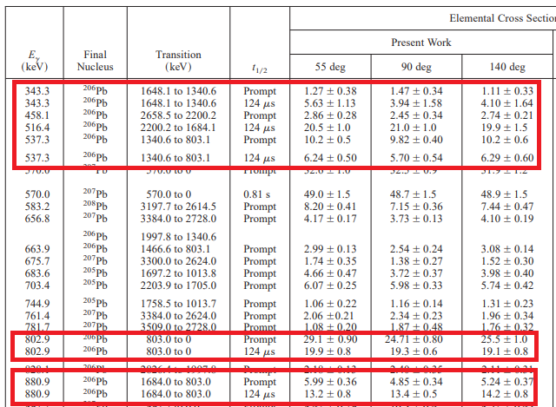

The authors report two components (“prompt” and “124 μsec”) for several ²⁰⁶Pb gamma lines (e.g., 803 keV 2⁺→0⁺ γ line). The “delayed” component is originated from gamma cascades through the 125 μsec quasi-metastable state at 2200 keV.

Their preceding article Hongyu Zho+,J,NSE,125,61,1997 (EXFOR 31528) shows a TOF-γ spectrum with two time windows – “WIN1” (30 nsec) for total “prompt” gamma + partial “delayed” gamma, and “WIN2” (160 nsec) for partial “delayed” gamma. The same spectrum and more technical details are published in Hongyu Zho+,J,NIM/A,371,504,1996.
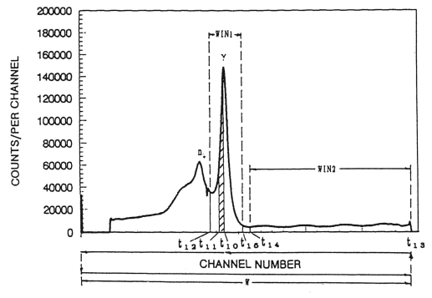

Namely, a measurement with fast timing may report only the “prompt” portion of the γ production cross sections. The Pb+n γ production cross section measurement at GELINA and published in A.Negret+,J,PR/C,91,064618,2015 (EXFOR 23292) is such an example. It mentions:
“The second limitation concerns an isomer at 2200.2 keV with a lifetime of 180(3) μs. The γ rays from the decay of this isomer (516.2 and 202.4 keV) are delayed and almost all of the decay occurs outside of the 24-μs time span of the present measurement. Therefore the γ rays emitted following the decay of the isomer are hard to observe and…”
Indeed Talys-1.9 reproduces their experimental 803 keV gamma production cross sections (EXFOR 23292.006) if we exclude contribution of the gammas originating from the cascades through the quasi-metastable state.
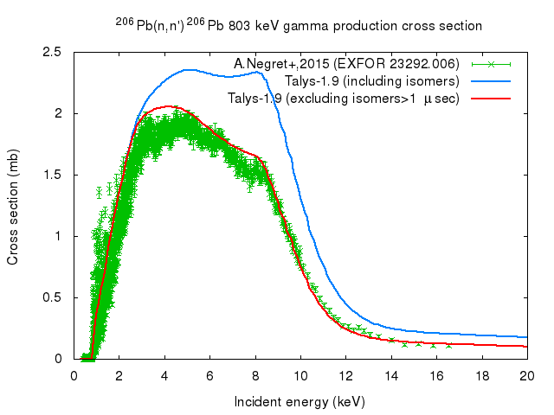
Comparison of production cross sections compiled from various articles
This implies datasets coded with (82-PB-206(N,INL)82-PB-206,PAR,DA,G) are not always comparable each other. Hongyu Zhou+,J,NSE,125,61,1997 (EXFOR 31528) mentions that:
“… different experimental methods can give different results. For example, the associated-particle method can give only the pure prompt component data. The pulsed-beam method can also produce different results because of different parameters sets used and different data reduction methods”.
Table collects the 803 keV γ-ray production cross sections. “prompt” and “delayed” are in terms of the half-life of 125 μsec quasi-metastable state, and only the 31492 article gives two components separately. Note that NaI has poor energy resolution, and it has more probability to detect some gamma lines unresolved from the 803 keV gamma line.

Table
Pb(n,γ+x) 803 keV (IT decay of 125 μsec ²⁰⁶Pb may contribute to the delayed portion)
EXFOR # | Year | θ  (deg) | En  (MeV) | dσ/dΩ  (mb/sr) | Remark
20164.057 | 1969 | 80 | 14.7 | 42(2) | GeLi
23341.026 | 1991 | 90 | 13.0 | 24.7(35) | NaI+TOF
13034.009 | 1972 | 90 | 14.4 | 47(8) | NaI
31492.006.1 | 2000 | 90 | 14.9 | 19.3(8) | GeLi+TOF, delayed
31492.006.2 | 2000 | 90 | 14.9 | 24.7(8) | GeLi+TOF, prompt
21304.029 | 1978 | 125 | 14.8 | 69.1(75) | GeLi
31492.006.1 | 2000 | 140 | 14.9 | 19.1(8) | GeLi+TOF, delayed
31492.006.2 | 2000 | 140 | 14.9 | 25.5(10) | GeLi+TOF, prompt

Experimental aspects
Some comments received from experts are collected below. I feel we should be careful when there is a level having a micro-sec order half-life.
- Nowadays it is common to uses fast timing / time gating with typical time resolution of ~30 nsec with old electronics or ~10 nsec with new electronics.
- In 1970s, the importance of the fast timing becomes apparent, and hardware became available.
- HPGe, GeLi and NaI have the time resolution of ~10 nsec or more (which is longer than the beam width). γ -flash gate window is set several times longer, but it is still in order of 100 ns. Namely the cascade following transition from a level with T_{1/2}~100 nsec or longer is not excluded.
- For ⁴⁸Ti(n,n’γ)⁴⁸Ti datasets (c.f. INDC(NDS)-0740), only around half of the measurements employed TOF to separate secondary gammas originated from background neutrons.
- There could be an impact of an isomer on a neutron capture cross section measurement with the pulse height weighting technique (PHWT) if the position of the isomer is comparable with the neutron binding energy of the compound nuclide B_{n} (N.B. The capture yield is determined by PHWT by Y=Σ_{i} [S_{i}W_{i}/(Bn+En)] where S_{i} is the pulse height of the i-th γ line and W_{i} is the weighting function.

Distribution:

a.koning@iaea.org
abhihere@gmail.com
aloks279@gmail.com
daniela.foligno@oecd-nea.org
dbrown@bnl.gov
draj@barc.gov.in
exfor@oecd-nea.org
fukahori.tokio@jaea.go.jp
ganesan555@gmail.com
gezg@ciae.ac.cn
iwamoto.osamu@jaea.go.jp
jmwang@ciae.ac.cn
kaltchen@ukr.net
kimdh@kaeri.re.kr
kimura.atsushi04@jaea.go.jp
l.vrapcenjak@iaea.org
manuel.bossant@oecd-nea.org
masaaki@nucl.sci.hokudai.ac.jp
marina-03-08@yandex.ru
michael.fleming@oecd-nea.org
mmarina@ippe.ru
nicolas.soppera@oecd-nea.org
n.otsuka@iaea.org
nrdc@jcprg.org
odsurenn@gmail.com
ogritzay@ukr.net
ogrudzevich@ippe.ru
otto.schwerer@aon.at
pikulina@expd.vniief.ru
pritychenko@bnl.gov
scyang@kaeri.re.kr
selyankina@expd.vniief.ru
sonzogni@bnl.gov
stakacs@atomki.mta.hu
stanislav.hlavac@savba.sk
sv.dunaeva@gmail.com
tada@nucl.sci.hokudai.ac.jp
taova@expd.vniief.ru
tarkanyi@atomki.hu
v.devi@iaea.org
v.zerkin@iaea.org
vidyathakur@yahoo.co.in
vsemkova@inrne.bas.bg
vvvarlamov@gmail.com
yolee@kaeri.re.kr
zholdybayev@inp.kz

cc:
intersurfen@gmail.com

