Nuclear Data Section
International Atomic Energy Agency
P.O.Box 100, A-1400 Vienna, Austria

Memo CP-D/1061

Date: 9 December 2022
To: Distribution
From: N. Otsuka, A. Rodrigo

Subject: Status of Filatenkov’s activation cross sections (EXFOR 41424/41614)
Many of the activation cross sections compiled in EXFOR 41424 from RI-258 (2001) have been superseded in September 2016 by the corresponding datasets in EXFOR 41614 compiled from INDC(CCP)-0460 (2016). However, a few subentries of EXFOR 41424 are still active, and I guess this is because the datasets in two entries are not for direct comparison (e.g., elemental cross section v.s. isotopic cross section, isomeric ratio v.s. isomer production cross sections).
During global assessment of the experimental isomeric ratios extracted from EXFOR, we decided to exclude all active EXFOR 41424 datasets since we see the corresponding datasets in EXFOR 41614 and do not want to give extra weight to Filatenkov’s work during estimation of the goodness-of-fit of a theoretical estimation.

Reaction | RI-258 | INDC(CCP)-0460
⁹³Nb(n,α)⁹⁰Y | 41424.021 | 41614.064/065
Mo(n,x)⁹⁵Nb | 41424.025 (isotopic xs) | 41614.072
Mo(n,x)⁹⁶Nb | 41424.026 (isotopic xs) | 41614.074
⁷⁴Se(n,2n)⁷³Se | 41424.057 | 41614.037/039
⁸²Se(n,2n)⁸¹Se | 41424.058 | 41614.048/050
⁹³Nb(n,α)⁹⁰Y | 41424.059 | 41614.064/065
¹⁰³Rh(n,2n)¹⁰²Rh | 41424.060 | 41614.086/088
¹¹⁶Cd(n,2n)¹¹⁵Cd | 41424.061 | 41614.114/115
¹⁸¹Ta(n,α)¹⁷⁸Lu | 41424.062 | 41614.174/176
We suggest CJD superseding these 41424 datasets by the corresponding 41614 datasets.
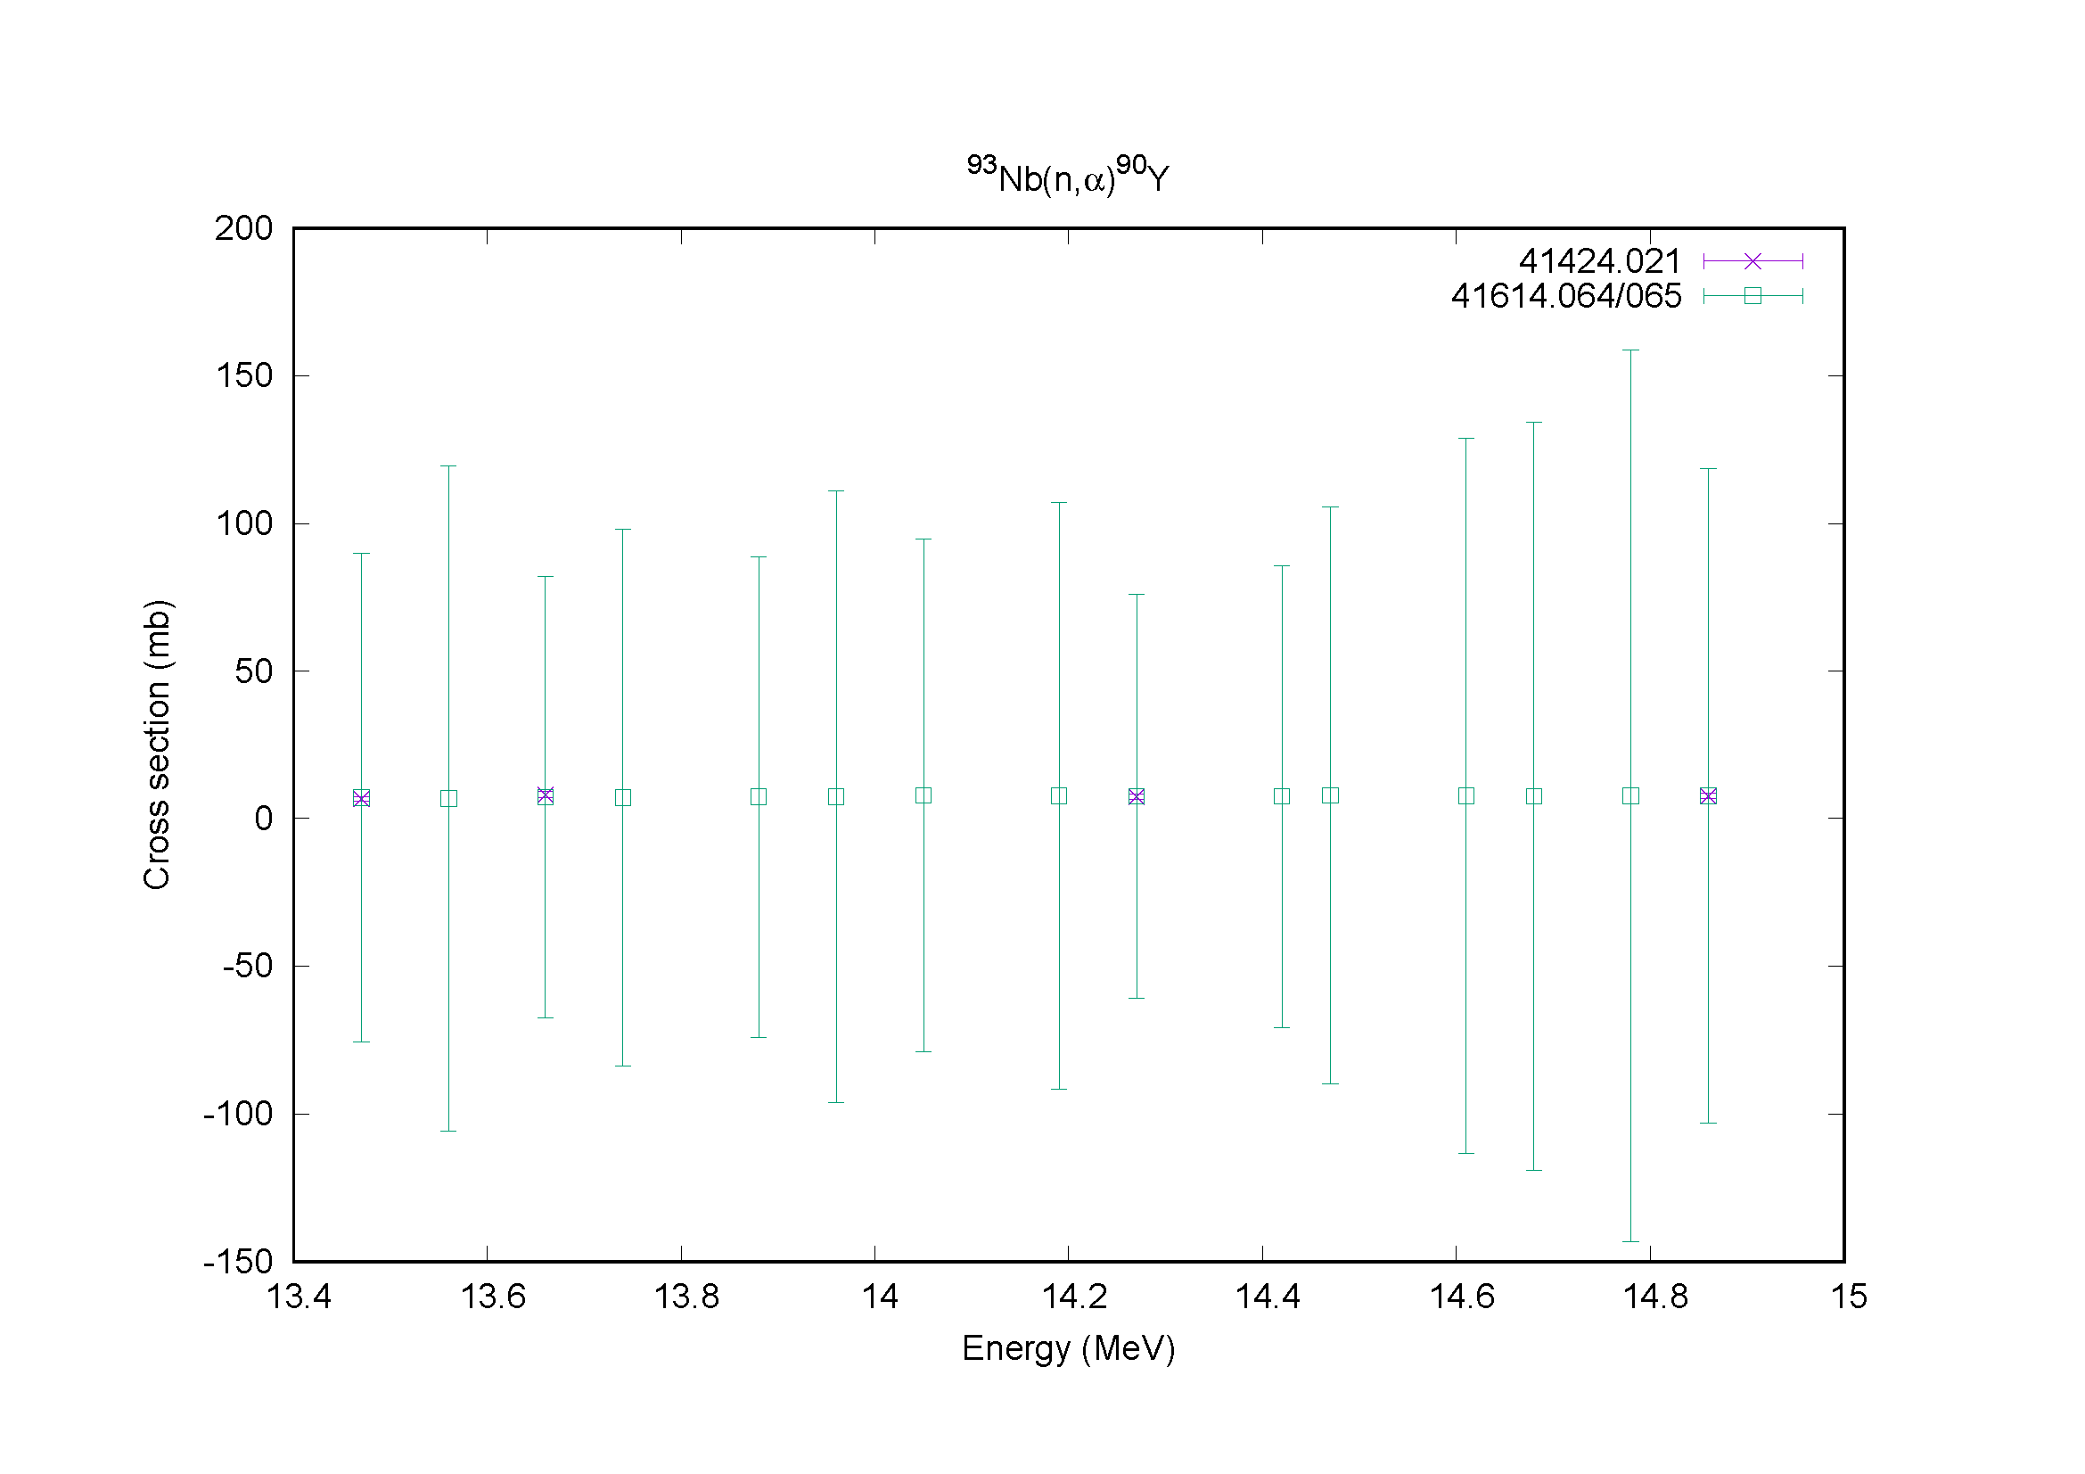
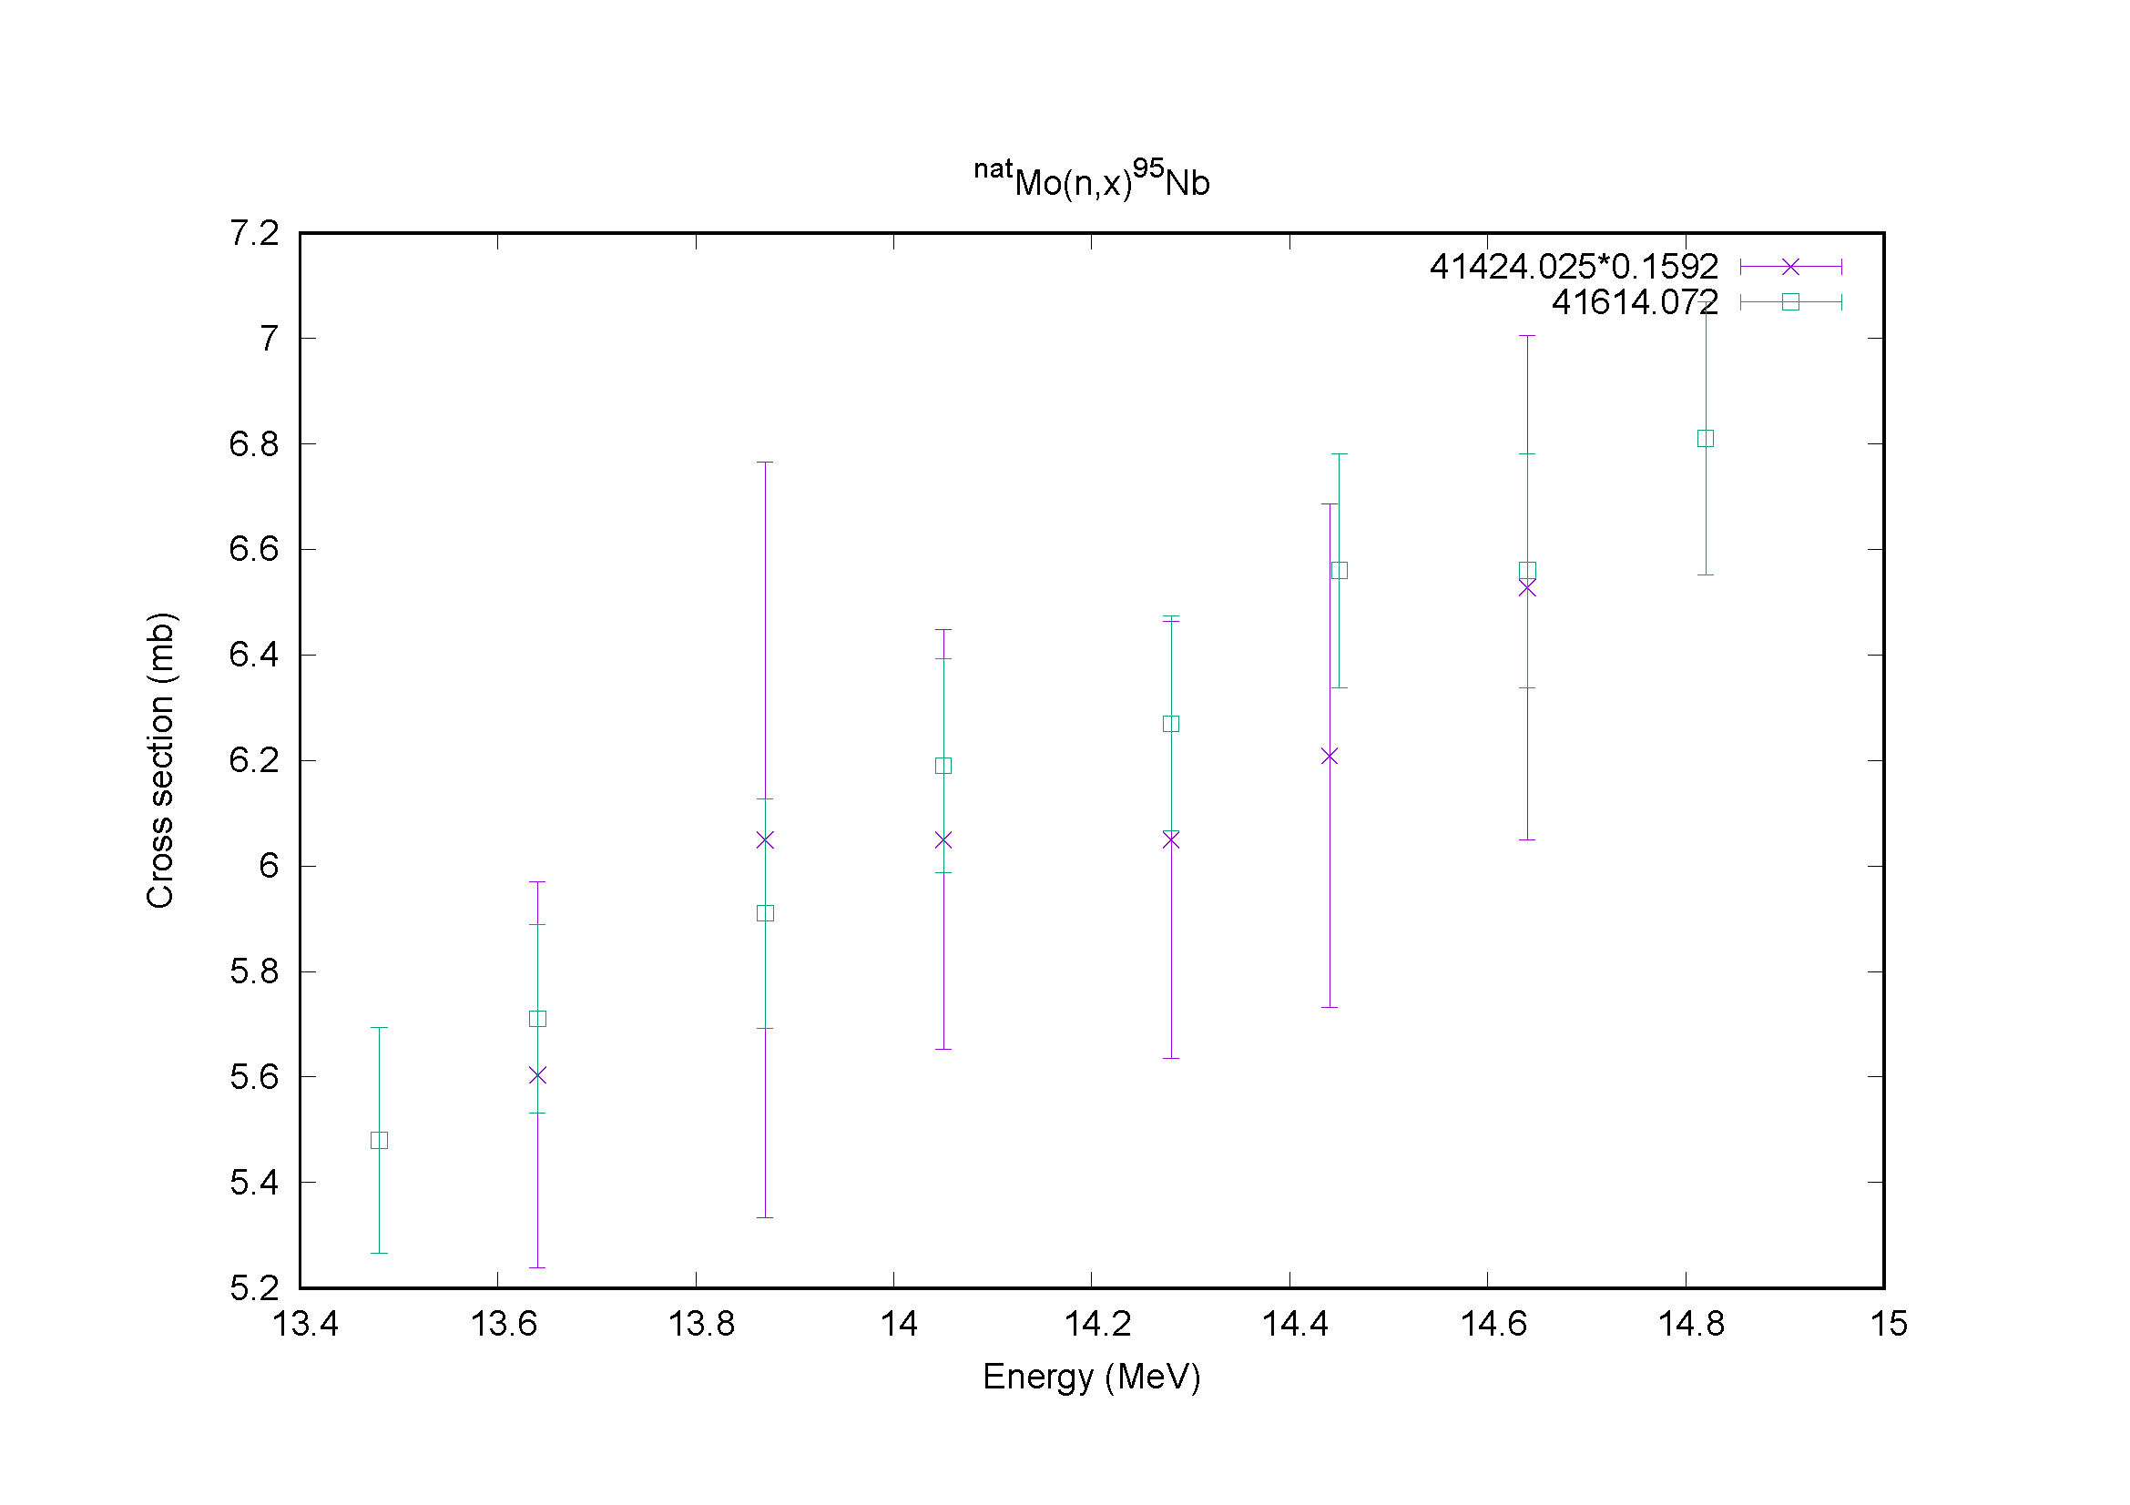
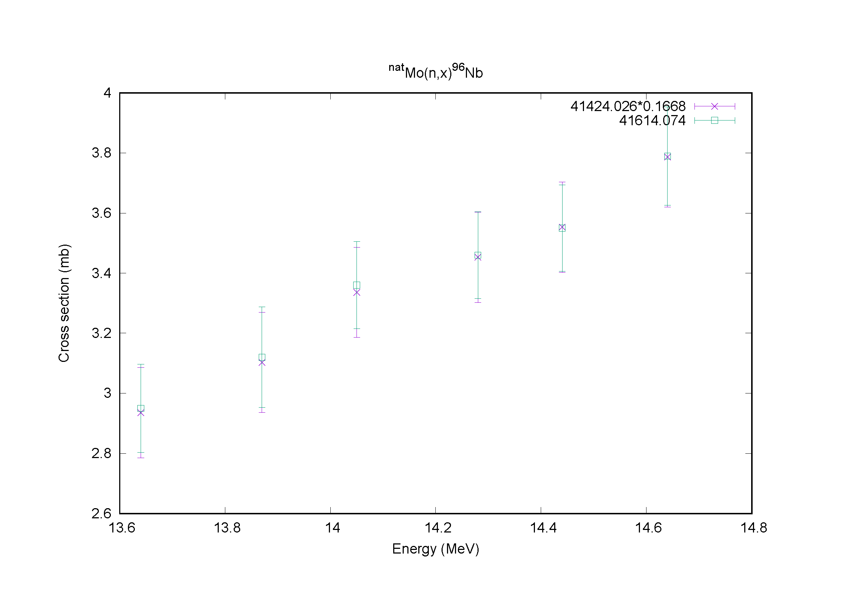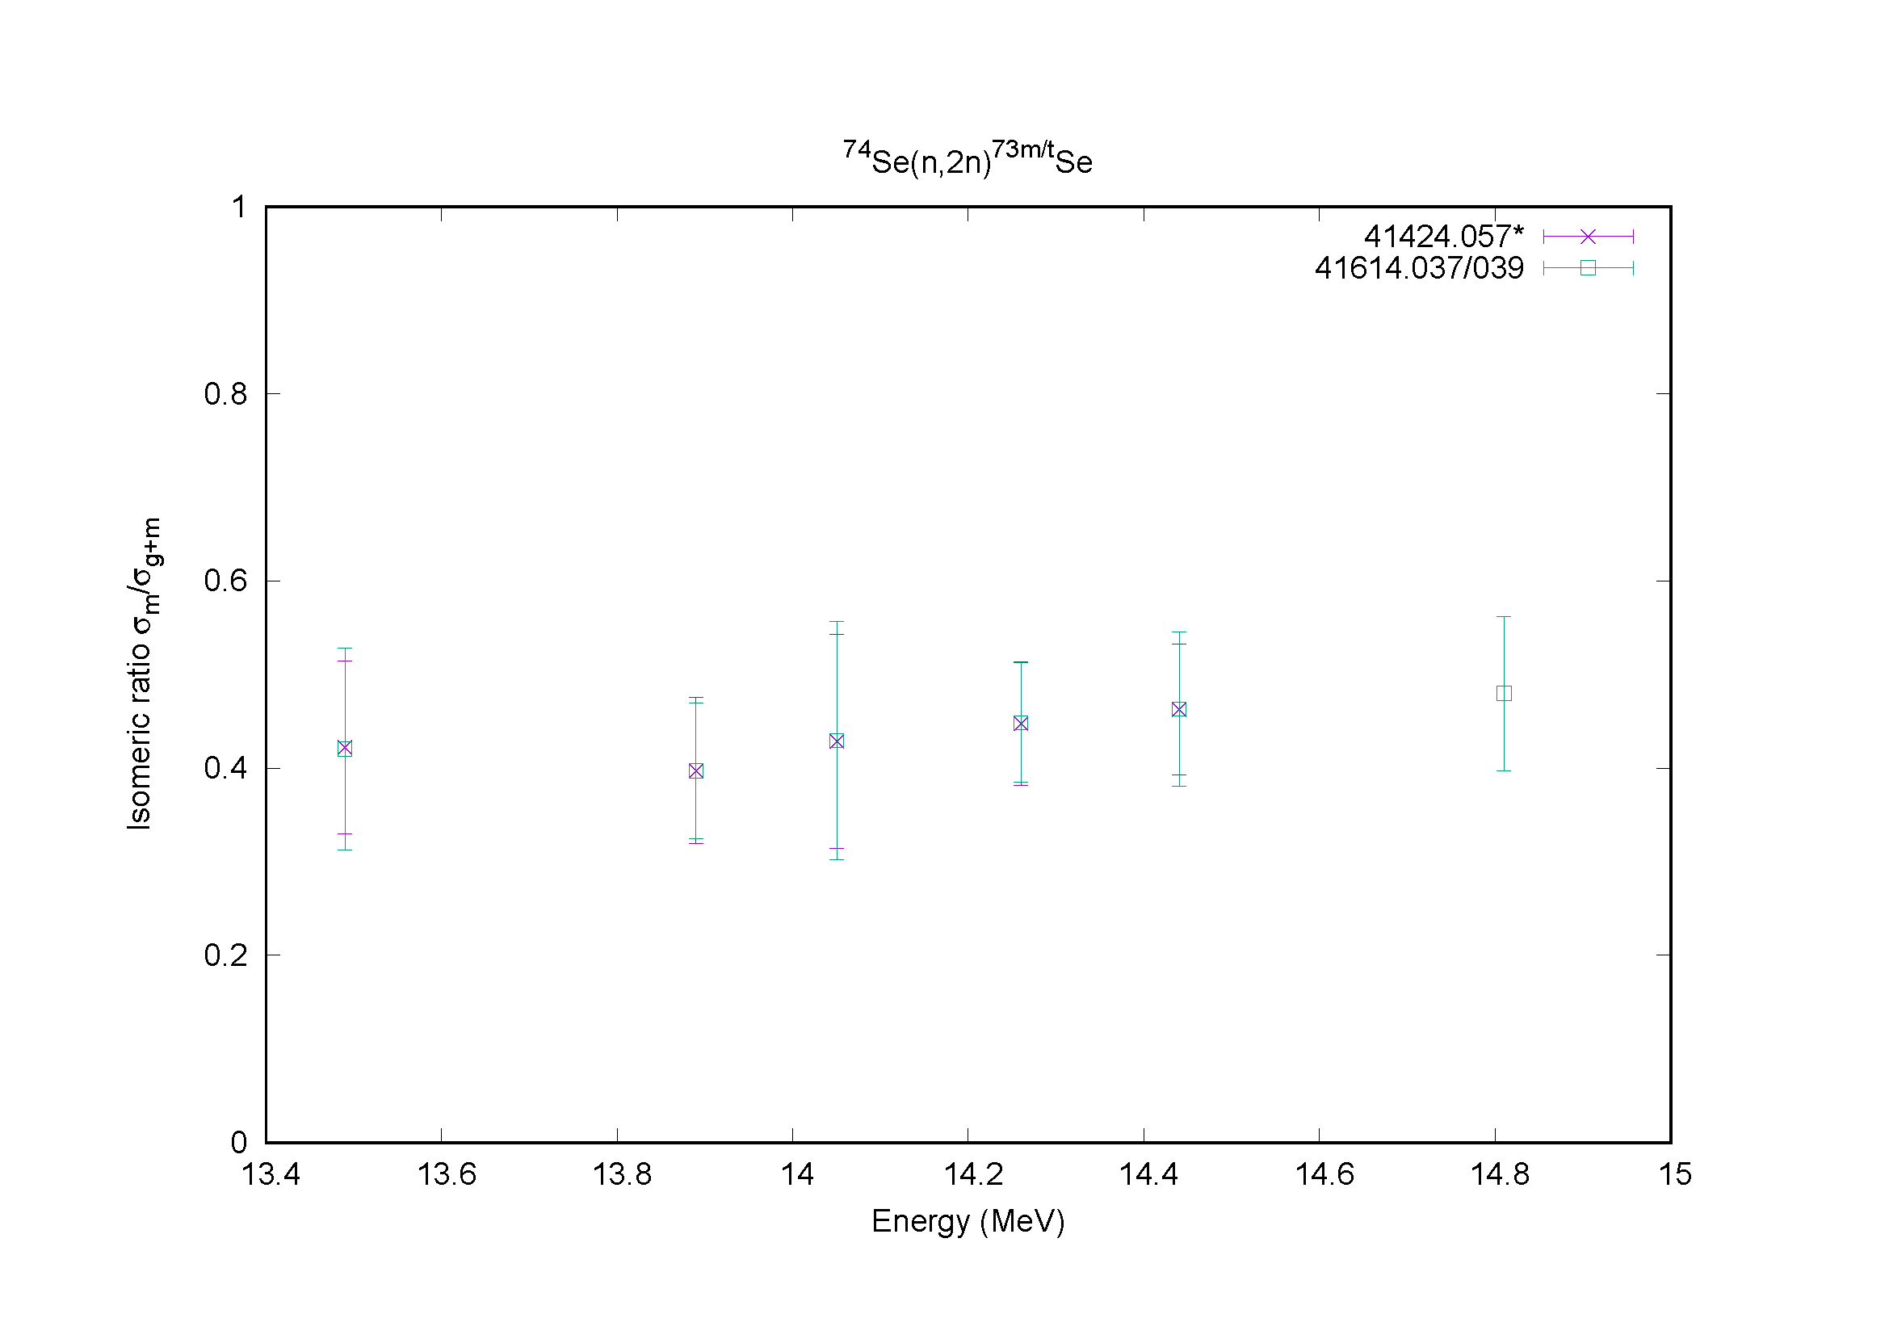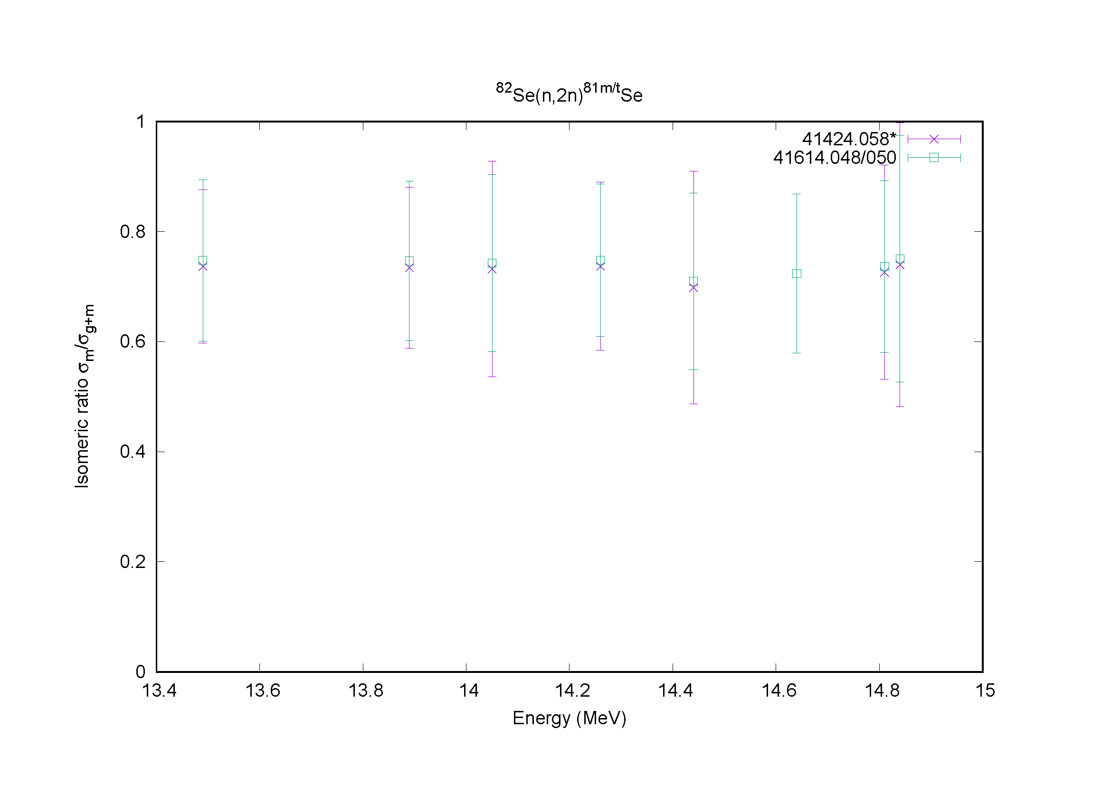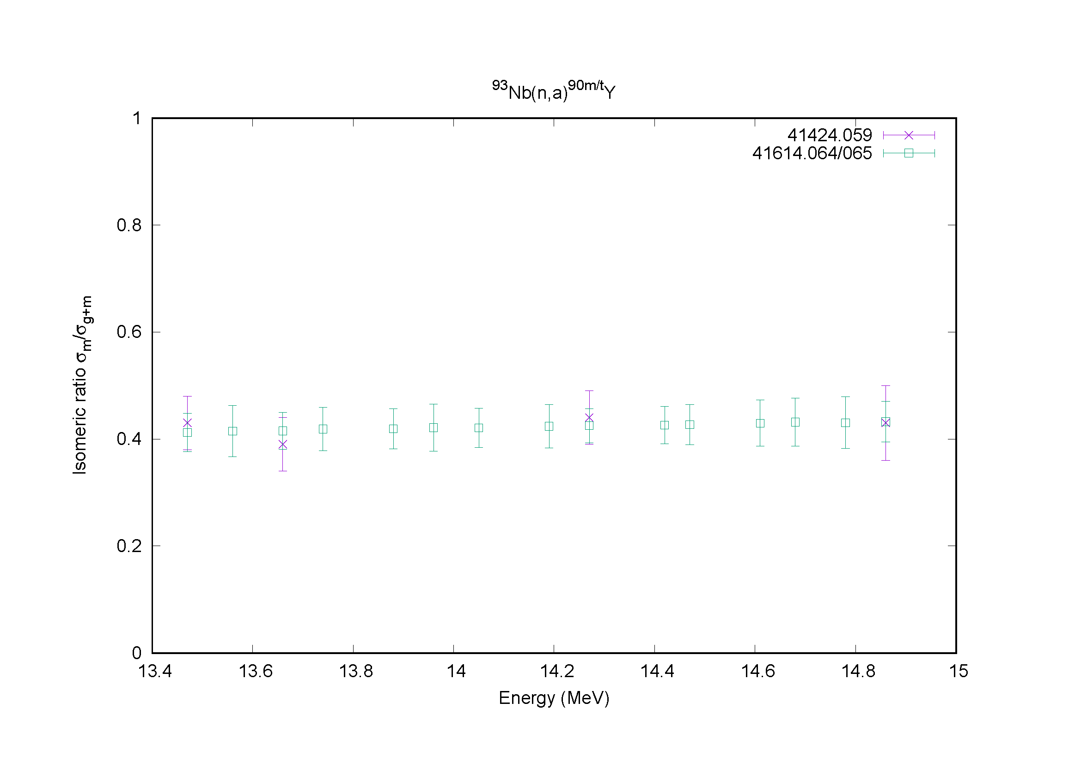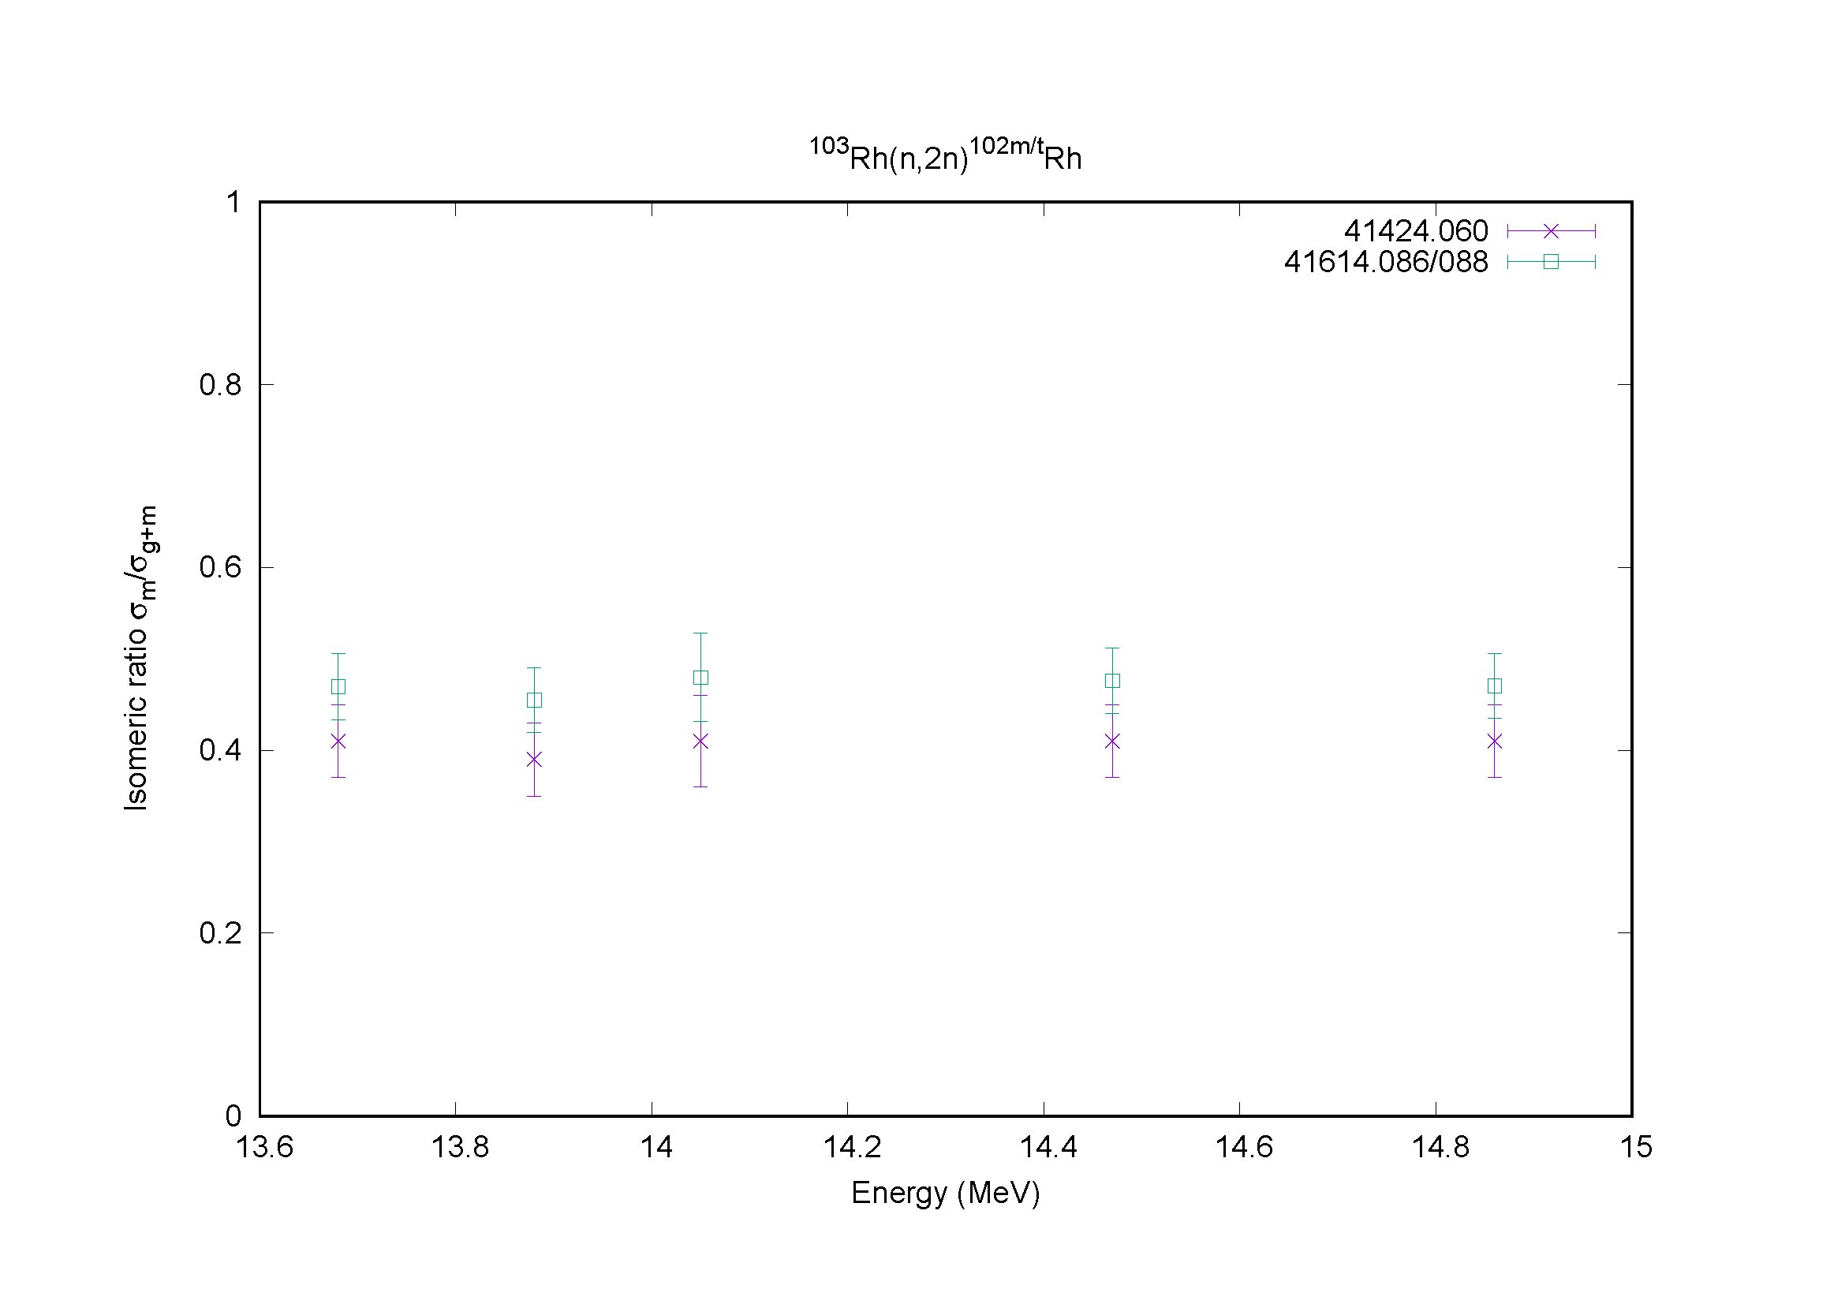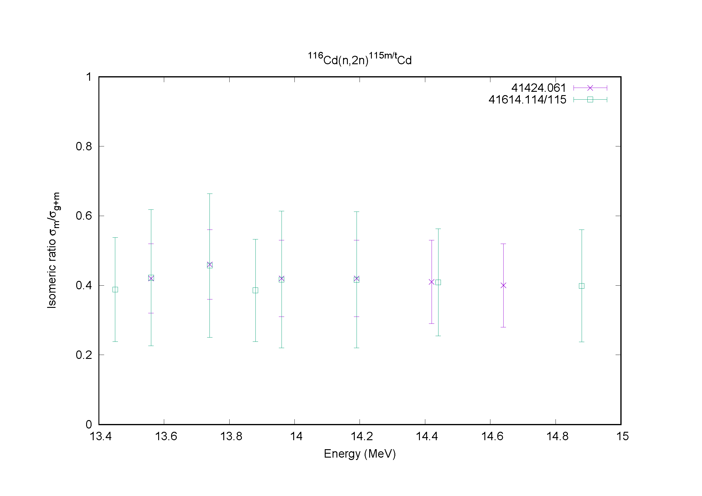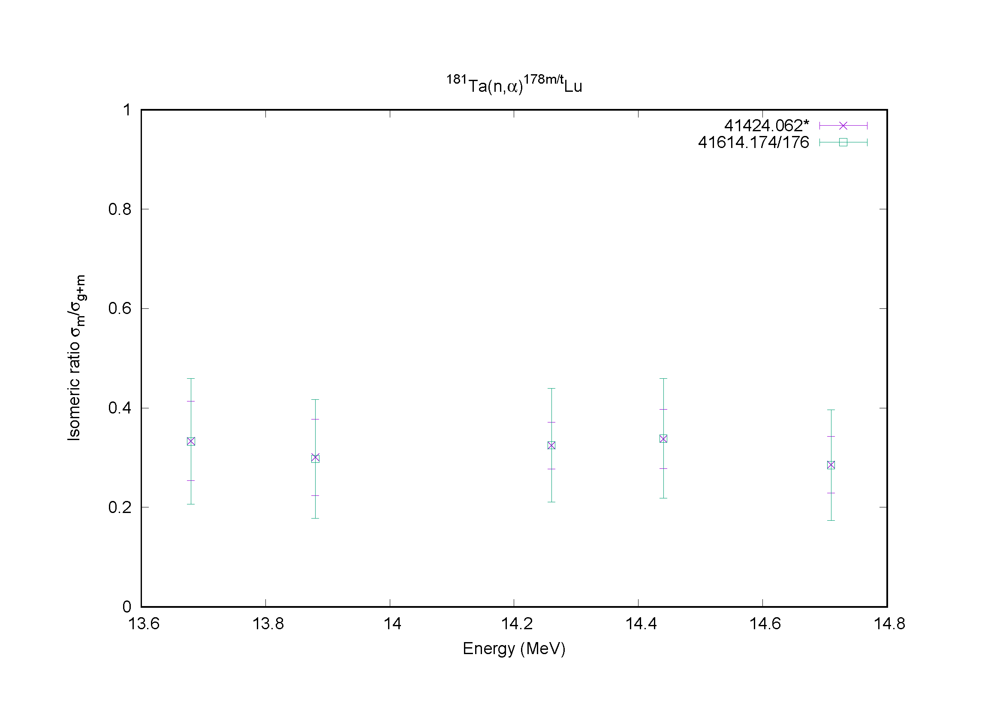

Distribution:

a.koning@iaea.org
abhihere@gmail.com
aloks279@gmail.com
daniela.foligno@oecd-nea.org
dbrown@bnl.gov
draj@barc.gov.in
exfor@oecd-nea.org
fukahori.tokio@jaea.go.jp
ganesan555@gmail.com
gezg@ciae.ac.cn
iwamoto.osamu@jaea.go.jp
jmwang@ciae.ac.cn
kaltchen@ukr.net
kimdh@kaeri.re.kr
kimura.atsushi04@jaea.go.jp
l.vrapcenjak@iaea.org
manuel.bossant@oecd-nea.org
masaaki@nucl.sci.hokudai.ac.jp
marina-03-08@yandex.ru
michael.fleming@oecd-nea.org
mmarina@ippe.ru
nicolas.soppera@oecd-nea.org
n.otsuka@iaea.org
nrdc@jcprg.org
odsurenn@gmail.com
ogritzay@ukr.net
ogrudzevich@ippe.ru
otto.schwerer@aon.at
pikulina@expd.vniief.ru
pritychenko@bnl.gov
scyang@kaeri.re.kr
selyankina@expd.vniief.ru
sonzogni@bnl.gov
stakacs@atomki.mta.hu
stanislav.hlavac@savba.sk
sv.dunaeva@gmail.com
tada@nucl.sci.hokudai.ac.jp
taova@expd.vniief.ru
tarkanyi@atomki.hu
v.devi@iaea.org
v.zerkin@iaea.org
vidyathakur@yahoo.co.in
vsemkova@inrne.bas.bg
vvvarlamov@gmail.com
yolee@kaeri.re.kr
zholdybayev@inp.kz

cc:
a.rodrigos@alumnos.upm.es

