Nuclear Data Section
International Atomic Energy Agency
P.O.Box 100, A-1400 Vienna, Austria

Memo CP-D/1062

Date: 13 December 2022
To: Distribution
From: N. Otsuka, A. Rodrigo

Subject: Status of Filatenkov’s activation cross sections (EXFOR 41240/41614)
Reference: Memo CP-D/1061
After comparison of Filatenkov’s activation cross sections in EXFOR 41424 and 41614, we also found similar pairs between EXFOR 41420 from RI-252 (1999) and EXFOR 41614 compiled from INDC(CCP)-0460 (2016).

Reaction | RI-252 | INDC(CCP)-0460 | Proposed action
⁵⁹Co(n,2n)⁵⁸Co | 41240.121 | 41614.023/024 | SPSDD
⁵⁸Ni(n,p)⁵⁸Co | 41240.122 | 41614.026/027 | SPSDD
⁸⁹Y(n,α)⁸⁶Rb | 41240.123 | 41614.053/054 | ? Some points discarded in 41614?
⁹²Mo(n,α)⁸⁹Zr | 41240.125 | 41614.066/067 | ? Some points discarded in 41614?
¹¹⁵In(n,p)¹¹⁵Cd | 41240.127 | 41614.118/120 | SPSDD
¹²⁰Te(n,2n)¹¹⁹Te | 41240.128 | 41614.139/141 | SPSDD
¹²²Te(n,2n)¹²¹Te | 41240.129 | 41614.143/145 | SPSDD
¹³⁰Te(n,2n)¹²⁹Te | 41240.130 | 41614.150/152 | SPSDD
¹³⁸Ba(n,α)¹³⁵Xe | 41240.131 | 41614.153/154 | SPSDD
¹⁵¹Eu(n,α)¹⁴⁸Pm | 41240.132 | 41614.163/165 | SPSDD
¹⁵¹Eu(n,2n)¹⁵⁰Eu | 41240.133 | 41614.167/169 | ? Some points discarded in 41614?
¹⁸⁵Re(n,2n)¹⁸⁴Re | 41240.135 | 41614.196/198 | SPSDD
We suggest CJD (1) superseding the nine 41240 datasets (121-122, 127-132, 135) by the corresponding 41614 datasets and (2) consulting with the authors whether we should supersede the rest three 41240 datasets (123, 125, 133), too
Note that our assessment does not study production of a nuclide having two or more metastable states.

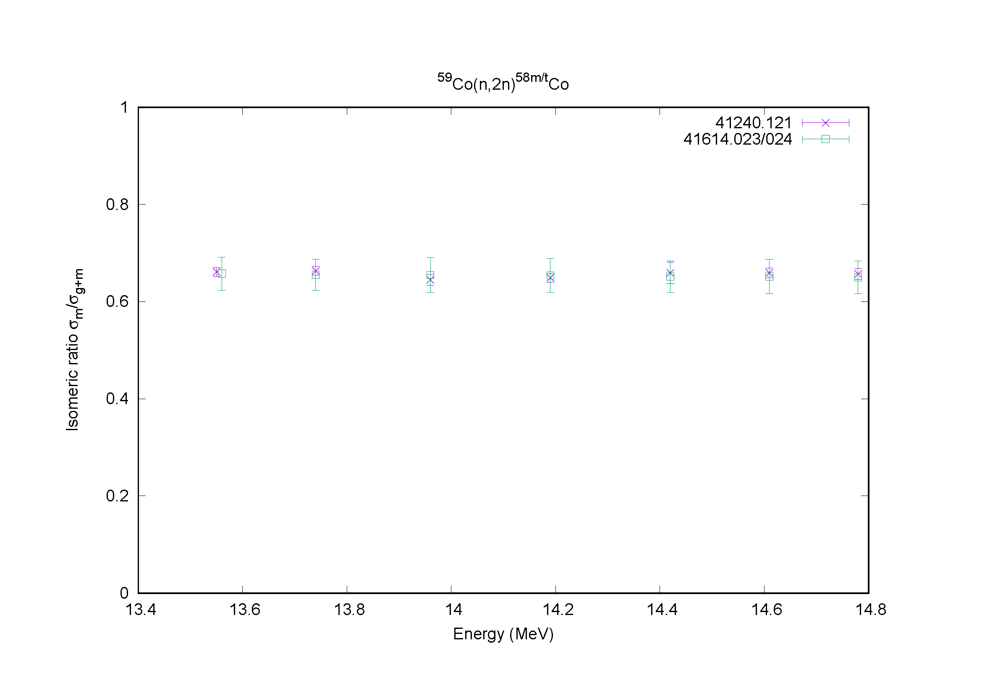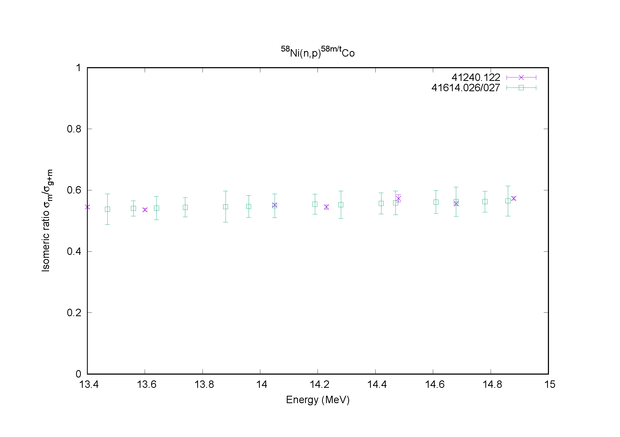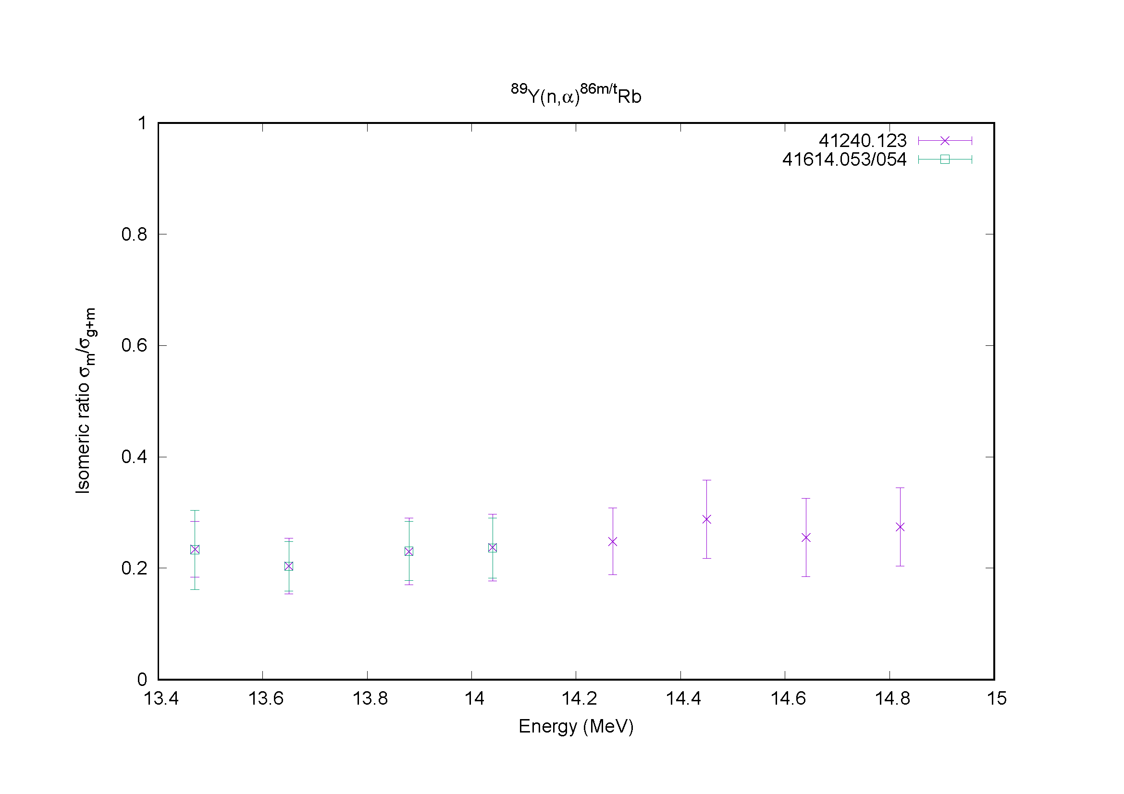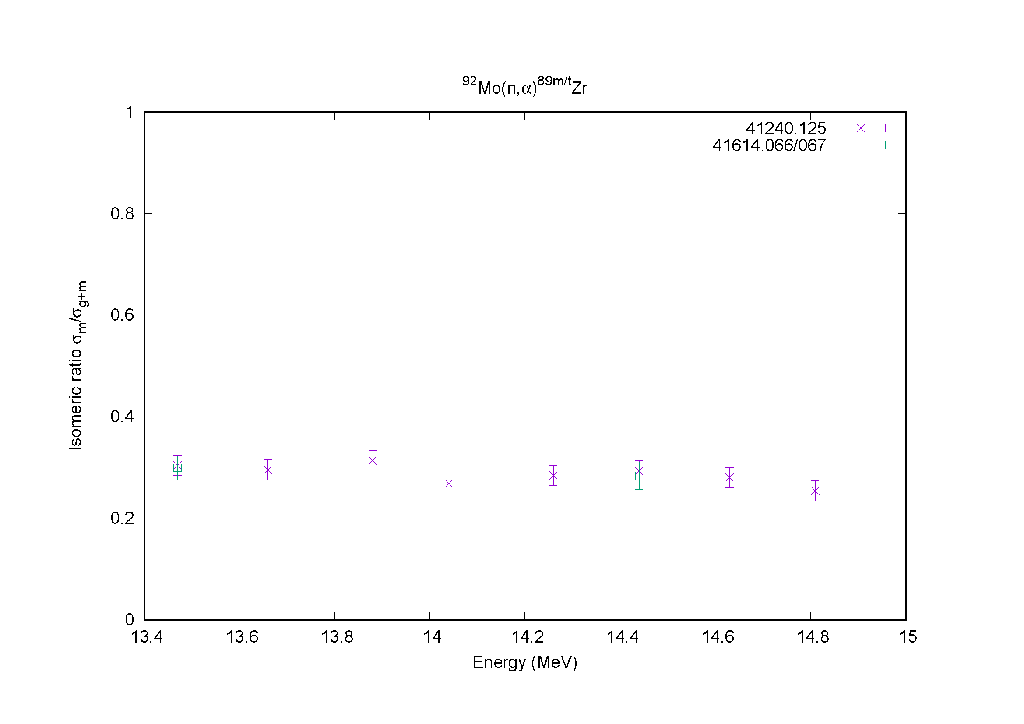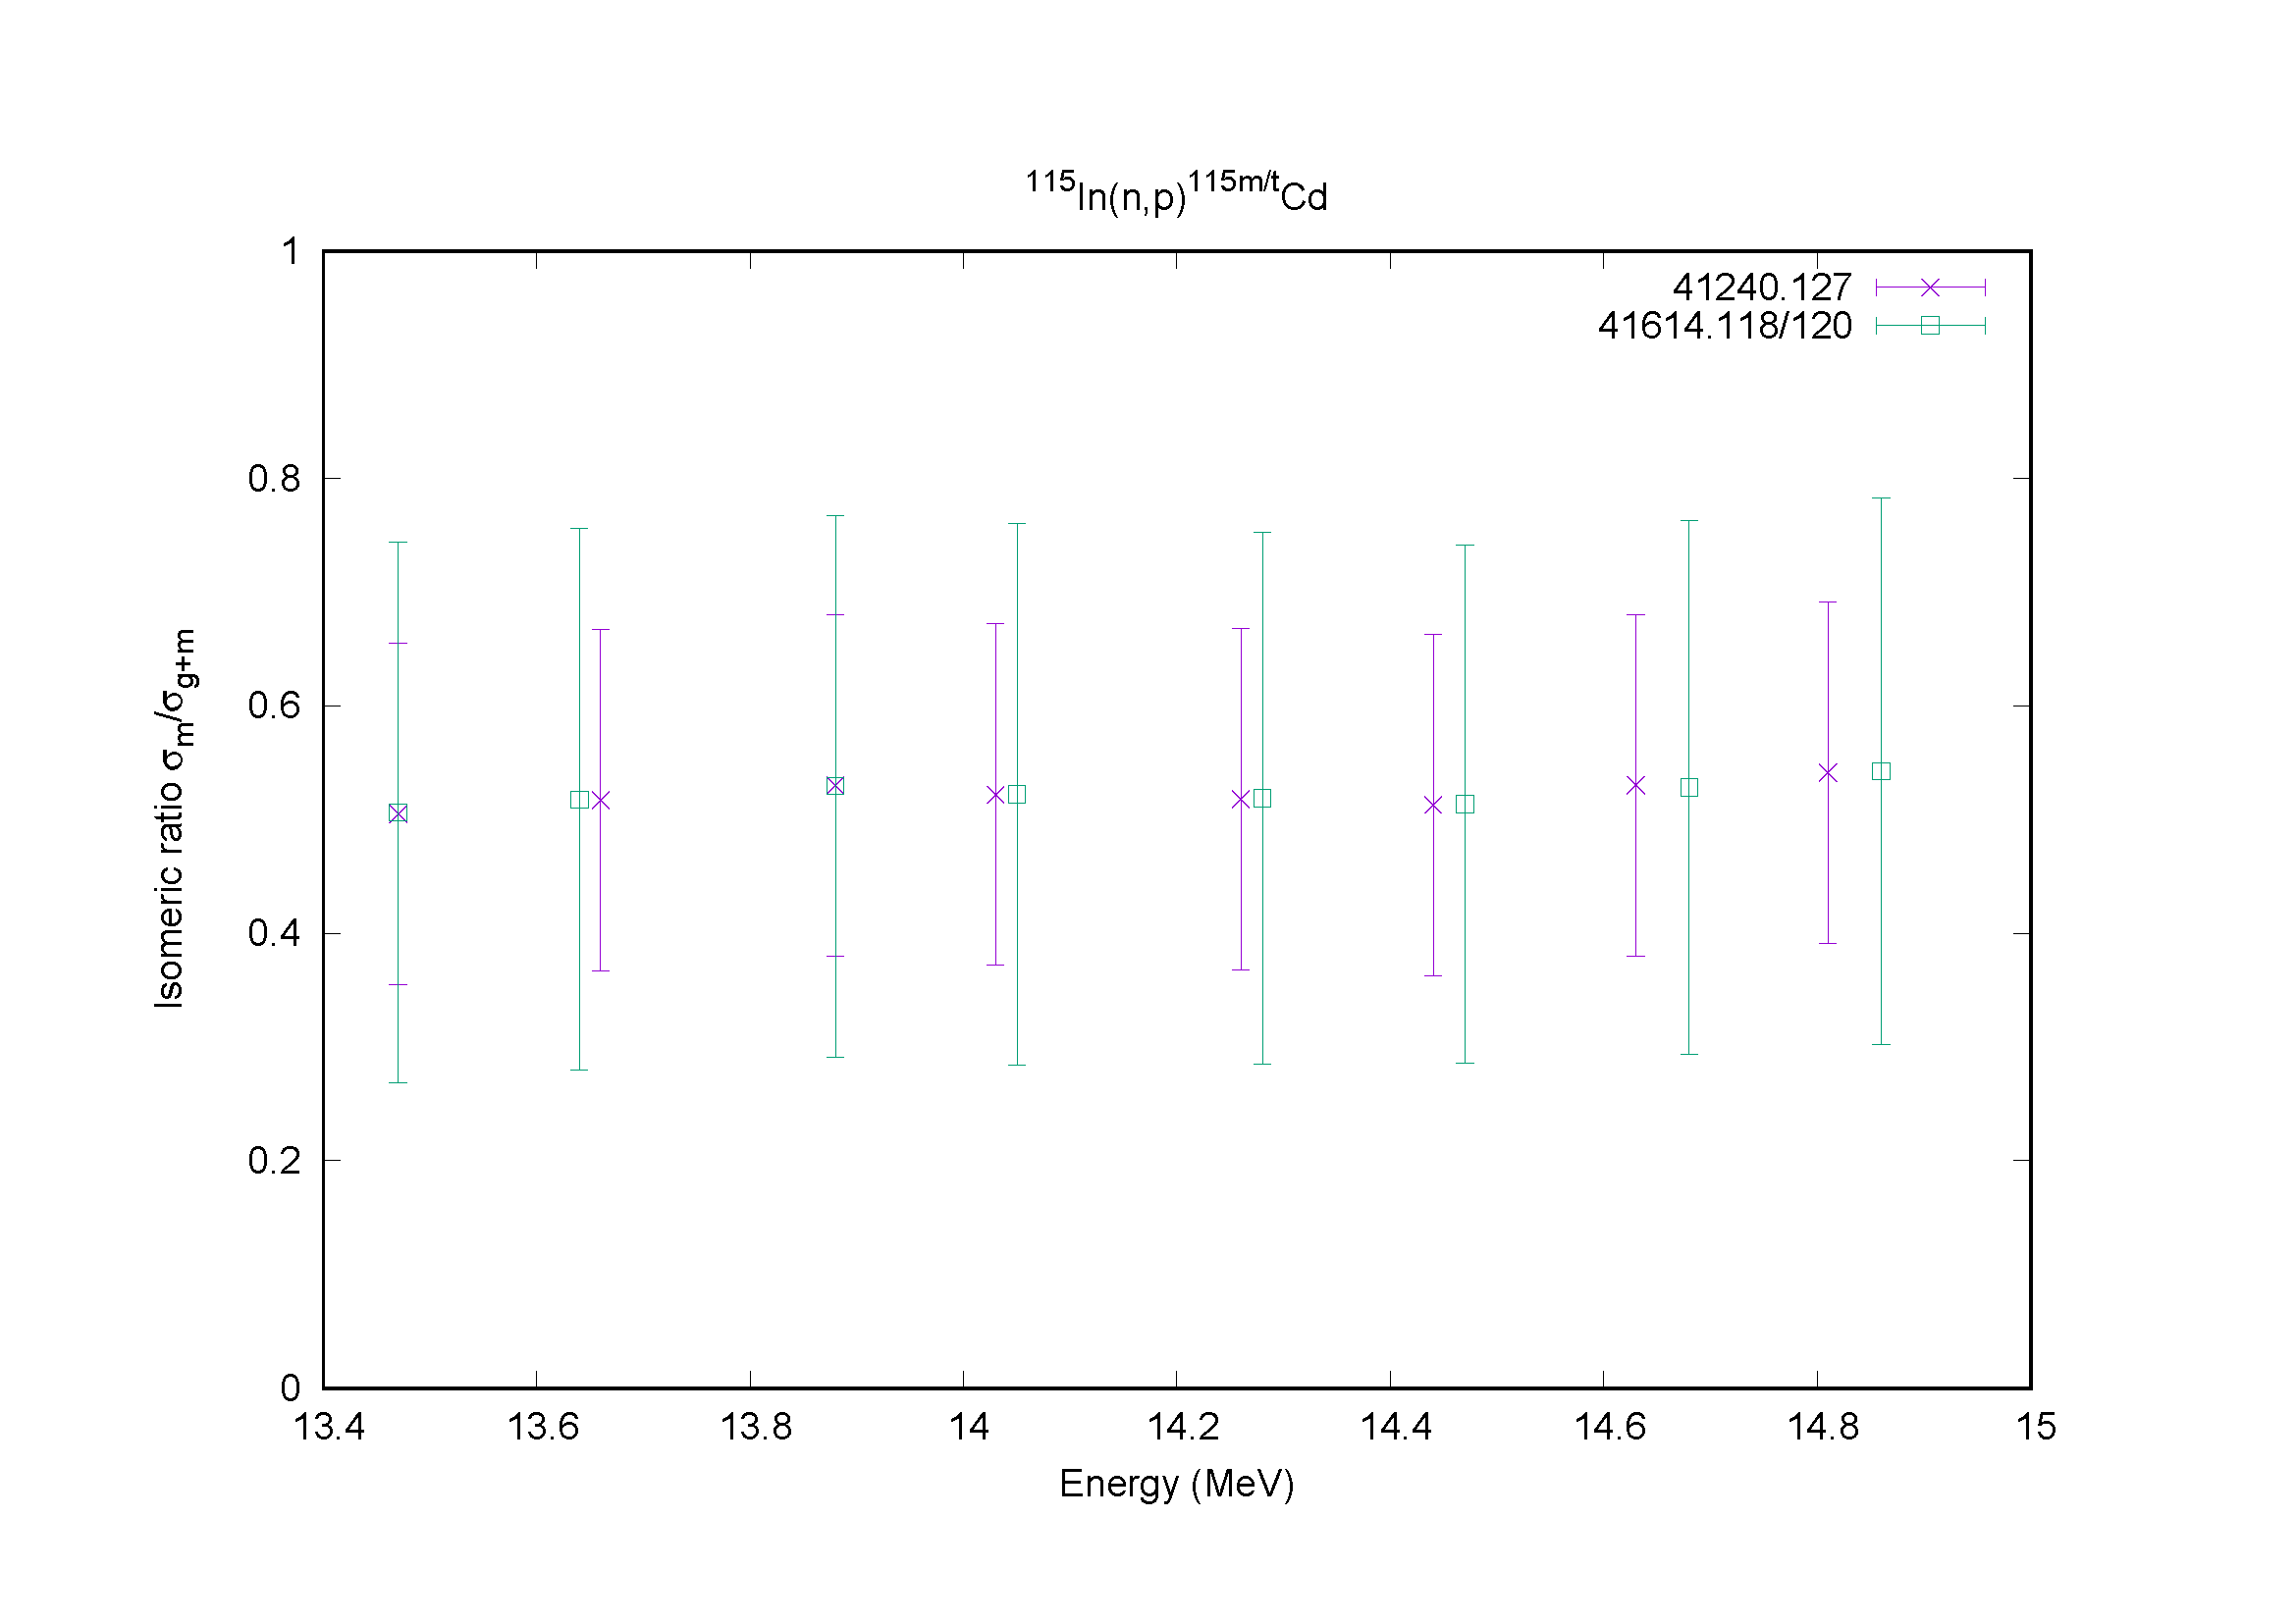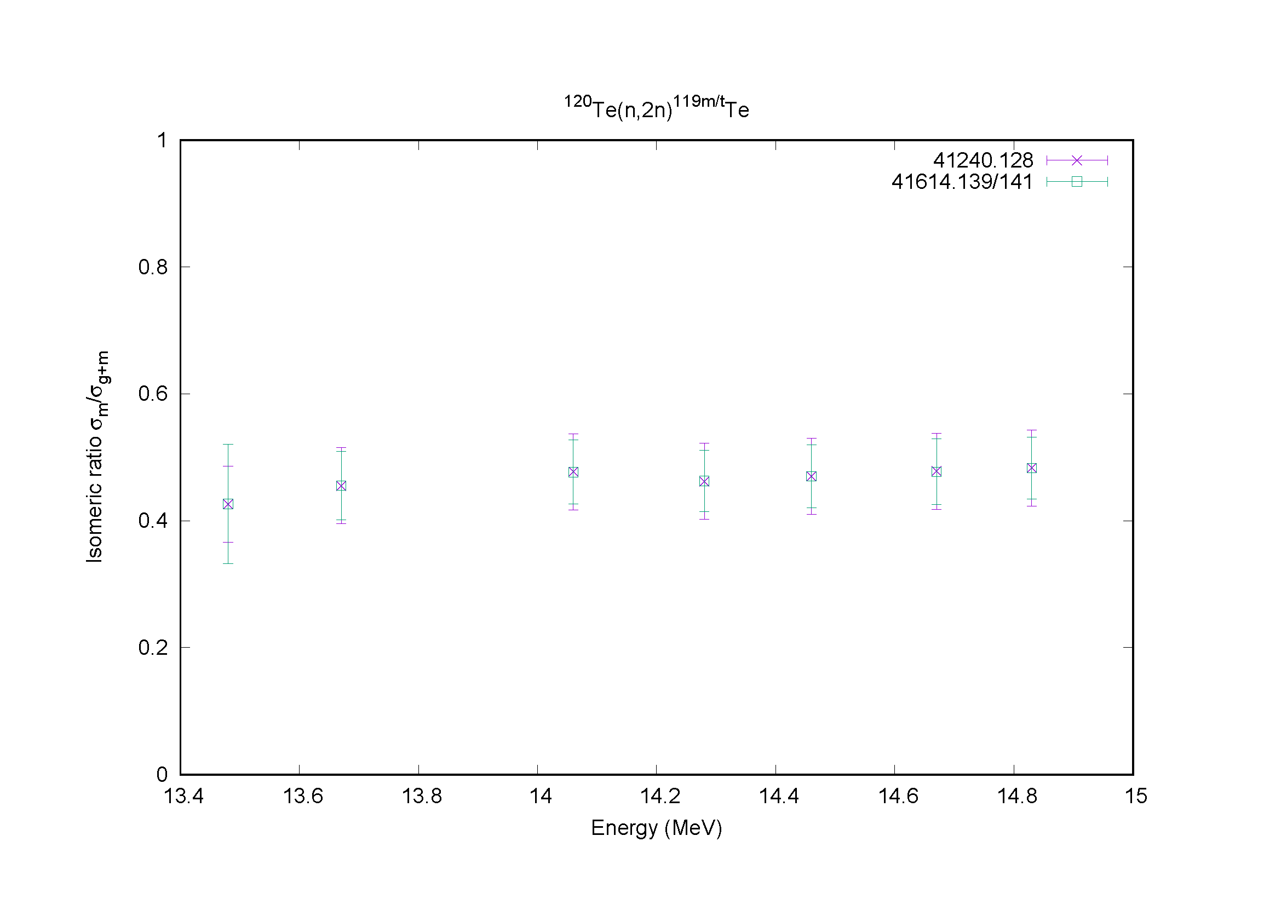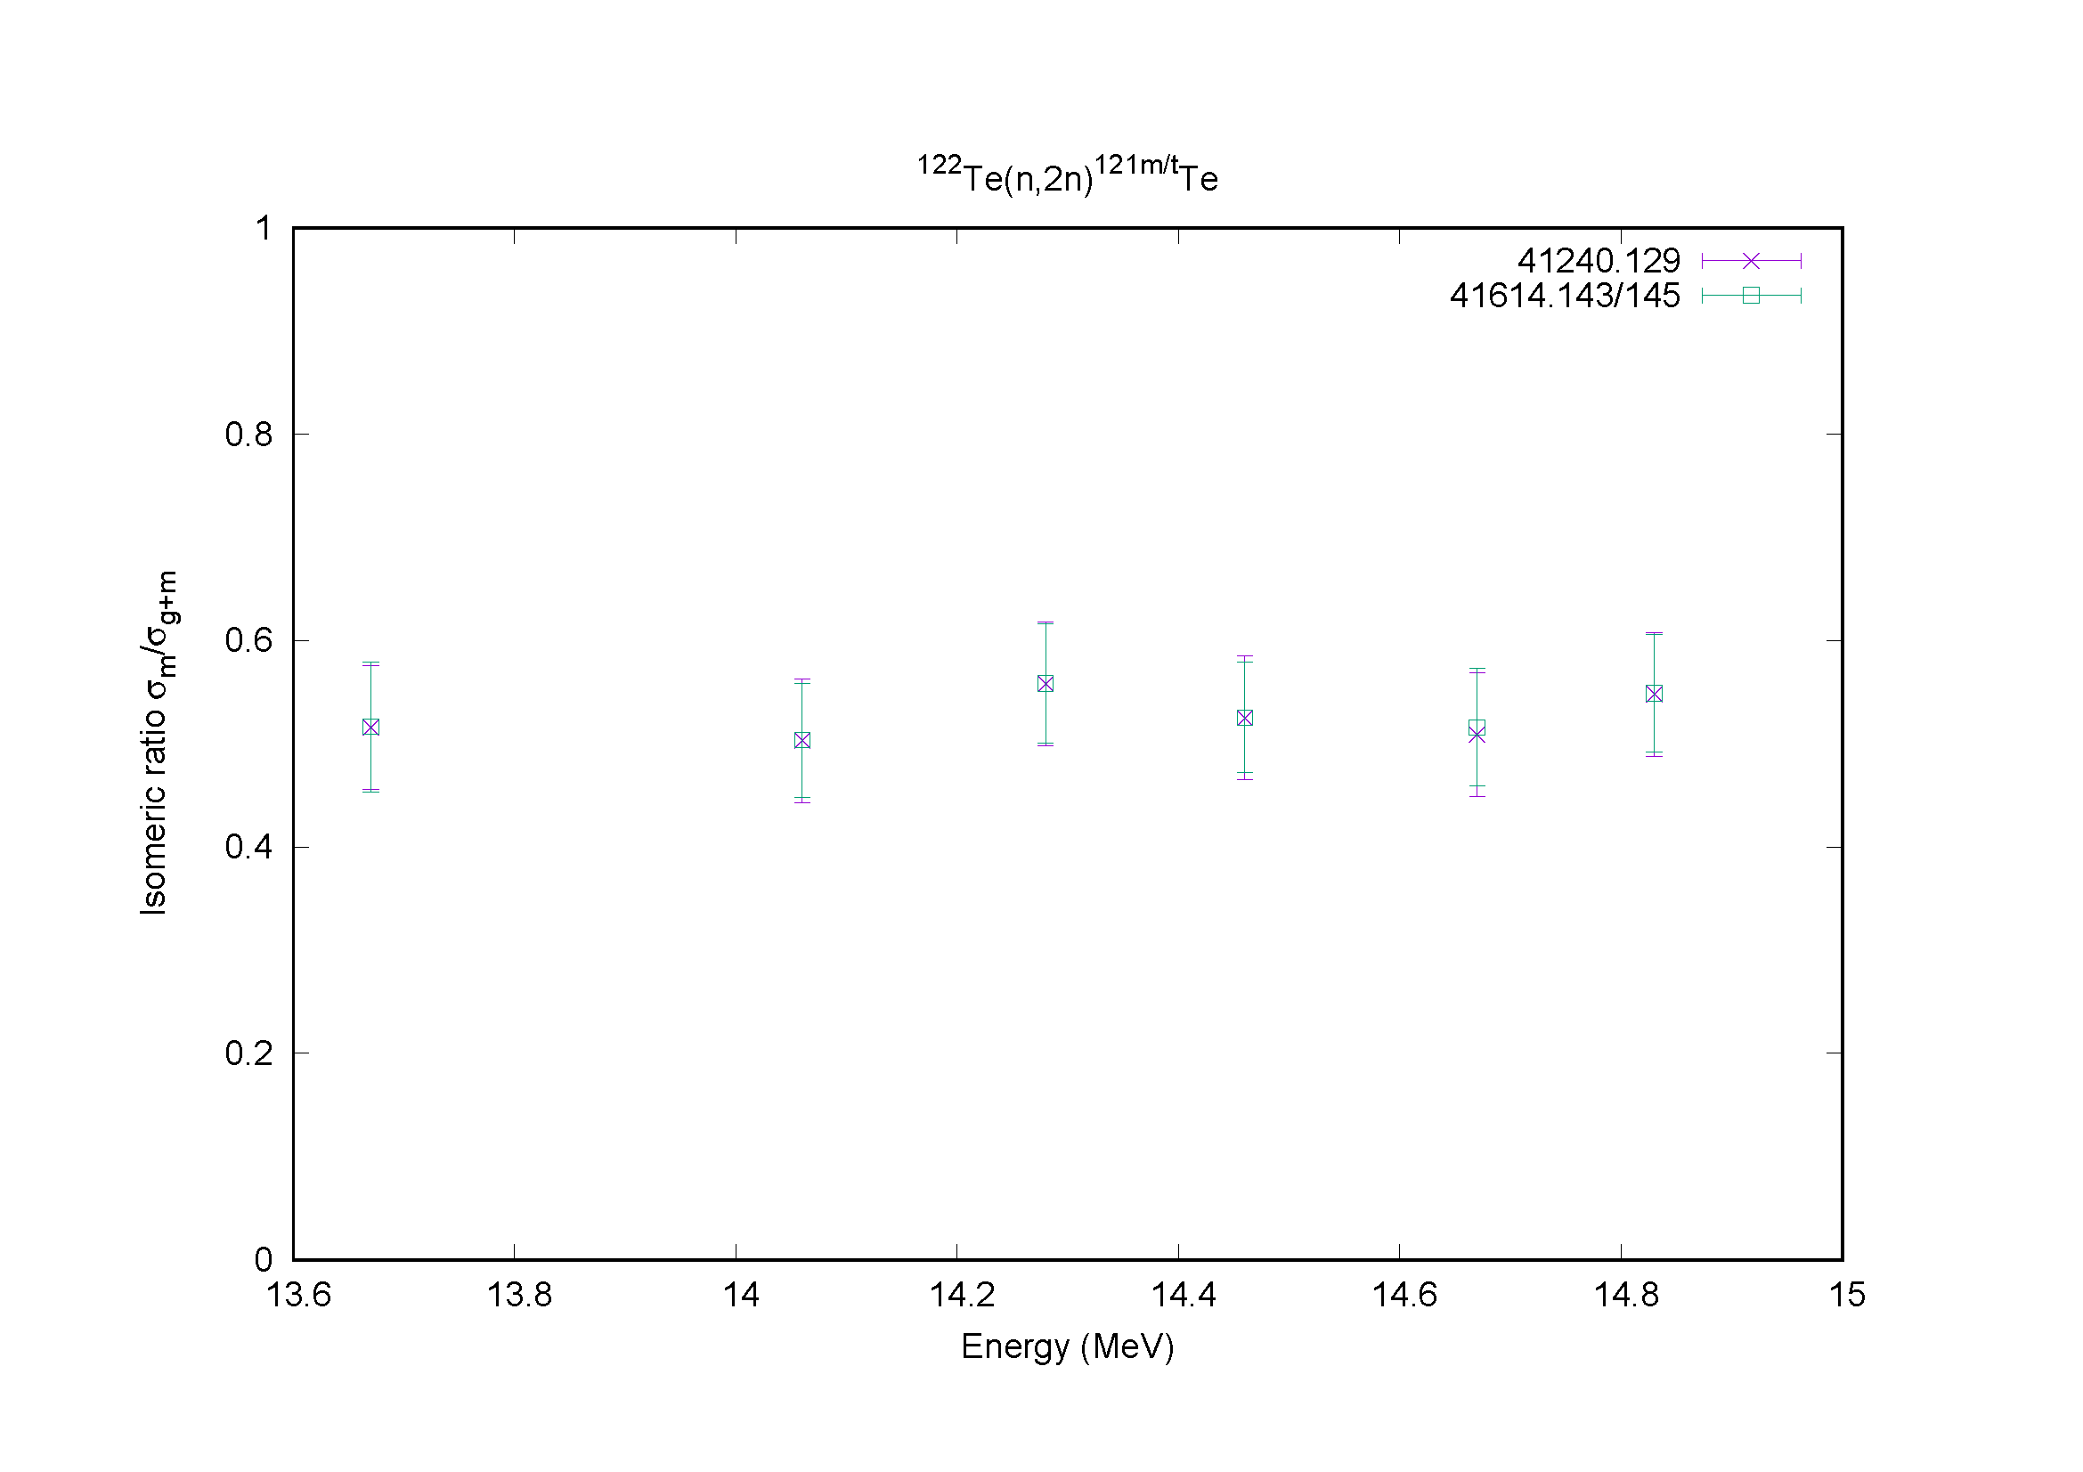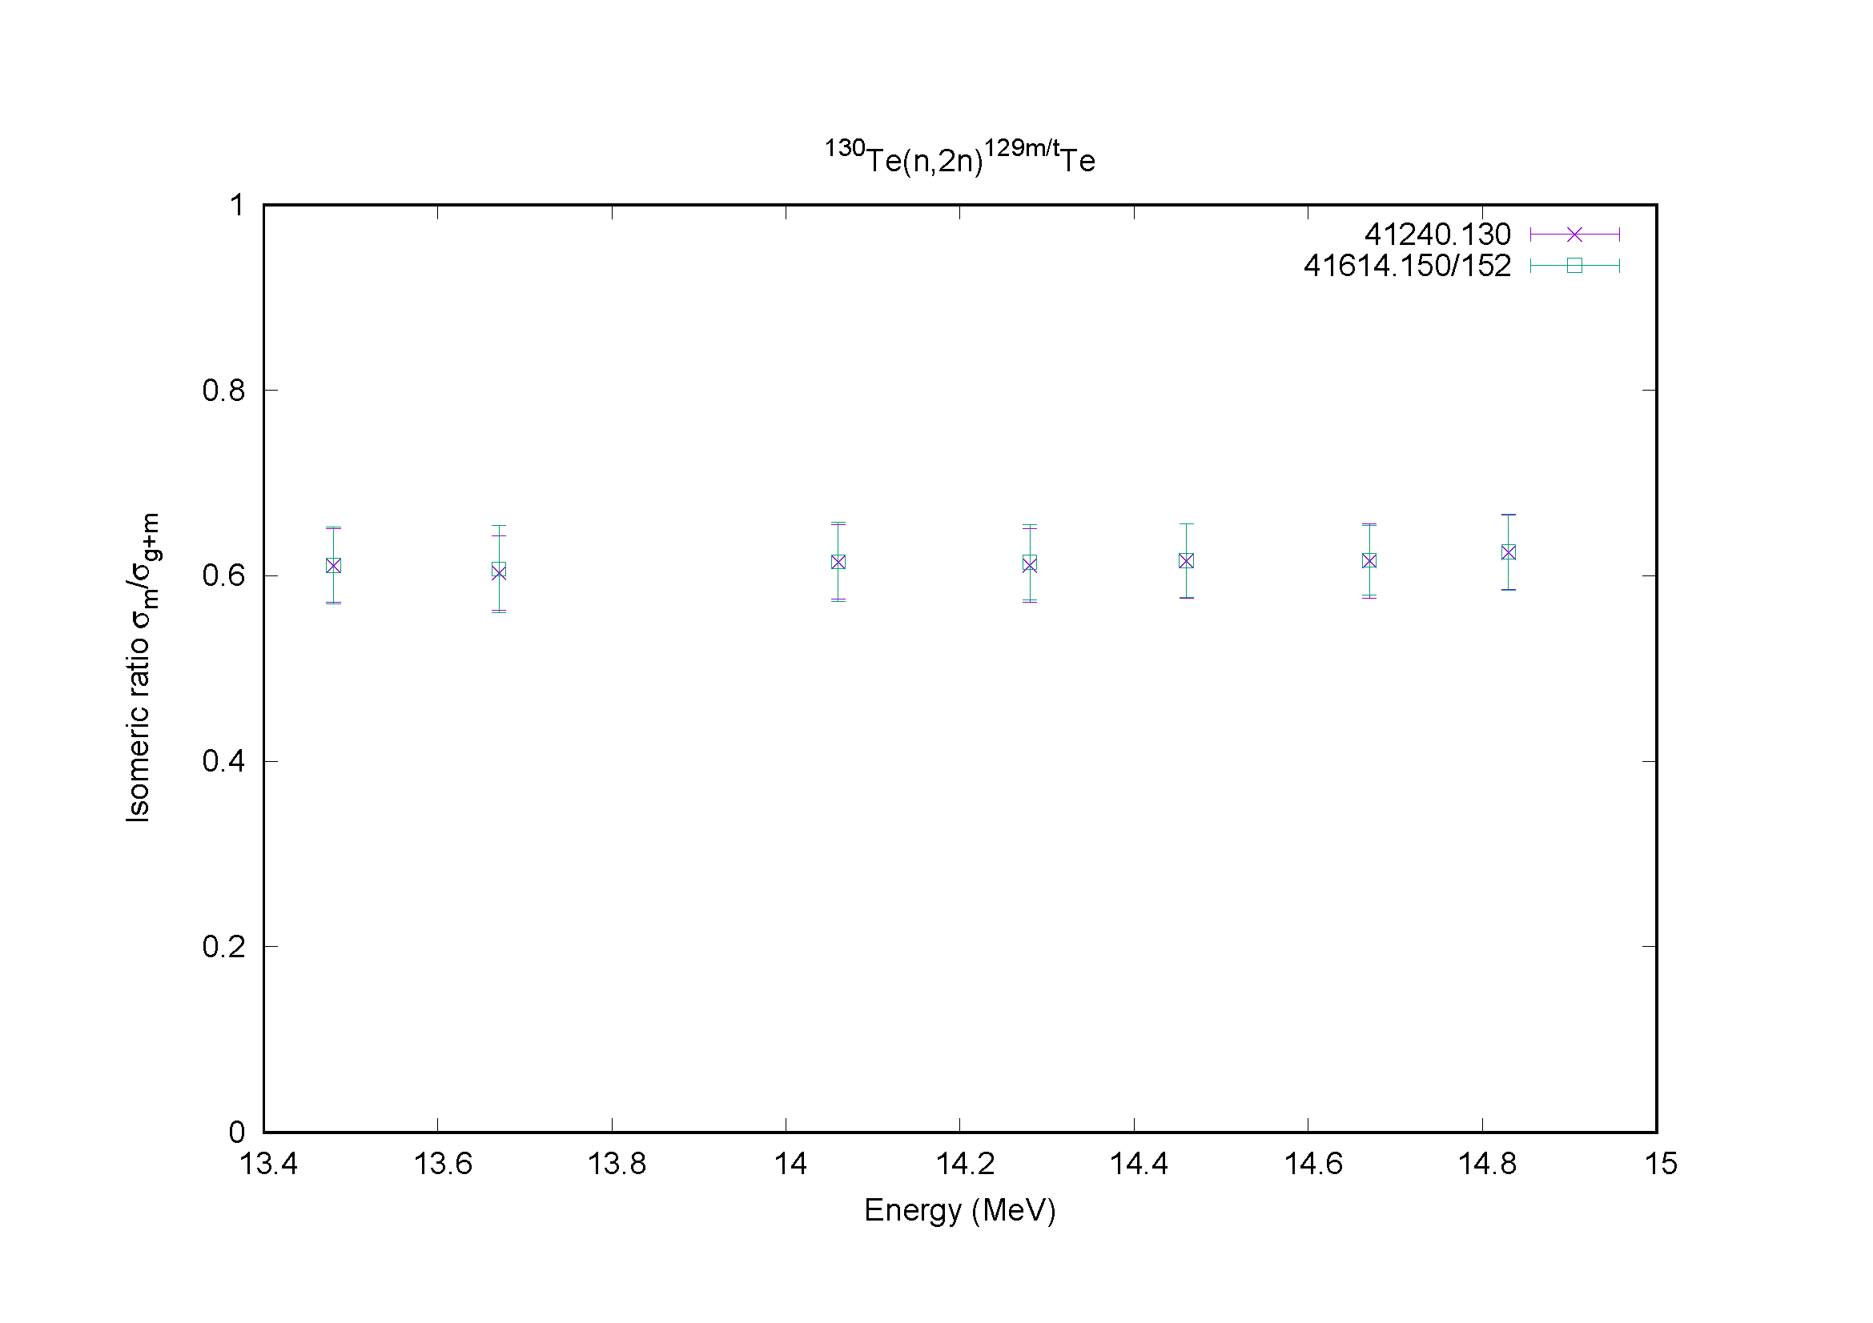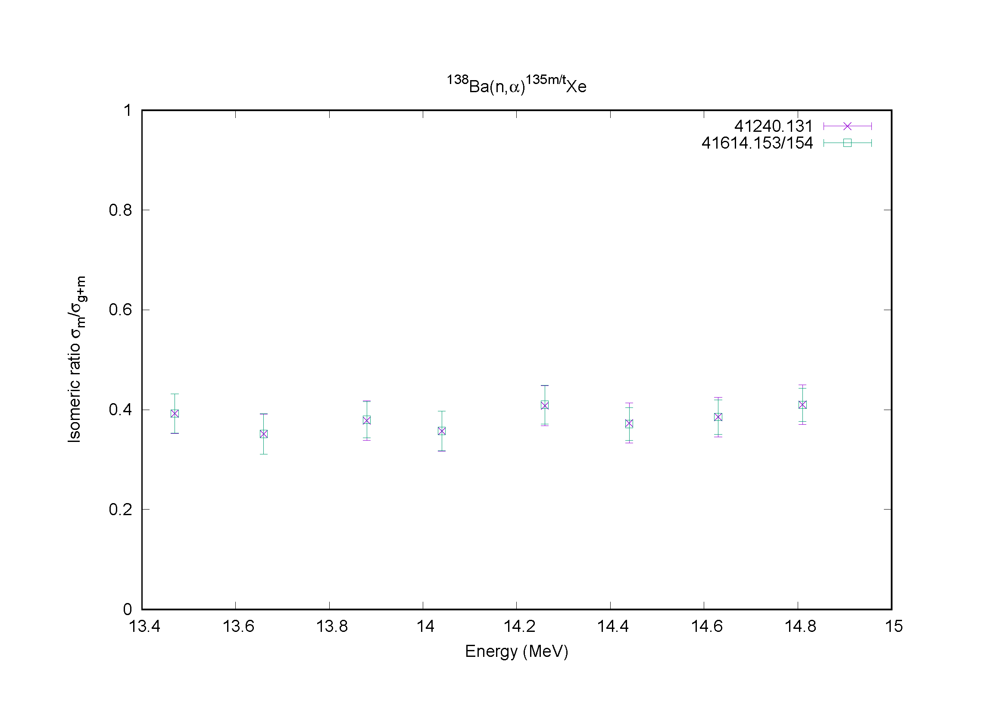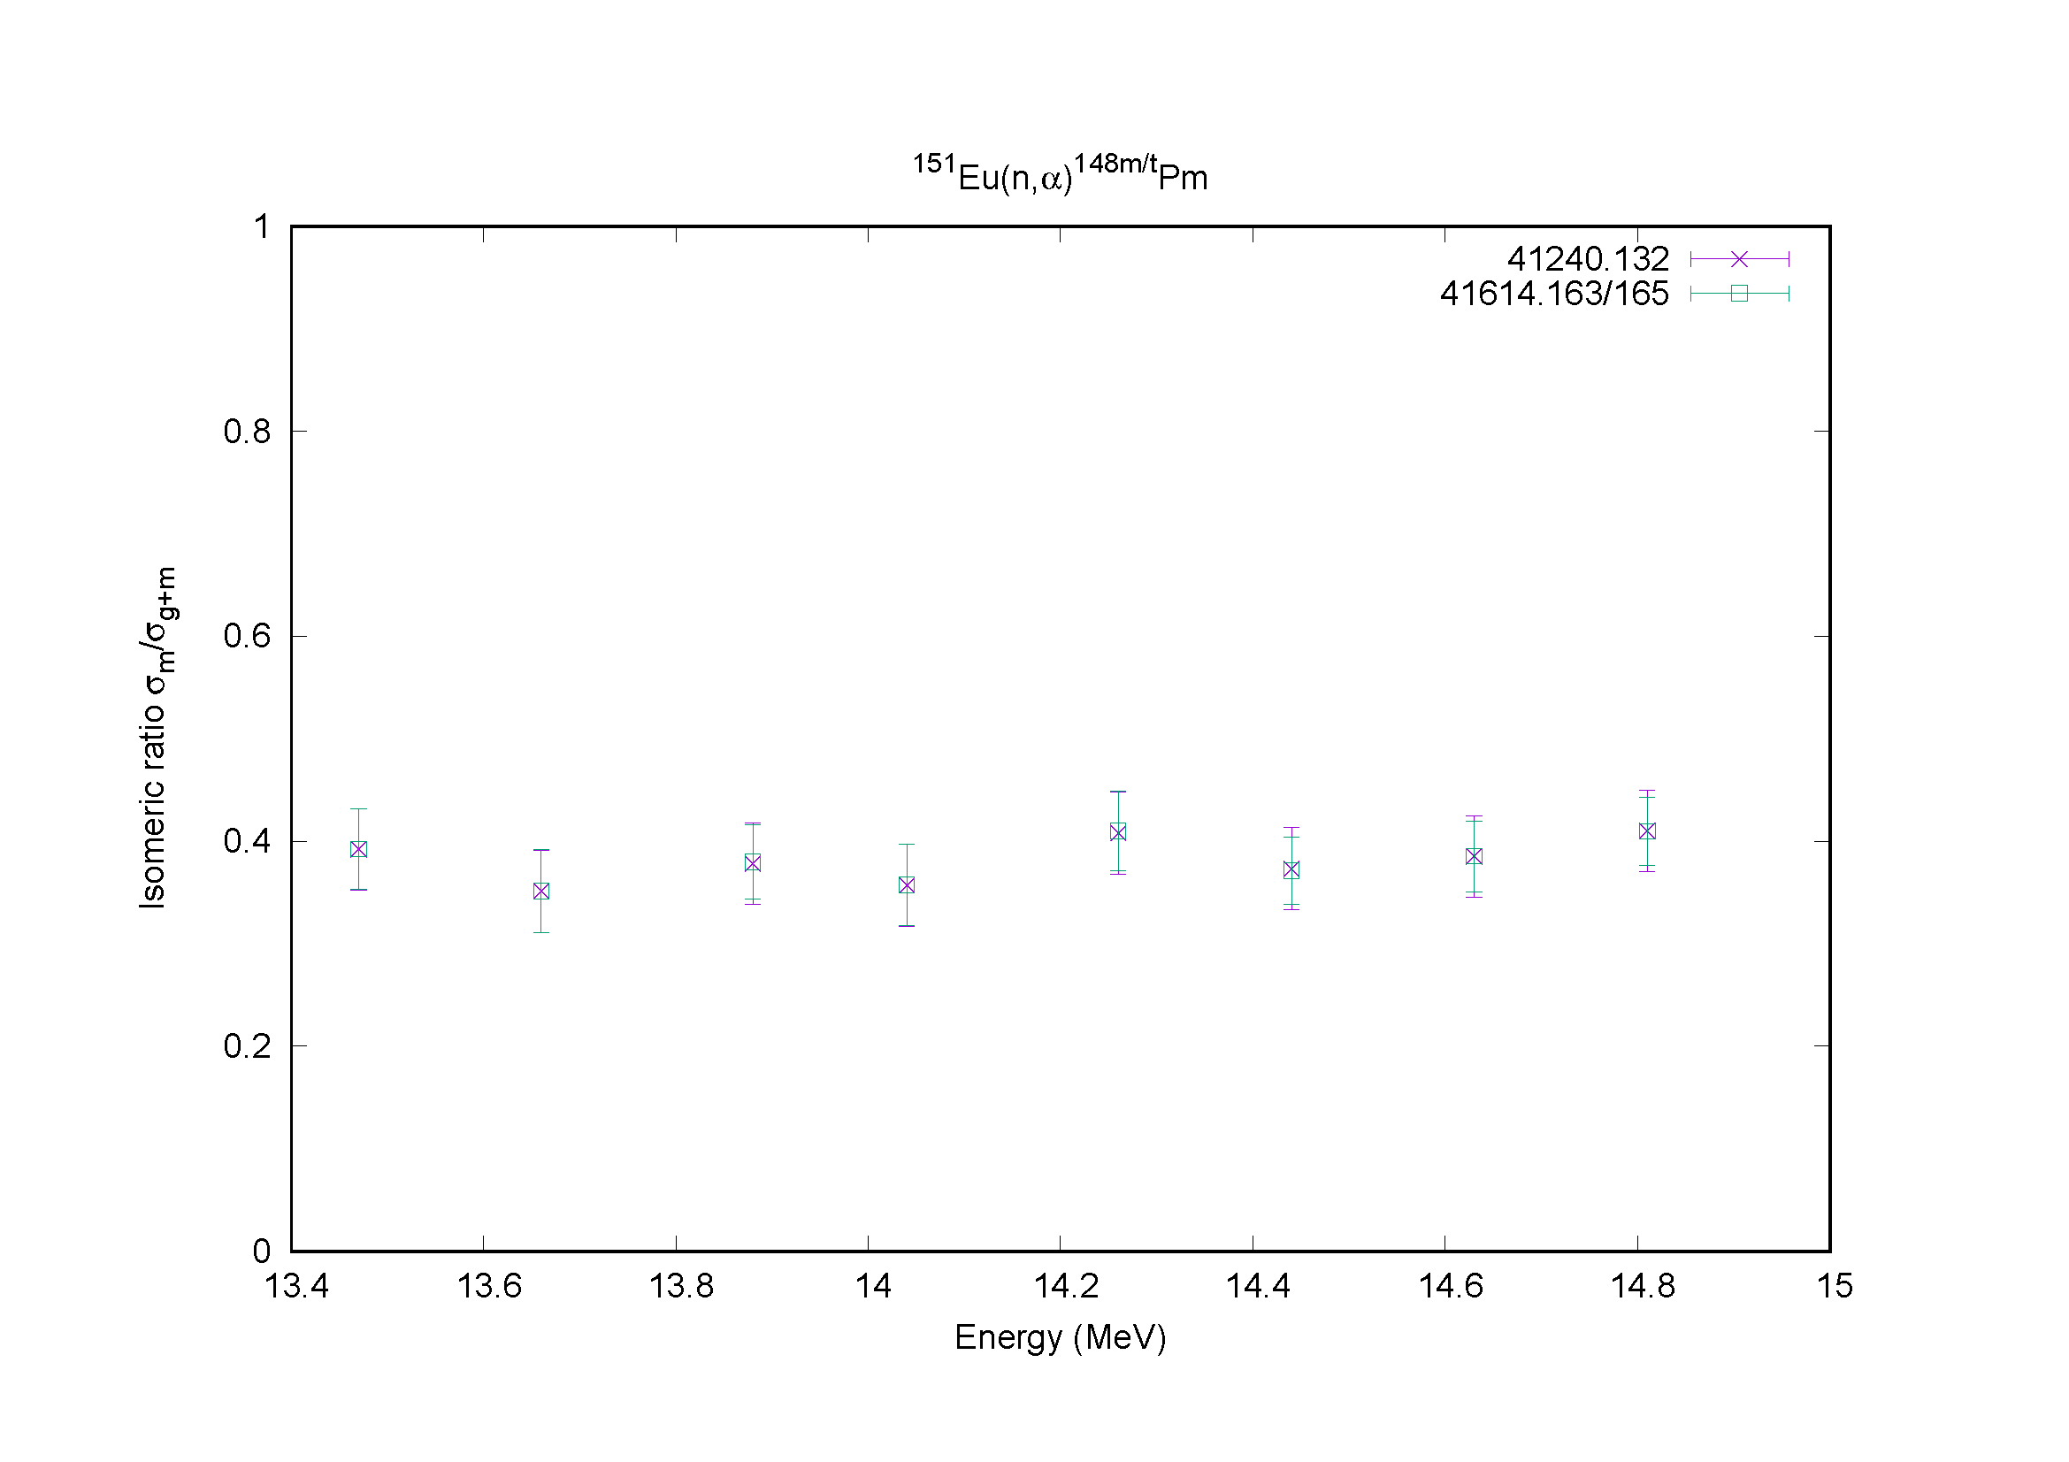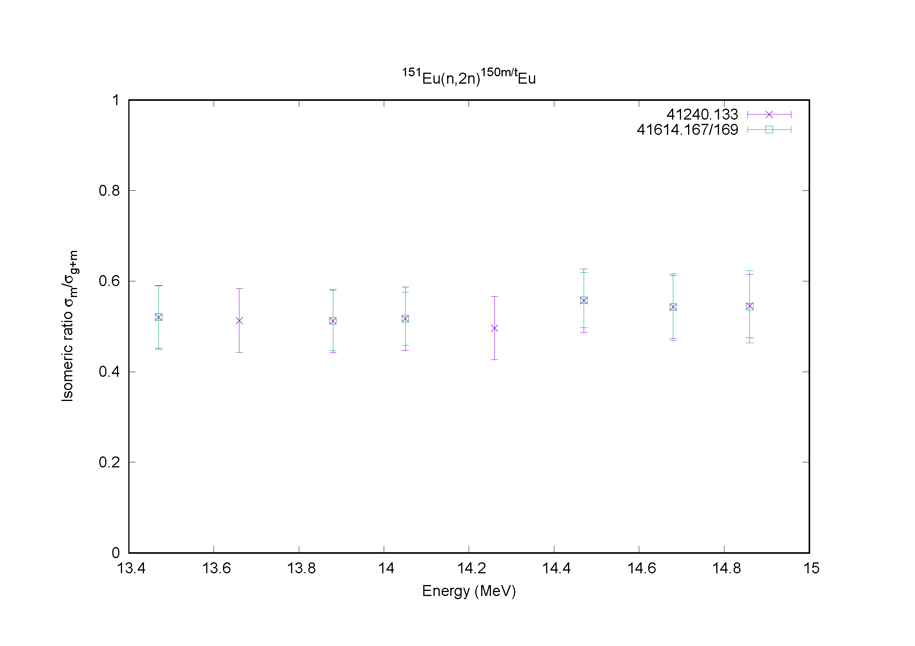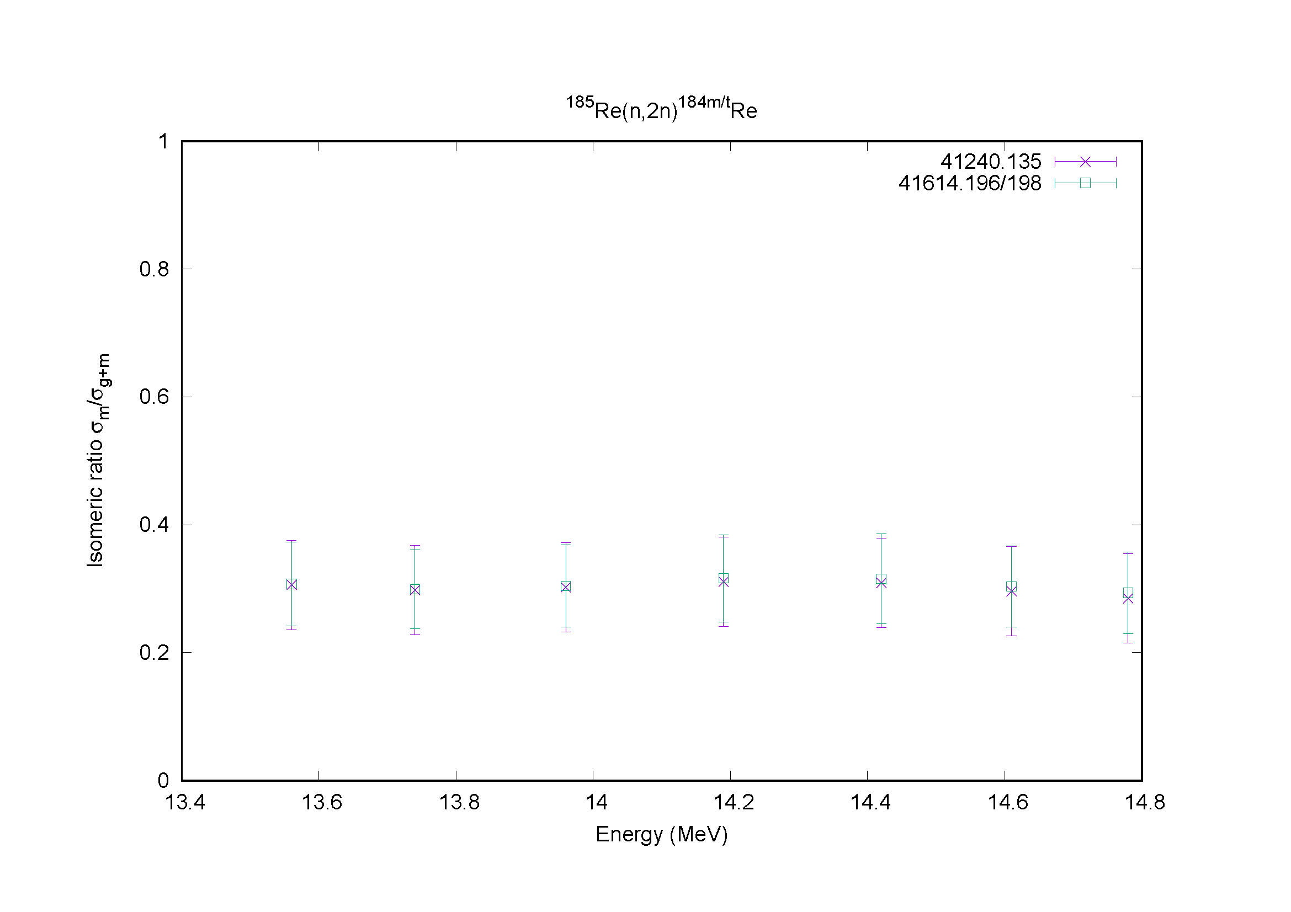

Distribution:

a.koning@iaea.org
abhihere@gmail.com
aloks279@gmail.com
daniela.foligno@oecd-nea.org
dbrown@bnl.gov
draj@barc.gov.in
exfor@oecd-nea.org
fukahori.tokio@jaea.go.jp
ganesan555@gmail.com
gezg@ciae.ac.cn
iwamoto.osamu@jaea.go.jp
jmwang@ciae.ac.cn
kaltchen@ukr.net
kimdh@kaeri.re.kr
kimura.atsushi04@jaea.go.jp
l.vrapcenjak@iaea.org
manuel.bossant@oecd-nea.org
masaaki@nucl.sci.hokudai.ac.jp
marina-03-08@yandex.ru
michael.fleming@oecd-nea.org
mmarina@ippe.ru
nicolas.soppera@oecd-nea.org
n.otsuka@iaea.org
nrdc@jcprg.org
odsurenn@gmail.com
ogritzay@ukr.net
ogrudzevich@ippe.ru
otto.schwerer@aon.at
pikulina@expd.vniief.ru
pritychenko@bnl.gov
scyang@kaeri.re.kr
selyankina@expd.vniief.ru
sonzogni@bnl.gov
stakacs@atomki.mta.hu
stanislav.hlavac@savba.sk
sv.dunaeva@gmail.com
tada@nucl.sci.hokudai.ac.jp
taova@expd.vniief.ru
tarkanyi@atomki.hu
v.devi@iaea.org
v.zerkin@iaea.org
vidyathakur@yahoo.co.in
vsemkova@inrne.bas.bg
vvvarlamov@gmail.com
yolee@kaeri.re.kr
zholdybayev@inp.kz

cc:
a.rodrigos@alumnos.upm.es

