Nuclear Data Section
International Atomic Energy Agency
P.O.Box 100, A-1400 Vienna, Austria

Memo CP-D/1064

Date: 24 December 2022
To: Distribution
From: N. Otsuka

Subject: Dictionary transmission 9127 and Season’s Greetings

Dictionary transmission 9127 is available in three formats (Trans, Archive and Backup) from the NDS open area: http://nds.iaea.org/nrdc/ndsx4/trans/dicts/. These dictionaries in zipped form (dicts-2022-12-24.zip) are also available: http://nds.iaea.org/exfor-master/backup/?C=M;O=D.
All memos submitted no later than 23 November (for dictionary 1, 2, 4, 16, 24-25, 30-35, 37, 236) or 23 December (for other dictionaries) are considered in this update.
All changes are summarized below. “Status” gives alteration flags and status codes defined in EXFOR/CINDA Dictionary Manual. These are also listed in the “EXCHANGE” file in the zipped file.

Dict. | Status | Code | Expansion | Remark
003 | ATRA | 1USASRF | Sanford Underground Research Facility, Lead, SD | CP-C/0500
006 | ATRA | IPNO-DRE- | Inst. de Phys. Nucl. Orsay Reports (Nucl.Phys.) | CP-N/0172
024 | DTRA | E-EXC-MAXA | Approximate upper limit of excitation energy range | 4C-3/0421
024 | ATRA | E-EXC-MX-A | Approximate upper limit of excitation energy range | 4C-3/0421
024 | ATRA | EN-RSL-HW1 | 1st incident projectile energy resolution (Half width) | CP-D/1059
024 | ATRA | EN-RSL-HW2 | 2nd incident projectile energy resolution (Half width) | CP-D/1059
024 | ATRA | WVE-LN-MAX | Upper boundary of wave length of incident particle | CP-C/0498
024 | ATRA | WVE-LN-MIN | Lower boundary of wave length of incident particle | CP-C/0498
031 | ATRA | EXL | Excitation to low-lying levels | 4C-3/0421
034 | DTRA | EXL | Excitation to low-lying levels | 4C-3/0421
236 | ATRA | BA/COH,SIG | Bound-atom coherent cross section | CP-C/0499
236 | ATRA | EXL,SIG | Cross section including excitation to low-lying levels | 4C-4/0234
236 | ATRA | ISP,DA | Differential cross section d/dA, partial for intermediate product | CP-F/0023
236 | ATRA | PAR,NU | Partial neutron yield | CP-C/0497

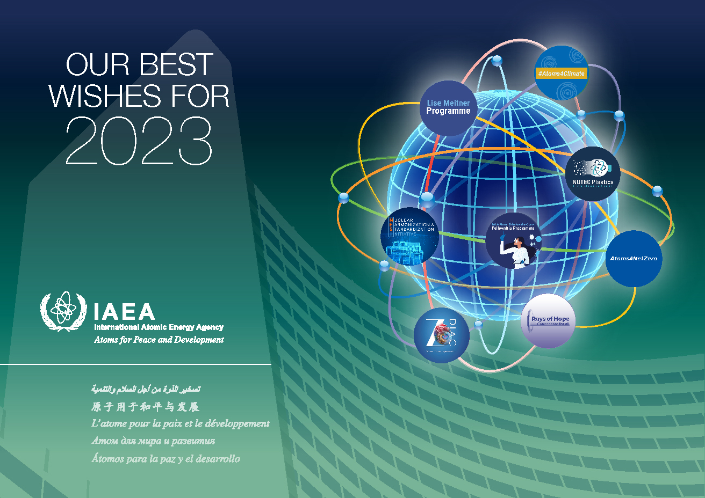

Distribution:

a.koning@iaea.org
abhihere@gmail.com
aloks279@gmail.com
daniela.foligno@oecd-nea.org
dbrown@bnl.gov
draj@barc.gov.in
exfor@oecd-nea.org
fukahori.tokio@jaea.go.jp
ganesan555@gmail.com
gezg@ciae.ac.cn
iwamoto.osamu@jaea.go.jp
jmwang@ciae.ac.cn
kaltchen@ukr.net
kimdh@kaeri.re.kr
kimura.atsushi04@jaea.go.jp
l.vrapcenjak@iaea.org
manuel.bossant@oecd-nea.org
masaaki@nucl.sci.hokudai.ac.jp
marina-03-08@yandex.ru
michael.fleming@oecd-nea.org
mmarina@ippe.ru
nicolas.soppera@oecd-nea.org
n.otsuka@iaea.org
nrdc@jcprg.org
odsurenn@gmail.com
ogritzay@ukr.net
ogrudzevich@ippe.ru
otto.schwerer@aon.at
pikulina@expd.vniief.ru
pritychenko@bnl.gov
scyang@kaeri.re.kr
selyankina@expd.vniief.ru
sonzogni@bnl.gov
stakacs@atomki.mta.hu
stanislav.hlavac@savba.sk
sv.dunaeva@gmail.com
tada@nucl.sci.hokudai.ac.jp
taova@expd.vniief.ru
tarkanyi@atomki.hu
v.devi@iaea.org
v.zerkin@iaea.org
vidyathakur@yahoo.co.in
vsemkova@inrne.bas.bg
vvvarlamov@gmail.com
yolee@kaeri.re.kr
zholdybayev@inp.kz

