Nuclear Data Section
International Atomic Energy Agency
P.O.Box 100, A-1400 Vienna, Austria

Memo CP-D/1069

Date: 17 February 2023
To: Distribution
From: V. Devi, N. Otsuka

Subject: Proposal to use non-integer numbers to define FLAG and DECAY-FLAG.

EXFOR Formats Manual Sect. 7 “DECAY-DATA” provides:

Flag. The general format of the code is an integer (n), where n has a numerical value that also appears in the data section under the data heading DECAY-FLAG.

We suggest allowing non-integer values in DECAY-FLAG (and also FLAG) to avoid the confusion caused by several definitions for the same nuclide's gamma lines.

Few References:

H.Naik et al., NSE,196,16,2022 (EXFOR 33169)
H.Naik et al., NSE,196,433,2022 (EXFOR 33173)
H.Naik et al., NSE,196,694,2022 (EXFOR 33174)
H.Naik et al., NSE,196,824,2022 (EXFOR 33178)
H.Naik et al., NSE,196,982,2022 (EXFOR 33179)
H.Naik et al., NSE,197,25,2023 (EXFOR 33185)

Below is a table providing multiple definition for gamma lines of the same nuclide (H.Naik+, J,NSE,196,982,2022, EXFOR 33179).

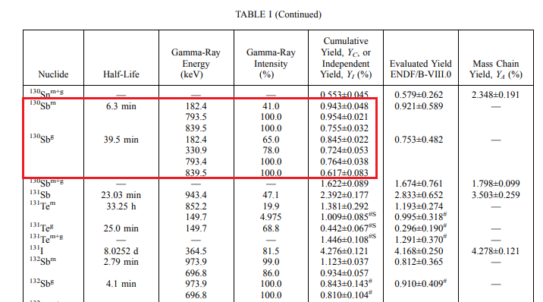

Example:
- Coding within the current rule
DECAY-DATA ((1301.)51-SB-130-G,39.5MIN,DG,330.9,0.780)
((1302.)51-SB-130-G,39.5MIN,DG,793.4,1.000)
((1303.)51-SB-130-G,39.5MIN,DG,839.5,1.000)
The flags must be represented as integer values, although the compiler attempted to use flags identical to the mass number of the specific nuclide (=130).

- Coding with the proposed rule
DECAY-DATA ((130.1)51-SB-130-G,39.5MIN,DG,330.9,0.780)
((130.2)51-SB-130-G,39.5MIN,DG,793.4,1.000)
((130.3)51-SB-130-G,39.5MIN,DG,839.5,1.000)
Utilizing non-integer values makes it easier to compile and verify data, which helps to solve the problem.

Therefore, we propose that the FLAG and DECAY-FLAG be defined using non-integer values.

Distribution:
a.koning@iaea.org  abhihere@gmail.com  aloks279@gmail.com  daniela.foligno@oecd-nea.org  dbrown@bnl.gov  draj@barc.gov.in  exfor@oecd-nea.org  fukahori.tokio@jaea.go.jp  ganesan555@gmail.com  gezg@ciae.ac.cn  iwamoto.osamu@jaea.go.jp  jmwang@ciae.ac.cn  kaltchen@ukr.net  kimdh@kaeri.re.kr  kimura.atsushi04@jaea.go.jp  l.vrapcenjak@iaea.org  manuel.bossant@oecd-nea.org  masaaki@nucl.sci.hokudai.ac.jp  marina-03-08@yandex.ru  michael.fleming@oecd-nea.org  mmarina@ippe.ru  nicolas.soppera@oecd-nea.org  n.otsuka@iaea.org | nrdc@jcprg.org  odsurenn@gmail.com  ogritzay@ukr.net  ogrudzevich@ippe.ru  otto.schwerer@aon.at  pikulina@expd.vniief.ru  pritychenko@bnl.gov  scyang@kaeri.re.kr  selyankina@expd.vniief.ru  sonzogni@bnl.gov  stakacs@atomki.mta.hu  stanislav.hlavac@savba.sk  sv.dunaeva@gmail.com  tada@nucl.sci.hokudai.ac.jp  taova@expd.vniief.ru  tarkanyi@atomki.hu  v.devi@iaea.org  v.zerkin@iaea.org  vidyathakur@yahoo.co.in  vsemkova@inrne.bas.bg  vvvarlamov@gmail.com  yolee@kaeri.re.kr  zholdybayev@inp.kz

