Nuclear Data Section
International Atomic Energy Agency
P.O.Box 100, A-1400 Vienna, Austria

Memo CP-D/1077

Date: 2023-03-27
To: Distribution
From: N. Otsuka
Subject: Unit of 20340.004, 010 and 011 (Pb-207 neutron scattering by Tomita)
Reference: Memo 4C-4/236

Memo 4C-4/236 introduces a question on the unit of the Legendre coefficients multiplied by 4π of ²⁰⁷Pb+n scattering in EXFOR 20340.004, 010 and 011 (MB/SR is coded instead of MB). If we assume that the actual unit as MB, then 20340.004 and 010 agree very well with JENDL-5 MF3 MT2, 51 and 52 cross sections.
I also confirmed the angular differential cross sections at 1.47 MeV on Fig.2 of the INDC report can be reproduced by applying this interpretation (MB instead of MB/SR) not only to the 0th coefficient but also to the higher order coefficients.
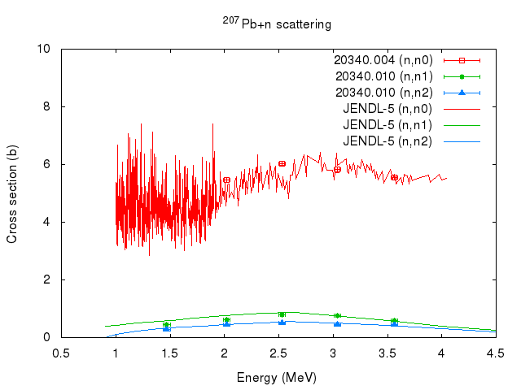
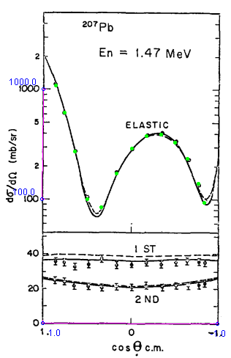

I suggest replacement of LEG/FCT with LEG/4PI and MB/SR with MB in these three subentries.

N.B. P,INDC(JAP)-017,6,1973 must be added as an alias of P,EANDC(J)-30,6,1973.

Distribution:

a.koning@iaea.org
abhihere@gmail.com
aloks279@gmail.com
daniela.foligno@oecd-nea.org
dbrown@bnl.gov
draj@barc.gov.in
exfor@oecd-nea.org
fukahori.tokio@jaea.go.jp
ganesan555@gmail.com
gezg@ciae.ac.cn
iwamoto.osamu@jaea.go.jp
jmwang@ciae.ac.cn
kaltchen@ukr.net
kimdh@kaeri.re.kr
kimura.atsushi04@jaea.go.jp
l.vrapcenjak@iaea.org
manuel.bossant@oecd-nea.org
masaaki@nucl.sci.hokudai.ac.jp
marina-03-08@yandex.ru
michael.fleming@oecd-nea.org
mmarina@ippe.ru
nicolas.soppera@oecd-nea.org
n.otsuka@iaea.org
nrdc@jcprg.org
odsurenn@gmail.com
ogritzay@ukr.net
ogrudzevich@ippe.ru
otto.schwerer@aon.at
pikulina@expd.vniief.ru
pritychenko@bnl.gov
scyang@kaeri.re.kr
selyankina@expd.vniief.ru
sonzogni@bnl.gov
stakacs@atomki.mta.hu
stanislav.hlavac@savba.sk
sv.dunaeva@gmail.com
tada@nucl.sci.hokudai.ac.jp
taova@expd.vniief.ru
tarkanyi@atomki.hu
v.devi@iaea.org
v.zerkin@iaea.org
vidyathakur@yahoo.co.in
vsemkova@inrne.bas.bg
vvvarlamov@gmail.com
yolee@kaeri.re.kr
zholdybayev@inp.kz

