Nuclear Data Section
International Atomic Energy Agency
P.O.Box 100, A-1400 Vienna, Austria

Memo CP-D/1087

Date: 2023-07-17
To: Distribution
From: N. Otsuka, S. Dunaeva
Subject: Dictionary 236 (Quantities): -L,SIG and -L,SIG,,SFC

EXFOR O0316.006 and 007 provide the “ground state” and quasi-metastable state (13.98 ms) production cross sections of ⁸⁷Sr(p,γ)⁸⁸Y in Table III of S. Harissopulos+, J,PR/C,104,02504,2021:

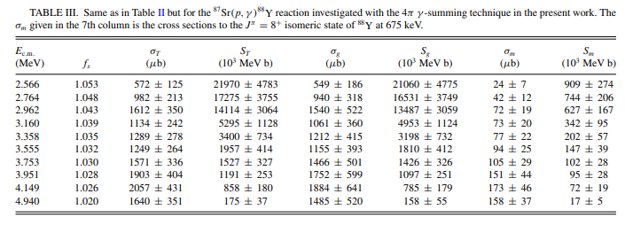

The “ground state” production provided in this table is the cross section excluding the quasi-metastable state production cross section. The nuclide does not have a metastable state, and we cannot define the ground state production cross section (The isomeric flag -G is legal only when the nuclide has a metastable state.).
This reminds us of discussion on gamma production cross section excluding cascade involving a quasi-metastable state in the NRDC 2023 meeting (WP2023-26). We found the branch code approved in the meeting L- (Excluding formation via quasi-metastable state production) is useful. We propose the following new quantity codes for compilation of the “ground state” production cross section and corresponding S-factor:

Example (O0316.006):

SUBENT O0316006 20230313 O0316 6 1
BIB 8 13 O0316 6 2
REACTION 1(38-SR-87(P,G)39-Y-88,L-,SIG) O0316 6 3
2(38-SR-87(P,G)39-Y-88,L-,SIG,,SFC) O0316 6 4
DECAY-DATA (39-Y-88,106.626D) O0316 6 5
…
ENDBIB 13 0 O0316 6 16
COMMON 2 3 O0316 6 17
EN-ERR ERR-2 O0316 6 18
MEV PER-CENT O0316 6 19
0.0075 10. O0316 6 20
ENDCOMMON 3 0 O0316 6 21
DATA 6 10 O0316 6 22
EN-CM DATA 1ERR-T 1DATA 2ERR-T 2MISC O0316 6 23
MEV MICRO-B MICRO-B B*MEV B*MEV NO-DIM O0316 6 24
2.566 549. 186. 2.1060E+07 4.775E+06 1.053 O0316 6 25
2.764 940. 318. 1.6531E+07 3.749E+06 1.048 O0316 6 26
2.962 1540. 522. 1.3487E+07 3.059E+06 1.043 O0316 6 27
…

Dictionary 236 (Quantities)
L-,SIG Cross section excluding quasi-metastable state production
L-,SIG,,SFC S-factor excluding quasi-metastable state production

Use of multiple reaction formalism for cross section and S-factor
We also propose the pair of the cross section and S-factor as a combination allowed to be together in the same subentry with the multiple reaction formalism.

Distribution:

a.koning@iaea.org
abhihere@gmail.com
aloks279@gmail.com
daniela.foligno@oecd-nea.org
dbrown@bnl.gov
dgremyachkin@ippe.ru
draj@barc.gov.in
exfor@oecd-nea.org
fukahori.tokio@jaea.go.jp
ganesan555@gmail.com
gezg@ciae.ac.cn
iwamoto.osamu@jaea.go.jp
jmwang@ciae.ac.cn
kaltchen@ukr.net
kimdh@kaeri.re.kr
kimura.atsushi04@jaea.go.jp
l.vrapcenjak@iaea.org
manuel.bossant@oecd-nea.org
marina-03-08@yandex.ru
michael.fleming@oecd-nea.org
mvmikhaylyukova@ippe.ru
nicolas.soppera@oecd-nea.org
nomura@nucl.sci.hokudai.ac.jp
n.otsuka@iaea.org
nrdc@jcprg.org
nshu@ciae.ac.cn
odsurenn@gmail.com
ogritzay@ukr.net
otto.schwerer@aon.at
pikulina@expd.vniief.ru
pritychenko@bnl.gov
scyang@kaeri.re.kr
selyankina@expd.vniief.ru
sonzogni@bnl.gov
stakacs@atomki.mta.hu
stanislav.hlavac@savba.sk
sv.dunaeva@gmail.com
tada@nucl.sci.hokudai.ac.jp
taova@expd.vniief.ru
tarkanyi@atomki.hu
v.devi@iaea.org
v.zerkin@iaea.org
vidyathakur@yahoo.co.in
vsemkova@inrne.bas.bg
vvvarlamov@gmail.com
yolee@kaeri.re.kr
zholdybayev@inp.kz

