Nuclear Data Section
International Atomic Energy Agency
P.O.Box 100, A-1400 Vienna, Austria

Memo CP-D/1091

Date: 2023-09-30
To: Distribution
From: N. Otsuka, J.M. Wang
Subject: Auchampaugh et al’s superseded (n,2n) datasets in EXFOR 12936
The (n,2n) cross sections measured with a large Gd-loaded liquid scintillator tank by Auchampaugh, Drake and Veeser in EXFOR 12936 were withdrawn by the last author on 10 October 1985.
STATUS (SPSDD) DATA WITHDRAWN, L.R.VEESER, 85/10/10.
These datasets are kept with STATUS=SPSDD and cannot be retrieved and plotted on the NDS EXFOR web retrieval system with the default setting.
In general, Auchampaugh et al. covers the energy above 14.7 MeV while Frehaut et al. covers the energy below 14.8 MeV, and hence they are complemental each other for evaluators. Some EXFOR users may want to utilize these datasets even if they are withdrawn by the author, and we would like to share their plots for your attention.
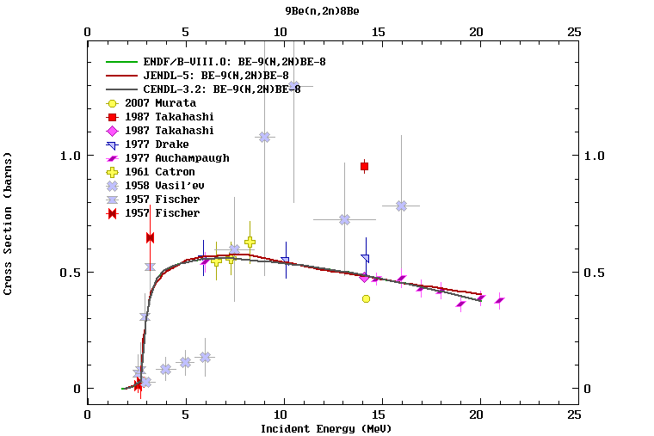

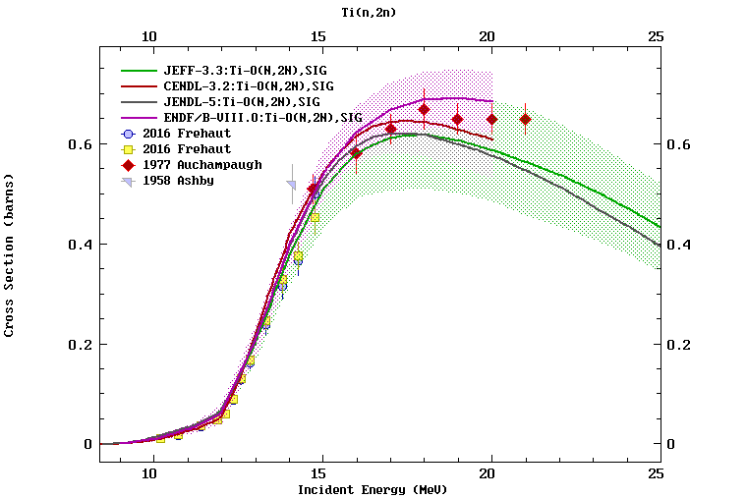

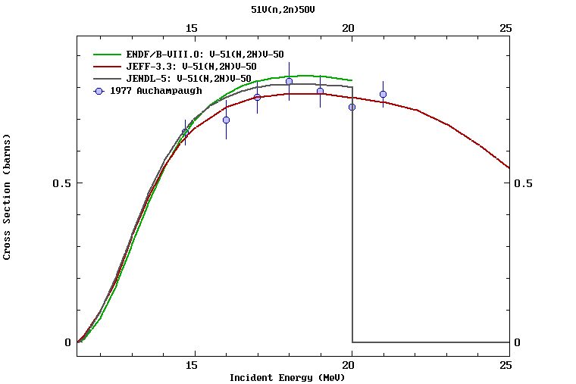

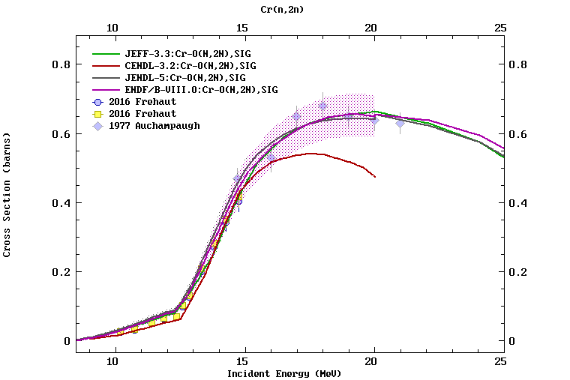

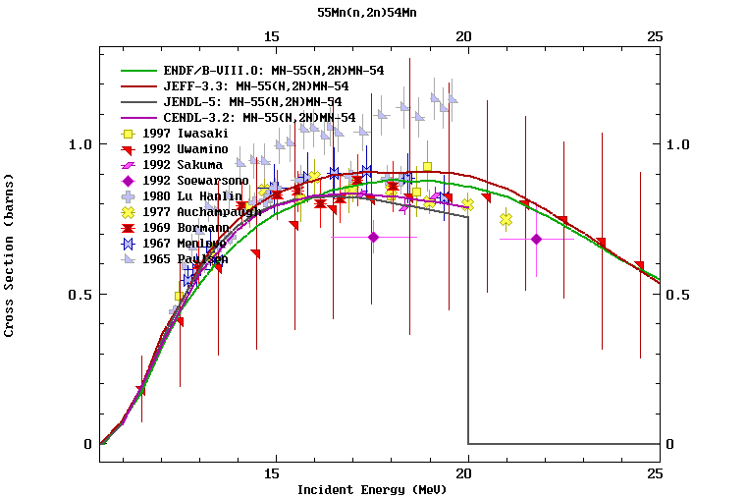

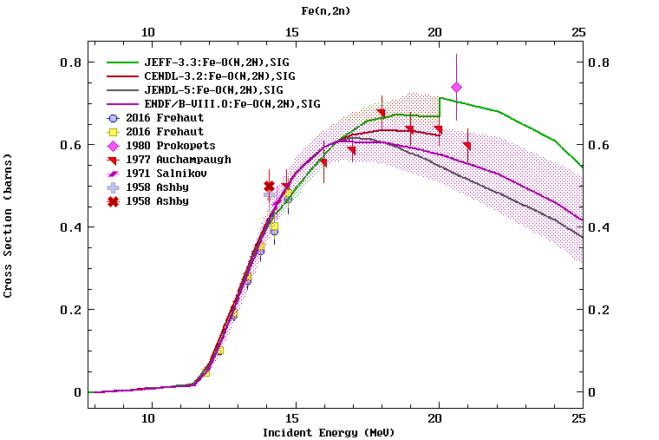

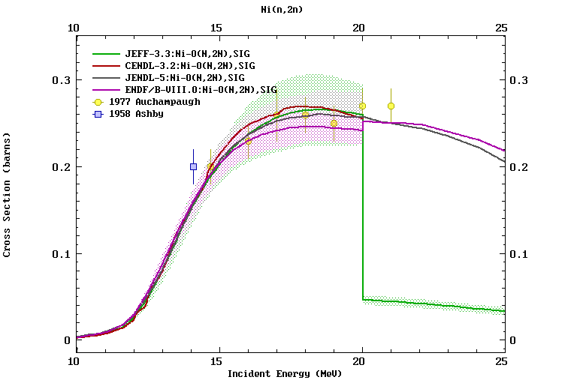

Distribution:

a.koning@iaea.org
abhihere@gmail.com
aloks279@gmail.com
daniela.foligno@oecd-nea.org
dbrown@bnl.gov
dgremyachkin@ippe.ru
draj@barc.gov.in
exfor@oecd-nea.org
fukahori.tokio@jaea.go.jp
ganesan555@gmail.com
gezg@ciae.ac.cn
iwamoto.osamu@jaea.go.jp
jmwang@ciae.ac.cn
julia.sprenger@oecd-nea.org
kaltchen@ukr.net
kimdh@kaeri.re.kr
kimura.atsushi04@jaea.go.jp
l.vrapcenjak@iaea.org
manuel.bossant@oecd-nea.org
marina-03-08@yandex.ru
michael.fleming@oecd-nea.org
mvmikhaylyukova@ippe.ru
nicolas.soppera@oecd-nea.org
nomura@nucl.sci.hokudai.ac.jp
n.otsuka@iaea.org
nrdc@jcprg.org
nshu@ciae.ac.cn
odsurenn@gmail.com
ogritzay@ukr.net
otto.schwerer@aon.at
pikulina@expd.vniief.ru
pritychenko@bnl.gov
scyang@kaeri.re.kr
selyankina@expd.vniief.ru
sonzogni@bnl.gov
stakacs@atomki.mta.hu
stanislav.hlavac@savba.sk
sv.dunaeva@gmail.com
tada@nucl.sci.hokudai.ac.jp
taova@expd.vniief.ru
tarkanyi@atomki.hu
v.devi@iaea.org
v.zerkin@iaea.org
vidyathakur@yahoo.co.in
vsemkova@inrne.bas.bg
vvvarlamov@gmail.com
yolee@kaeri.re.kr
zholdybayev@inp.kz

