Nuclear Data Section
International Atomic Energy Agency
P.O.Box 100, A-1400 Vienna, Austria

Memo CP-D/1097

Date: 21 November 2023
To: Distribution
From: V. Devi, N. Otsuka

Subject: Dictionary 24 (Data heading) – ANG-APRX
In EXFOR D1004 and D1042, authors report the average of cross sections measured at several angles.

Example (D1042.003): ⁹Be(⁸Li,⁷Li)¹⁰Be double differential cross sections from measurements at nine angles plotted on Fig.6 of O.C.B. Santos et al., Eur. Phys. J. A 59 (2023) 48.
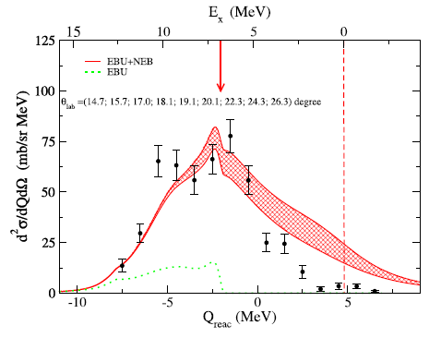
Recalling repetition of a heading for unresolved secondary energies, one might think to compile the dataset in the above figure with repetition of the heading ANG:

COMMON
ANG ANG ANG ANG ANG ANG
ANG ANG ANG
ADEG ADEG ADEG ADEG ADEG ADEG
ADEG ADEG ADEG
14.7 15.7 17.0 18.1 19.1 20.1
22.3 24.3 26.3
ENDCOMMON

though appearance of multiple angles does not express poor resolution of detection angle. We rather propose use of a new heading ANG-APRX, and explain its under the keyword ANG-SEC:

ANG-SEC (ANG-APRX,3-LI-7) Averaged over nine angles 14.7,15.7,
17.0, 18.1, 19.1, 20.1, 22.3, 24.3 and 26.3 degree.
…
ENDBIB 4 0
COMMON 1 3
ANG-APRX
ADEG
20.
ENDCOMMON 3 0

Dictionary 24 (Data heading)
ANG-APRX Approximate value of angle in laboratory system

Distribution:

a.koning@iaea.org
aloks279@gmail.com
daniela.foligno@oecd-nea.org
dbrown@bnl.gov
dgremyachkin@ippe.ru
draj@barc.gov.in
exfor@oecd-nea.org
fukahori.tokio@jaea.go.jp
ganesan555@gmail.com
gezg@ciae.ac.cn
iwamoto.osamu@jaea.go.jp
jmwang@ciae.ac.cn
julia.sprenger@oecd-nea.org
kaltchen@ukr.net
kimdh@kaeri.re.kr
kimura.atsushi04@jaea.go.jp
l.vrapcenjak@iaea.org
manuel.bossant@oecd-nea.org
marina-03-08@yandex.ru
michael.fleming@oecd-nea.org
mvmikhaylyukova@ippe.ru
nicolas.soppera@oecd-nea.org
nomura@nucl.sci.hokudai.ac.jp
n.otsuka@iaea.org
nrdc@jcprg.org
nshu@ciae.ac.cn
odsurenn@gmail.com
ogritzay@ukr.net
otto.schwerer@aon.at
pikulina@expd.vniief.ru
pritychenko@bnl.gov
scyang@kaeri.re.kr
selyankina@expd.vniief.ru
sonzogni@bnl.gov
stakacs@atomki.mta.hu
stanislav.hlavac@savba.sk
sv.dunaeva@gmail.com
tada@nucl.sci.hokudai.ac.jp
taova@expd.vniief.ru
tarkanyi@atomki.hu
v.devi@iaea.org
v.zerkin@gmail.com
vidyathakur@yahoo.co.in
vsemkova@inrne.bas.bg
vvvarlamov@gmail.com
yolee@kaeri.re.kr
zholdybayev@inp.kz

