Nuclear Data Section
International Atomic Energy Agency
P.O.Box 100, A-1400 Vienna, Austria

Memo CP-D/1099

Date: 23 December 2023
To: Distribution
From: N. Otsuka

Subject: Dictionary transmission 9129 and Season’s Greetings

Dictionary transmission 9129 is available in three formats (Trans, Archive and Backup) from the NDS open area: http://nds.iaea.org/nrdc/ndsx4/trans/dicts/. These dictionaries in zipped form (dicts-2023-12-21.zip) are also available: http://nds.iaea.org/exfor-master/backup/?C=M;O=D.
The same update made with the new procedure presented in the NRDC 2023 meeting is available as transmission 9929 on the NDS open area as a trial dictionary for your testing. I am planning to move to this new procedure in 2024, and your feedback on the trial dictionary is highly appreciated.
All memos submitted no later than 21 November (for dictionary 1, 2, 4, 16, 24-25, 30-35, 37, 236) or 21 December (for other dictionaries) are considered in this update.
All changes are summarized below. “Status” gives alteration flags and status codes defined in EXFOR/CINDA Dictionary Manual. These are also listed in the “EXCHANGE” file in the zipped file.
Additional changes introduced in this memo are summarized below:
Dictionary 3 (Institutes)
3CLMCLM (Replacement “Columbia” with “Colombia”.)
4UZ UZB (Adoption of an English translation as per a comment from Feruzjon Ergashev)

Dictionary 5 (Journals)
APP/BS (Replacement of “Series” with “Supplement”.)

Dictionary 6 (Reports)
INDC(TUK)- Turkish report to the I.N.D.C. (This is printed on the some Turkish reports.)

Dictionary 236 (Quantities)
EXL,DA (Correction of the reaction type code and unit family code)

I would like thank Nicolas Soppera for valuable comments on a draft of the new dictionary.

Dict. | Status | Code | Expansion | Remark
003 | ATRA | 2JPNFMU | Fukushima Medical University, Fukushima | CP-E/0168
003 | MTRA | 3CLMCLM | Colombia, Rep. | This memo
003 | MOBS | 4CCPGKS | State Committee on Standards, Moscow | Editorial
003 | MTRA | 4UZ UZB | Institute of Nuclear Physics, Tashkent | This memo
005 | MTRA | APP/BS | Acta Physica Polonica, Part B Proceeding Suppl. | This memo
006 | ATRA | INDC(TUK)- | Turkish report to the I.N.D.C. | This memo
021 | ATRA | DIFUS | Diffusion approximation | CP-S/0009
024 | ATRA | ANG-APRX | Approximate angle, laboratory system | CP-D/1097
024 | MTRA | ANG-RSL-FW | Angular resolution (full width) | CP-E/0169
024 | MTRA | ANG-RSL-HW | Angular resolution (half width) | CP-E/0169
024 | ATRA | ANG1-RSLHW | 1st angular resolution (half width) | CP-E/0169
024 | ATRA | ANG2-RSLHW | 2nd angular resolution (half width) | CP-E/0169
024 | MTRA | E-APRX | Approximate energy of outgoing particle, lab. system | Editorial
024 | ATRA | E1-RSL-FW | 1st outgoing particle energy resolution (full width) | CP-E/0169
024 | MTRA | EN-APRX | Approximate incident projectile energy | Editorial
236 | MTRA | EXL,DA | Angular diff. cross section including excitation to low-lying levels) | This memo
236 | ATRA | L-,SIG | Cross section excluding quasi-metastable state production | CP-D/1087
236 | ATRA | L-,SIG,,SFC | S-factor excluding quasi-metastable state production | CP-D/1087

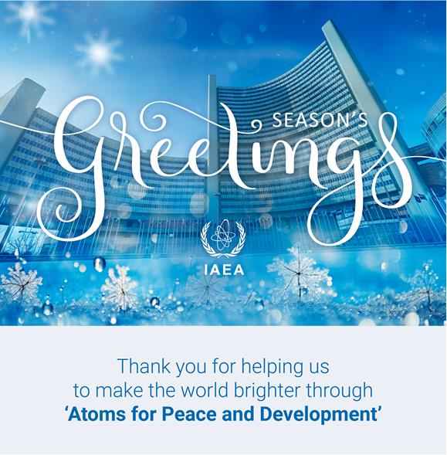

Distribution:

a.koning@iaea.org
aloks279@gmail.com
daniela.foligno@oecd-nea.org
dbrown@bnl.gov
dgremyachkin@ippe.ru
draj@barc.gov.in
exfor@oecd-nea.org
fukahori.tokio@jaea.go.jp
ganesan555@gmail.com
gezg@ciae.ac.cn
iwamoto.osamu@jaea.go.jp
jmwang@ciae.ac.cn
julia.sprenger@oecd-nea.org
kaltchen@ukr.net
kimdh@kaeri.re.kr
kimura.atsushi04@jaea.go.jp
l.vrapcenjak@iaea.org
manuel.bossant@oecd-nea.org
marina-03-08@yandex.ru
michael.fleming@oecd-nea.org
mvmikhaylyukova@ippe.ru
nicolas.soppera@oecd-nea.org
nomura@nucl.sci.hokudai.ac.jp
n.otsuka@iaea.org
nrdc@jcprg.org
nshu@ciae.ac.cn
odsurenn@gmail.com
ogritzay@ukr.net
otto.schwerer@aon.at
pikulina@expd.vniief.ru
pritychenko@bnl.gov
scyang@kaeri.re.kr
selyankina@expd.vniief.ru
sonzogni@bnl.gov
stakacs@atomki.mta.hu
stanislav.hlavac@savba.sk
sv.dunaeva@gmail.com
tada@nucl.sci.hokudai.ac.jp
taova@expd.vniief.ru
tarkanyi@atomki.hu
v.devi@iaea.org
v.zerkin@gmail.com
vidyathakur@yahoo.co.in
vsemkova@inrne.bas.bg
vvvarlamov@gmail.com
yolee@kaeri.re.kr
zholdybayev@inp.kz

