2000 May
Nuclear Reaction Data Center Meeting
Institute of Physics and Power Engineering, Obninsk

Participants
CHINA: Zhuang Youxiang
HUNGARY: Ferenc Tárkányi
JAPAN: Masaki Chiba, Akira Hasegawa, Kiyoshi Kato, Yoshihide Obayashi (observer)
REPUBLIC OF KOREA: Jonghwa Chang
RUSSIA: Svetlana Babykina, Feliks Chukreev, Svetlana Dunaeva, Stanislav Maev,
Vasili Manokhin, Vladimir Varlamov. Observers: Anatoly Blokhin, Igor Boboshin, A.N. Grebennikov, Anatoly Ignatyuk, Nikolai Kulagin, Anatoly Pashchenko, Sophiya Taova, Konstantin Zolotarev
UKRAINE: Olena Gritzay. Observers: Olexander Kalchenko, Mercury Vlasov
UNITED STATES OF AMERICA: Victoria McLane,Pavel Obložinský
OECD Nuclear ENERGY Agency: Mark Kellett, Claes Nordborg
IAEA: Vladimir Pronyaev, Otto Schwerer
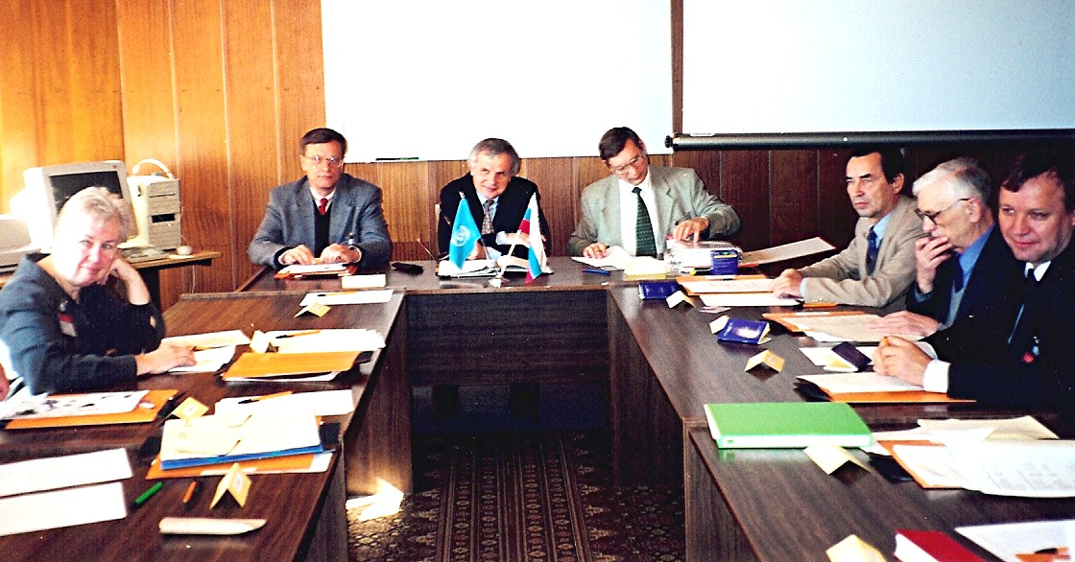
Left to right: Vicki, Otto, Pavel, Vladimir P., Vasili, Stanislav, Nicoli Kulagin?

Cocktail Party
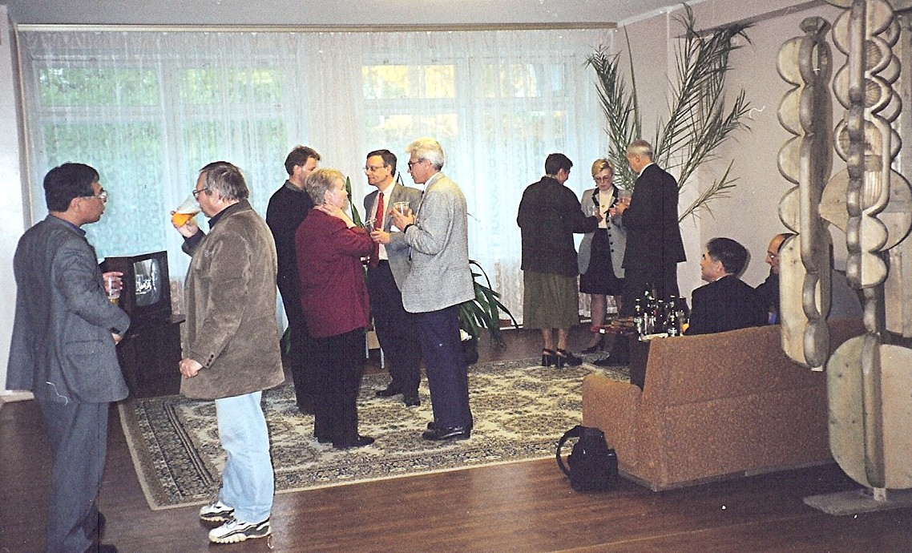

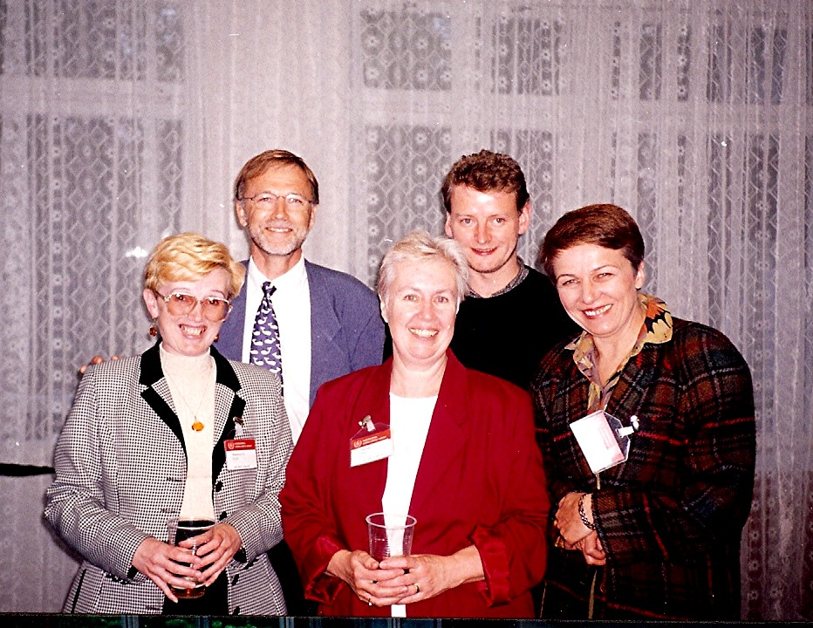

Front: Svetlana, Vicki, Olena
Back: Claes, Mark

Peter’s Tour of Moscow
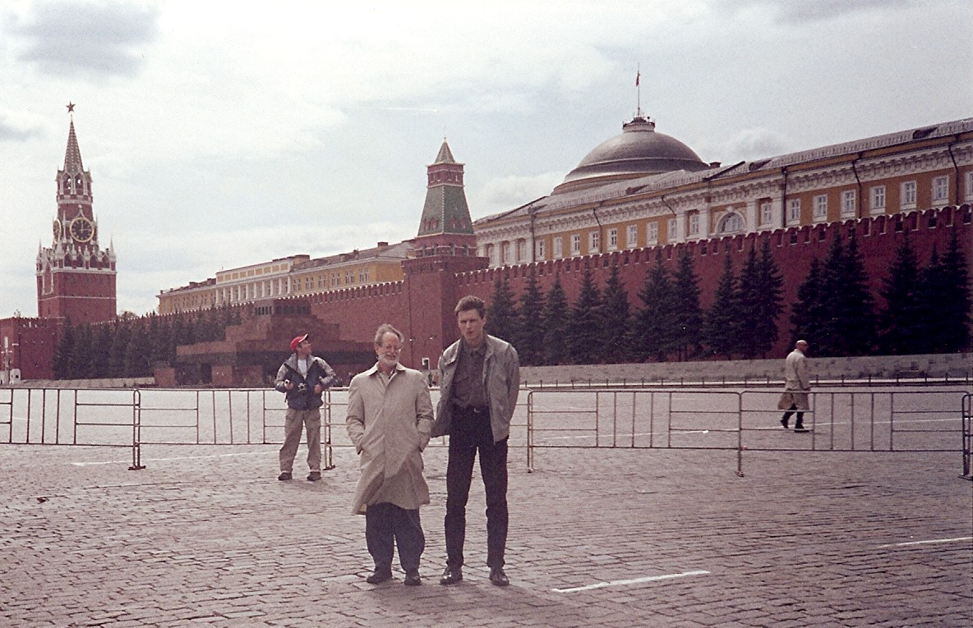

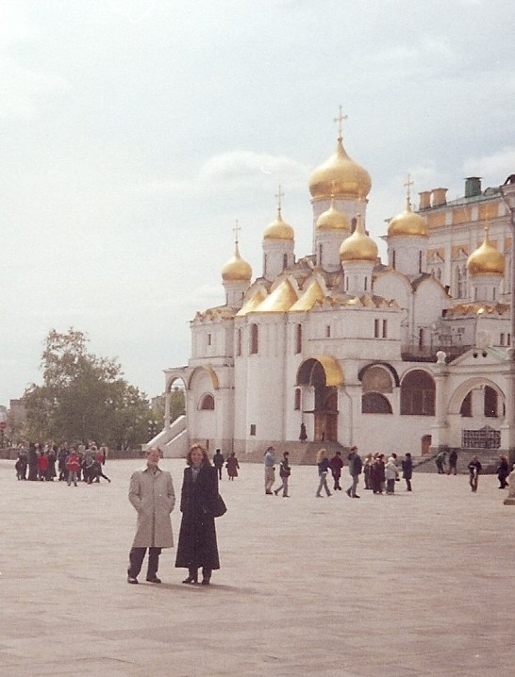
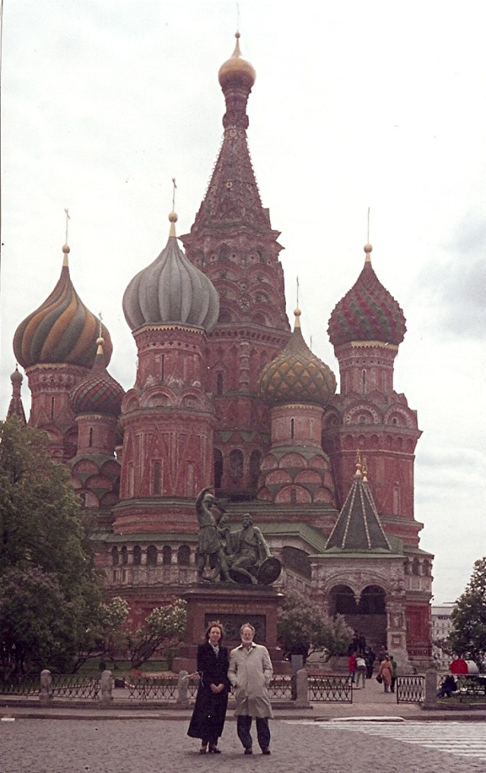

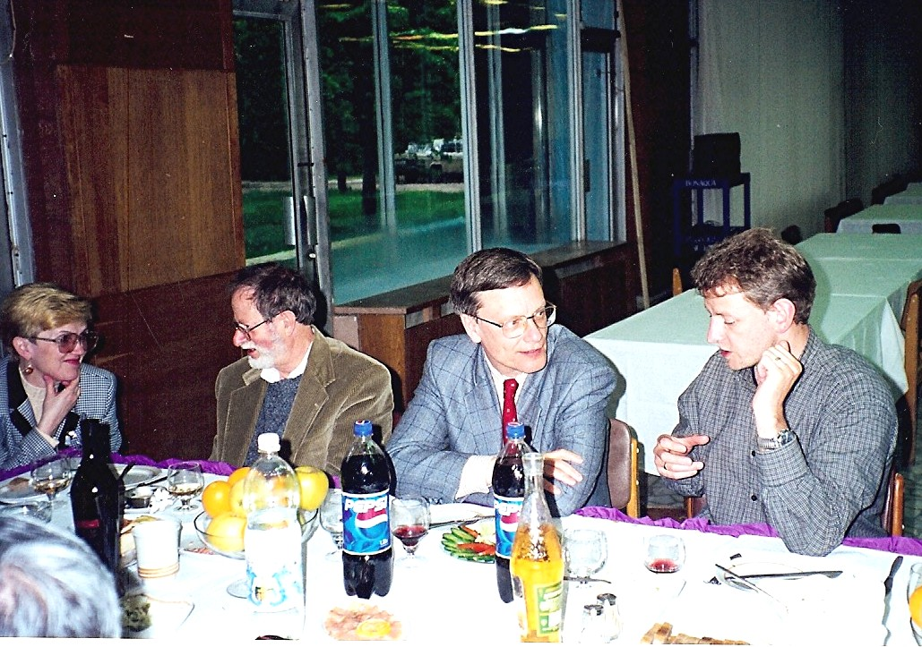
Dinner

Svetlana, Peter Kahn, Otto, Mark

Lunch at the Varlamov’s, Moscow
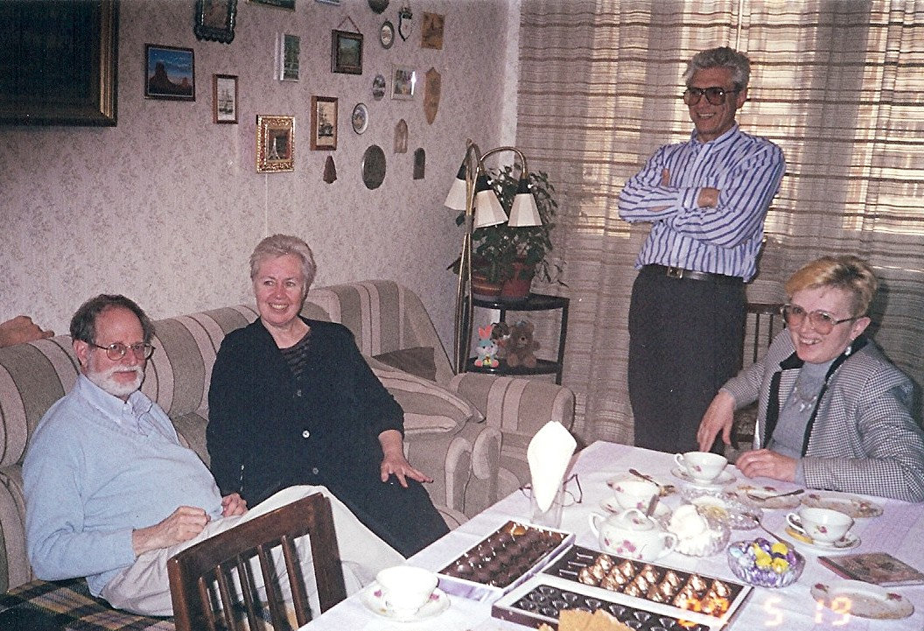

Peter, Vicki, Vladimir, Svetlana

2000 May
St. Petersburg
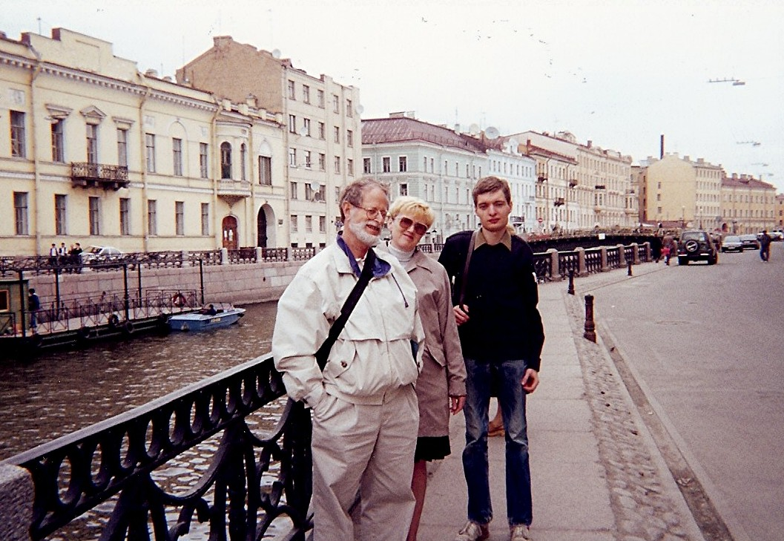

Peter, Svetlana, Student

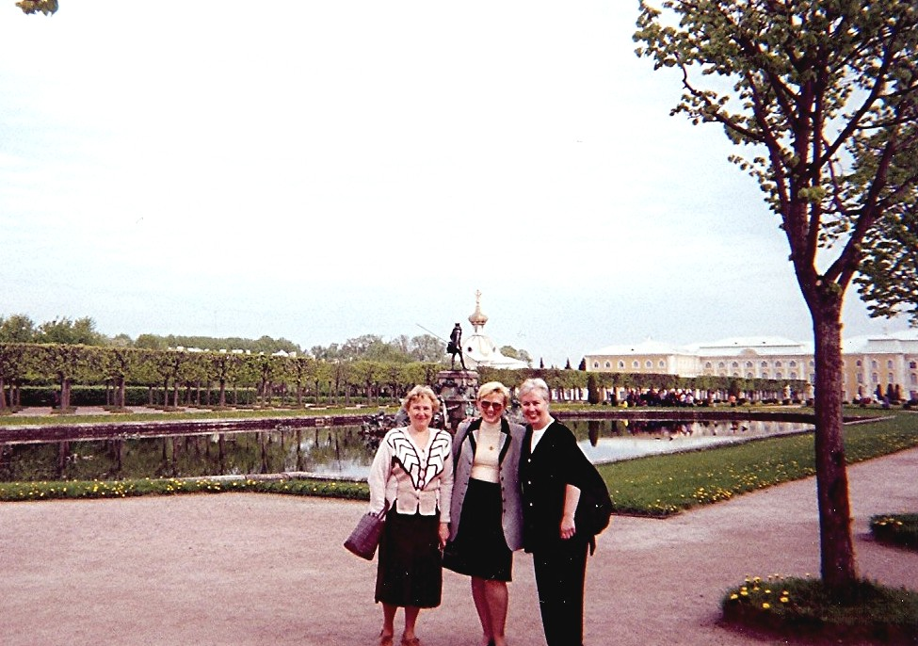

Svetlana’s friend, Svetlana, Vicki

2000 May
Sarov
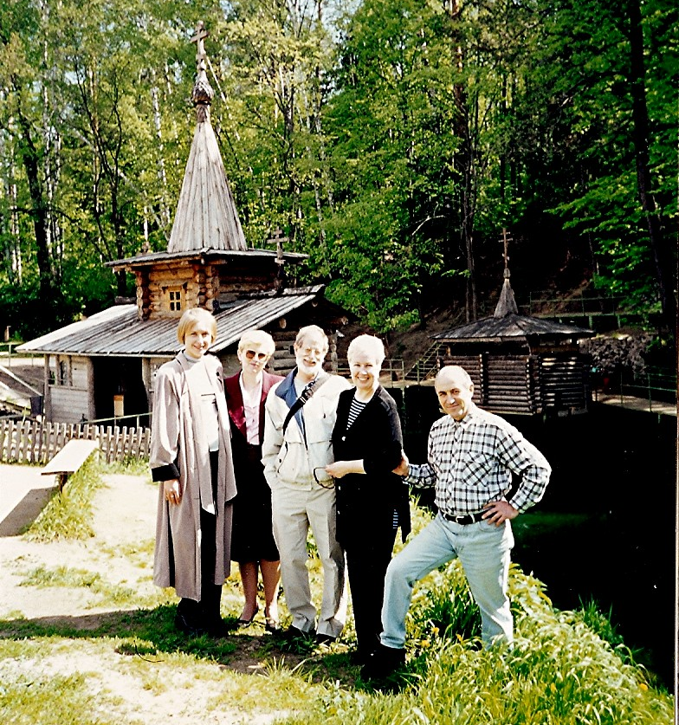

Facilitator, Svetlana, Peter, Vicki, Anatoly Zvenigarodsky

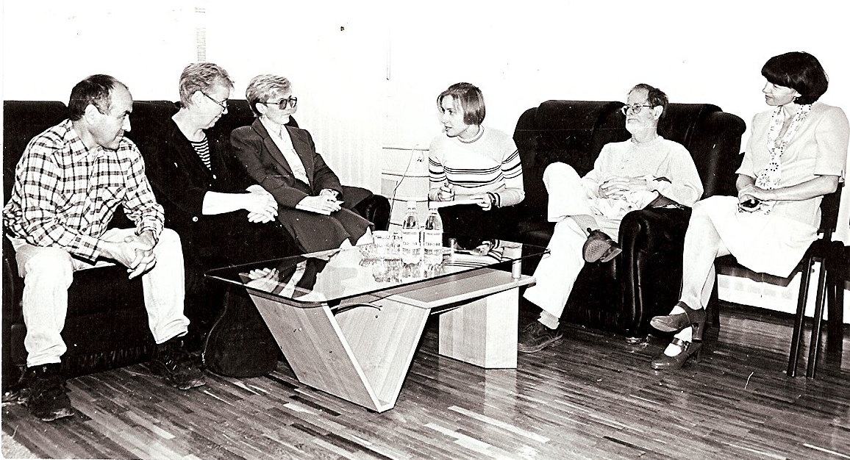

Anatoly, Vicki, Svetlana, Svetlana Zezulina (interpreter), Peter, Sophie

Peter, Vicki, Valerij Punin

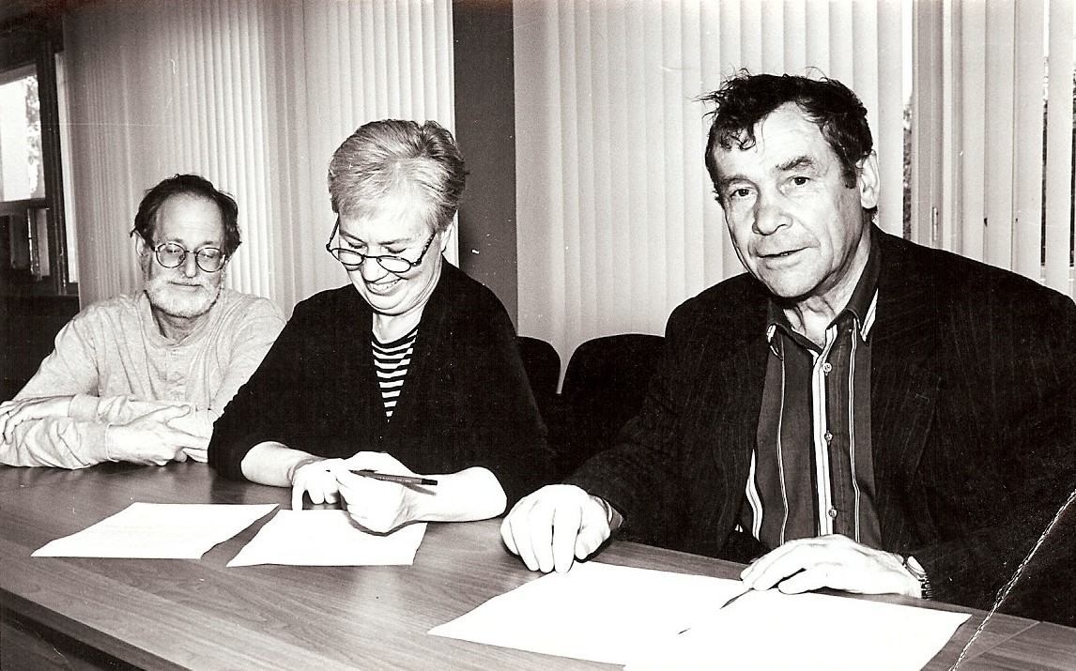

2000 September
Workshop on Relational Database and Java Technologies
Brookhaven National Laboratory

Participants
CHINA: Shu Nengchuan
JAPAN: Yoshihide Obayashi
RUSSIA: Svetlana Dunaeva, Andre Grebennikov, Nikolai Kulagin, Sophiya Taova
IAEA: Liam Costello, Viktor Zerkin Schwerer
UNITED STATES: Ramon Arcilla, Thomas Burrows, Charles dunford, Robert Kinsey, Victoria McLane, Pavel Obložinský, Yako Sanborn, Alejandro Sonzogni, Jagdish Tuli, David Winchell, Craig Stone (Sacramento, CA

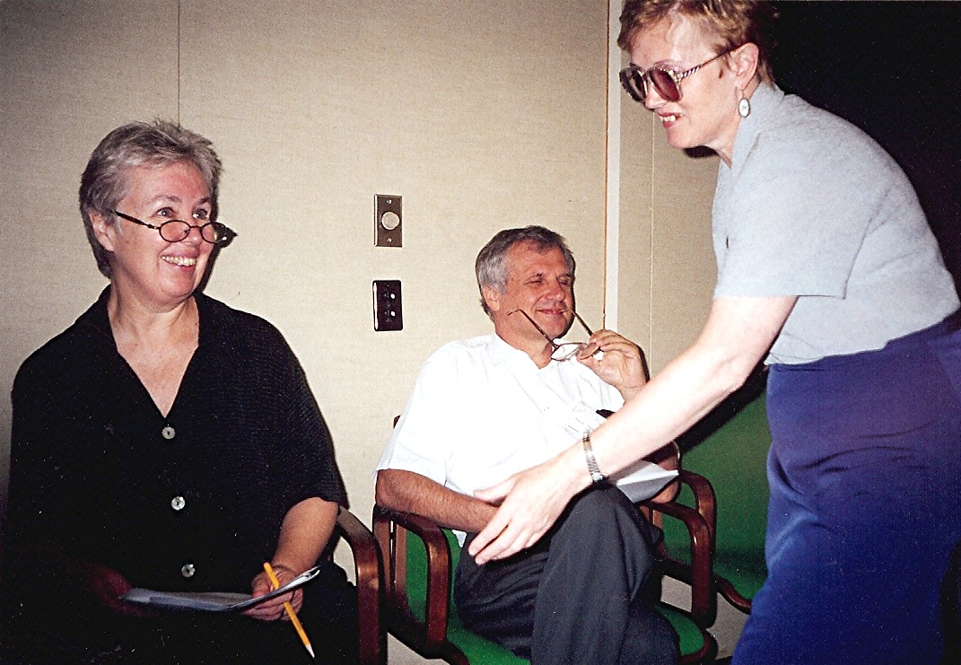

Vicki, Pavel, Svetlana

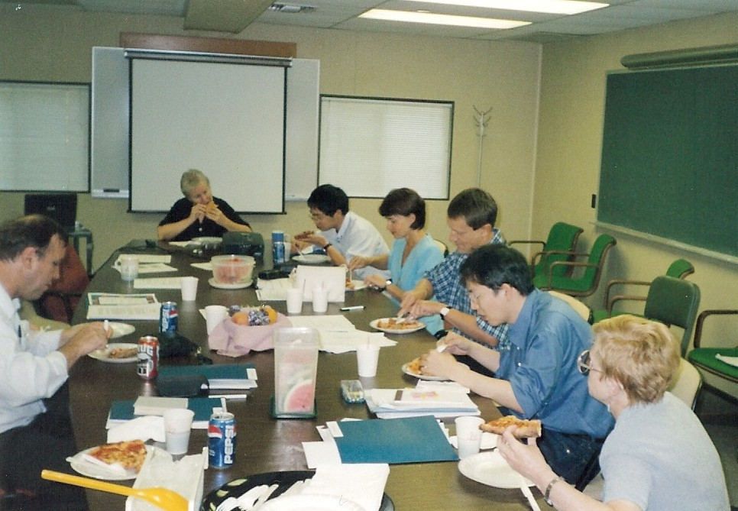
Lunch

Left to right: Nikolai, Vicki, Shu Nengchuan, Sophie, Viktor, Yoshihide Ohbayashi, Svetlana

Excursion to New York City

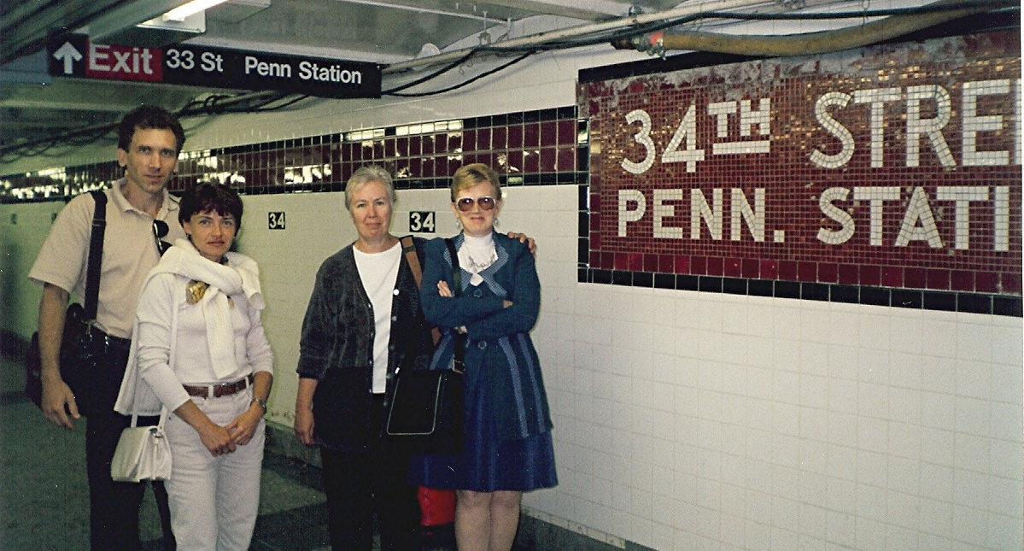

Subway station: Andre, Sophie, Vicki, Svetlana

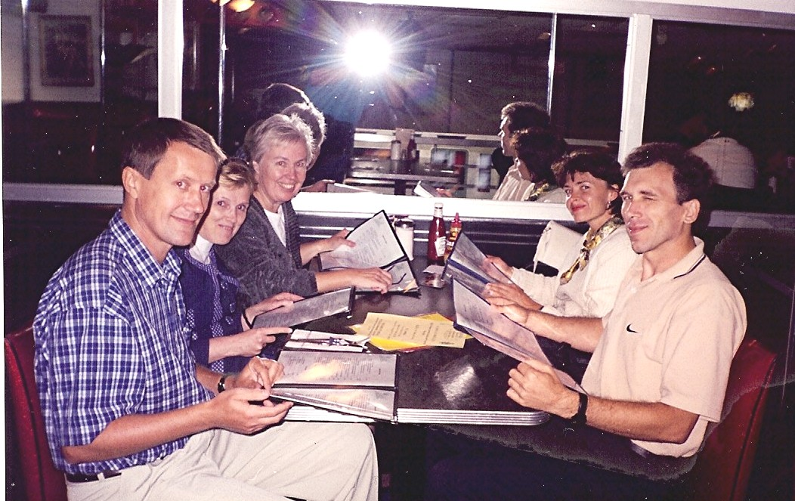

Ellen’s Stardust Diner: Viktor, Svetlana, Vicki, Sophie, Andre
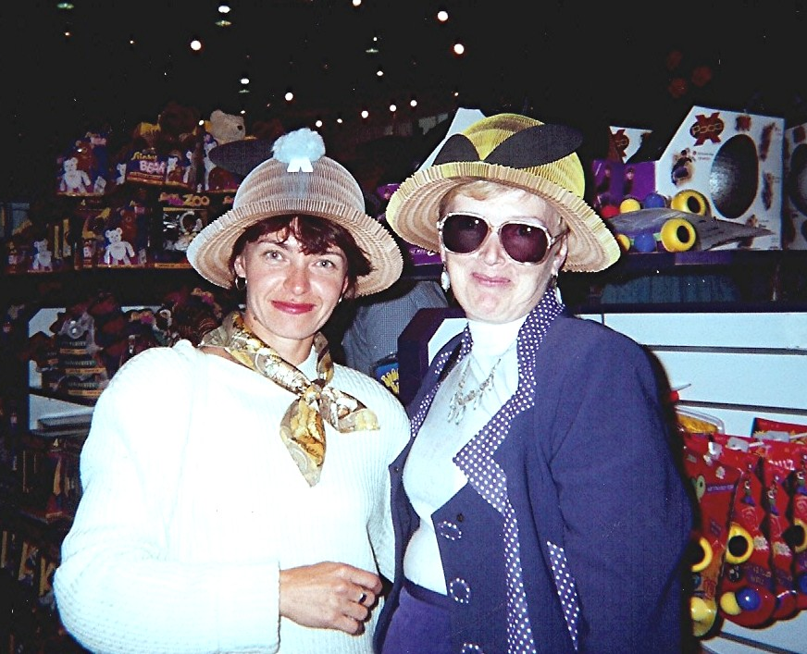

Sophie & Svetlana trying on hats.

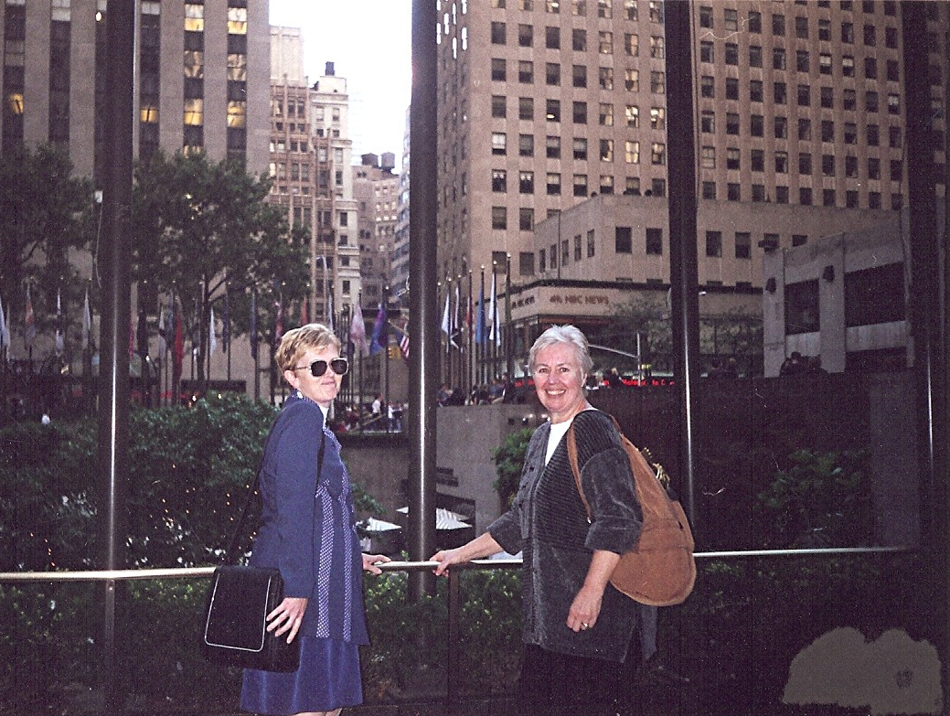

Svetlana & Vicki
at Rockafeller Center

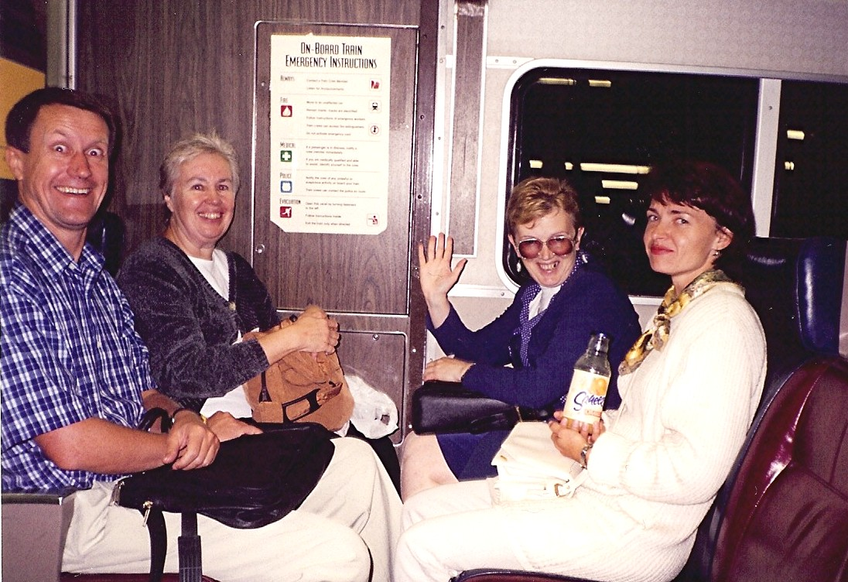

On the Long Island Railroad: Viktor, Vicki, Svetlana, Sophie

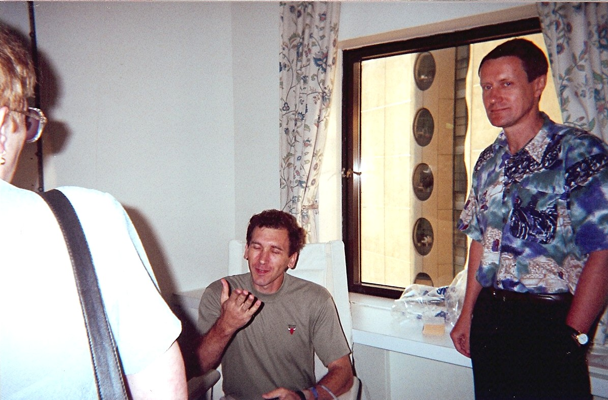

Svetlana & Viktor visiting Andre in Stony Brook Hospital

September 2000
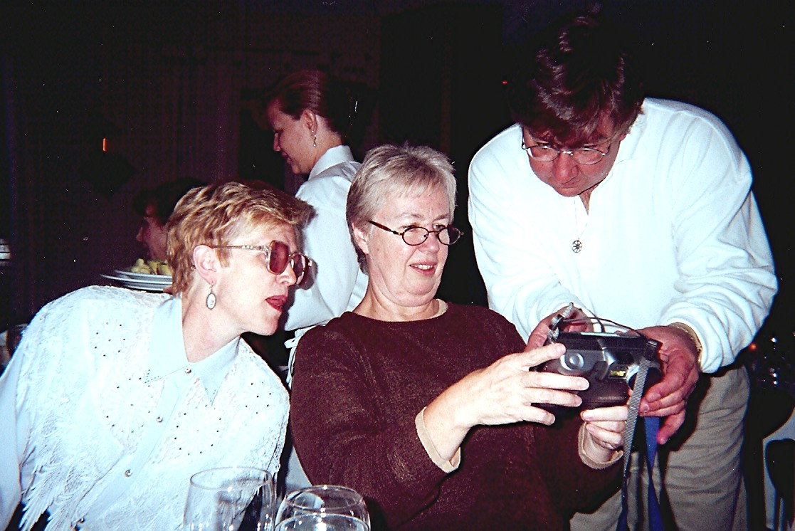
Vicki’s Birthday Dinner, Elk Hotel
Svetlana, Vicki & Craig (Vicki’s son)

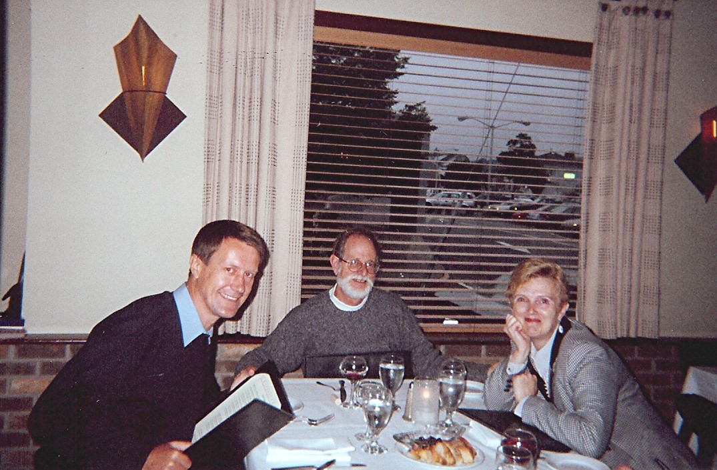

Viktor, Peter & Svetlana

At Vicki & Peter’s House

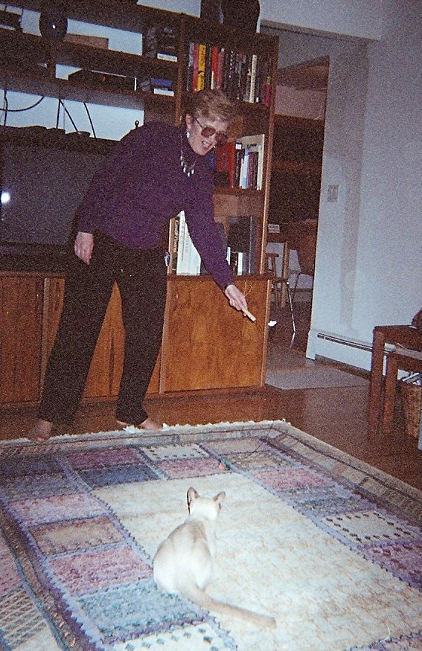

Svetlana & Jessi

2000 October
Washington, D.C.

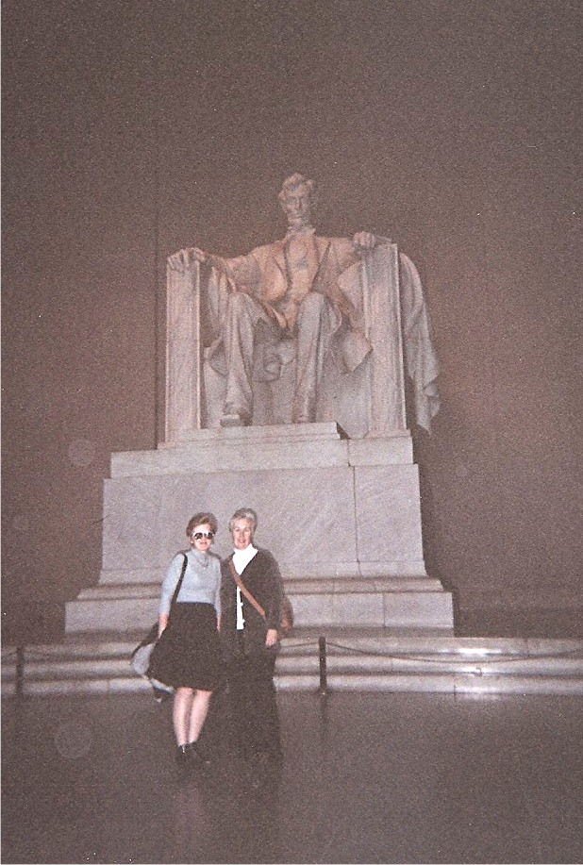

Svetlana & Vicki
Lincoln Memorial

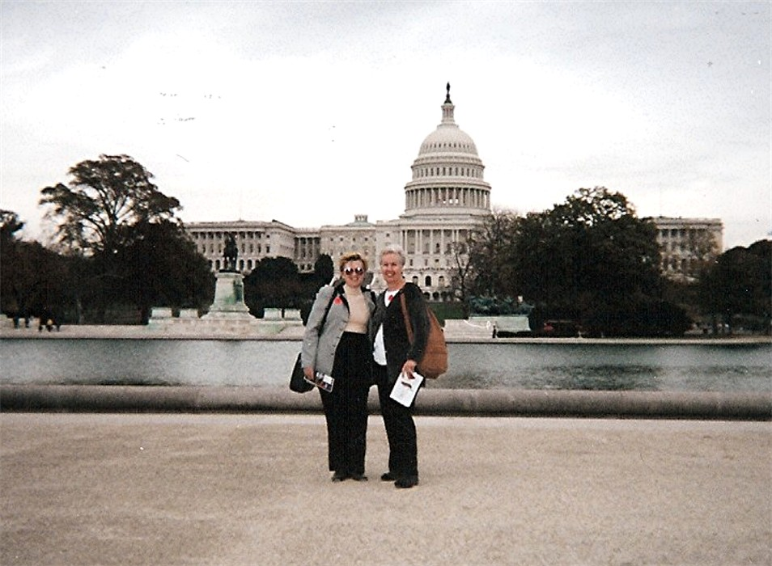

Svetlana & Vicki U. S. Capitol in background

2000 October
Atlantic City

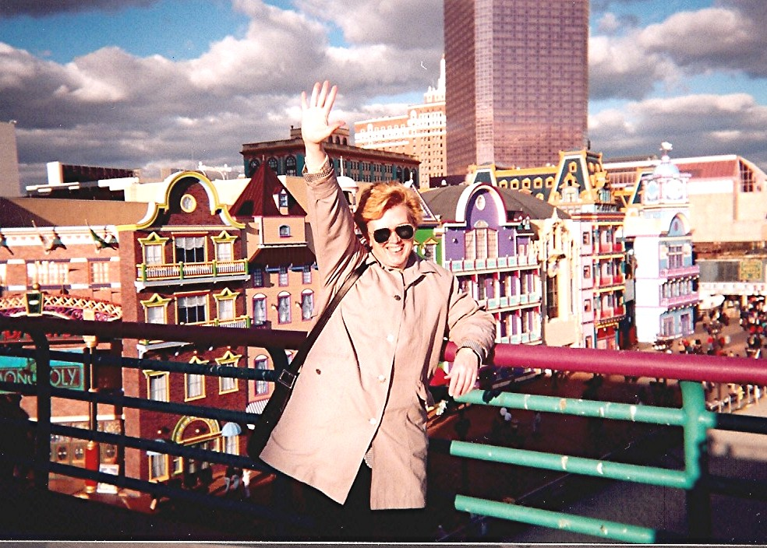

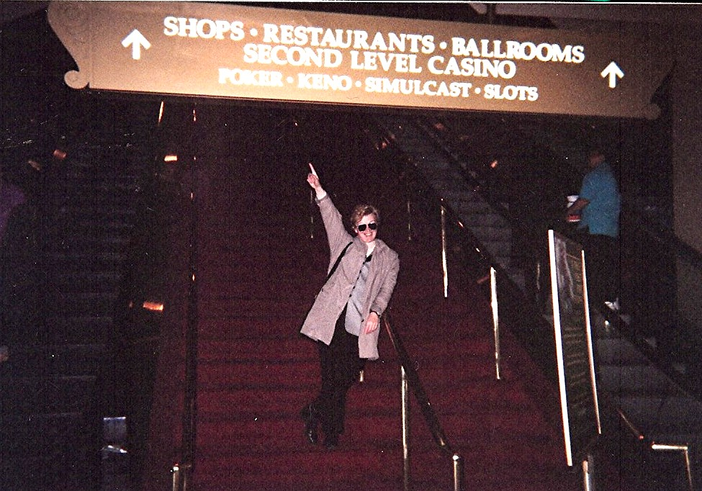

2000 October
Halloween Party at NNDC
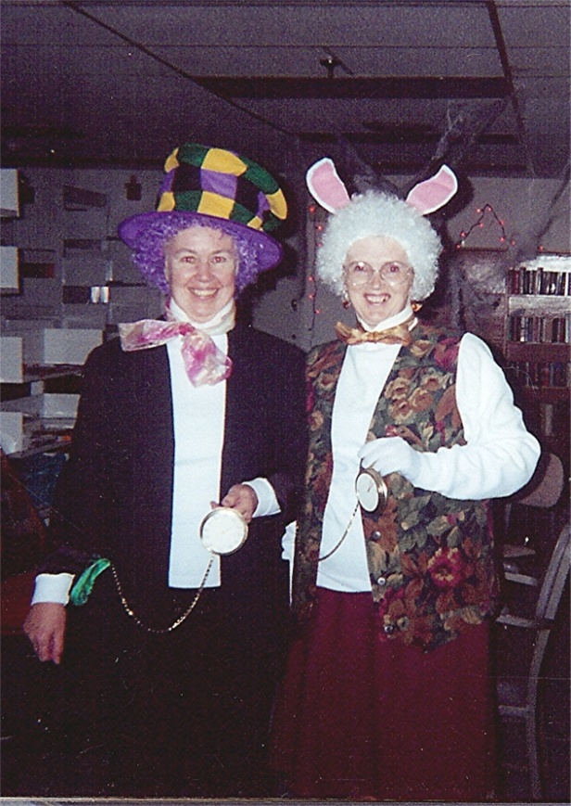

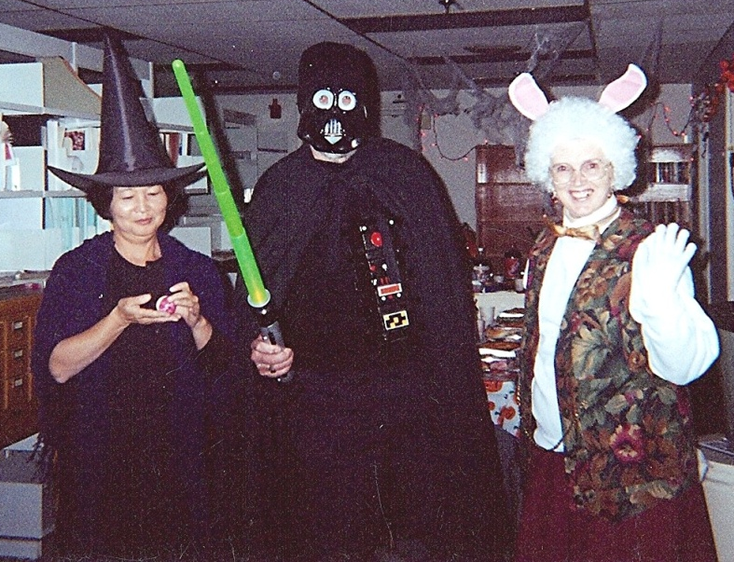
Mad Hatter & White Rabbit
(Vicki & Svetlana)

Yako Sanborn, Alejandro & Svetlana
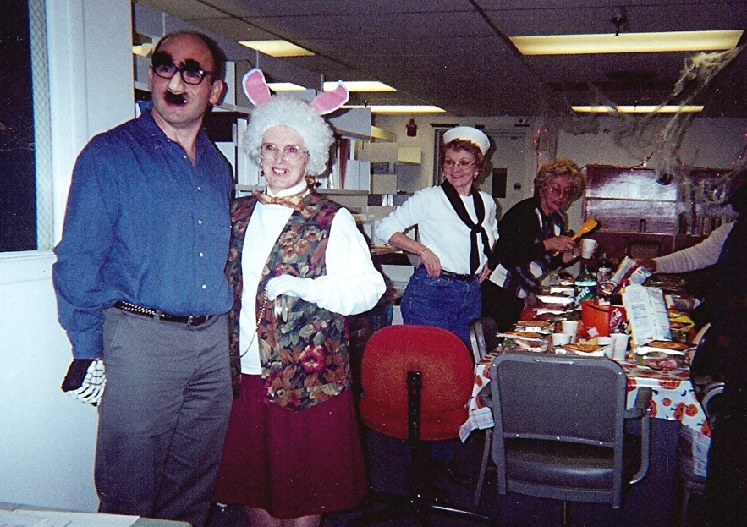

Yako Sanborn, Bob Kinsey & Svetlana

Alejandro & Svetlana

