1969 June
Ninth Four-Centre Meeting
Moscow, USSR

Participants
RUSSIA: Alexander Abramov, Anatoly Ignatyuk, Valery Ivanovich Popov, S.I. Sukhoruchkin, Yu.G. Klimov, Irina Goreva Tichonov (interpreter)
UNITED STATES OF AMERICA: Sol Pearlstein
CCDN: Victor Bell, Horst Liskien
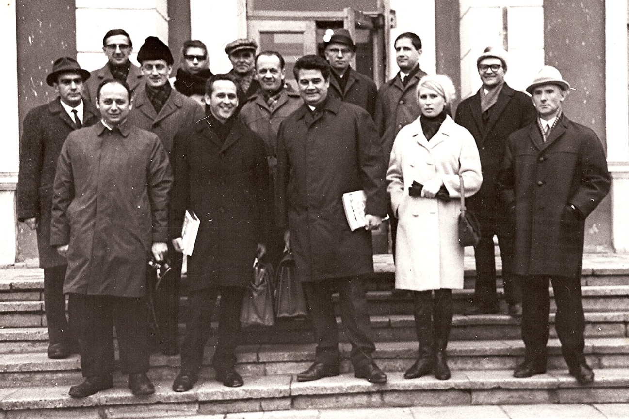
IAEA: Hans Lemmel, Alex Lorenz, Joseph Schmidt

1st Row: Sol Pearlstein, Alex Lorenz, Joe Schmidt, Irina Goreva (interpreter,foreign office, IPPE), Yu.G. Klimov
2nd Row: Valery Popov, Vic Bell, Alexander Abramov, Dmitri Kardashev
3rd Row: Horst Liskien, Valya Kondretova, A. Sokolov (Foreign Office), Peter Otstavnov,
Hans Lemmel

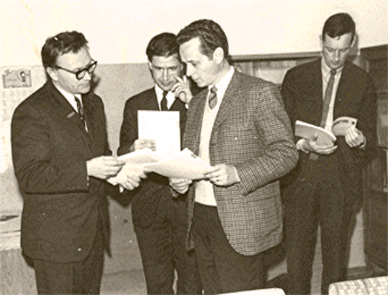
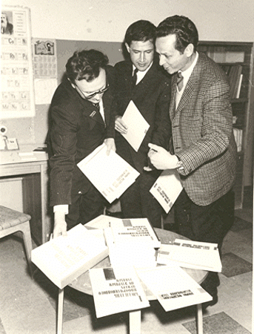

Dmitri Kardashev, Hans Lemmel, Alex Lorenz, Vic Bell

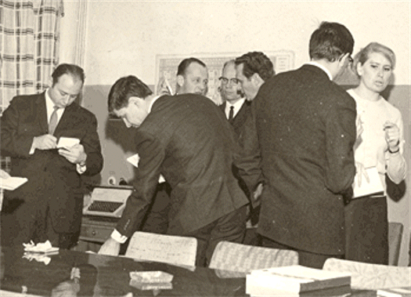

Dmitri, Hans, Alex

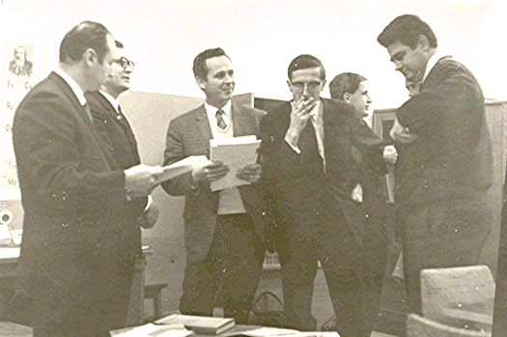
Sol Pearlstein, Hans, Alexander Abramov, Peter Otstavnov, Alex, Horst Liskien (Back), Irina Goreva

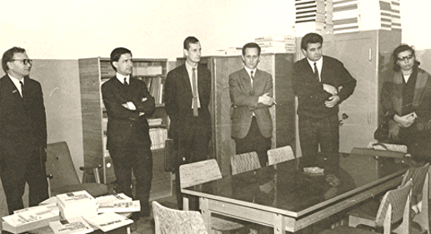

Sol, Dmitri, Alex, Horst, Hans, Joe

Dmitri, Hans, Vic, Alex, Joe Schmidt, Valya Kondretova

