1973 June
Ninth Four-Centre Meeting
Moscow/Obninsk, USSR

Participants
RUSSIA: V. M. Bychkov, Vladimir Pronyaev, L. P. Abagyan, A. Abramov, Yu.G. Bobkov, M.N. Nikolaev, M.Z. Tarasko, L.N. Usachev
UNITED STATES OF AMERICA: Victoria McLane May, Sol Pearlstein
CCDN: Fritz Fröhner, Hans Potters
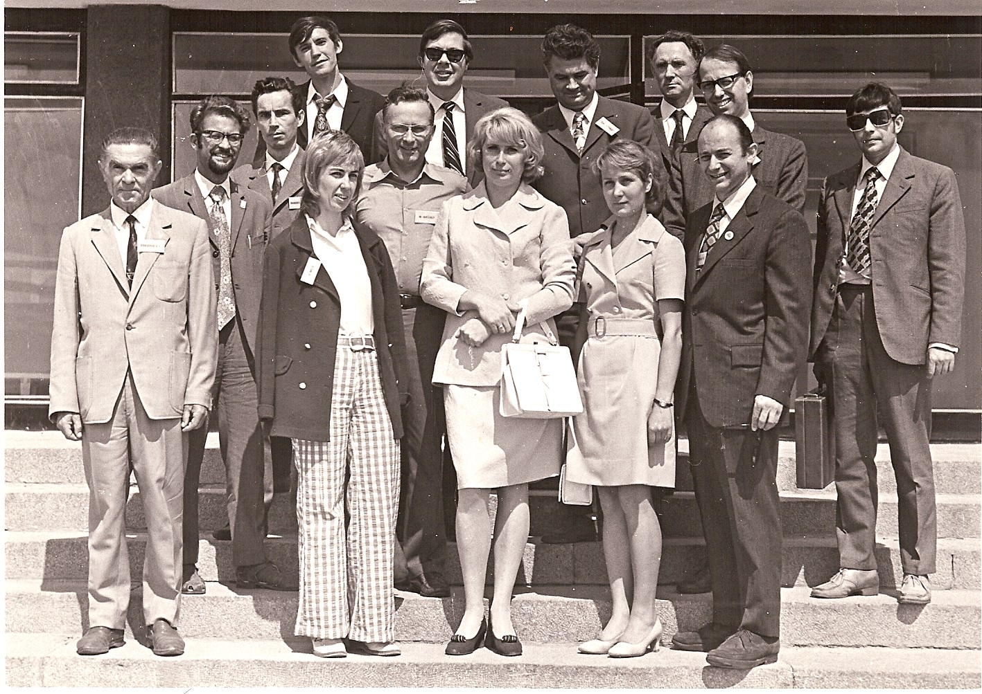
IAEA: Charles Dunford, Joseph Schmidt

Front: A. Sokolov (foreign office, IPPE), Vicki McLane May, Irina Goreva (interpreter), Lyuba Tarasko, Sol Pearlstein
Back (left to right): Vladimir Vozyakov, Vasili Manokhin, Yuri Bobkov, Fritz Fröhner, Charlie Dunford, Joe Schmidt, Yuri Klimov (Minatom), Hans Potters, Anatoly Bakunyaev (Minatom)

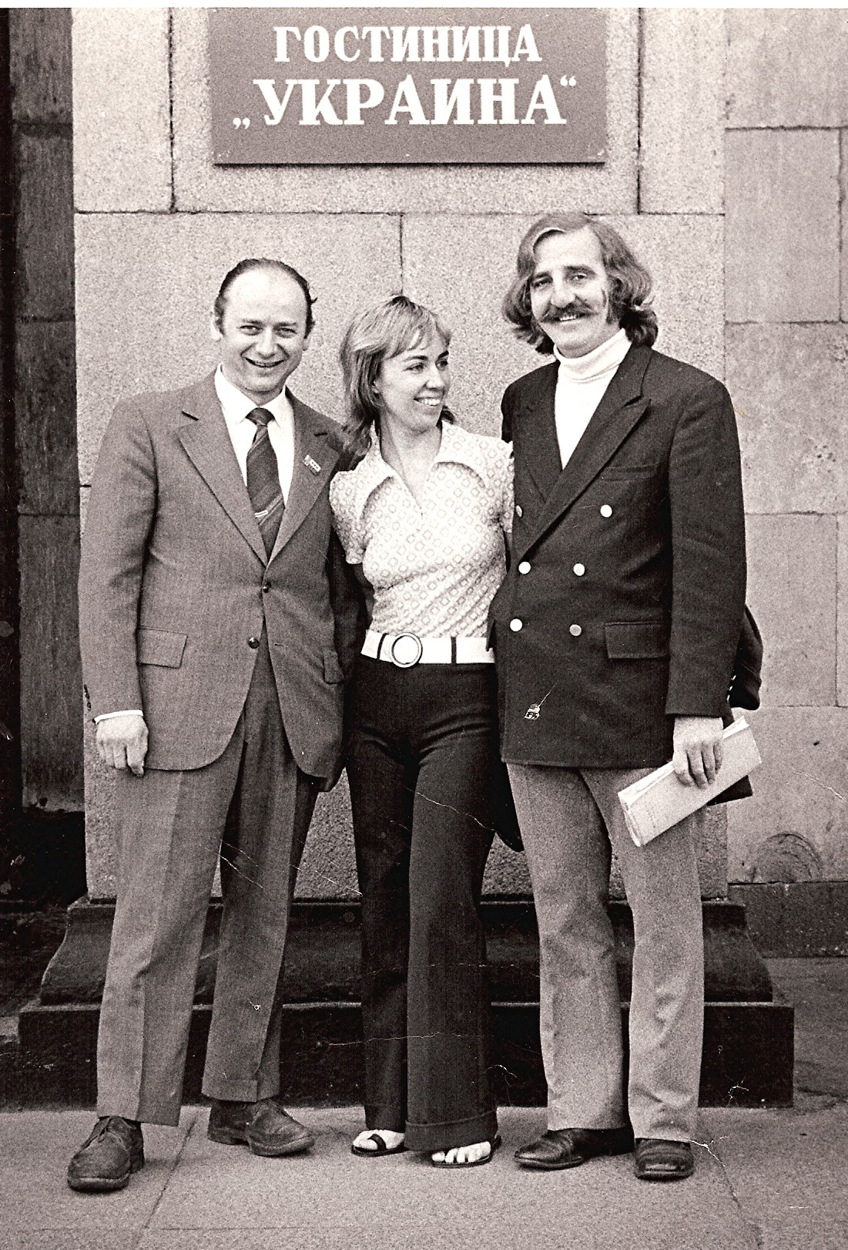

Sol, Vicki & John May
Outside Hotel Ukraina

