1991 October
11th CONSULTANTS MEETING OF
NUCLEAR REACTION DATA CENTRES
Obninsk, USSR

Participants
CHINA: Cai Dunjiu, Liang Qichang
RUSSIA: Obninsk - Vasili Manokhin, Anatoly Ignatjuk, Vladimir Pronyaev, Anatoly Blokhin, Stanislav Maev, Olga Pakhomova, S.M. Nasyrova, Konstantin Zolotarev, V.V. Vozyakov; CAJaD - Feliks Chukreev, Svetlana Babykina, Viktor Vukolov, V.E. Makarenko; CDFE - Vladimir Varlamov, Boris Ishkhanov, V.V. Sapunenko, N.G. Efimkin; RI - A.A. Rimsky-Korsakov, A.V. Daniel
UNITED STATES OF AMERICA: Victoria McLane, Sol Pearlstein
JAPAN: Yoshihiko Tendow, Masaki Chiba
NEA Data Bank: Claes Nordborg
IAEA: Hans Lemmel, Joseph Schmidt
Bottom step: Cai Dunjui, Vasili Manokhin, Hans Lemmel, Anatoli Blokhin
2nd step: Liang Qichang, Larisa Botyanovskaya, Stasa Maev, Vicki McLane, Svetlana Babykina, Masaki Chiba, Yoshihiko Tendow, Sol Pearlstein, V.A. Vukolov
Back: Aleksandr Korotaev (Foreign relations), Marina Ulaeva, Konstantin Zolotarev, Olga Pakhomova, Claes Nordborg, S.M. Nasyrova, V.E. Makarenko (behind Nasyrova), Vladimir Varlamov, Vladimir Pronyaev, Joe Schmidt
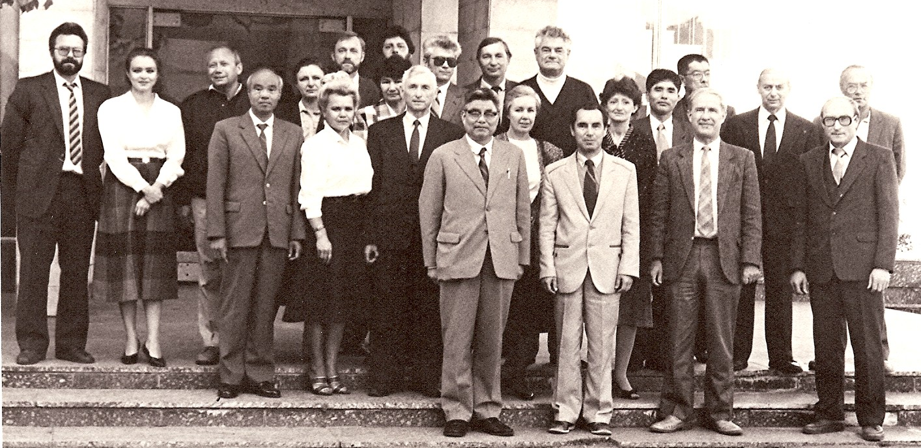

Banquet
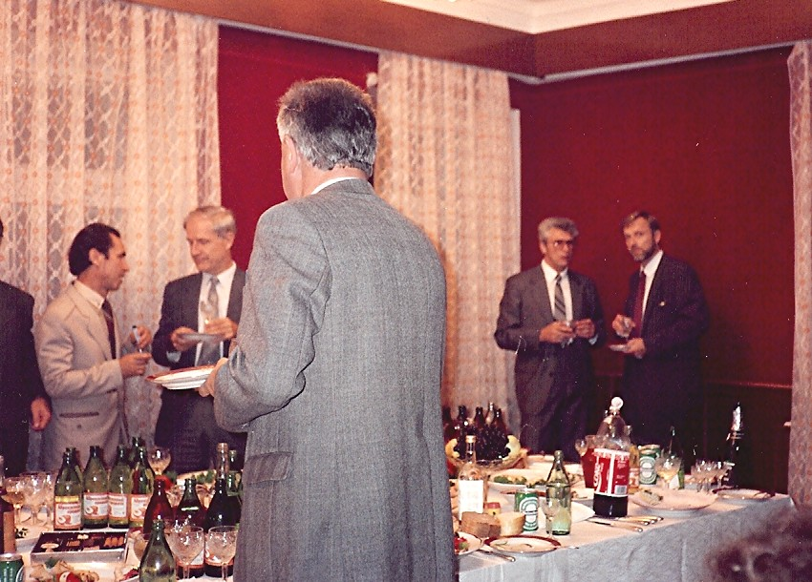

Vasili, Hans, Vladimir & Claes
Joe with back to camera

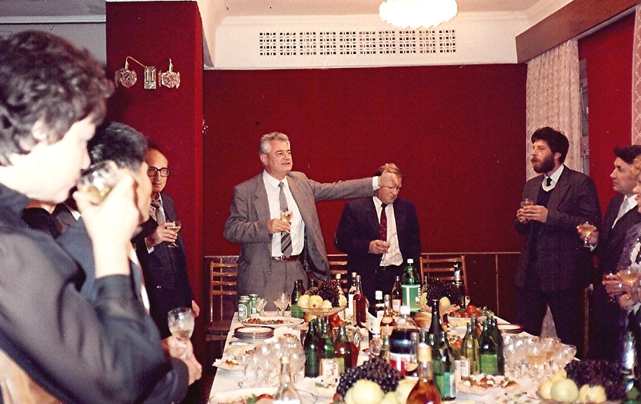

Joe giving a toast

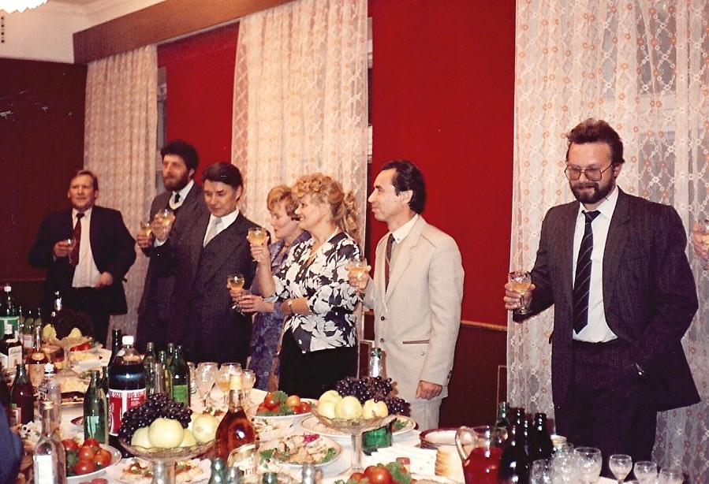

V.Archangelsky (Foreign relations),
V. Makarenko,
Anatoly & Galina Ignatyuk,
Raisa & Vasili Manokhin,
Aleksandr Korotaev

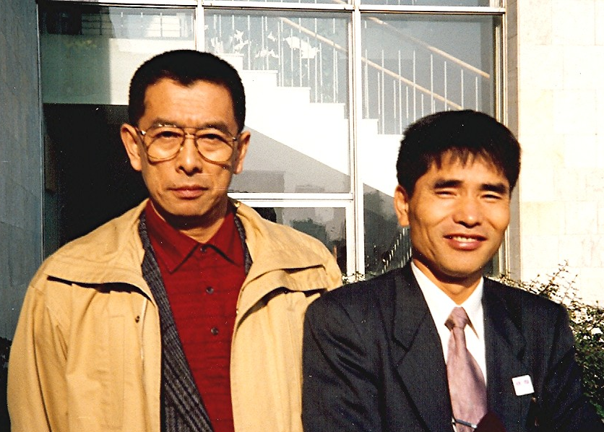
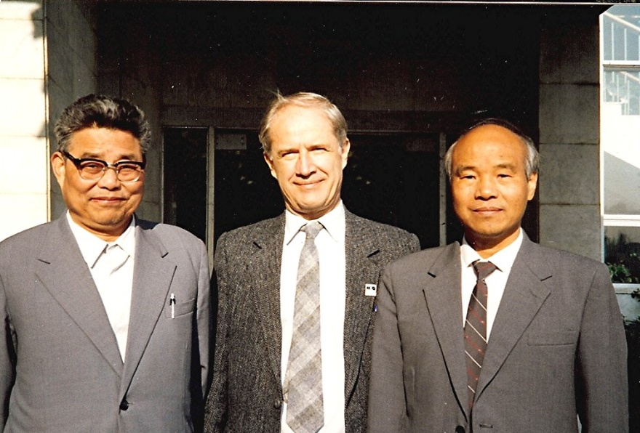
Yoshihiko Tendow, Masaki Chiba Cai Dunjui, Hans Lemmel, Liang Qichang
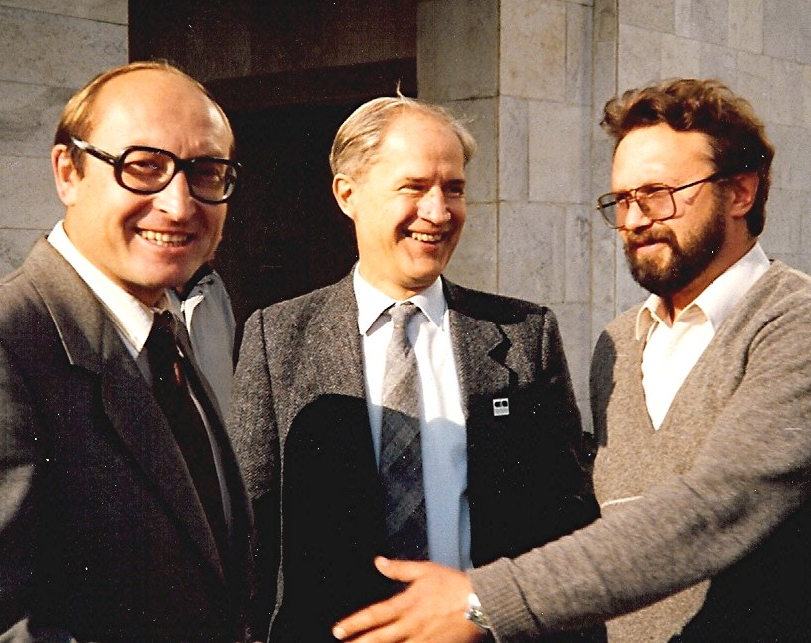
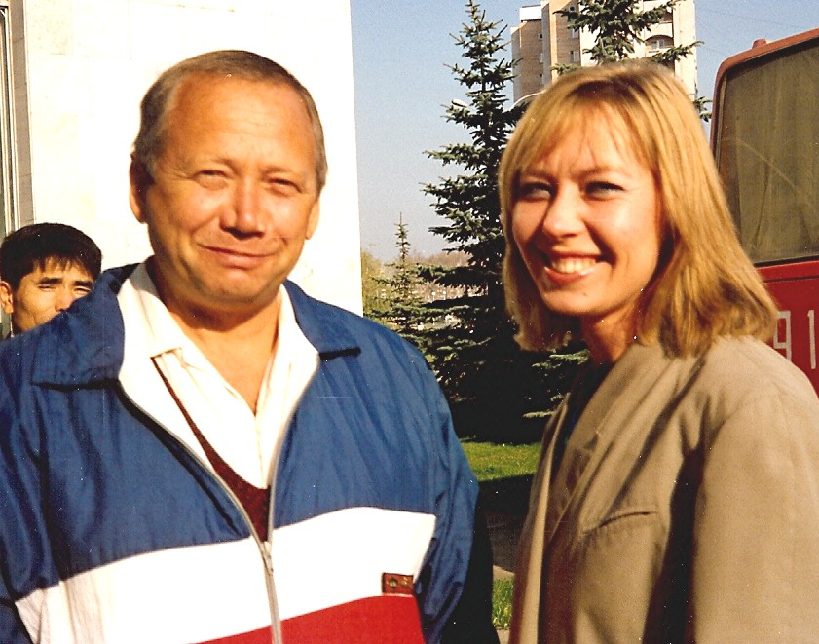
Anatoly Blokhin, Hans Lemmel, Konstantin Zolotarev, Rita Skripova
Aleksandr Korotaev
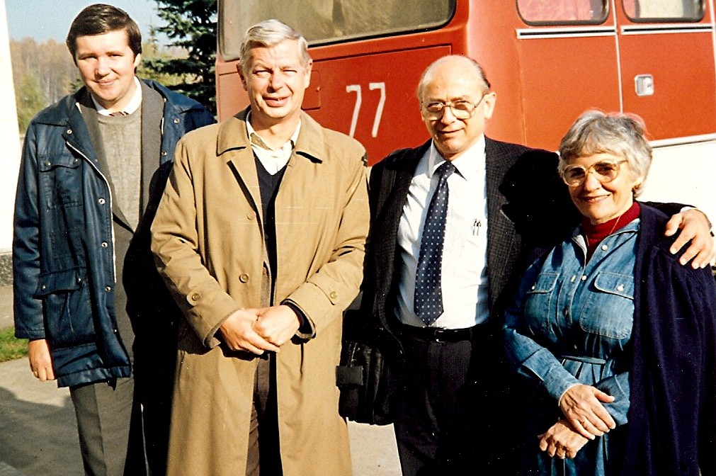

A.V. Daniel, A.A. Rimsky-Korsakov,
Sol & Susan Pearlstein

