1998 May
Nuclear Reaction Data Center Meeting
IAEA, Vienna

Participants
CHINA: Liu Tong
HUNGARY: Ferenc Tárkányi
JAPAN: Akira Hasagawa, Kiyoski Kato, Yoshihiko Tendow, Masaki Chiba
RUSSIA: Feliks Chukreev, Svetlana Dunaeva, Stanislav Maev, Vasili Manokhin,
Vladimir Varlamov
UKRAINE: Oleksandr. Kalchenko, Mercury Vlasov
UNITED STATES OF AMERICA: Charles Dunford, Victoria McLane
OECD Nuclear ENERGY Agency: Claes Nordborg, Mark Kellett
IAEA: Douglas Muir, Vladimir Pronyaev, Otto Schwerer

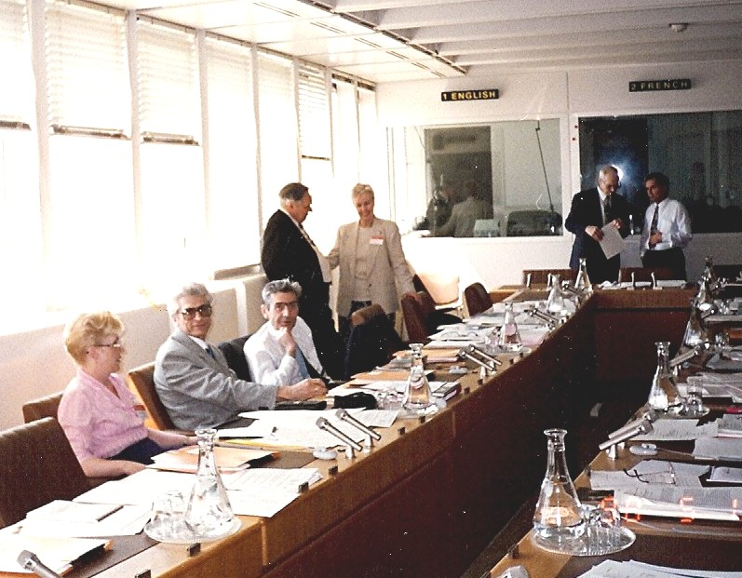

Left to right: Svetlana, Vladimir V., Feliks, Mercury, Vicki, Doug, Vasili

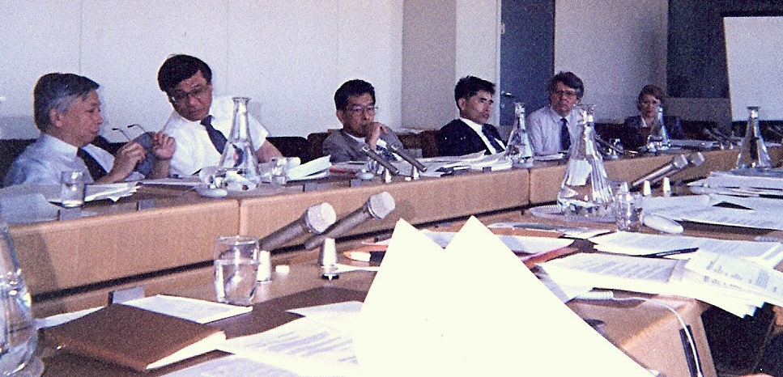

Akira Hasagawa, Kiyoski Kato, Yoshihiko Tendow, Masaki Chiba,
Ferenc Tárkányi, Raquel Paviotti-Corcuera(?)
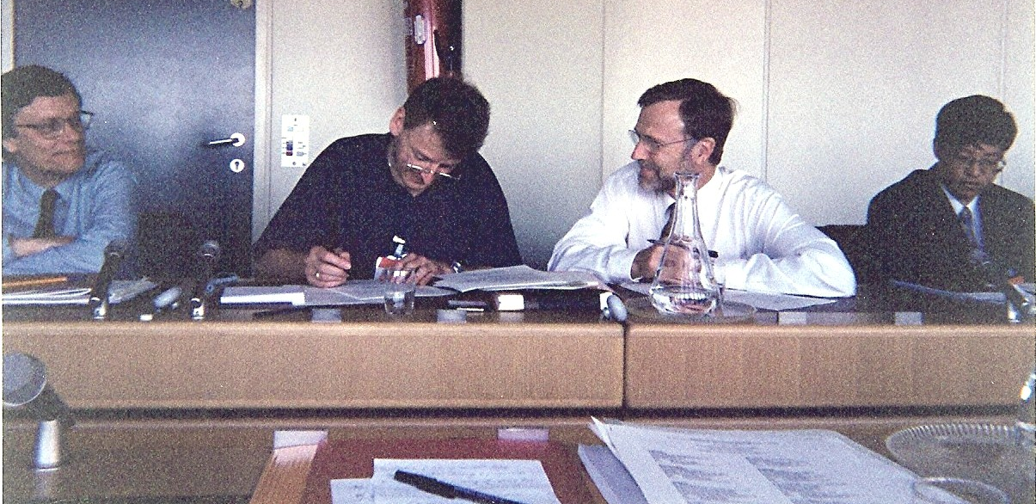

Otto Schwerer, Mark Kellett, Claes Nordborg, Liu Tong
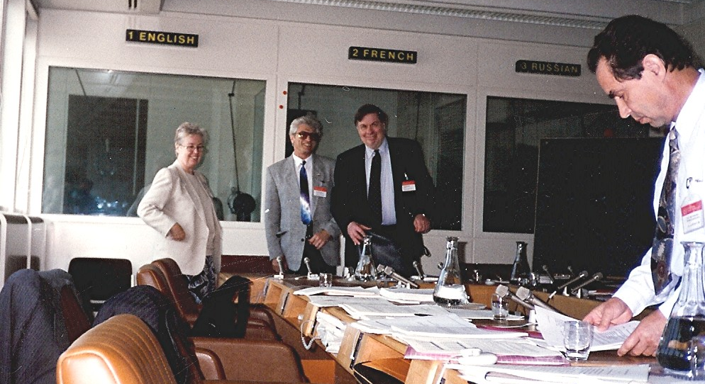

Vicki McLane, Vladimir Varlamov, Charlie Dunford, Vasili Manokhin

At Lunch
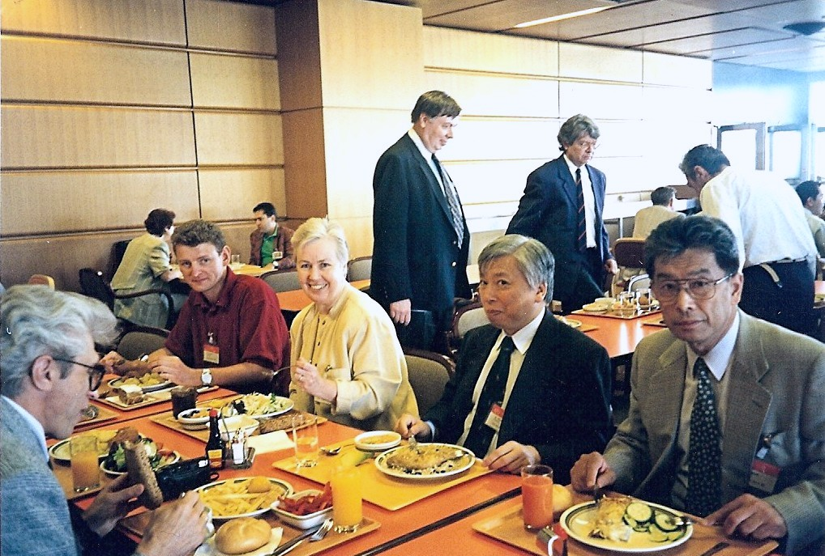

Vladimir, Mark, Vicki, Akira, Yoshihiko
Charlie & Ferenc at table in back

In Library
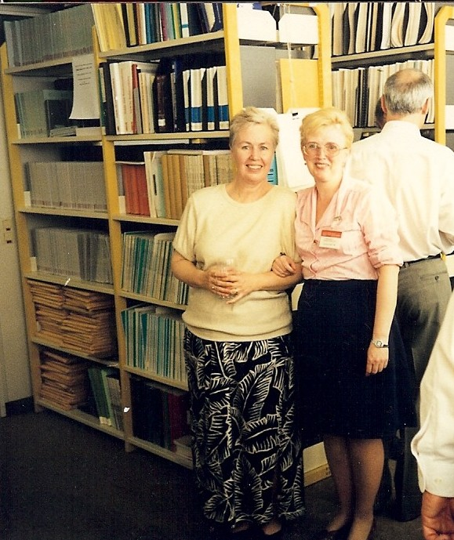

Vicki & Svetlana

