Determination of the Helium-4 Mass in a Penning Trap

- Brunner, T. Engel, H. Klein, A. Schmitt and G. Werth
Institut für Physik, Universität Mainz, D-55099 Mainz, Germany

Abstract

We have measured the cyclotron frequencies of He⁺, H₂⁺ and D₂⁺ ions in a room temperature Penning trap. The resonances were detected destructively by a time-of-flight technique. The statistical uncertainty of the resonance frequencies was generally below 1ppm. A detailed account of measures to minimize systematic frequency shift is presented. Using the accepted values for the proton an deuteron mass we obtain a value for the ⁴He mass: M(⁴He) = 4.002 603 248 9 (22) (0.5 ppm). It is in agreement to the accepted value.

PACS: 27.10.+h, 32.10.Bi, 7.75.+h

- Introduction

The masses of atoms and nuclei represent one of the most fundamental properties of these systems. Their measurement has been pursued since a long time with increasing precision. A significant step towards higher accuracy has been the introduction of Penning ion traps [1,2] into mass spectrometry. Charged particles are confined by static electric and magnetic fields for very long times and their cyclotron frequency ω_{c} = (e/m)B in a strong magnetic field B is determined. The ratio of cyclotron frequencies of two different ions in the same magnetic field gives directly their mass ratio.

The properties of Penning traps have been extensively treated in the literature [1,2]. In the ideal case the electric trapping potential has a quadrupolar shape

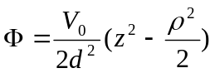 (1)

where d is a characteristic dimension of the trap and V_{o} the applied voltage between ring and endcap electrodes.

The motion of a single particle of charge q and mass m in such a potential is given by three harmonic oscillations of frequencies

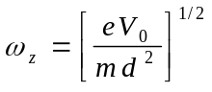 (2)

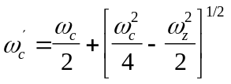 (3)

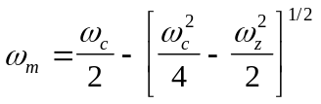 (4)

ω_{z}, ω_{c}´, ω_{m} are the axial, reduced cyclotron and magnetron frequency, respectively. One way to obtain the requested free ions cyclotron frequency ω_{c} from measurements of the three eigenfrequencies is to use the so-called invariance theorem [3]

ω_{c}² = ω_{c}´² + ω_{z}² + ω_{m}² (5)

which is independent of trap misalignments to first order. The sideband

ω_{c} = ω_{c}´ + ω_{m} (6)

an also be measured directly by excitation using a proper geometry of the excitation field.

Existing Penning trap mass spectrometers use different ways to detect the eigenfrequencies of the ions motion in the trap. At the University of Washington, Seattle, [4 ] and at MIT, Boston, [5 ] sensitive methods have been developed to detect the image currents induced in the trap electrodes by the ions oscillation. This allows non-destructive detection of the ionic resonances. A single ion can be kept in the trap virtually for ever and cooled to the ambient temperature which can be held at the boiling point of liquid He. In contrast Penning trap mass spectrometers at ISOLODE/CERN [6] and Stockholm [7] use a time of flight method developed by Gräff et al. [8] to detect excited ionic resonances in a destructive way. The ions are kicked out of the trap and there time of flight to a distant detector is measured. Since the ions spent only a short time in the trap, this method does not allow ion cooling. It is, however, easy to inject ions from outside sources into the trap which is of advantage for the investigation of unstable isotopes or highly charged ions.

The accuracy of Penning trap mass spectrometer is basically limited by the stability and homogeneity of the magnetic field and the coherence time for the interaction of the trapped ion with the r.f. field which excites the motional oscillations. Statistical uncertainties of resonance frequencies below the ppb level are almost routinely obtained. In order to obtain the corresponding precision a careful account of possible systematic shifts of the eigenfrequencies is required. They stem mainly from trap imperfections, fluctuations of the magnetic field, and finite ion energies.

In this contribution we describe measurements in a Penning trap mass spectrometer which was used previously to determine the mass ratios of some light ions [9,10]. The present experiments deal with mass ratios of Hydrogen and Deuterium molecular ions to ⁴He⁺ ions. Using the accepted values of the proton and deuteron mass we can calculated the atomic mass of ⁴He. This may be of interest in view of some discrepancies between the accepted value [11] and a recently obtained value by the Stockholm group [12]. Preliminary values of our experiment have been published elsewhere [13].

- Experiment

2.1 Experimental setup

Our experimental setup is described in some detail in ref. [9]. We use a trap of characteristic dimension d = 7.3 mm, ρ₀/z₀ = 1.16, where ρ₀ is the trap radius, 2z₀ the closest distance between the endcaps and d = [ρ₀²/2 + z₀²]^{1/2} . The electrodes are made from a Copper-Nickel alloy and carefully machined into hyperbolic shape to create a quadrupole potential. Adding ferromagnetic Ni to Copper reduces the total susceptibility which is close to 0 at 3.99% part of Ni [14]. We have measured the susceptibility of our sample to -0.022 10⁻² emu/g, which is a factor of 9.2 lower than oxygen-free copper which is usually employed in such devices. The electrodes were gold plated to reduce the chance of surface charges. The trap size has been chosen after extensive investigations on smaller and larger traps as a compromise between a small trapping volume and low distortion of the electrode shape. The endcap electrodes have central holes of 0.8 mm diameter for injection of electrons into the trap and for ejection of ions. Additional guard electrodes placed between the ring and endcaps as well as outside the endcaps near the entrance and exit holes serve to compensate for field imperfections caused by the truncation of the electrodes, possible misalignements or machining errors. The ring electrode is segmented into 4 equal quadrants to allow the application of radio-frequency fields in different geometries. For isolation between the different electrodes we used Macor. The structure is made as symmetric as possible and uses a small amount of material to minimise the influence of the traps susceptibility to the magnetic field inhomogeneity. Fig. 1 shows details of our trap.

The trap was placed in the centre of a superconducting solenoid of 7 Tesla field strength whose measured inhomogeneity was less than 1 part in 10⁷ in a sphere of 5 mm diameter. The influence of external magnetic fields on the field strength at the ions position was reduced by a compensating coil [15]. The reduction factor was 30 as measured by application of a well defined dipole field outside the solenoid. Apart from short time intervals when the magnets cryostat was filled with liquid He or N₂ we did not observe a long term drift of the magnetic field at the 10⁻⁹ level.

The base pressure in our apparatus was 1x10⁻¹⁰ mbar as measured by an ionisation gauge at about half a meter distance from the trap. We used electroionisation of the H₂ component of the background gas to create H₂⁺ ions, while for experiments on He⁺ or D₂⁺ we introduced a small amount of He or D₂ through a needle valve. The measured pressure then was raised to about 3x10⁻¹⁰ mbar. At this pressure the collision limited coherence time of the ion in the trap was longer than 2 seconds.

2.2 Experimental procedure

After creation of ions inside the trap by an electron pulse of typically 10 ms length the ions are stored for 1 second and are then ejected from the trap. They were detected by a channel-plate multiplier placed at the end of our cryostat at about 50 cm distance from the trap (Fig.2). The magnetic field at the detectors position was reduced to 0.25 Tesla. Ions of different mass, created by the electron pulse, arrive at the detector at different times as seen in fig 3a. A radio-frequency field applied between the traps endcap electrodes eliminates all ions from the trap whose axial frequency is resonantly excited by the field. We swept the frequency across a range which covered the axial oscillation frequency of all detected ion species except that under investigation. Fig. 3b shows the result of such a cleaning procedure, which assures that no unwanted ion is left in the trap. We then reduced the electron current to such an amount that typically only in one out of three creation-detection cycles a single ion is detected. At a detection efficiency of our channel-plate of 30% this makes it sufficiently unlikely that more than a single ion is in the trap at the same time.

Cyclotron excitation is performed by an r.f. field applied between opposite parts of the segmented ring electrode. The effect of resonant excitation is to increase the radial energy. After ejection of the ions by a short electric pulse the increase in radial energy if transformed into axial energy by the fringe field of the magnet. This increase in axial energy reduces the flight time to the detector. We measure the average flight time to the detector which shows a minimum at resonant excitation.

The excitation starts after the cleaning period and lasts one second. The amplitude of the exciting r.f. field is set to a value which reduces the time-of flight to the detector by typically 30%. A complete measurement of a cyclotron resonance consists of about 20 creation - detection cycles, during which the excitation frequency of several tens of MHz is varied in steps of 50 mHz around the resonance. To improve the signal-to-noise ratio each measurement was repeated 50 times. Test experiments with many more repetitions and a good signal-to-noise ratio demonstrated that the expected line shape and width is experimentally obtained. The line shape is given by the Fourier transform of the excitation period of length τ,

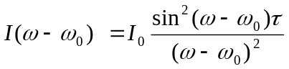 (7)

where 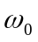 is the resonance frequency and 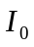a normalising factor. Test measurements with extended averaging revealed the expected sidebands from eqn. (7). In our actual runs for mass comparison of two ions we did less averaging to reduce the total time of a measurement. The sideband structure was less visible and we used for simplicity a Lorentzian line shape to determine the centre frequency. Test of fits using the true and the simplified line shape showed that neither the centre frequency nor its uncertainty changed beyond the statistical expectations. The half width of the resonance, given by

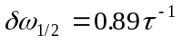 (8)

agree well with the expectation. Fig. 4 shows examples of the perturbed cyclotron frequencies for H₂⁺ and ⁴He⁺.

3. Systematic frequency shifts

While the statistical uncertainty in frequency of a cyclotron resonance line in general was well below the 1 ppb level (see fig 4) the precision of a mass comparison is limited by the level at which systematic frequency shifts can be accounted for. Such frequency shifts arise from imperfections in the trap structure, machining errors, misalignments, or space charge, when several ions are confined simultaneously.
The influence of trap imperfections on the position of the motional resonances of a trapped ion has been calculated in detail by several authors [1,6,9,16]. The real potential of the trap can be expressed as a series expansion in terms of spherical harmonics:

V´ = V₀ Σ C_{k} (ρ/d)^{k} P_{k} (cosθ) (9)

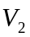is the ideal quadrupole potential

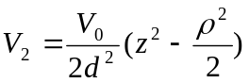 (10)

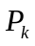are the spherical harmonics of order k and 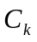denotes the strength of the perturbing potential of order k.

In a similar way the magnetic field can be expanded along the z-axis as

B=B₀ Σ b_{k} z^{k}. (11)

The deviations of the electric and magnetic fields from the ideal form shift the cyclotron frequency by an amount which has been calculated in [1,6,9,16] up to the 4th order. If we include the next orders and assume spherical trap symmetry around the z-axis and reflection symmetry about the radial plane, for which the odd orders in the expansion vanish, we obtain the shift in frequency due to electrical imperfections [17]
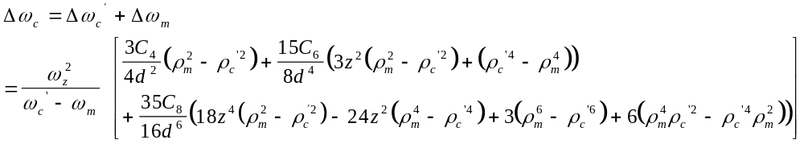

Similarly for the magnetic case, the shift in frequency is given by

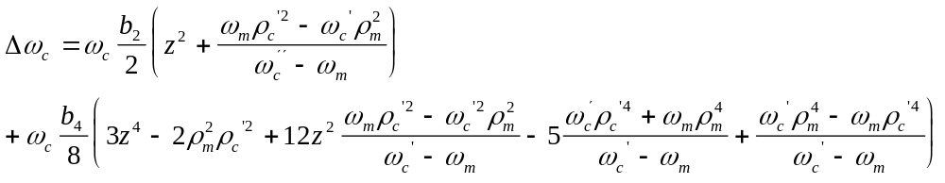 (13)

Here z, ρ_{c´}, ρ_{m} are the axial oscillation amplitudes and the radii of the reduced cyclotron and magnetron motion, respectively. In our experiment the largest contribution comes from the terms containing . z can be as large as several mm, since it is given by the position of the ions at the instant of creation by electroionisation. This can be anywhere along the z-axis. The second largest part comes from terms containing 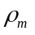 which can assume a maximal value of 0.4 mm, given by the radius of the electron entrance hole in the endcap compensation electrode. The radius of the reduced cyclotron orbit at our magnetic field strength of 7 Tesla and a radial ion energy, which increases from 1/40 eV at creation to about 0.65 eV at resonant excitation is only 10 μm and terms containing higher orders in this coordinate can generally be neglected.

Finally an angle ε between the traps symmetry axis and the magnetic field direction shifts the cyclotron frequency by an amount [1,9]

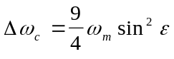 (14)

The maximal size of this angle in our experiment can be calculated from the size of the entrance and exit holes in the endcap compensation electrodes of 0.8 mm diameter, considering the fact that the electron beam to create ions starts from a source outside the trap, travels along a magnetic field line and passes through both the holes. We obtain ε_{max} = 0.2º.
As shown by Brown and Gabrielse [1], eqn. (5) is independent of a tilt angle ε to first order. A measurement of all three frequencies thus would virtually eliminate this uncertainty in the determination of ω_{c}. In our experiment, however, we cannot measure the axial frequency ω_{z} sufficiently accurate and thus cannot make use of this property.

3.1 Minimising frequency shifts

From eqns. (12,13) it is obvious that there are two ways to minimise shifts of the cyclotron frequency imposed by trap imperfections: Reduction of higher order contributions to the trapping potential and the magnetic field as well as reduction of the ion oscillation amplitudes. Both ways have been pursued in our experiment.

- Reduction of the axial oscillation amplitude

Initially the ions are created at a low trapping voltage (150 mV). After creation the voltage is raised to 1850 mV. If the voltage increase is performed adiabatically (Vt⁻¹ /ω_{z}V << 1) the amplitude decreases by the 4th root of the ratio of the final to initial voltage [9], in our case by nearly a factor 2. If we assume reasonably that the ion creation is distributed with equal probability along the z axis, the initial mean axial oscillation amplitude of 2.1 mm is reduced to about 1 mm. This is still larger than the cyclotron and magnetron radius and thus gives rise to the largest contribution to frequency shifts according to eqns.(12,13).

- Tuning the trap

Voltages V_{c} applied to the guard electrodes between ring and endcap as well as outside the endcap electrodes serve to minimise higher order contributions to the trapping potential. We calculated the necessary voltages to minimise simultaneously the coefficients C₄ and C₆ in the series expansion of the potential (eqn. 9) using the program SIMION [18]. Without any applied correction voltage the coefficients C₄ and C₆ are calculated as 0.13 and 3.1, respectively. Simultaneous minimisation appeared in the simulation at correction voltages of V_{c} = 0.461 V₀ for the radial correction electrodes and V_{h} = 2.259 V₀ for the endcap correction electrodes. At these voltages the coefficients C₄ and C₆ assume a value of 2.10⁻⁵ and -6.10⁻⁴, respectively. When we tuned these voltages experimentally, we found that the linewidth of the reduced cyclotron resonance shows a distinct minimum at a certain value of the correction voltage V_{c}. At the same voltage the change in time-of-flight of the ions to the detector after resonant excitation shows a maximum (fig. 5). We obtained experimentally a value of V_{c} = 0.43 V₀, which agrees reasonably well with the calculated value. Also the lineshape of the resonance becomes asymmetric for wrong values of the correction voltage and symmetric for a well tuned trap (fig. 6). No significant change on the resonance line was found upon variation of V_{h}and we used the calculated value for our measurements. We estimate the uncertainty in the calculated values of the correction voltages to 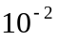. We use this uncertainty later on to estimate the remaining frequency shifts arising from trap imperfections.

- Magnetic field inhomogeneities

The magnetic field along the z-axis was measured by the frequency of the ions cyclotron resonance when the trap was moved along the field direction. The obtained data points could be well fitted by a parabola and we obtained a coefficient 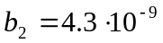 mm⁻² for a quadratic contribution to the magnetic field. The value of the quadratic field distortion by the traps susceptibility was calculated to 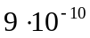 mm⁻².

- Ion-ion interaction

The Coulomb potential of different simultaneously confined ions in the trap represents a perturbation of the trapping potential and thus may cause a shift of the eigenfrequencies. Although we kept the number of detected ions in each measuring cycle low, there is a chance to have several ions at the same time in the trap due to the statistical nature of the ion creation in the trap and the detection process of the channel plate. Assuming a Poisson distribution for the detection probability we have for an average detected ion number of n=0.3, as typical for our experiment, chances of 74%, 22% and 3% to detect 0,1 or 2 ions, respectively, in each cycle.
We have measured the shift of the cyclotron frequencies for different detected ion numbers n. Fig. 7 shows an example for H₂⁺. From a linear fit to the data we obtain shifts of 0.29 (6) Hz/n for H₂⁺, 0.175 (21) Hz/n for D₂⁺, and 0.15 (3) Hz/n for ⁴He⁺.

3.1.5 Temporal magnetic field instabilities

Precise mass measurements require that the cyclotron frequencies of different ions are compared at the same magnetic field. As it is well known, the field of superconducting solenoids may exhibit temporal drifts and jumps, caused by pressure changes in the magnets cryostat, by flux quantum jumps or by varying ambient fields. We have measured the temporal variation of our magnetic field by monitoring the cyclotron frequency of an ion over an extended period of time. Fig. 8 shows a typical example. We took data points every 20 min over a period of 30 hours. The magnetic field shows variations of the order of 10⁻⁹. They appear in a random manner and no systematic drift is seen. To reduce the possible influence of short term variations on the position of the cyclotron resonances of different ions we changed between two ion species after each data point when we scanned the applied radio frequency. The change was effected every 1.3 minutes. Checks on the statistical distribution of the measured frequency ratios did not show any deviation from the expectation beyond statistical scatter. So we conclude that time variation of the magnetic field does not contribute to the error significantly at our level of precision.

- Measurements

After setting the voltages of the correction electrodes to the optimum values we excited the sideband resonance at ω_{c} = ω_{c}´ + ω_{m} by a radio-frequency field applied between two adjacent quadrants of the ring electrode. Comparison of two different ions took place, as mentioned above, by switching between the different ions after each frequency point. The average time-of-flight for each data point was determined after 50 - 100 measuring cycles. The data points for each ion were fitted by a Lorentzian line shape. The statistical uncertainty of the line centre generally was below 1 ppb as seen in fig. 4. The measurements were repeated many times. A histogram of the frequency ratio for two different ions shows a Gaussian distribution (fig.9), from which the mean was taken. Data were taken for ⁴He⁺/H₂⁺ and ⁴He⁺/D₂⁺ mass ratios.
An additional measurement on the ⁴He⁺/D₂⁺ mass ratio was performed by an excitation of the frequency 2ω_{c}´. This resonance could be observed at higher excitation amplitudes. The magnetron frequency, required for the calculation of ω_{c}, was determined from the difference of ω_{c}´ and ω_{c}. The magnetron frequency shows only a small dependence on the mass of the ions and its values were determined as 376.69 (24) Hz and 376.17 (35) Hz for D₂⁺ and ⁴He⁺, respectively. Statistical checks were made in a similar way as described above and no deviation from a purely statistical scatter of the data was found.

- Systematic errors

The frequency shifts arising from the residual values of the higher order contributions in the trapping potential as discussed in 3.1.2 as well as from the second order coefficient b₂ in the magnetic field from 3.1.3. were calculated. Their influence on the mass ratios are listed in table 1. They are in all cases below 10⁻¹⁰ and can be neglected compared to the statistical uncertainty. The uncertainty from a possible angle ε_{max} between the trap axis and the magnetic field direction (eqn. 14) is negligible for the mass doublet ⁴He⁺/D₂⁺, since it cancels out in the first order, but contributes to the error budget for non-doublets. Similarly the effect of ion-ion interaction can be neglected for doublets, but represents in our case the largest systematic uncertainty for the mass ratios for a non-doublet.
Finally a shift of the cyclotron frequencies arises from the second order Doppler effect. The ions energy is increased by the excitation process from initially thermal values. From the measured shape of the magnetic field strength along the axis between the trap and the detector and the measured reduction in flight time at resonant cyclotron excitation we calculate that the maximum energy of the detected ion was 0.65 eV. We take this value to calculate the maximum relativistic shift and its influence on the mass ratio.

From the quadratic sum of the systematic uncertainties in table 1 we find that in case of the mass doublet ⁴He⁺/D₂⁺ the systematic error is smaller than the statistical uncertainty while for the non-doublet ⁴He⁺/H₂⁺ the systematic uncertainty dominates.

- Results and discussions

The results of our mass comparisons for ⁴He⁺/H₂⁺ and ⁴He⁺/D₂⁺ are

⁴He⁺/H₂⁺ : 1.986 031 327 4 (31) 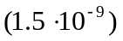
⁴He⁺/D₂⁺ : 0.993 643 871 28 (55) 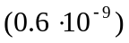

The quoted uncertainties are the quadratic sum of the statistical and systematical uncertainties. For the ⁴He⁺/D₂⁺ case we have combined our results from the independent determinations by ω_{c} and 2ω_{c}´ which gave the same numbers within the statistical error.

From the mass ratios we can calculate the mass values for the neutral Helium atom. When we use the accepted values for the proton and deuteron mass from the most recent CODATA compilation [19] and the known values for the ionisation and dissotiation energies of the atoms and molecules (including a small correction for the average vibrational quantum number of the molecules 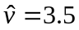 [20,21] ) we obtain for m(H₂⁺) = 2.015 101 497 03 (36) u and m(D₂⁺) = 4.027 654 988 04 (70) u. It the follows for the mass of the neutral ⁴He atom:

From ⁴He⁺/H₂⁺ : m (⁴He) = 4.002 603 254 5 (63) au
From ⁴He⁺/D₂⁺ : : m (⁴He) = 4.002 603 248 2 (24) au

In table 2 we list the weighted mean of these results along with other recently obtained values.

Our final result is in agreement to the accepted value of the ⁴He mass. It deviates from the recently obtained value by the SMILTRAP group. Although our error bar is somewhat larger than those by previous experiments our result may help to obtain a reliable and accurate mass value. Results at the 1ppb level of precision „should not remain unchallenged: checks by another group, at the same level of precision, are highly desirable to strengthen the validity of their mass measurements, and transform these very precise measurements into very accurate ones“[G.Audi]. Further improvement of our result would theoretically be possible when the largest uncertainty in our experiment arising from the ion-ion interaction would be reduced. This requires a further reduction of the average detected ion number n. Since this is already as low as n=0.3 or even below it would increase the total time for a measurement. This has the risk of temporal instabilities of the magnetic field and also of the electric trapping field. Thus we conclude that further improvements of our present technique is limited by practical constraints.

- Acknowledgements

Our experiments were supported by the Deutsche Forschungsgemeinschaft. We thank R. Ley for careful checking our calculations and A. Drakoudis for help with the manuiscript.

References

[1] L. Brown and G. Gabrielse, Rev.Mod.Phys. 58, 233 (1986)

[2] F. Vedel and G. Werth in: Practical Aspects of Ion Trap Mass Spectrometry (R.E. March and
J.F.Todd, eds.), vol. II, p. 237, CRC Press, Boca Raton (1995)

[3] L.S. Brown and G. Gabrielse, Phys. Rev. A 25, 2423 (1982)

[4] F.L.Moore, D.L.Farnham, P.B.Schwinberg and R.S. Van Dyck,Jr., Nucl.Instr. Meth.
B43, 425 (1989)

[5] E.A. Cornell et al., Phys. Rev. Lett. 63, 1674 (1989)

[6] G. Bollen, R.B.Moore, G.Savard and H. Stolzenberg, J. Appl. Phys. 68, 4355 (1990)

[7] R. Jertz et al., Z. Phys. D21 , 179 (1991)

[8] G.Gräff, H. Kalinowsky and J. Traut, Z. Phys. A 297, 35 (1980)

[9] Ch. Gerz, D. Wilsdorf and G. Werth, Nucl. Instr. Meth. B47, 453 (1990)

[10] D. Hagena and G. Werth, Europhys. Lett. 15, 491 (1991)

[11] R.S.van Dyck Jr. et al., in: Trapped Charged Particles and Fundamental Physics (D. Dubin and
D. Schneider eds.)AIP Conf. Proc. No 457, 101 (1999)

[12] T. Fritioff et al., submitted to Eur. Phys. J. D

[13] S. Brunner et al., in: Trapped Charged Particles and Fundamental Physics (D. Dubin and
D. Schneider eds.)AIP Conf. Proc. No 457, 125 (1999)

[14] E.W.Pugh and F.M. Ryan, Phys. Rev. 111, 1038 (1958)

[15] G. Gabrielse and J. Tan, J. Appl. Phys. 63, 5143 (1988)

[16] M. Kretzschmar, Z. Naturf. 45a, 965 (1990)

[17] H. Klein, Diplomarbeit (unpublished), Mainz ( 1996)

[18] SIMION 3D, Version 6.0, Idaho Natl. Eng. Lab. (1995)

[19] P.J.Mohr and B.N.Taylor, J. Phys. Chem.Reference Data 28, 1713 (1999)

[20] F. von Busch and G. Dunn, Phys. Rev A5, 1726 (1972)

[21] Y. Weijun, R. Alheit and G. Werth, Z. Phys.D 28, 87 (1993)

Tables

Tab. 1: Fractional uncertainties from trapping field imperfections, ion-ion interaction and
relativistic mass shifts on the mass ratios of ⁴He⁺, H₂⁺ and D₂⁺

 | ⁴He⁺/H₂⁺ | ⁴He⁺/D₂⁺
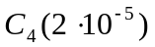 | 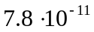 | 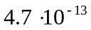
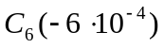 | 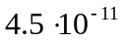 | 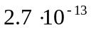
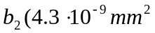 | 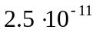 | 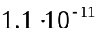
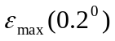 | 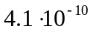 | 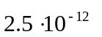
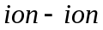 | 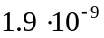 | 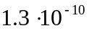
rel. mass shift | 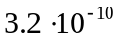 | 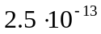
quadratic sum | 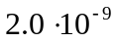 | 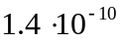

Table 2: Mass values for atomic ⁴He

4.002 603 248 9 (22) | This work
4.002 603 256 8 (13) | Ref.. [12]
4.002 603 249 7 (10) | Accepted value [19]

Figure captions

Fig. 1: Scale drawing of our trap structure. Full: Main trap electrodes, hatched: Correction electrodes.
The closest distance between the endcap electrodes is 8.0 mm

Fig. 2: Set-up of the experiment

Fig. 3: Time-of-flight spectrum of ions created from the background gas by electroionisation.
(a, left): Complete spectrum. The strong signal corresponds to mass 2 ions, the smaller ones to N₂⁺, and O₂⁺. (b, right): remaining m = 2 ions after excitation of the axial resonance frequency of unwanted species.

Fig. 4: Mean time-of flight for H₂⁺ ions (left) and ⁴He⁺ ions (right) when a radio frequency
field is scanned around ω_{C}´. The full width corresponds to the Fourier limit of the
excitation time of 1 s. The experimental data points are fitted by a Lorentzian line and
the statistical uncertainty is below 1ppb

Fig. 5 : Full width of the cyclotron frequency of H₂⁺ ions (open circles) and reduction in
time-of-flight to the detector at resonant excitation (full circles) for different voltages
V_{c} applied to the correction electrodes. The voltages are given in units of the trap
voltage V_{o}. For V_{c} = 0.43 V₀ the minimum in linewidth and the maximal change in
time-of-flight indicate the optimum correction voltage to minimise higher order
contributions to the trapping potential.

Fig. 6: Cyclotron resonances ω_{C}´ for different correction voltages:V_{c} = 0.3, 0.43, and 0.65 V₀
(from left to right) indicating line asymmetries for distorted trap potentials

Fig. 7: Shift of the cyclotron frequency at different detected H₂⁺ ion numbers n. A linear fit
through the experimental values gives a dependence δω_{c} = 0.29 (6) n [Hz]

Fig. 8: Temporal stability of the magnetic field from our superconducting solenoid.
Data were taken every 20 min. The solid line is the average of z adjacent data points.

Fig. 9: Histogram of 216 values of ⁴He⁺/H₂⁺ mass ratios, derived from their cyclotron
resonances. The shape is nearly a Gaussian (dotted line). The uncertainty of the
mean is 1.5 10⁻¹⁰.

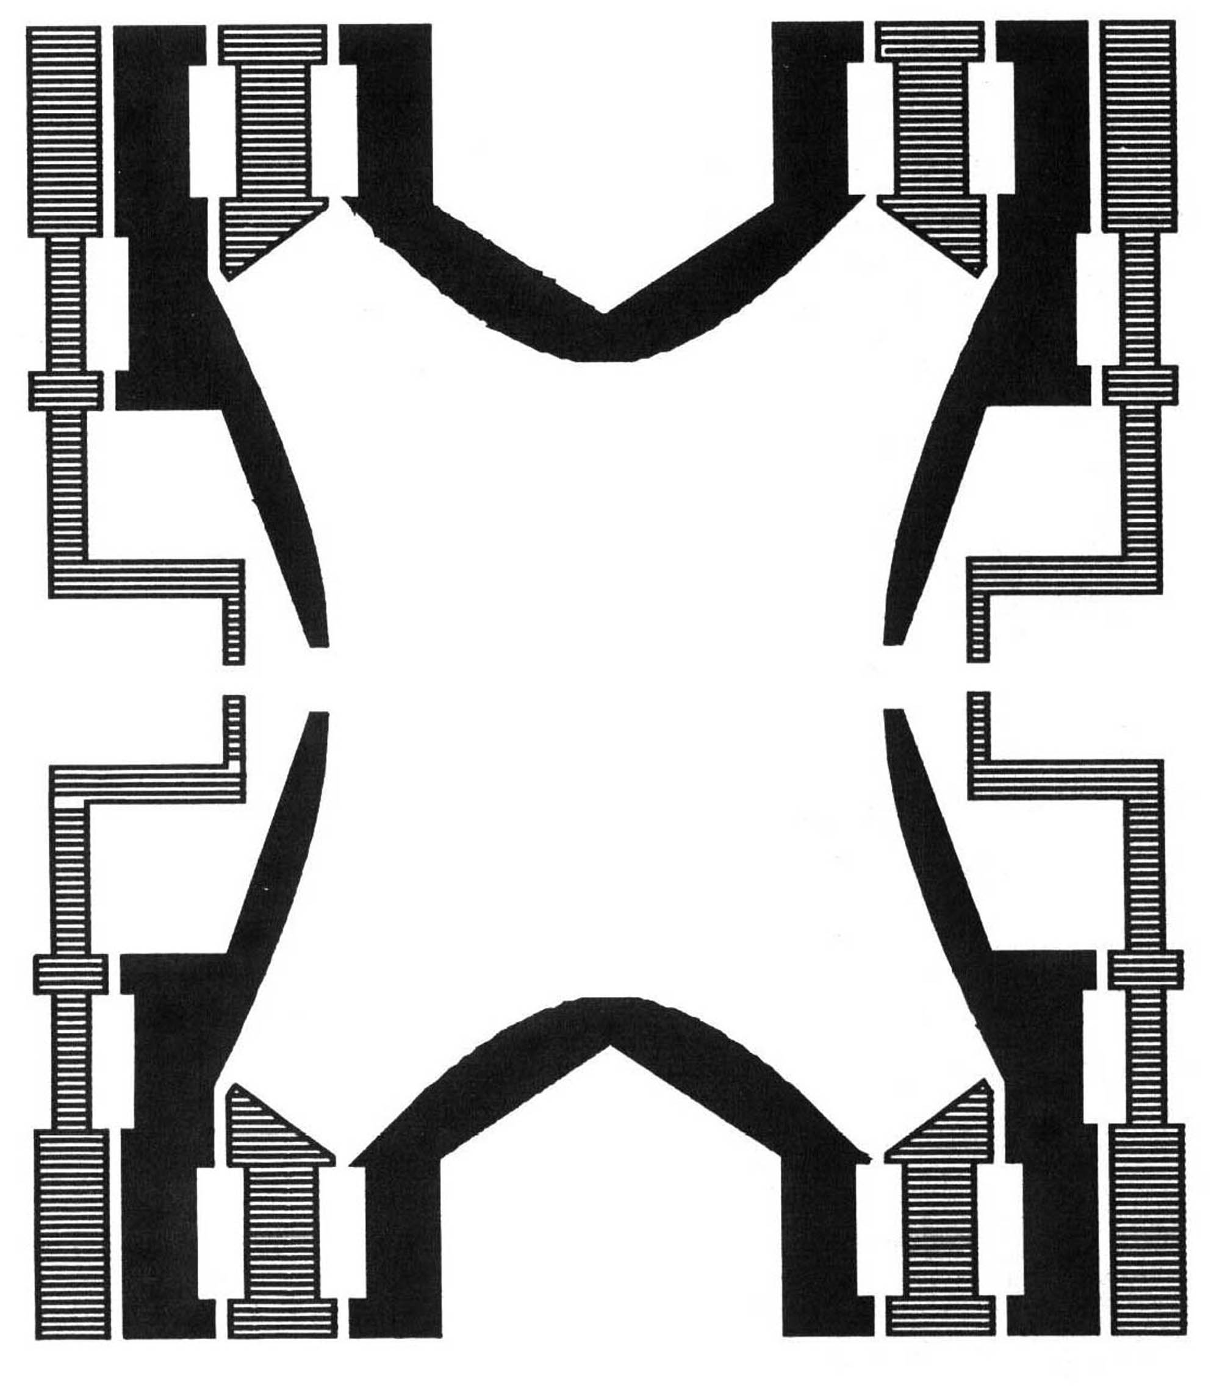

Fig. 1

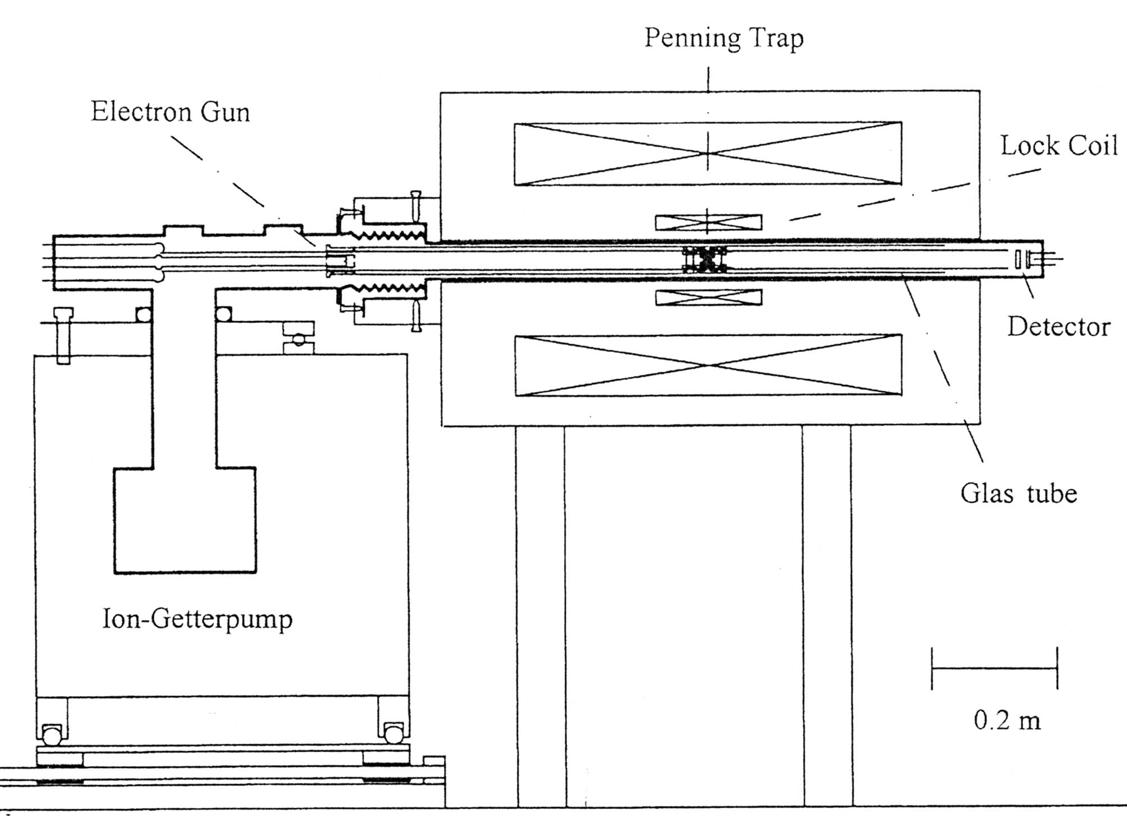
Fig. 2

Fig. 3

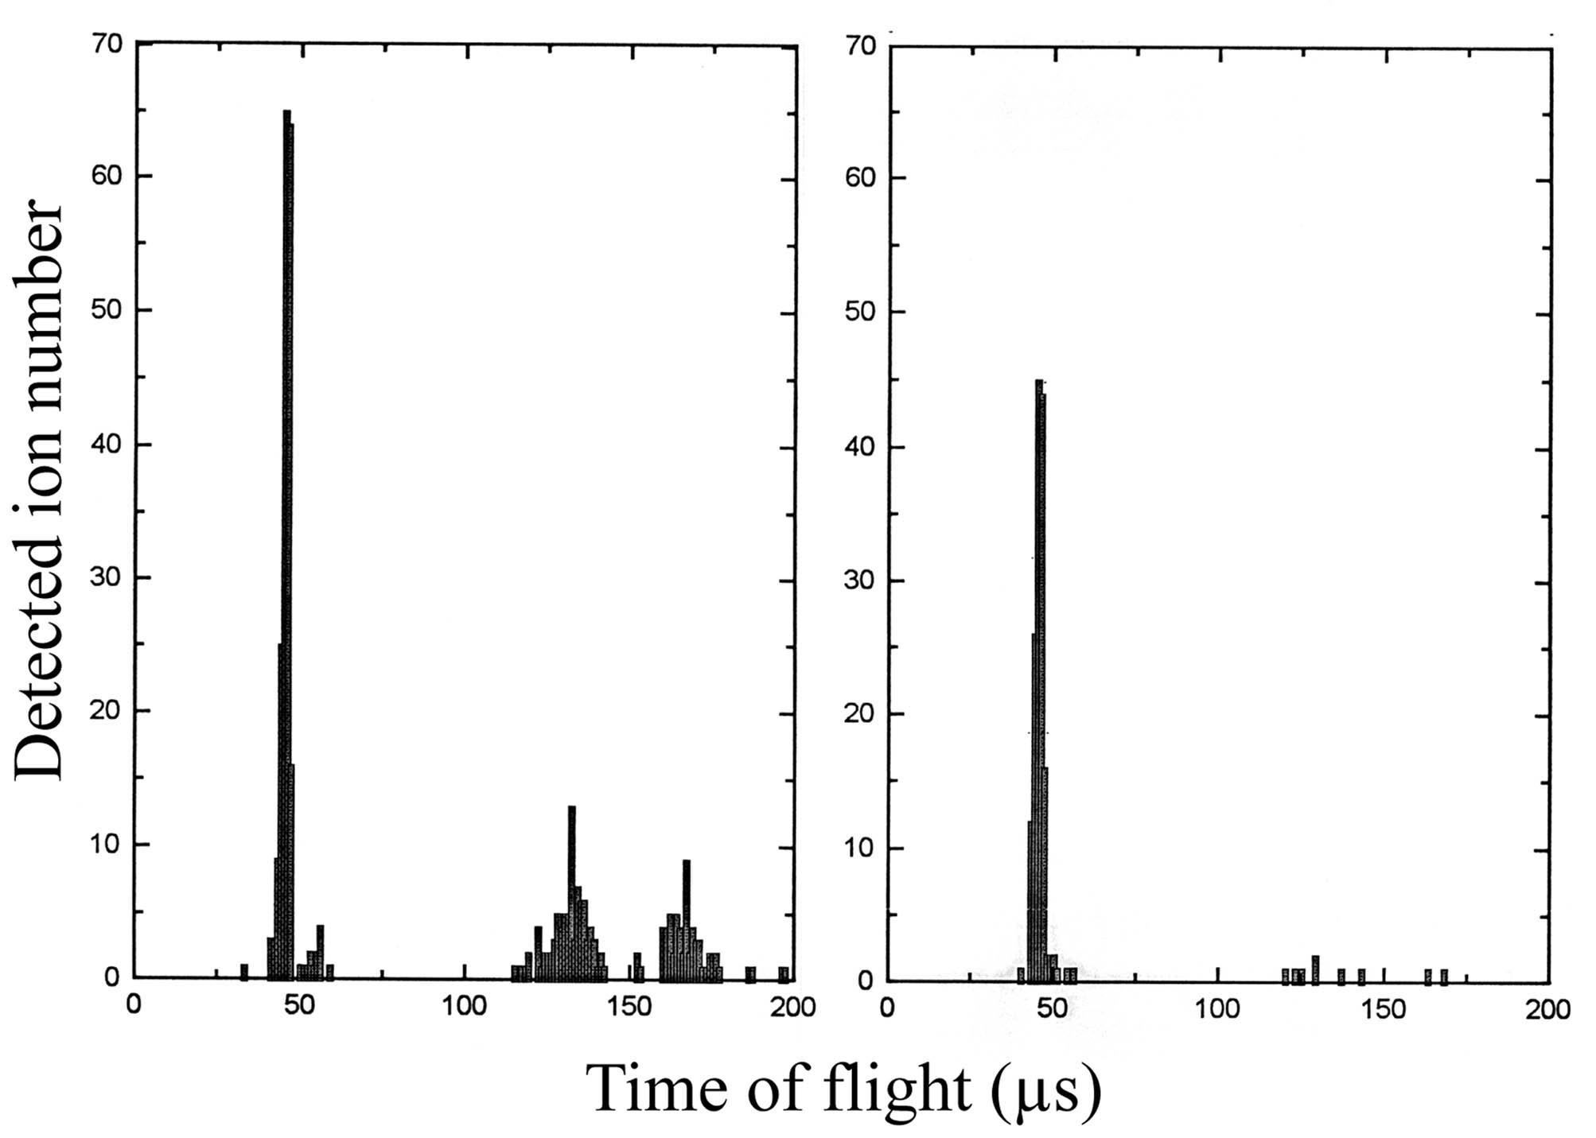

Fig. 4
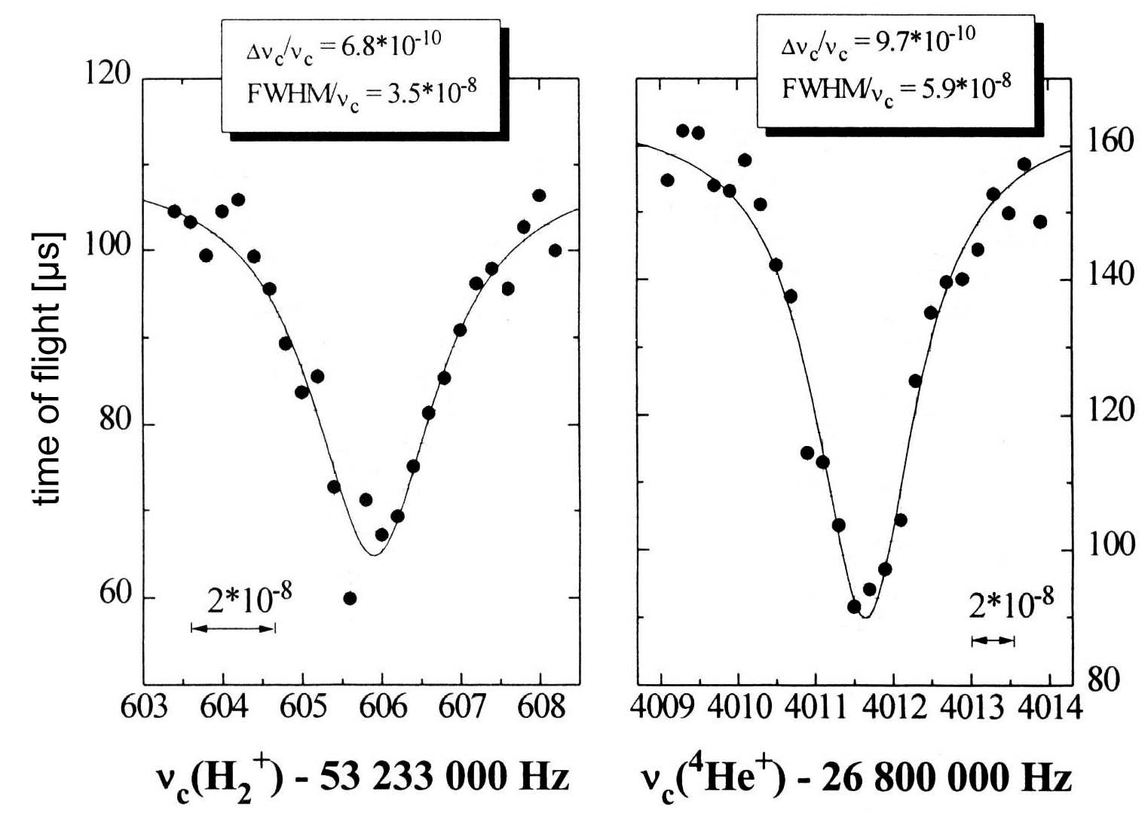

Fig. 5
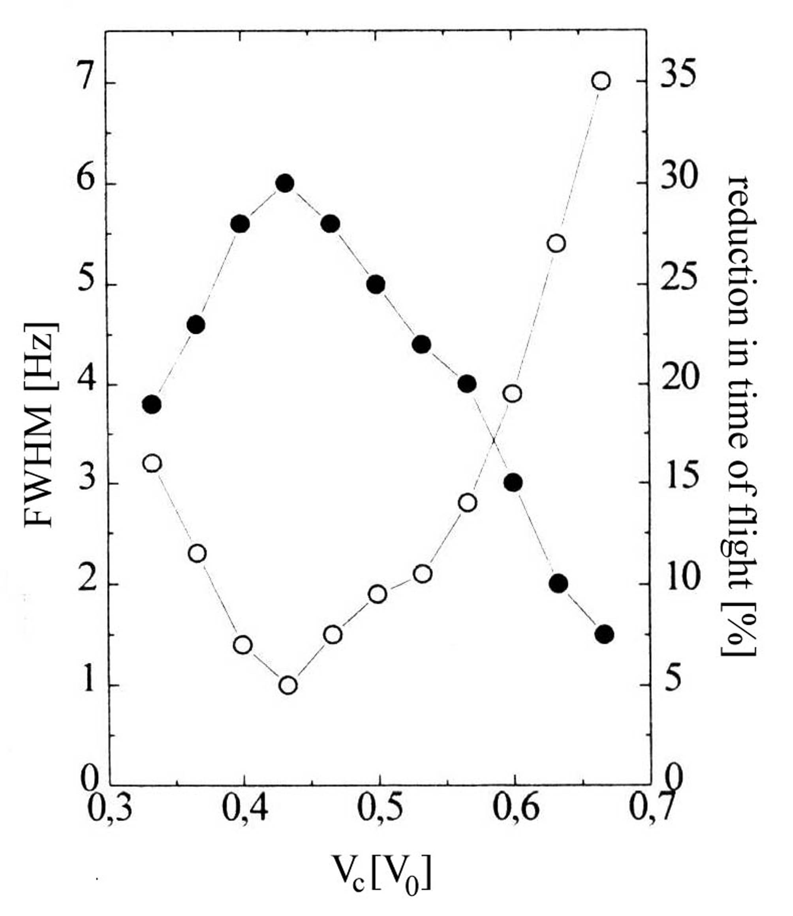

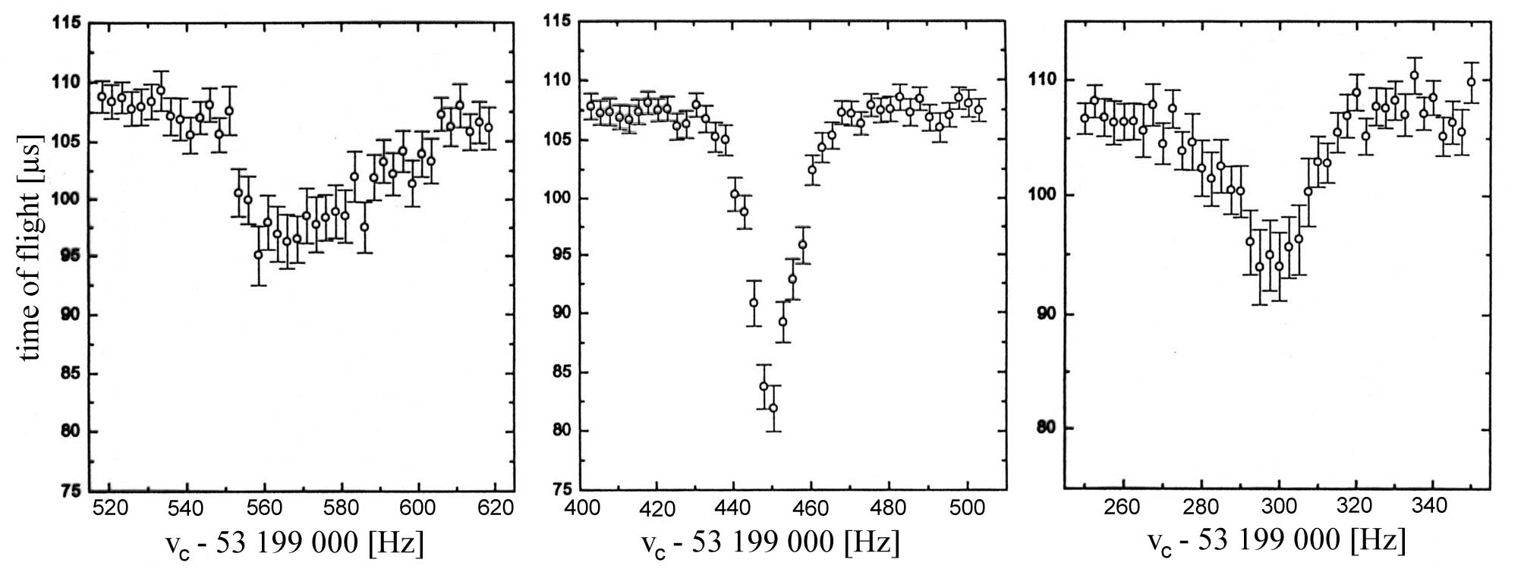
Fig. 6

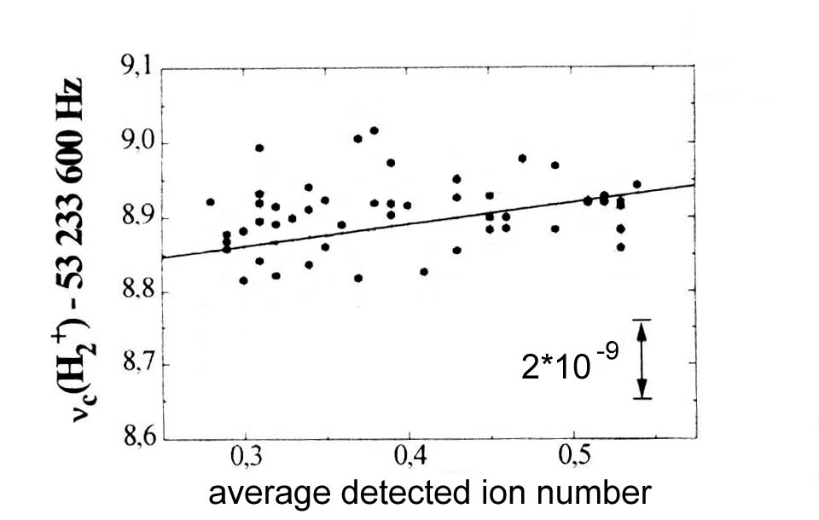

Fig.7

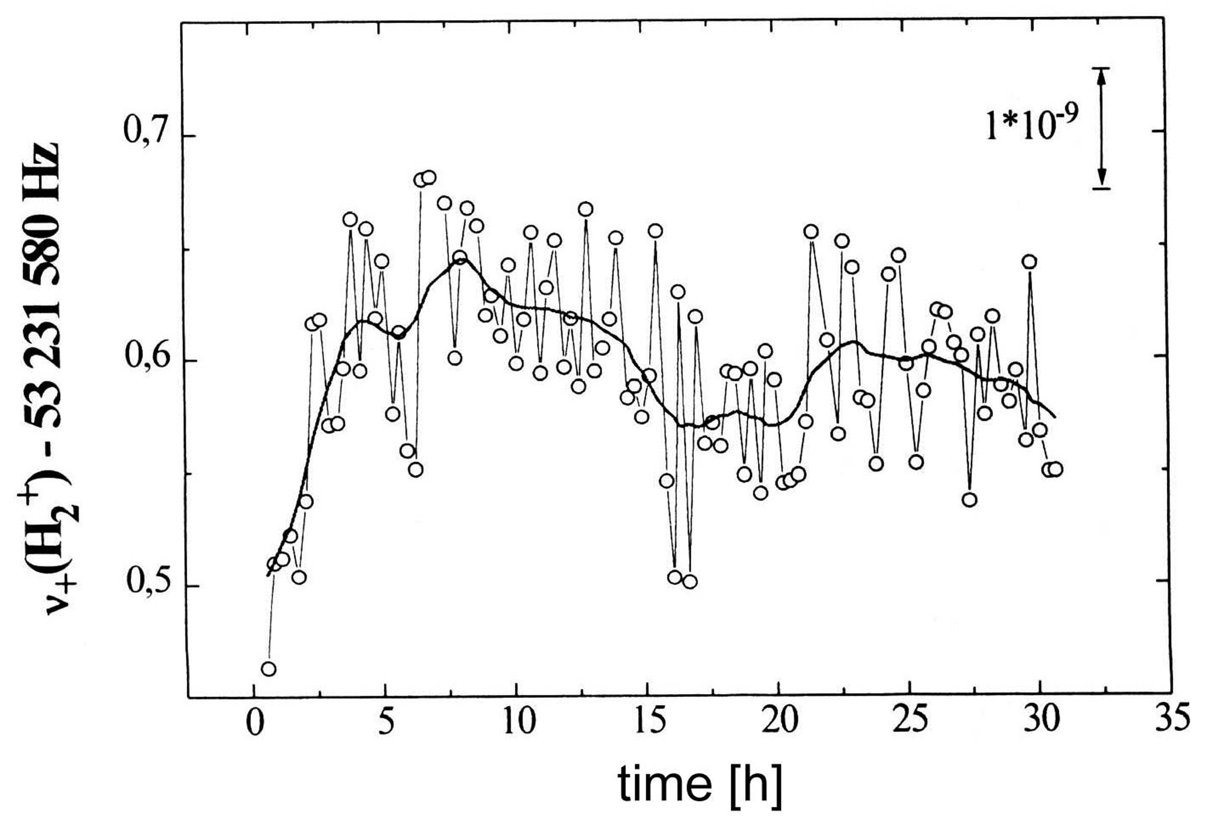
Fig. 8

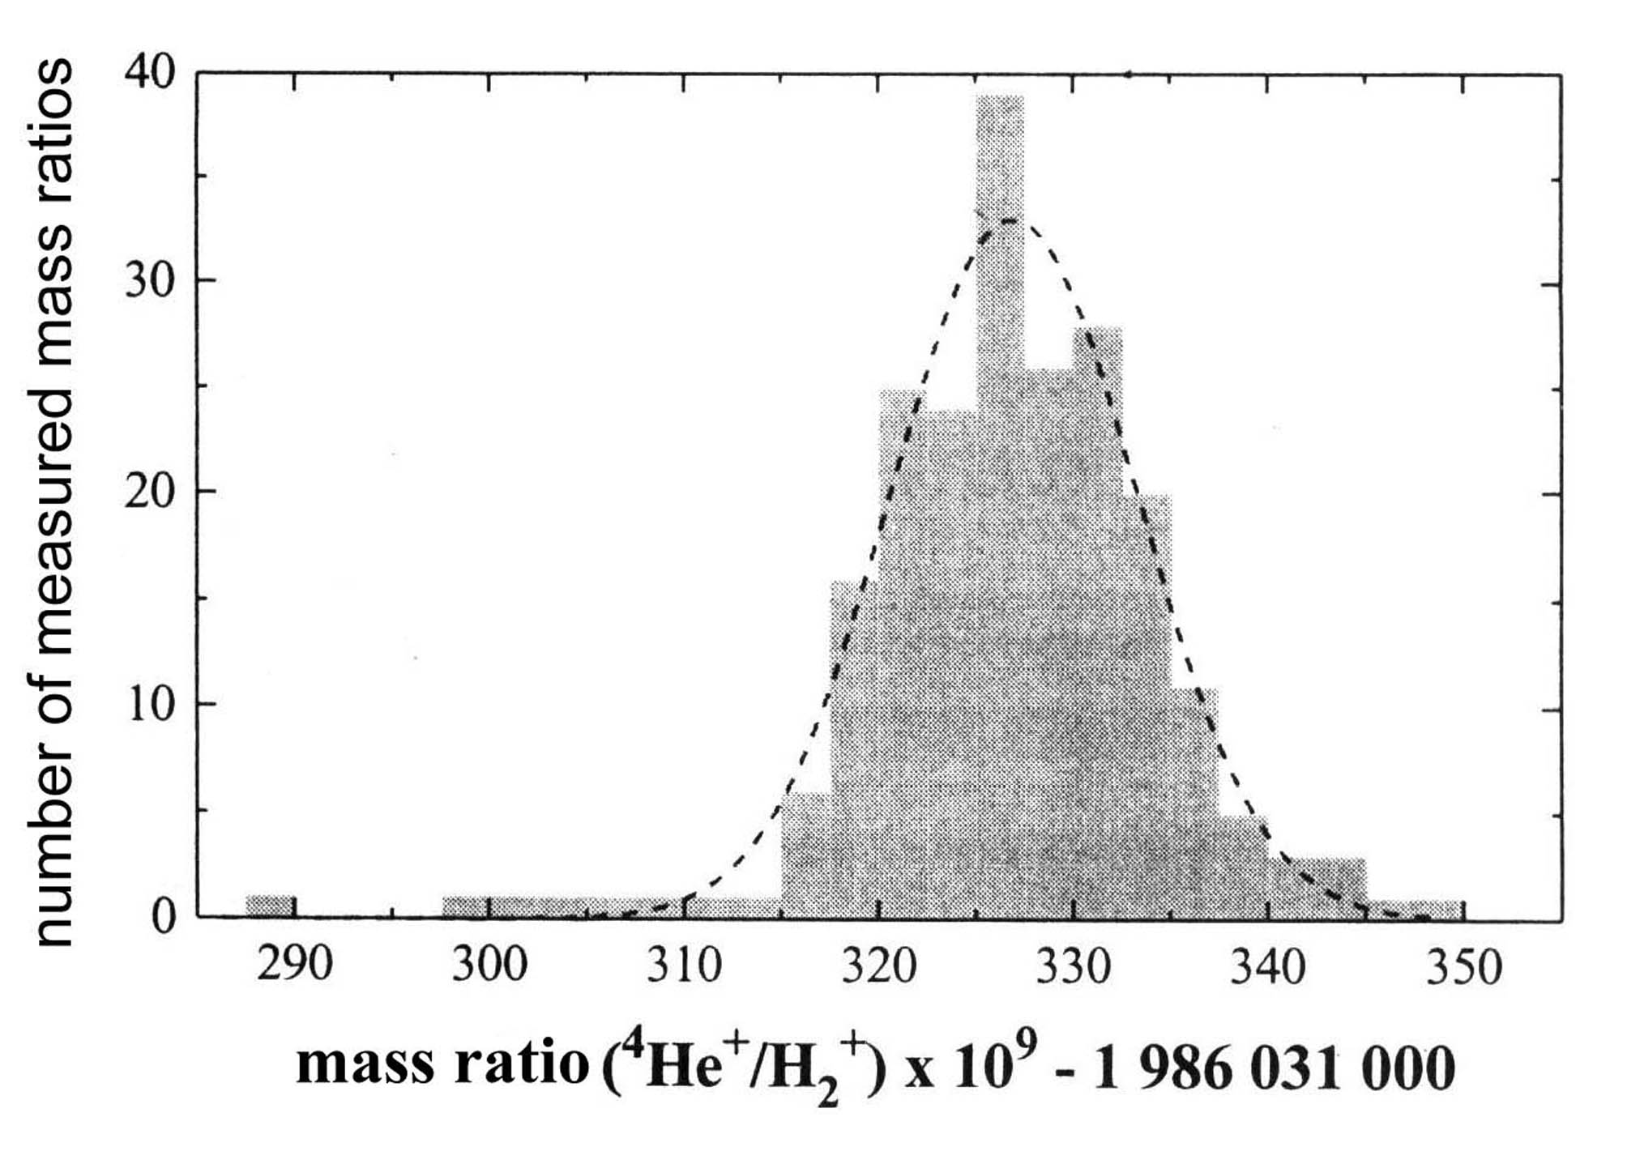
Fig. 9

