Extension of the H-3 Evaluation to 60 MeV for FENDL-3

Andrej Trkov

October 2011

Introduction
One of the objectives of the IAEA CRP on the FENDL-3 library is to provide evaluated nuclear reaction data for all materials relevant for fusion-related neutronics calculations up to incident neutron energies of 60 MeV. Starter evaluations were selected and in case they did not extend up to the desired incident neutron energies, the Japanese colleagues extended the range to at least 60 MeV using data from the TENDL-2010 library. Unfortunately this was not possible for the light nuclides because TENDL-2010 is based on nuclear model calculations, which are not applicable for the lightest nuclides. The evaluations in the new ENDF/B-VII.1b4 library for ¹H and ²H cover the desired energy range, but no evaluation extends beyond 20 MeV for ³H, ³He and ⁴He. In the present work the extension of the ³H evaluation to 60 MeV is described.

Procedures
The FENDL-3 starter library contains the ENDF/B-VII.0 evaluation. In this library the (n,2n) reaction cross sections are grossly underestimated, compared to a single measurement by Mather [1] (see the discussion below) so the cross sections for this reaction were replaced by those from ENDF/B-VI.8 in the candidate evaluation for ENDF/B-VII.1. This modified evaluation was taken as a starting point for FENDL-3. The evaluation was checked against the experimental data in the EXFOR database. Extension to each reaction was made as described below. In the plots the updated evaluation (extended to 60 MeV, labelled “fendl3”) is compared with the ENDF/B-VII.0 evaluation (labelled “e70”) and the experimental data.

Total cross section
The data of Phillips [2], Battat [3] and Katsurov [4] were considered. The total cross section is the sum of the partials. The constituent reaction cross sections (mainly the elastic), were adjusted such that the total cross section matched the bulk of the experimental points. The total cross section plot is shown on Figure 1.

Elastic cross section
Measurements of the competing reactions (n,2n) and (n,3n) exist only at 14 MeV and are negligible in comparison with the elastic cross section. At energies above 20 MeV the measurements of Seagrave indicate a distinct drop in the elastic cross sections. Considering the constraint on the measured total cross section, this could indicate that the competing reactions are becoming significant. However, there are no measurements of the competing reactions at these energies that could support such an increase, so the elastic cross section was extrapolated linearly in log-log scale with the gradient adjusted to match the measured total cross sections. The elastic cross section plot is shown on Figure 2.

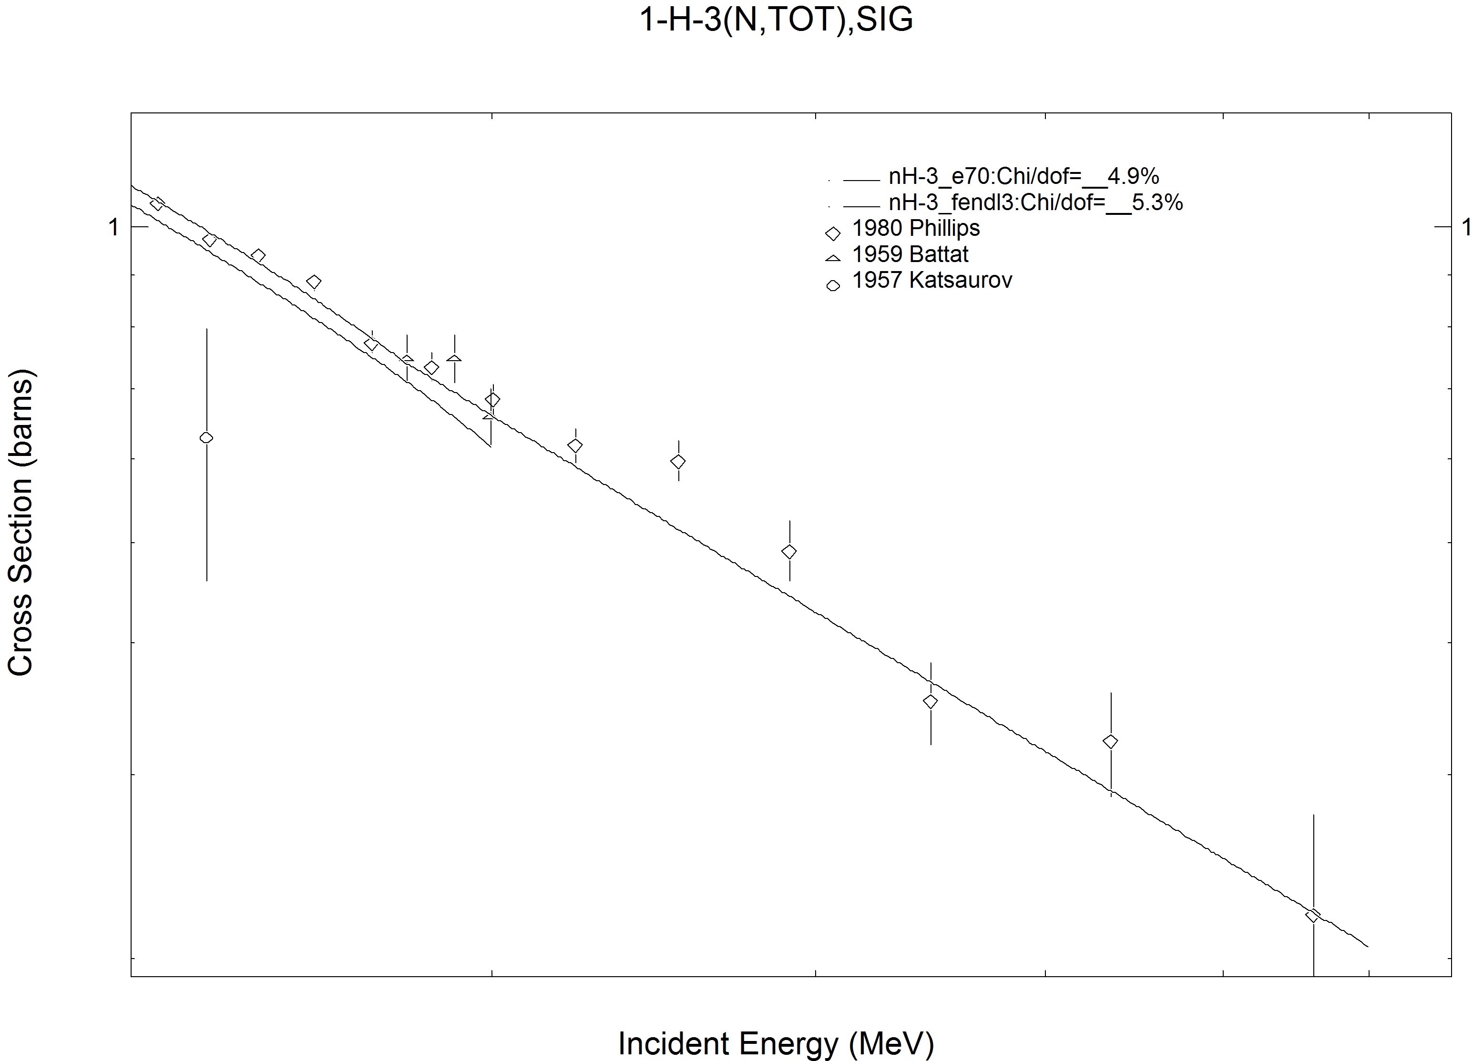
Figure 1: Total cross section of ³He extended to neutron incident energies up to 60 MeV.

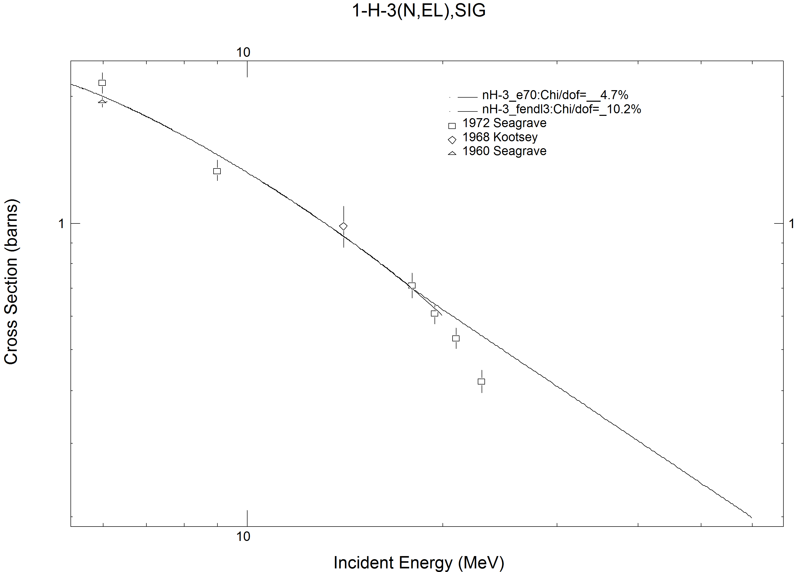
Figure 2: Elastic cross section of ³He extended to neutron incident energies up to 60 MeV.
Elastic angular distributions
Above 20 MeV measurements of the elastic angular differential cross sections by Seagrave [1] are available and they extend up to 23 MeV. The plots of the cross sections are shown on Figures 3 and 4. The angular distributions are in good agreement with the measurements. A flat extrapolation to 60 MeV was performed.

Non-elastic cross section
The non-elastic reaction cross sections are redundant and can be reconstructed from the cross sections of the constituting (n,2n) and (n,3n) reactions. Some measurements declared to be the non-elastic cross section exist in EXFOR by Seagrave, which suggest a strong increase of the (n,2n) and (n,3n) cross sections above 20 MeV, but since the same author also reported the declining elastic cross sections in this energy range, an error in the assignment of the contributions to the reaction can not be excluded. The experimental data were ignored. The plot of the cross sections is shown on Figure 5.

Two-neutron emission cross section
The two-neutron emission cross section has a threshold at 8.35 MeV. A single measurement by Mather [1] is available. This measurement was strongly underpredicted in ENDF/B-VII.0 library. The cross sections were replaced by those from the ENDF/B-VI.8 evaluation, which are in good agreement with the measurement. For this reason the ENDF/B-VII.1b4 evaluation for this material was taken as a starting point. The data were extrapolated linearly in log-log scale to approximately preserve the gradient of the cross sections at 20 MeV. The plot of the cross sections is shown on Figure 6. The angular distributions and the emission spectra were extrapolated flat to 60 MeV.

Three-neutron emission cross section
The three-neutron emission cross section has a threshold at 11.32 MeV. A single measurement by Mather [1] is available. The cross sections are not present in the ENDF/B-VII.0 evaluation, but they appear in JEFF-3.2 and originate from the CENDL-2 evaluation and were normalised to the measured cross section at 14 MeV. The cross sections for this reaction are also present in the EAF-2010 library and tend to be somewhat higher, but they are given up to 60 MeV. The cross sections from the EAF-2010 library were adopted for the FENDL-3 library for this reaction. The plot of the cross sections is shown on Figure 7.
Since no double-differential data exist in any of the evaluated data files, the neutron emission is assumed isotropic in the laboratory system and the emission spectrum is represented by the evaporation spectrum with an effective temperature of 600 keV, independent of incident neutron energy.
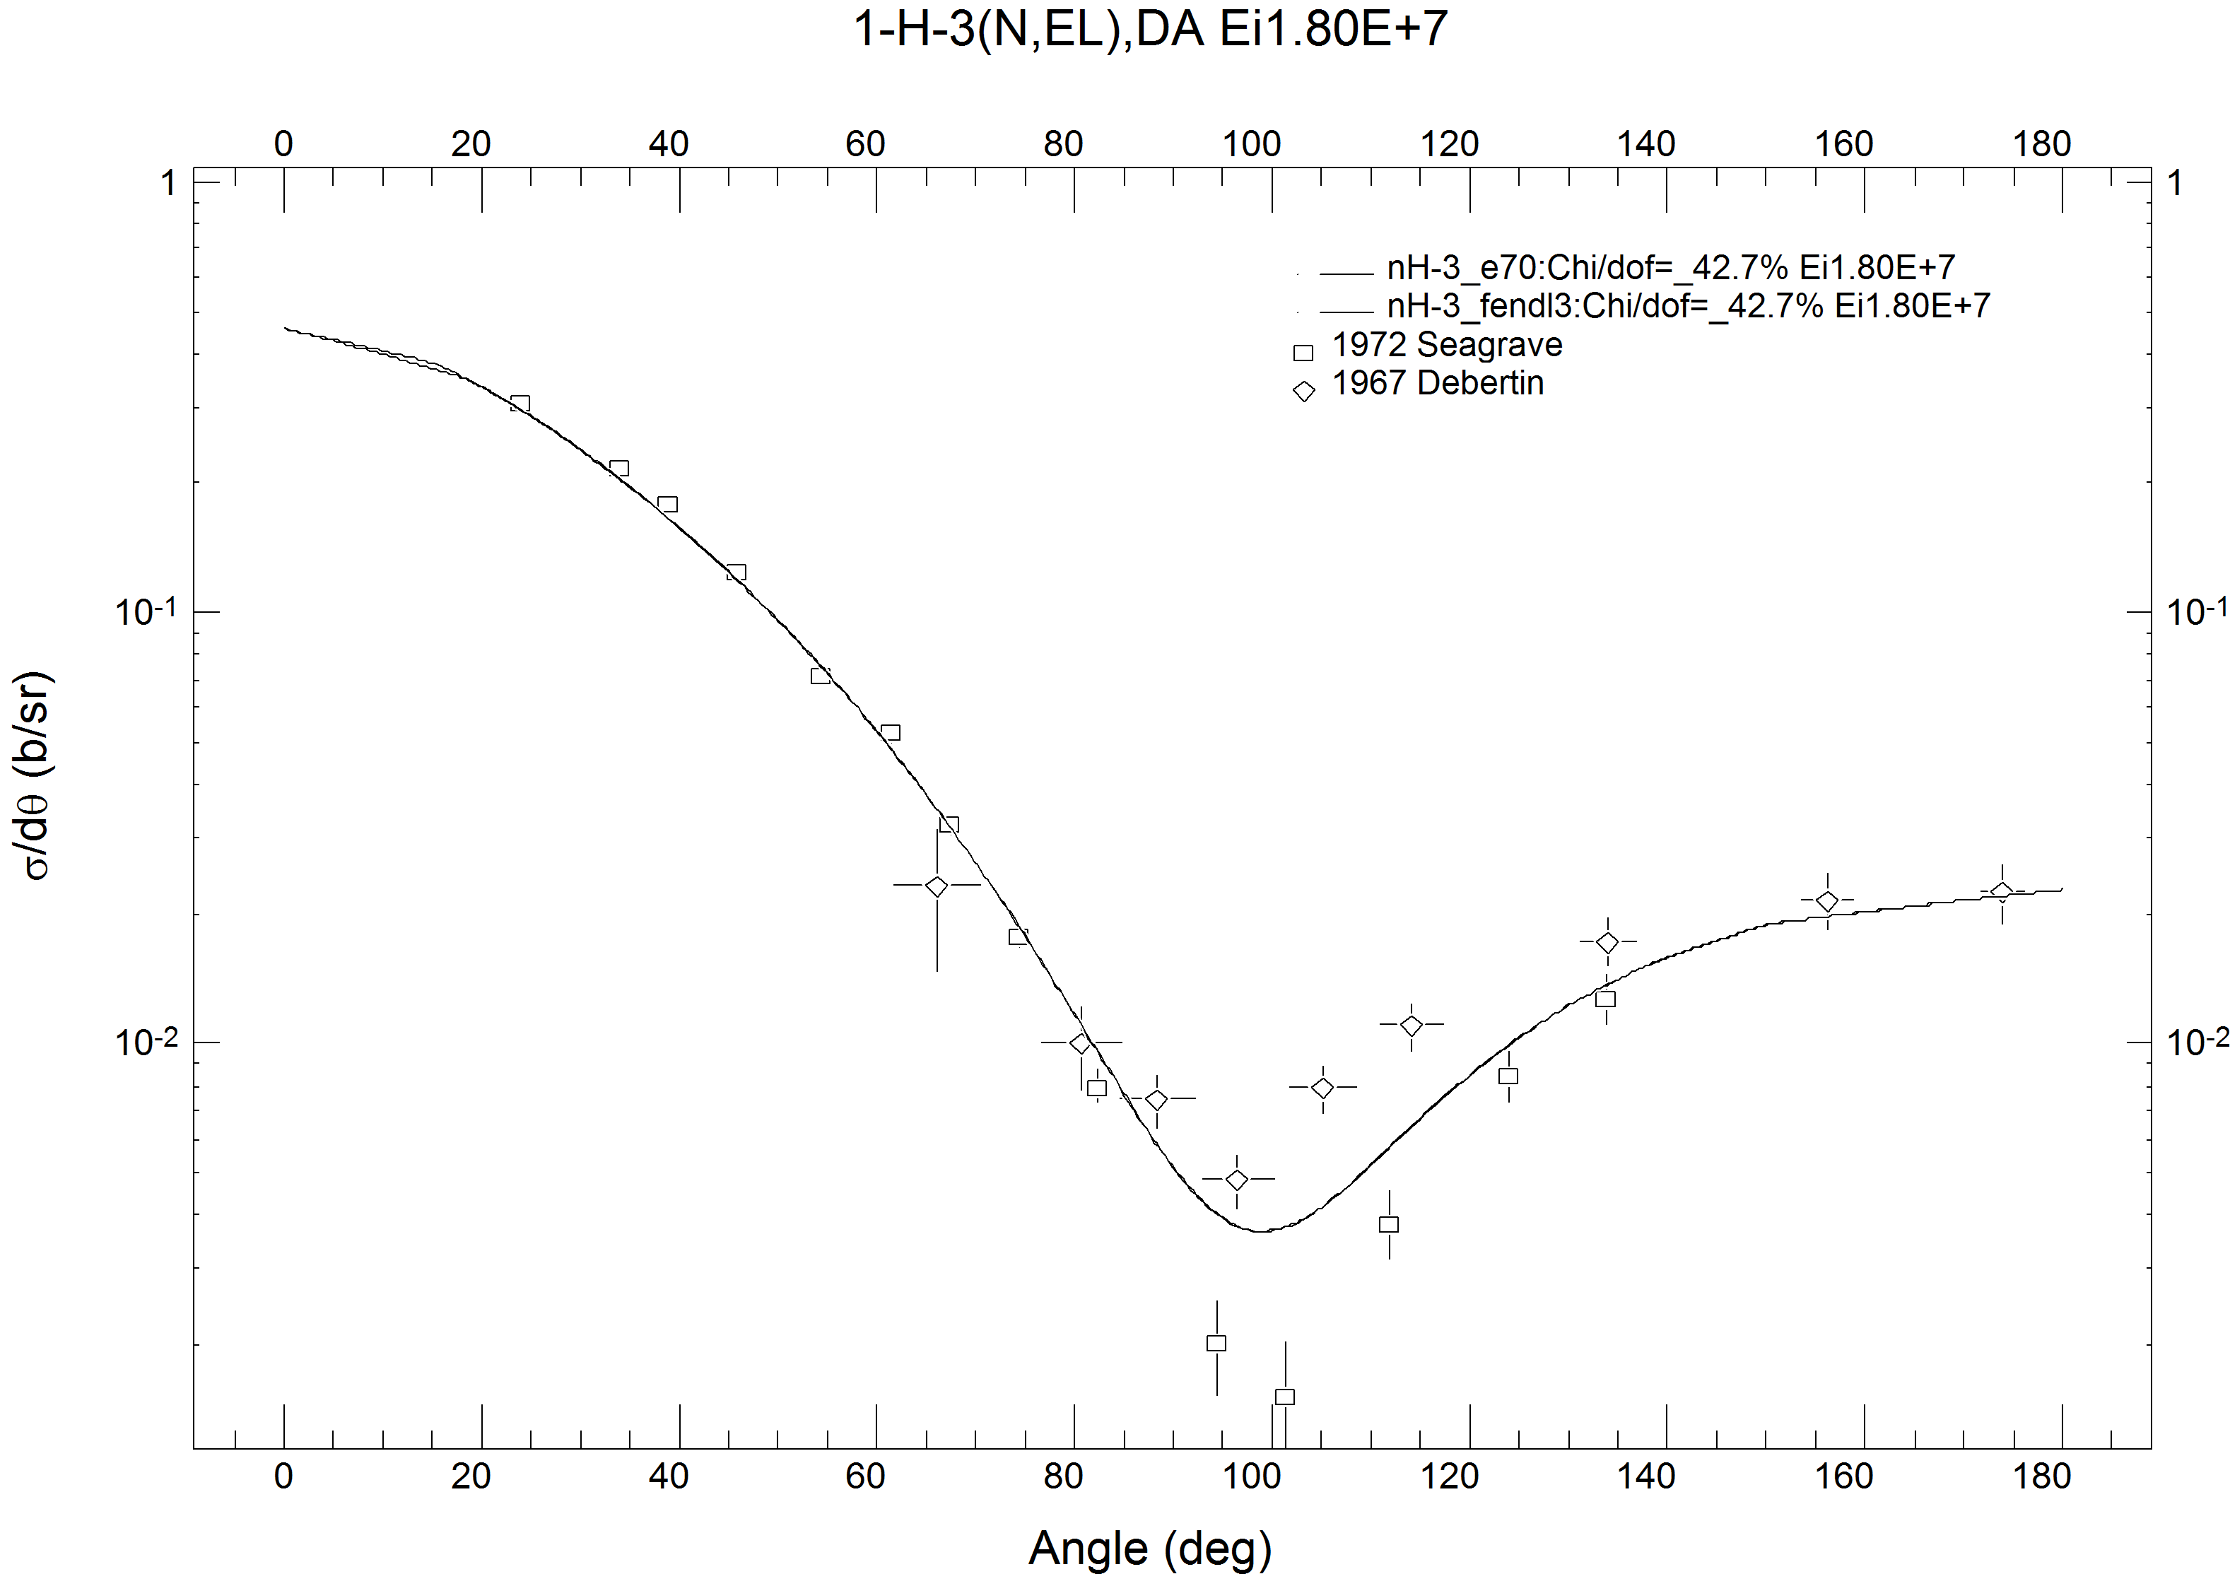
Figure 3: Differential elastic cross section of ³H for incident neutrons of 18 MeV.

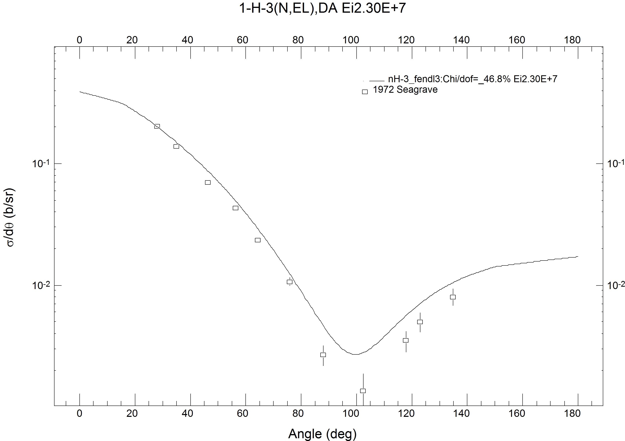
Figure 4: Differential elastic cross section of ³H for incident neutrons of 23 MeV.

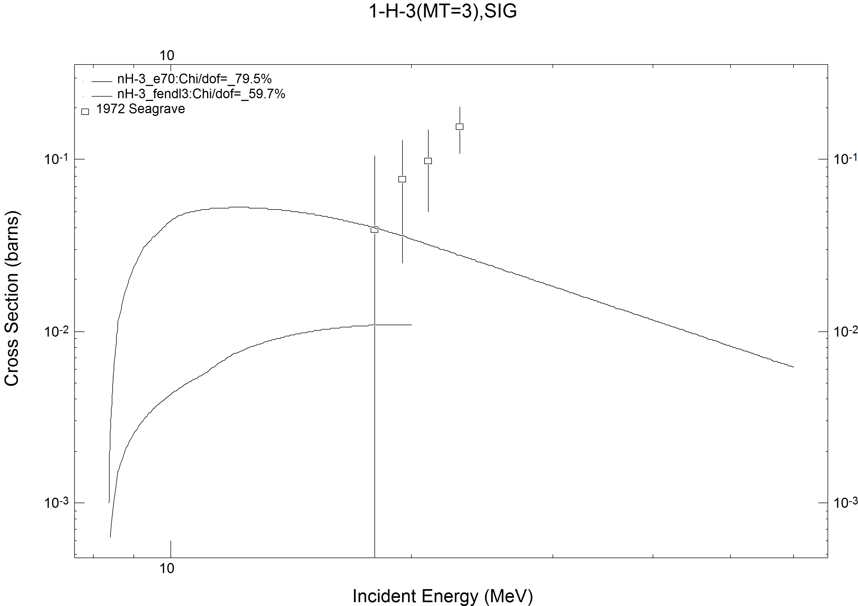
Figure 5: Non-elastic cross section of ³H .

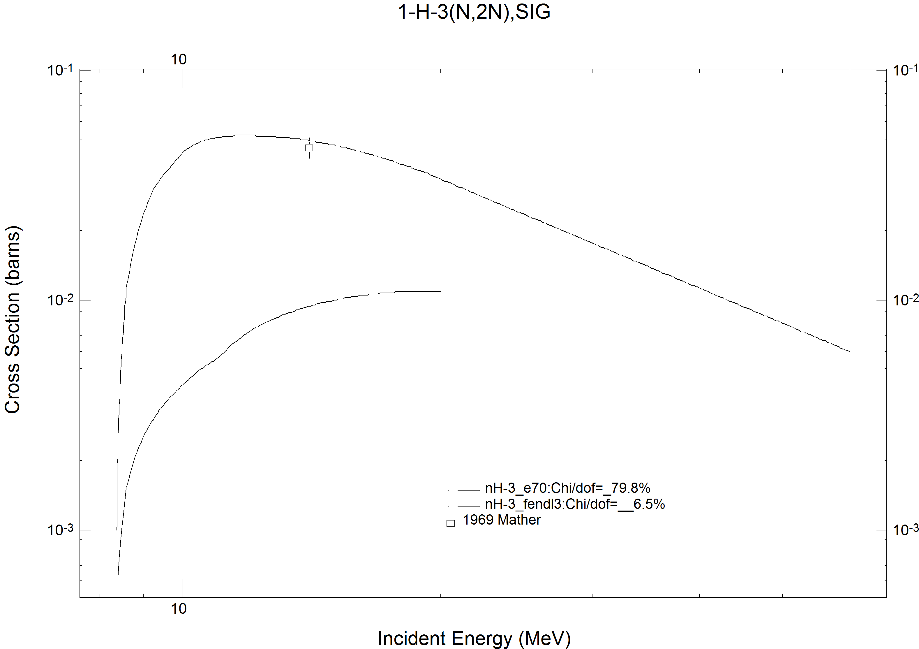
Figure 6: The (n,2n) reaction cross section of ³H.

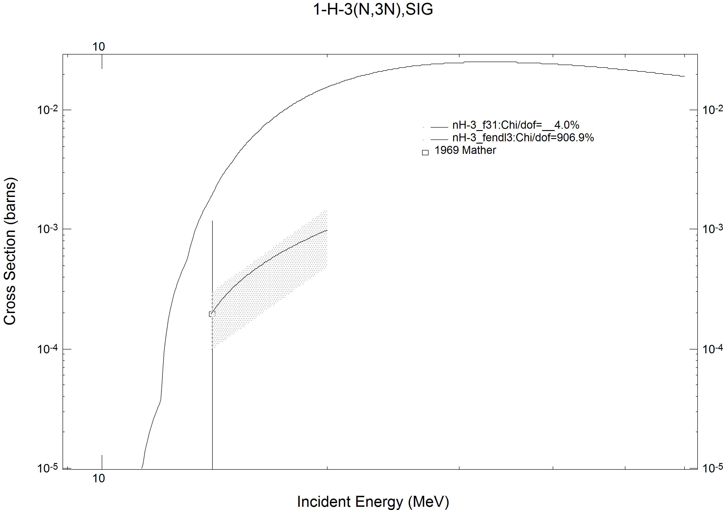
Figure 7: The (n,3n) reaction cross section of ³H.

Verification
The CHECKR code reported no problems. Fizcon reports that for MT=16 in MF=5 the value of U is not consistent. It seems likely that this is a false message because FIZCON compares (Q+U)/Q to a tolerance of 10⁻³, but U is given in the laboratory system while the Q-value is defined in the centre-of-mass system. The PSYCHE code reports that the scattering radius of 0.364 is not in the range between 0.1011 and 0.2456, but this is the evaluator’s choice. PSYCHE also reports that the total secondary energy exceeds the available energy for the (n,2n) reaction, but this problem is inherited from the original evaluation.
Processability of the file is checked by running the codes of the PrePro-2010 series including LINEAR, RECENT, SIGMA1 and FIXUP. Further testing is done by running NJOY to generate an ACE library for Monte Carlo codes like MCNP and a MATXS library for deterministic codes. The heating curve generated by the HEATR module is useful for checking potential energy-balance problems and is shown in Figure 8. The figure did not reveal any problems. The plots produced by the ACER module also showed nothing suspicious and are not presented.

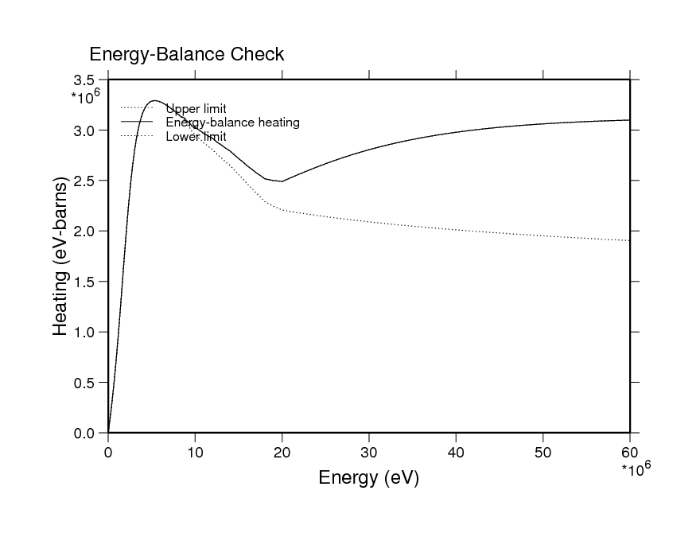
Figure 8: Plot of the heating in ³H calculated by the HEATR module of NJOY.

Conclusions
An ad-hoc evaluated nuclear data file for ³H for incident neutrons with energies up to 60 MeV was produced for inclusion in the FENDL-3 library by extending the ENDF/B-VII.1b4 evaluation. It incorporates the information contained in other evaluated data files and the experimental EXFOR database. The trends in the total cross section are consistent with the measured data. The experimental information on the other reaction channels is poor and there are no theoretical model calculations to support the data included in the evaluation. The evaluation is complete in the sense that it allows the preparation of application libraries, but should not be relied upon for detailed calculations that are sensitive to the non-elastic reactions on tritium.

References
- D.S.Mather, L.F.Pain, Measurement of (n,2n) and (n,3n) cross sections at 14 MeV incident energy, A.W.R.E. Aldermaston Reports; No.47/69 (1969), EXFOR: 20794.
- T.W.Phillips, B.L.Berman, 3He Neutron Total Cross Section for Tritium, Physical Review, Part C, Nuclear Physics; Vol.22, p.384 (1980), EXFOR: 10945.
- M.E.Battat, R.O.Bondelid, J.H.Coon, L.Cranberg, R.B.Day, F.Edeskuty, A.H.Frentrop, R.L.Henkel, R.L.Mills, R.A.Nobles, J.E.Perry, D.D.Phillips, T.R.Roberts, S.G.Sydoriak, Total neutron cross sections of the hydrogen and helium isotopes, Nuclear Physics; Vol.12, p.291 (1959), EXFOR: 11021.
- L.N.Katsaurov, R.M.Musaeljan, V.I.Popov, Total Tritium Cross Section for Neutrons with Energies of 2.5 and 14 MeV, Atomnaya Energiya, Supplement; Vol.5, p.71 (1957), EXFOR: 40773.

