Extension of the He-3 Evaluation to 60 MeV for FENDL-3

Andrej Trkov

October 2011

Introduction
One of the objectives of the IAEA CRP on the FENDL-3 library is to provide evaluated nuclear reaction data for all materials relevant for fusion-related neutronics calculations up to incident neutron energies of 60 MeV. Starter evaluations were selected and in case they did not extend up to the desired incident neutron energies, the Japanese colleagues extended the range to at least 60 MeV using data from the TENDL-2010 library. Unfortunately this was not possible for the light nuclides because TENDL-2010 is based on nuclear model calculations, which are not applicable for the lightest nuclides. The evaluations in the new ENDF/B-VII.1b4 library for ¹H and ²H cover the desired energy range, but no evaluation extends beyond 20 MeV for ³H, ³He and ⁴He. In the present work the extension of the ³He evaluation to 60 MeV is described.

Procedures
The JENDL-4 evaluation is taken as a starting point. The evaluation was checked against the experimental data in the EXFOR database. Extension to each reaction was made as described below. In the plots the JENDL-4 evaluation (extended to 60 MeV, labelled “fendl3”) is compared with the ENDF/B-VII.1b4 evaluation (labelled “e71”) and the experimental data.

Total cross section
The data of Haesner [1], Goulding [2] and Battat [3] were considered. The total cross section is the sum of the partials. The constituent reaction cross sections (mainly the elastic), were adjusted such that the total cross section matched the bulk of the experimental points. The total cross section plot is shown on Figure 1.

Elastic cross section
The competing reactions (n,p) and (n,d) are small. The elastic cross sections were extrapolated linearly on log-log scale with a gradient adjusted to match the measured total cross sections. Experimental data for the elastic cross sections above 20 MeV by Haesner [1] are available in EXFOR, but they seem to be strongly underestimated and are inconsistent with the measured total cross sections, so they are ignored. The elastic cross section plot is shown on Figure 2.

Elastic angular distributions
Above 20 MeV measurements of the elastic angular differential cross section by Haesner [1] are available and they extend up to 30 MeV. The plots of the cross sections are shown on Figures 3 to 5. The angular distributions in the JENDL-4 evaluation are in good agreement with the measurements. Some systematic discrepancy is due to the underestimation of the elastic cross section as evident from Figure 2. A flat extrapolation to 60 MeV was performed.
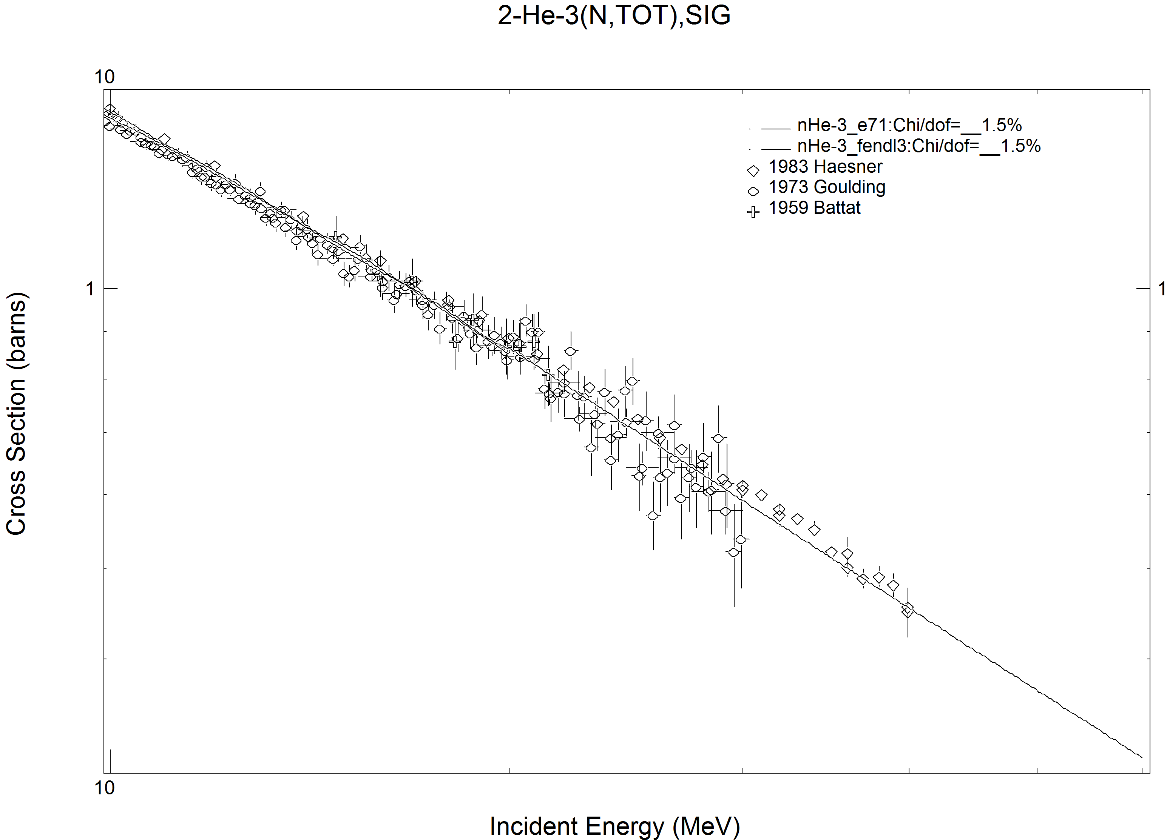
Figure 1: Total cross section of ³He extended to neutron incident energies up to 60 MeV.

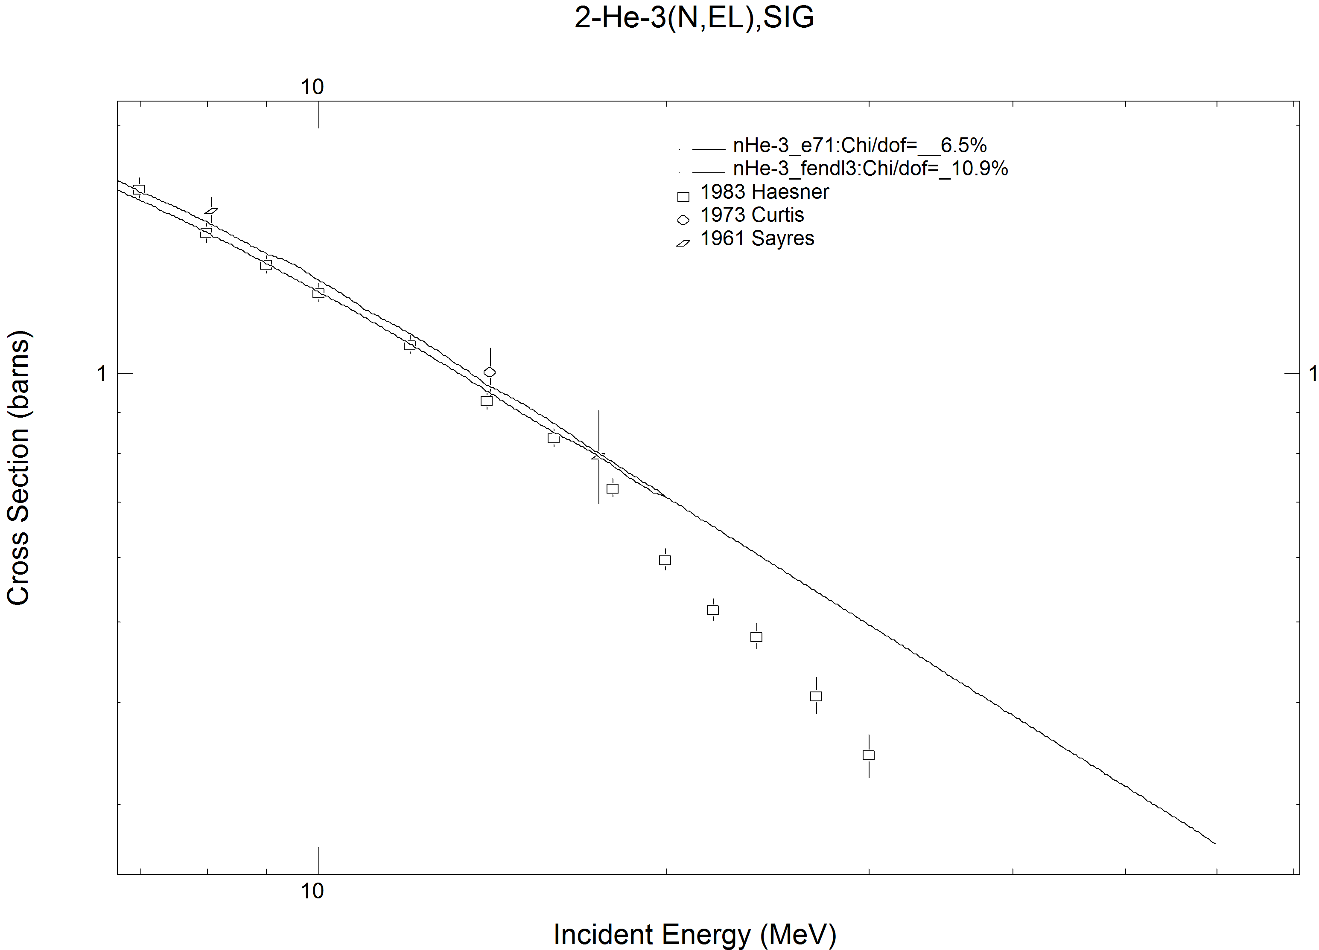
Figure 2: Elastic cross section of ³He extended to neutron incident energies up to 60 MeV.
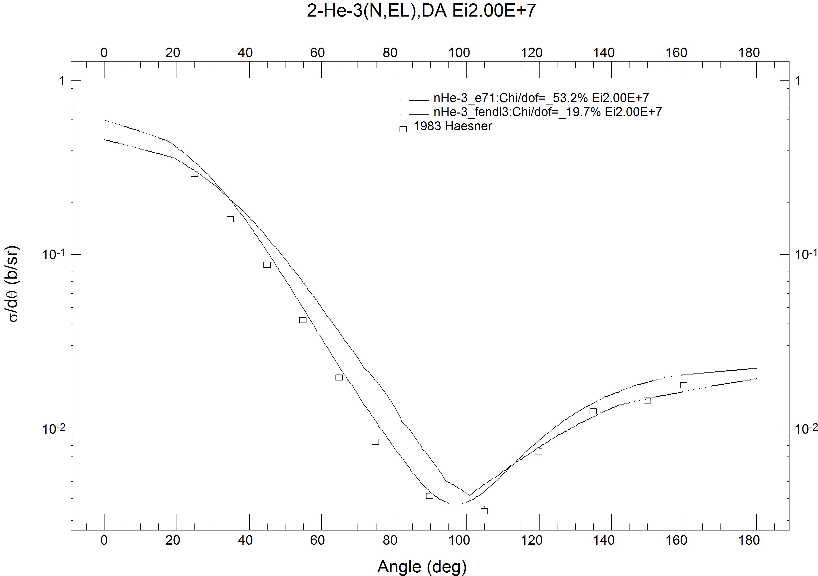
Figure 3: Differential elastic cross section of ³He for incident neutrons of 20 MeV.

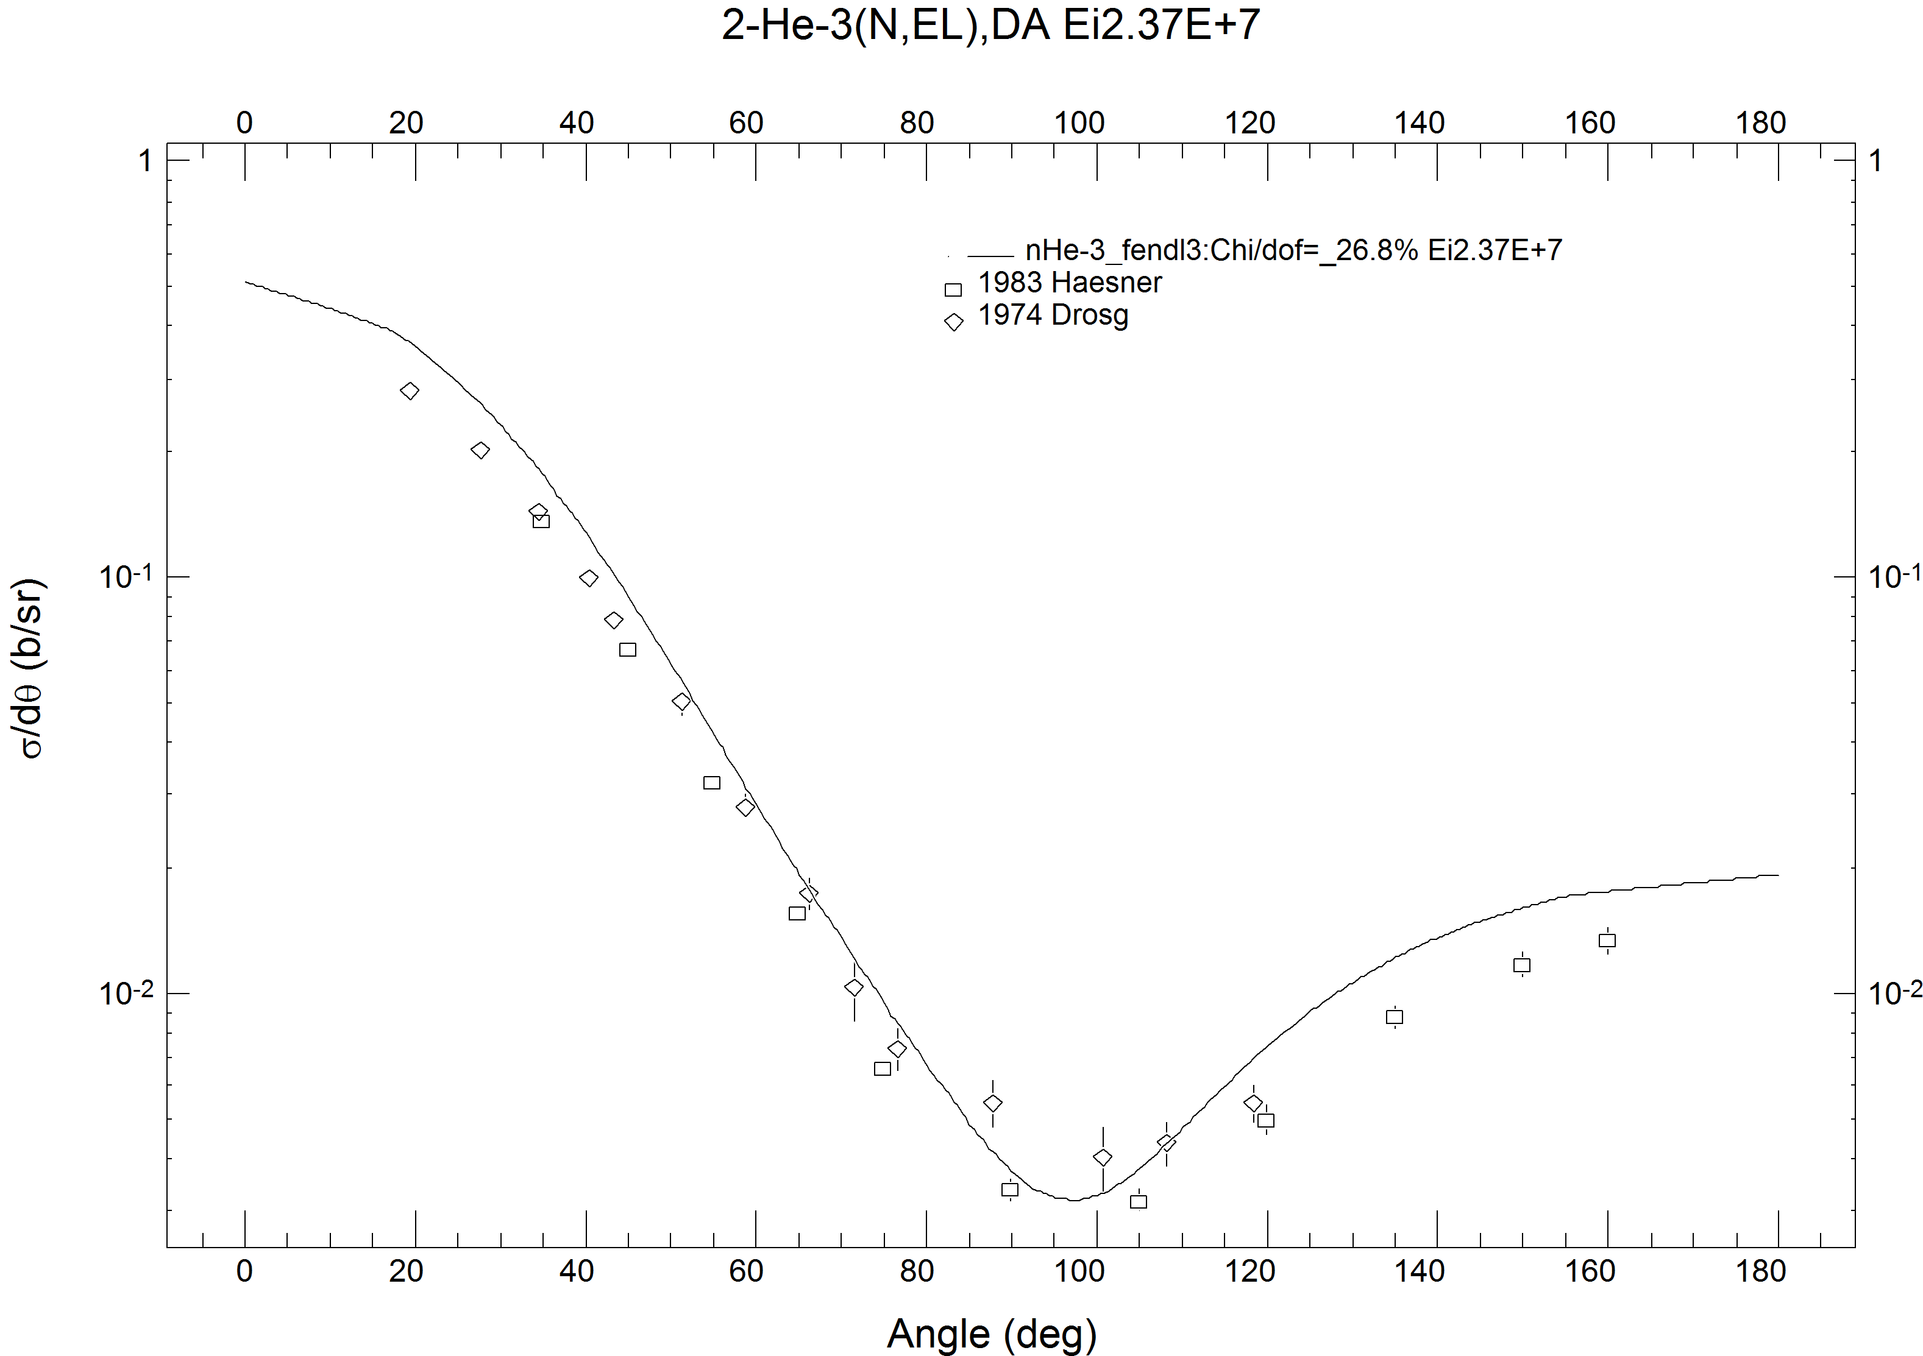
Figure 4: Differential elastic cross section of ³He for incident neutrons of 23.7 MeV.

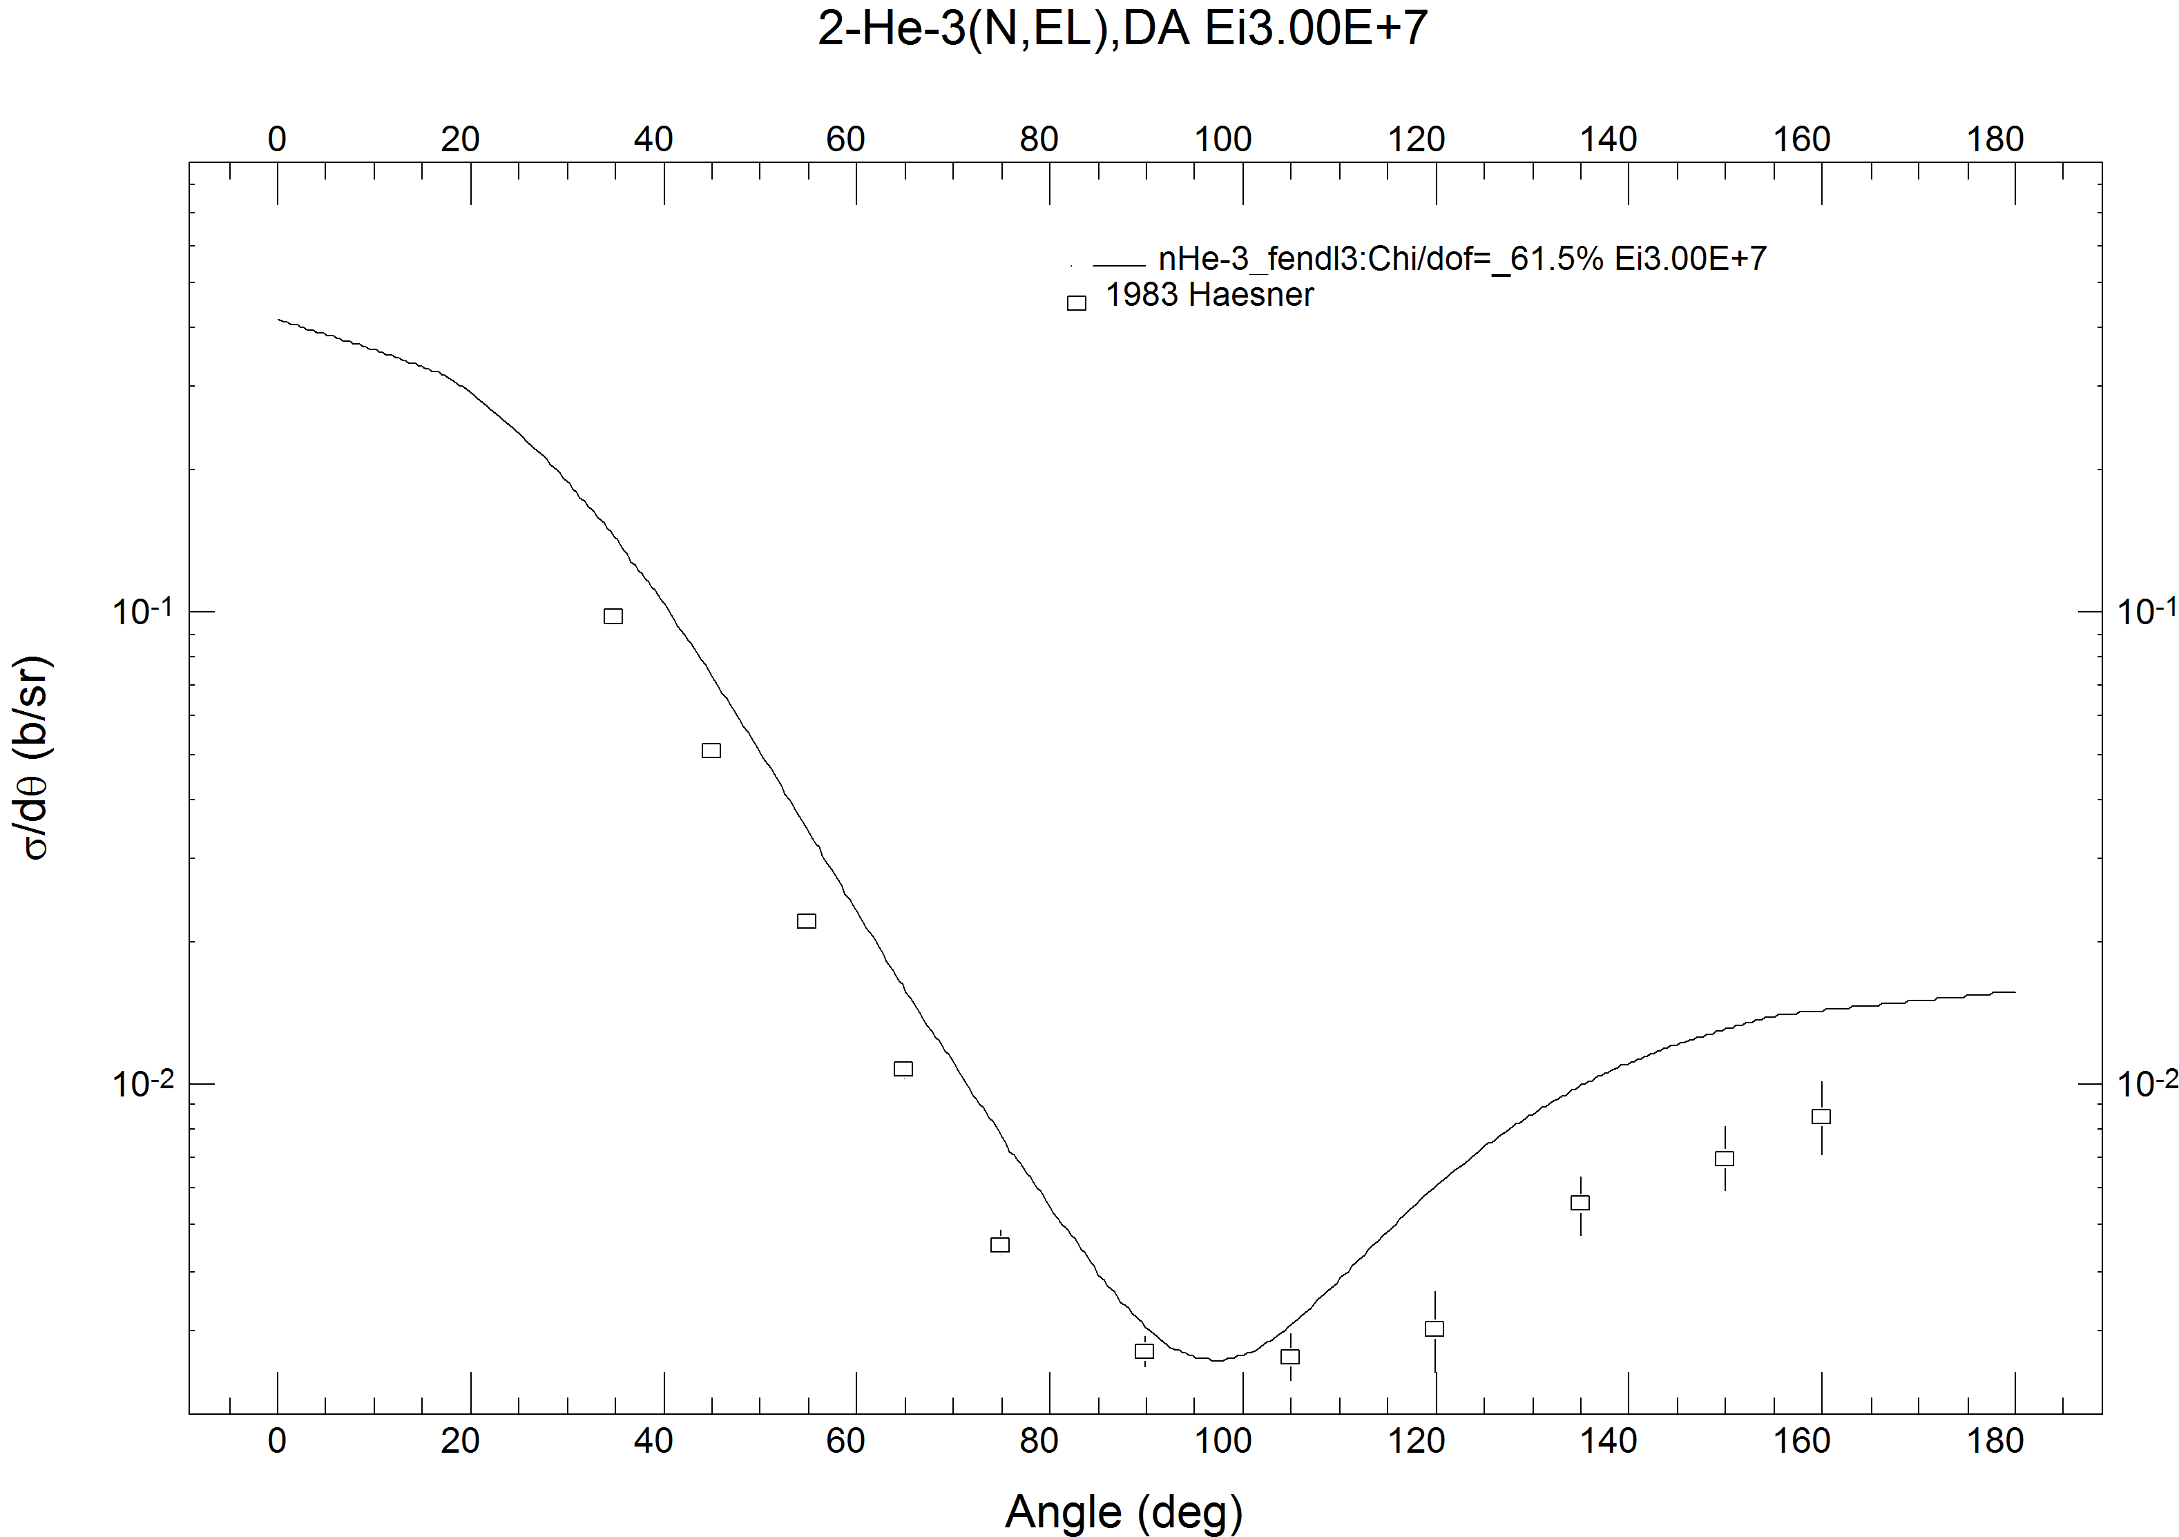
Figure 5: Differential elastic cross section of 4He for incident neutrons of 60 MeV

Non-elastic cross section
The non-elastic cross section is redundant and can be reconstructed from the cross sections of the constituting reactions. It is sometimes needed to describe the gamma-emission data, but this is not the case for ³He. Therefore, the reaction was deleted from the original file.

Radiative capture cross section
The radiative capture cross sections in the JENDL-4 library differ considerably from those in the ENDF/B-VII.1b4 library, which tend to be supported by the data of Komar and some other measurements, which are not in EXFOR. It is possible that the ENDF/B-VII.1b4 data are closer to the truth for this reaction in this energy region, but for the sake of consistency the JENDL-4 cross sections are retained. Extrapolation to 60 MeV is done assuming approximately a 1/v shape. The plot is shown on Figure 6.

Proton emission cross section
The proton emission cross section in JENDL-4 follows the data of Haesner [1] near 20 MeV. The same experimental data extend to 30 MeV. Extrapolation to 60 MeV is performed assuming linear behaviour in log-log scale with a gradient to match the Haesner data. The plot of the cross sections is shown in Figure 7. No emission spectra or angular distributions of protons are given.

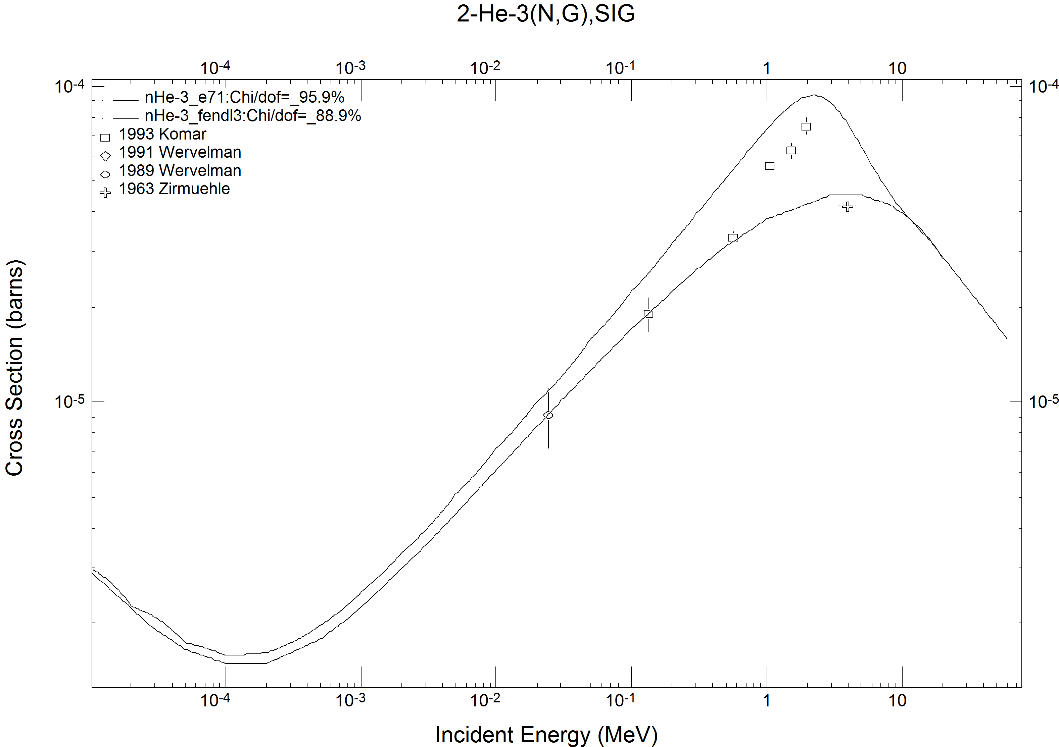
Figure 6: Radiative capture cross section of ³He .

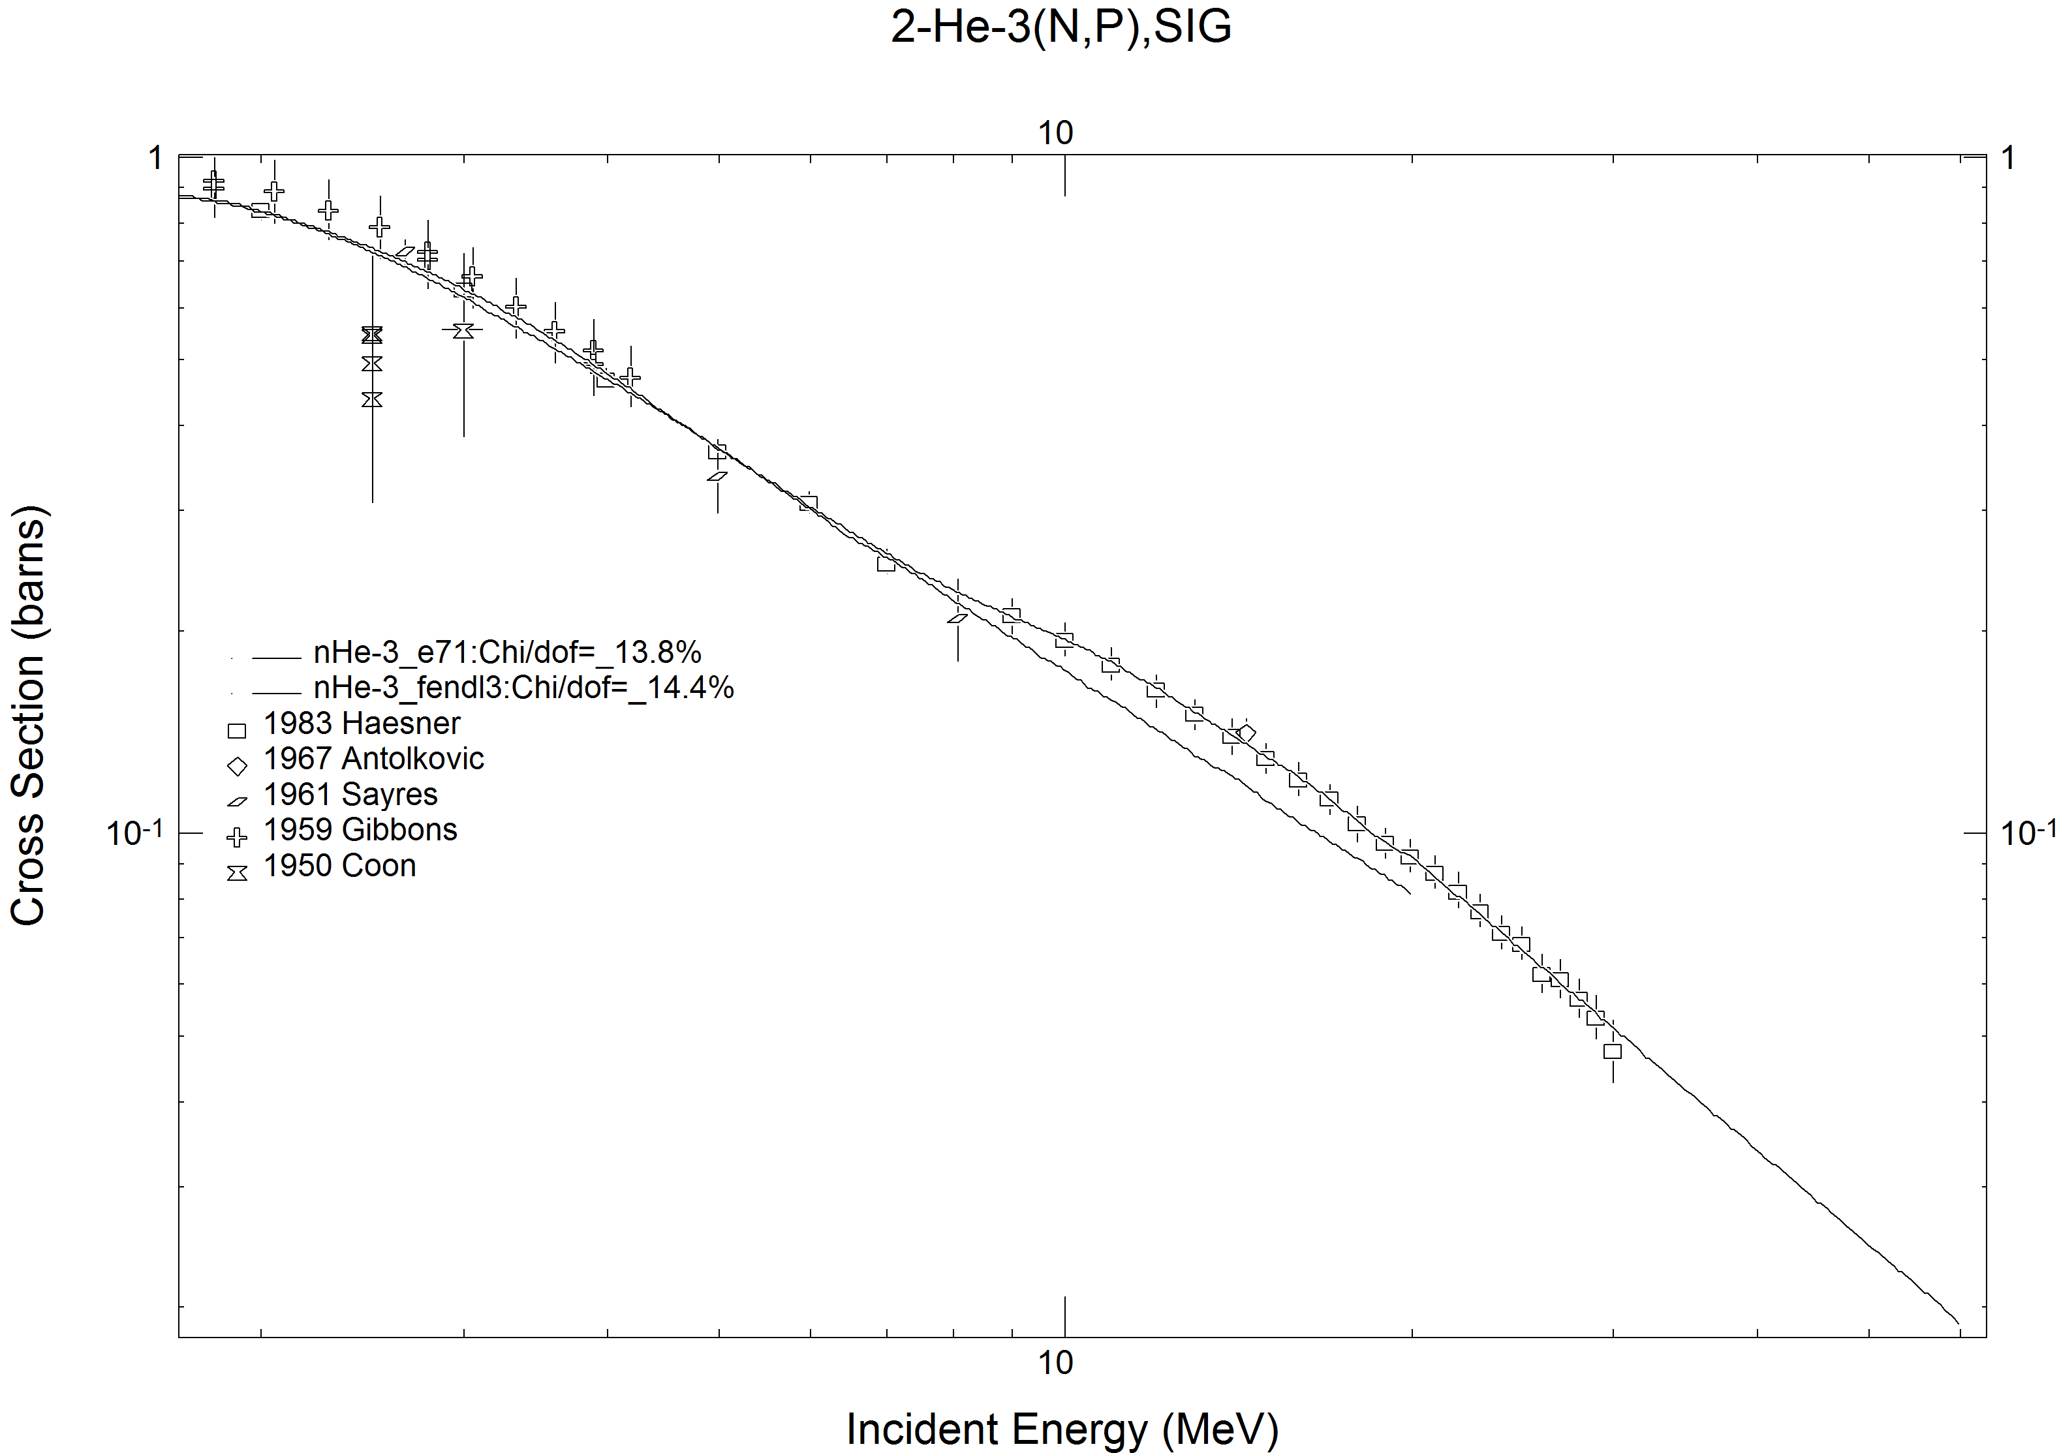
Figure 7: The (n,p) reaction cross section of ³He.
Deuteron emission cross section
Deuteron emission cross section has a threshold at 4.36 MeV. Above 10 MeV the data of Haesner [1] are available. The JENDL-4 evaluation seems to follow the data better than the ENDF/B-VII.1b4 evaluation. The measured data are available up to 30 MeV. Extrapolation to 60 MeV is performed assuming linear behaviour in log-log scale with a gradient to match the Haesner data. The cross section plot is shown in Figure 8. No emission spectra or angular distributions of deuterons are given.

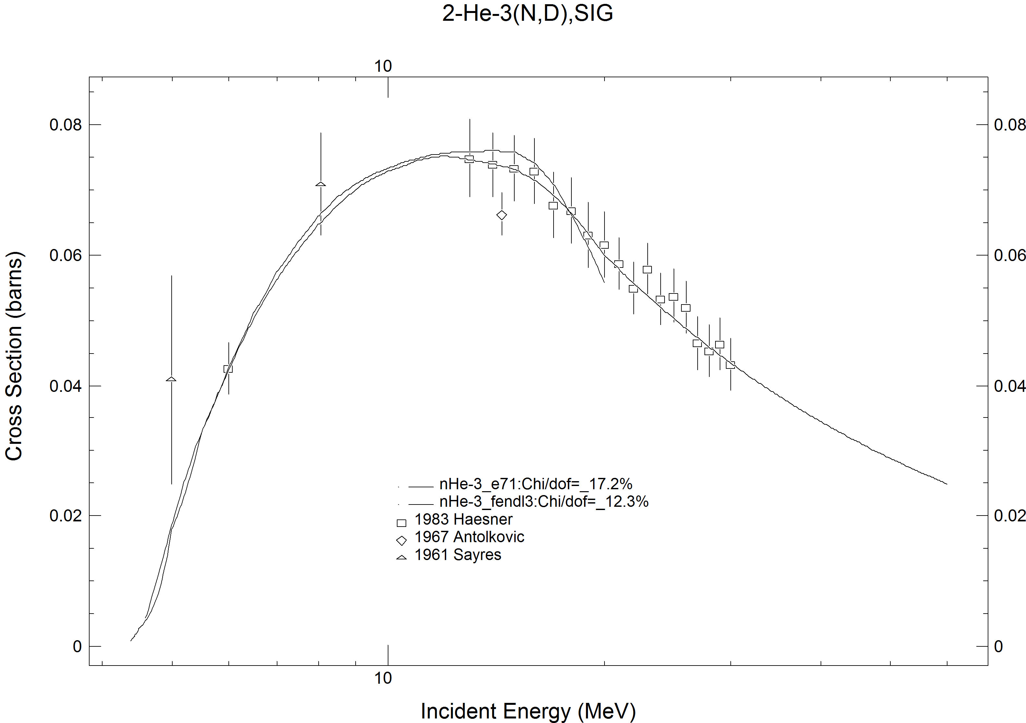
Figure 8: The (n,d) reaction cross section of ³He.

Verification
Neither the CHECKR nor the FIZCON codes reported no problems. PSYCHE reports that the scattering radius of 0.3 is not in the range between 0.1011 and 0.2456, but this is the evaluator’s choice.
Processability of the file is checked by running the codes of the PrePro-2010 series including LINEAR, RECENT, SIGMA1 and FIXUP. Further testing is done by running NJOY to generate an ACE library for Monte Carlo codes like MCNP and a MATXS library for deterministic codes. The heating curve generated by the HEATR module is useful for checking potential energy-balance problems and is shown in Figure 9. The figure did not reveal any problems. The plots produced by the ACER module also showed nothing suspicious and are not presented.

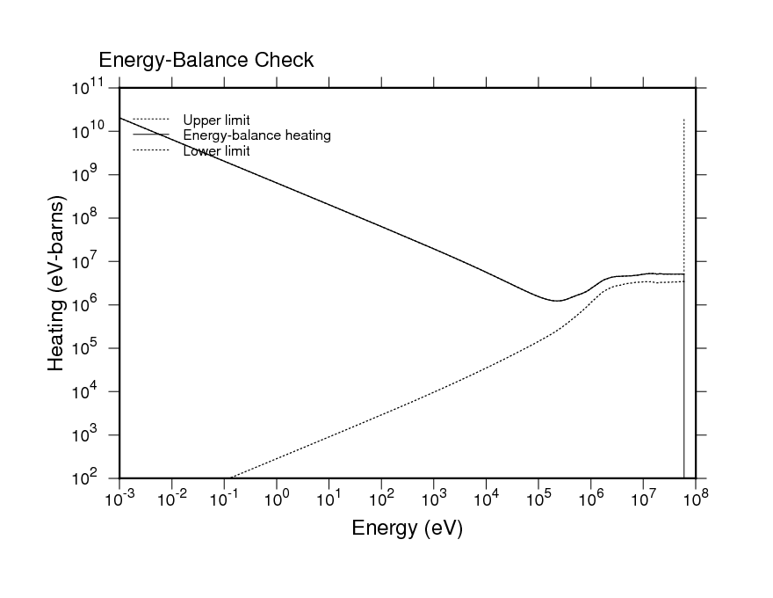
Figure 9: Plot of the heating calculated by the HEATR module of NJOY.

Conclusions
A viable evaluated nuclear data file for ³He for incident neutron energies up to 60 MeV was produced for inclusion in the FENDL-3 library by extending the JENDL-4 evaluation. The extension is based on ad-hoc methods and can not compete with evaluations based on rigorous R-matrix analysis such as announced by G. Hale from the Los Alamos National Laboratory, but the data from that evaluation above 20 MeV have not been released and are not likely to be available before the release of FENDL-3.

References
- B.Haesner, W.Heeringa, H.O.Klages, H.Dobiasch, G.Schmalz, P.Schwarz, J.Wilczynski, B.Zeitnitz, F.Kappeler, Measurement of the 3He and 4He Total Neutron Cross Sections up to 40 MeV, Physical Review, Part C, Nuclear Physics; Vol.28, Issue.3, p.995 (1983), EXFOR: 21883.
- C.A.Goulding, P.Stoler, J.D.Seagrave, 3He and 4He Total Neutron Cross Sections in the MeV Region, Nuclear Physics, Section A; Vol.215, p.253 (1973), EXFOR: 10278.
- M.E.Battat, R.O.Bondelid, J.H.Coon, L.Cranberg, R.B.Day, F.Edeskuty, A.H.Frentrop, R.L.Henkel, R.L.Mills, R.A.Nobles, J.E.Perry, D.D.Phillips, T.R.Roberts, S.G.Sydoriak, Total neutron cross sections of the hydrogen and helium isotopes, Nuclear Physics; Vol.12, p.291 (1959), EXFOR: 11021.

