Nuclear Data Section
International Atomic Energy Agency
P.O.Box 100, A-1400 Vienna, Austria

Memo 4C-3/0422

Date: 2023-10-05
To: Distribution
From: N. Otsuka, S.Dunaeva
Subject: NODATA record with free text: ALL POINTS ELIMINATED

In the relation with EXFOR master production, I checked whether there are any meaningful characters in cols. 63-66 of system identifiers and found only “ALL POINTS ELIMINATED FROM SET” as the meaningful one.

Example:

NODATA 0 0 ALL POINTS ELIMINATED FROM SET 20113005 26

It has been known this text is seen in some neutron data entries adopted from the BNL2005 master for production of the common EXFOR master. NNDC, NEA DB, NDS and CJD are invited for restoration of the numerical data (with background information under COMMENT, CRITIQUE, STATUS etc. if any).

The NDS retrieval system allows us to check what were originally compiled in this subentry:

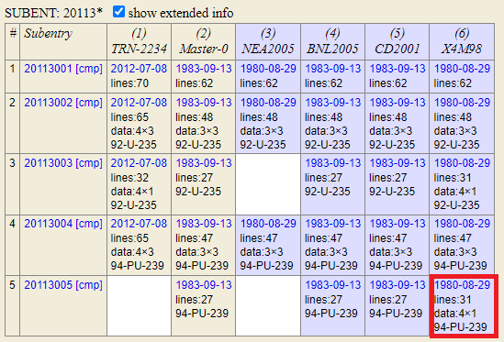

By clicking the date, we can see the numerical data originally compiled in this subentry:

DATA 4 1 20113005 26
EN-MAX EN-MIN DATA DATA-ERR 20113005 27
MEV MEV NO-DIM NO-DIM 20113005 28
6.74000E+1 0.00000E+0 2.70400E+0 5.10000E-2 20113005 29
ENDDATA 3 0 20113005 30

A secondary reference of this entry (H.Conde+, C,70HELSINKI,2,139,1970) reports this nu-bar value (2.704±0.051) as a preliminary value, and the compiler should think how to make this subentry more informative (e.g., restoration of the DATA section with an appropriate status code such as SPSDD and PRELM.).
As these characters may be eliminated during processing (e.g., during EXFOR master production), I would like to encourage NNDC, NEA DB, NDS and CJD to revise these subentries to exclude this free text under NODATA.

Subentries with free text “ALL POINTS ELIMINATED FROM SET” (as of 2 Oct. 2023)

- 10051.015-016,018-020,022-024,026-027,029-030,032
- 20113.005
- 20119.011
- 20152.020
- 20375.004,007
- 20390.005
- 20520.003,005
- 20797.002,004,006
- 21434.002
- 21435.002
- 21439.002-005
- 21442.002
- 21443.002-010
- 21447.002
- 21450.002
- 21841.003
- 21987.003
- 22000.004-007
- 30046.003-005
- 40518.013

Distribution:

a.koning@iaea.org
abhihere@gmail.com
aloks279@gmail.com
daniela.foligno@oecd-nea.org
dbrown@bnl.gov
dgremyachkin@ippe.ru
draj@barc.gov.in
exfor@oecd-nea.org
fukahori.tokio@jaea.go.jp
ganesan555@gmail.com
gezg@ciae.ac.cn
iwamoto.osamu@jaea.go.jp
jmwang@ciae.ac.cn
julia.sprenger@oecd-nea.org
kaltchen@ukr.net
kimdh@kaeri.re.kr
kimura.atsushi04@jaea.go.jp
l.vrapcenjak@iaea.org
manuel.bossant@oecd-nea.org
marina-03-08@yandex.ru
michael.fleming@oecd-nea.org
mvmikhaylyukova@ippe.ru
nicolas.soppera@oecd-nea.org
nomura@nucl.sci.hokudai.ac.jp
n.otsuka@iaea.org
nrdc@jcprg.org
nshu@ciae.ac.cn
odsurenn@gmail.com
ogritzay@ukr.net
otto.schwerer@aon.at
pikulina@expd.vniief.ru
pritychenko@bnl.gov
scyang@kaeri.re.kr
selyankina@expd.vniief.ru
sonzogni@bnl.gov
stakacs@atomki.mta.hu
stanislav.hlavac@savba.sk
sv.dunaeva@gmail.com
tada@nucl.sci.hokudai.ac.jp
taova@expd.vniief.ru
tarkanyi@atomki.hu
v.devi@iaea.org
v.zerkin@iaea.org
vidyathakur@yahoo.co.in
vsemkova@inrne.bas.bg
vvvarlamov@gmail.com
yolee@kaeri.re.kr
zholdybayev@inp.kz

