Nuclear Data Section
International Atomic Energy Agency
P.O.Box 100, A-1400 Vienna, Austria

Memo CP-D/1018

Date: 31 July 2021
To: Distribution
From: N. Otsuka

Subject: Na-24 isomer production data

Only the ground state is the isomeric state of ²⁴Na (i.e., states having half-life longer than 0.1 msec). Its first excitation level at 472 keV is a quasi-isomer (T_{1/2}=20 msec). The isomeric transition probability of 99.95%, and production of the quasi-isomer can be identified by detection of the 427 keV prompt gamma (e.g., online prompt gamma detection, cyclic activation). Its measurement technique is different from detection of the ground state (usual activation), and presence of 11-NA-24-G in REACTION SF4 (i.e., ²⁴Na production cross section excluding the quasi-isomer production) would be questionable.
I was asked by an EXFOR user if EXFOR C0700.005 (a dataset compiled with SF4=11-NA-24-G) excludes production of the short-lived state. As I (and maybe some of you) know “11-NA-24-G” is often seen in EXFOR Master, I extracted all 99 datasets coded with REACTION SF4=11-NA-24-G or 11-NA-24-M from EXFOR Master 2021-06-28, and quickly checked each dataset against the source article. They are mainly charged-particle induced data, and typically -G appeared when the entries were created or revised in 1997-2003.
In some datasets, originally -G or ISOMER=0 was added during revision of the entry.
Examples
- 20735.002: 11-NA-24-G+M,,SIG/SUM was revised to 11-NA-24-G,M+,SIG.
- B0073.020: 11-NA-24,M+,SIG was revised to 11-NA-24-G,CUM,SIG.
- M0152.002: ISOMER=0 was added to all data lines unless ISOMER=1 is given (!), then ISOMER=0 was deleted for many data lines (but kept for ²⁴Na).
- T0131.019: 11-NA-24,CUM,SIG (B0096.040) was revised to 11-NA-24-G,CUM,SIG.

My conclusions after the assessment are
- 11-NA-24-G in REACTION SF4 must be 11-NA-24 (but see also my remark on 22012.003).
- 11-NA-24-M in REACTION must be 11-NA-24-L
EXFOR 22012 is only the entry compiling the production cross section with 11-NA-24-G and 11-NA-24-M in REACTION SF4 together, which are tabulated and plotted as “(n,α₀)” and “(n,α₁)” cross sections in the source article (See next page). The former one is compared with the ²⁷Al(n,α)²⁴Na cross sections (important dosimetry cross section) evaluated by Tagesen & Vonach. The article figure shows the evaluated cross section agree with the (n,α₀) cross section, and I believe EXFOR 22012.003 includes the 20 msec state production.
Table 1 and Figure 5 of W.Enz et al., Ann. Phys. (Leipzig) 42(1985) 283
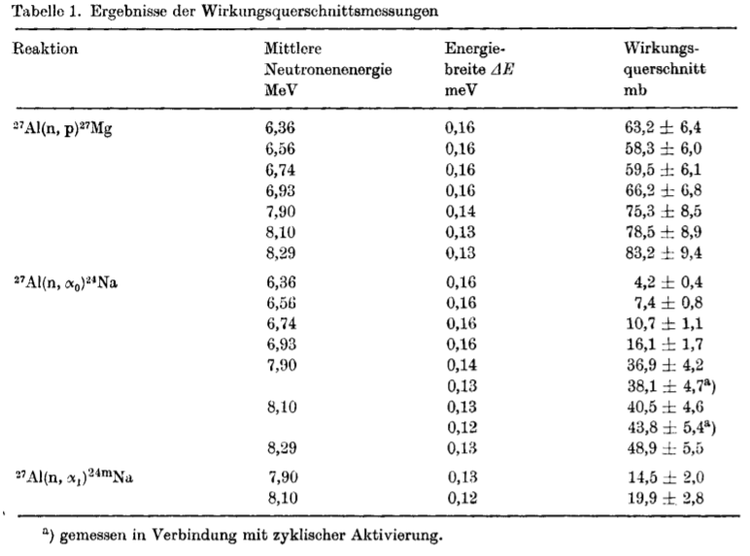
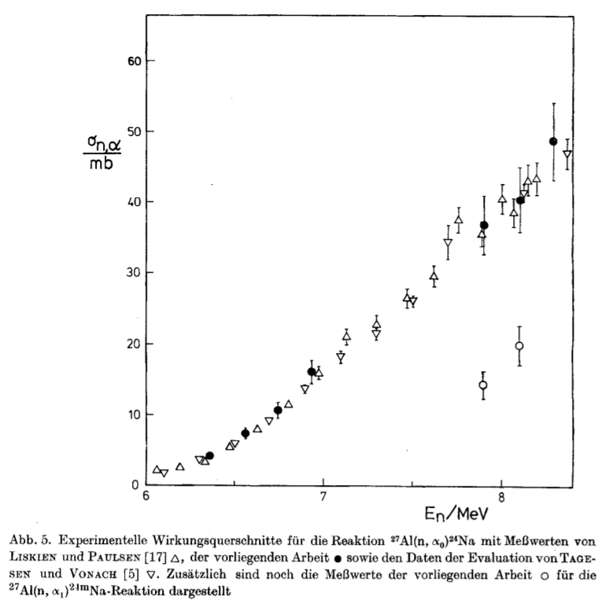

Datasets coded with SF4=11-NA-24-G or 11-NA-24-M in EXFOR Master 2021-06-28
“Detected” gives the radiation detected. 0.47, 1.37 and 2.76 gives the gamma energies in MeV.

Subentry | REACTION | Proposal | Detected | Additional comment
10186.002 | (13-AL-27(N,A)11-NA-24-M,,SIG) | Replace -M with -L. | 0.47 | Cyclic activation
10186.003 | (12-MG-24(N,P)11-NA-24-M,,SIG) | Replace -M with -L. | 0.47 | Cyclic activation
11365.002 | (11-NA-23(N,G)11-NA-24-G,,SIG,,SPA) | Remove -G.? | ? | The source (report) not available.
20191.002 | (13-AL-27(N,A)11-NA-24-G,,SIG,,FIS) | Remove -G. | B-
20735.002 | (12-MG-24(N,P)11-NA-24-G,M+,SIG,,FIS) | Remove -G. | B | Originally compiled with -G+M,,SIG/SUM
20735.003 | (13-AL-27(N,A)11-NA-24-G,M+,SIG,,FIS) | Remove -G. | B | Originally compiled with -G+M,,SIG/SUM
22012.003 | (13-AL-27(N,A)11-NA-24-G,,SIG) | Remove -G. | 0.47 | See the remark on the article table and figure in this memo.
22012.004 | (13-AL-27(N,A)11-NA-24-M,,SIG) | Replace -M with -L. | 1.37
22201.002 | ((26-FE-56(N,P)25-MN-56,,SIG)/  (13-AL-27(N,A)11-NA-24-G,,SIG)) | Remove -G. | ?
22201.003 | ((28-NI-58(N,P)27-CO-58,,SIG)/  (13-AL-27(N,A)11-NA-24-G,,SIG)) | Remove -G. | ?
31528.010 | (13-AL-27(N,A)11-NA-24-M,,SIG) | Replace -M with -L. | 0.47 | SF7=G -> DG for some points of 002 and 003.
40589.002 | (11-NA-23(N,G)11-NA-24-M,,SIG,,MXW) | Replace -M with -L. | ?
40784.003 | (12-MG-0(N,X)11-NA-24-M,,SIG) | Replace -M with -L. | 0.47
40784.004 | (13-AL-27(N,A)11-NA-24-M,,SIG) | Replace -M with -L. | 0.47
A0438.003 | (26-FE-0(6-C-12,X)ELEM/MASS,CUM,SIG) | Remove ISOMER=0 for 11-NA-24. | DG
A0438.005 | (26-FE-0(8-O-16,X)ELEM/MASS,CUM,SIG) | Remove ISOMER=0 for 11-NA-24. | DG
A0439.003 | (41-NB-93(6-C-12,X)ELEM/MASS,CUM,SIG) | Remove ISOMER=0 for 11-NA-24. | DG
A0439.005 | (73-TA-181(6-C-12,X)ELEM/MASS,CUM,SIG) | Remove ISOMER=0 for 11-NA-24. | DG
A0463.002 | (29-CU-0(3-LI-7,X)ELEM/MASS,CUM,SIG) | Remove ISOMER=0 for 11-NA-24. | DG
A0486.005 | (82-PB-0(3-LI-7,X)ELEM/MASS,CUM,SIG) | Remove ISOMER=0 for 11-NA-24. | DG
A0611.008 | (50-SN-118(P,X)11-NA-24-G,CUM,SIG) | Remove -G. | DG
B0016.003.1 | (13-AL-27(P,X)11-NA-24-G,M+,SIG,,,EXP) | Remove -G. | B- | The source (thesis) not available.
B0016.003.2 | (13-AL-27(P,X)11-NA-24-G,M+,SIG,,,EXP) | Remove -G. | DG | The source (thesis) not available.
B0022.003 | (13-AL-27(P,X)11-NA-24-G,CUM,SIG,,,EVAL) | Remove -G. | B-,1.37,2.76
B0022.004 | ((13-AL-27(P,X)11-NA-24-G,CUM,SIG,,,EVAL)/  (6-C-12(P,X)6-C-11,,SIG,,,EVAL)) | Remove -G.
B0049.004 | (12-MG-25(P,2P)11-NA-24-G,M+,SIG,,,EXP) | Remove -G. | B?
B0073.020 | (13-AL-27(P,X)11-NA-24-G,CUM,SIG,,,EXP) | Remove -G. | 1.37
B0076.003 | (13-AL-27(P,X)11-NA-24-G,CUM,SIG,,,EXP) | Remove -G. | B
B0078.002.2 | (29-CU-0(P,X)11-NA-24-G,IND/M+,SIG,,,EXP) | Remove -G. | 1.37
B0078.002.R | ((29-CU-0(P,X)10-NE-24,CUM,SIG,,,EXP)/  (29-CU-0(P,X)11-NA-24-G,IND/M+,SIG,,,EXP)) | Remove -G. | 1.37
B0078.003.1 | (47-AG-0(P,X)10-NE-24,CUM,SIG,,,EXP) | Remove -G. | 1.37
B0078.003.2 | (47-AG-0(P,X)11-NA-24-G,IND/M+,SIG,,,EXP) | Remove -G. | 1.37
B0078.003.R | ((47-AG-0(P,X)10-NE-24,CUM,SIG,,,EXP)/  (47-AG-0(P,X)11-NA-24-G,IND/M+,SIG,,,EXP)) | Remove -G. | 1.37
B0078.004.1 | (79-AU-197(P,X)10-NE-24,CUM,SIG,,,EXP) | Remove -G. | 1.37
B0078.004.2 | (79-AU-197(P,X)11-NA-24-G,IND/M+,SIG,,,EXP) | Remove -G. | 1.37
B0078.004.R | ((79-AU-197(P,X)10-NE-24,CUM,SIG,,,EXP)/  (79-AU-197(P,X)11-NA-24-G,IND/M+,SIG,,,EXP)) | Remove -G. | 1.37
B0078.005.2 | (92-U-0(P,X)11-NA-24-G,IND/M+,SIG,,,EXP) | Remove -G. | 1.37
B0078.005.R | ((92-U-0(P,X)10-NE-24,CUM,SIG,,,EXP)/  (92-U-0(P,X)11-NA-24-G,IND/M+,SIG,,,EXP)) | Remove -G. | 1.37
B0147.003 | (79-AU-197(PIP,X)11-NA-24-G,CUM,SIG,,,EXP) | Remove -G. | DG
B0147.004 | (79-AU-197(PIN,X)11-NA-24-G,CUM,SIG,,,EXP) | Remove -G. | DG
C0700.005 | (13-AL-27(P,N+3P)11-NA-24-G,,SIG) | Remove -G. | B
M0152.002 | (29-CU-0(G,X)ELEM/MASS,,SIG,,BRA) | Remove ISOMER=0 for 11-NA-24. | 1.37
M0152.003 | (29-CU-0(G,X)ELEM/MASS,,SIG,,BRA) | Remove ISOMER=0 for 11-NA-24. | 1.37
M0152.004 | (29-CU-0(G,X)ELEM/MASS,,SIG,,BRA) | Remove ISOMER=0 for 11-NA-24. | 1.37
M0152.005 | (29-CU-0(G,X)ELEM/MASS,,SIG,,BRA) | Remove ISOMER=0 for 11-NA-24. | 1.37
M0152.006 | (25-MN-55(G,X)ELEM/MASS,,SIG,,BRA) | Remove ISOMER=0 for 11-NA-24. | 1.37
M0152.007 | (25-MN-55(G,X)ELEM/MASS,,SIG,,BRA) | Remove ISOMER=0 for 11-NA-24. | 1.37
M0152.008 | (25-MN-55(G,X)ELEM/MASS,,SIG,,BRA) | Remove ISOMER=0 for 11-NA-24. | 1.37
M0152.009 | (25-MN-55(G,X)ELEM/MASS,,SIG,,BRA) | Remove ISOMER=0 for 11-NA-24. | 1.37
M0152.010 | (23-V-51(G,X)ELEM/MASS,,SIG,,BRA) | Remove ISOMER=0 for 11-NA-24. | 1.37
M0152.011 | (23-V-51(G,X)ELEM/MASS,,SIG,,BRA) | Remove ISOMER=0 for 11-NA-24. | 1.37
M0152.012 | (23-V-51(G,X)ELEM/MASS,,SIG,,BRA) | Remove ISOMER=0 for 11-NA-24. | 1.37
M0152.013 | (23-V-51(G,X)ELEM/MASS,,SIG,,BRA) | Remove ISOMER=0 for 11-NA-24. | 1.37
M0152.014 | (29-CU-0(G,X)ELEM/MASS,,SIG,,BRA) | Remove ISOMER=0 for 11-NA-24. | 1.37
M0152.015 | (25-MN-55(G,X)ELEM/MASS,,SIG,,BRA) | Remove ISOMER=0 for 11-NA-24. | 1.37
M0152.016 | (23-V-51(G,X)ELEM/MASS,,SIG,,BRA) | Remove ISOMER=0 for 11-NA-24. | 1.37
O0412.002 | (11-NA-23(P,PIP)11-NA-24-G,IND/M+,SIG) | Remove -G. | B,2.76
O0412.003 | (12-MG-0(P,X)11-NA-24-G,CUM,SIG) | Remove -G. | B,2.76
O0412.004 | (14-SI-0(P,X)11-NA-24-G,CUM,SIG) | Remove -G. | B,2.76
O0412.006 | (16-S-0(P,X)11-NA-24-G,CUM,SIG) | Remove -G. | B,2.76
O0412.007 | (17-CL-0(P,X)11-NA-24-G,CUM,SIG) | Remove -G. | B,2.76
O0412.008 | (19-K-0(P,X)11-NA-24-G,CUM,SIG) | Remove -G. | B,2.76
O0412.009 | (20-CA-0(P,X)11-NA-24-G,CUM,SIG) | Remove -G. | B,2.76
O0412.011 | (22-TI-0(P,X)11-NA-24-G,CUM,SIG) | Remove -G. | B,2.76
O0412.012 | (23-V-51(P,X)11-NA-24-G,CUM,SIG) | Remove -G. | B,2.76
O0412.013 | (24-CR-0(P,X)11-NA-24-G,CUM,SIG) | Remove -G. | B,2.76
O0412.014 | (25-MN-55(P,X)11-NA-24-G,CUM,SIG) | Remove -G. | B,2.76
O0412.015 | (26-FE-0(P,X)11-NA-24-G,CUM,SIG) | Remove -G. | B,2.76
O0412.016 | (27-CO-59(P,X)11-NA-24-G,CUM,SIG) | Remove -G. | B,2.76
O0412.017 | (28-NI-0(P,X)11-NA-24-G,CUM,SIG) | Remove -G. | B,2.76
O0412.018 | (29-CU-0(P,X)11-NA-24-G,CUM,SIG) | Remove -G. | B,2.76
O0412.019 | (30-ZN-0(P,X)11-NA-24-G,CUM,SIG) | Remove -G. | B,2.76
O0412.020 | (31-GA-0(P,X)11-NA-24-G,CUM,SIG) | Remove -G. | B,2.76
O0412.021 | (32-GE-0(P,X)11-NA-24-G,CUM,SIG) | Remove -G. | B,2.76
O0412.022 | (33-AS-75(P,X)11-NA-24-G,CUM,SIG) | Remove -G. | B,2.76
O0412.023 | (34-SE-0(P,X)11-NA-24-G,CUM,SIG) | Remove -G. | B,2.76
O0412.024 | (38-SR-0(P,X)11-NA-24-G,CUM,SIG) | Remove -G. | B,2.76
O0412.025 | (39-Y-89(P,X)11-NA-24-G,CUM,SIG) | Remove -G. | B,2.76
O0412.026 | (40-ZR-0(P,X)11-NA-24-G,CUM,SIG) | Remove -G. | B,2.76
O0412.027 | (41-NB-93(P,X)11-NA-24-G,CUM,SIG) | Remove -G. | B,2.76
O0412.028 | (42-MO-0(P,X)11-NA-24-G,CUM,SIG) | Remove -G. | B,2.76
O0412.029 | (46-PD-0(P,X)11-NA-24-G,CUM,SIG) | Remove -G. | B,2.76
O0412.030 | (47-AG-0(P,X)11-NA-24-G,CUM,SIG) | Remove -G. | B,2.76
O0412.031 | (48-CD-0(P,X)11-NA-24-G,CUM,SIG) | Remove -G. | B,2.76
O0412.032 | (49-IN-0(P,X)11-NA-24-G,CUM,SIG) | Remove -G. | B,2.76
O0412.033 | (50-SN-0(P,X)11-NA-24-G,CUM,SIG) | Remove -G. | B,2.76
O0412.034 | (73-TA-181(P,X)11-NA-24-G,CUM,SIG) | Remove -G. | B,2.76
O0412.035 | (79-AU-197(P,X)11-NA-24-G,CUM,SIG) | Remove -G. | B,2.76
O0412.036 | (82-PB-0(P,X)11-NA-24-G,CUM,SIG) | Remove -G. | B,2.76
O0412.037 | (92-U-0(P,X)11-NA-24-G,CUM,SIG) | Remove -G. | B,2.76
O0467.002 | (92-U-0(P,X)11-NA-24-G,CUM,SIG) | Remove -G. | 1.37,2.76
O0500.004 | (82-PB-0(P,X)11-NA-24-G,CUM,SIG) | Remove -G. | 1.37? | Not clear if the decay data are from the authors. (Not seen in Gloris's thesis.)
P0067.005 | (13-AL-27(D,P+A)11-NA-24-G,,SIG) | Remove -G. | B | -G in 002-004 removed in 2000. 005 overlooked?
P0124.002 | (13-AL-27(D,P+A)11-NA-24-G,,SIG) | Remove -G. | B
T0131.019 | (26-FE-0(P,X)11-NA-24-G,CUM,SIG) | Remove -G. | B | -G was added when it was moved from B0096.
T0131.044 | (29-CU-0(P,X)11-NA-24-G,CUM,SIG) | Remove -G. | B | -G was added when it was moved from B0096.
T0200.002 | (29-CU-0(6-C-12,X)ELEM/MASS,CUM,SIG) | Remove ISOMER=0 for 11-NA-24. | DG
T0200.003 | (29-CU-0(6-C-12,X)ELEM/MASS,CUM,SIG) | Remove ISOMER=0 for 11-NA-24. | DG
T0201.002 | (29-CU-0(6-C-12,X)ELEM/MASS,CUM,SIG) | Remove ISOMER=0 for 11-NA-24. | DG

Distribution:

a.koning@iaea.org
abhihere@gmail.com
aloks279@gmail.com
bknayak@barc.gov.in
daniela.foligno@oecd-nea.org
dbrown@bnl.gov
draj@barc.gov.in
exfor@oecd-nea.org
franco.michel-sendis@oecd-nea.org
fukahori.tokio@jaea.go.jp
ganesan555@gmail.com
gezg@ciae.ac.cn
iwamoto.osamu@jaea.go.jp
jmwang@ciae.ac.cn
kaltchenko@kinr.kiev.ua
kimdh@kaeri.re.kr
kimura.atsushi04@jaea.go.jp
l.vrapcenjak@iaea.org
manuel.bossant@oecd-nea.org
masaaki@nucl.sci.hokudai.ac.jp
michael.fleming@oecd-nea.org
mmarina@ippe.ru
nicolas.soppera@oecd-nea.org
n.otsuka@iaea.org
nrdc@jcprg.org
odsurenn@gmail.com
ogritzay@ukr.net
ogrudzevich@ippe.ru
otto.schwerer@aon.at
pikulina@expd.vniief.ru
pritychenko@bnl.gov
scyang@kaeri.re.kr
selyankina@expd.vniief.ru
sonzogni@bnl.gov
stakacs@atomki.mta.hu
stanislav.hlavac@savba.sk
sv.dunaeva@gmail.com
tada@nucl.sci.hokudai.ac.jp
taova@expd.vniief.ru
tarkanyi@atomki.hu
vvvarlamov@gmail.com
v.zerkin@iaea.org
vidyathakur@yahoo.co.in
vsemkova@inrne.bas.bg
yolee@kaeri.re.kr
zholdybayev@inp.kz

cc:
alexander.konobeev@kit.edu

