Nuclear Data Section
International Atomic Energy Agency
P.O.Box 100, A-1400 Vienna, Austria

Memo CP-D/1021

Date: 18 August 2021
To: Distribution
From: N. Otsuka, S. Dunaeva

Subject: Use of NUMBER-CM and compilation of 0th order Legendre coefficients

1. Do we need heading NUMBER-CM?
It is obvious that the fitting coefficients are to express an angular dependent quantity in the centre-of-mass system when the coefficients are coded under the heading DATA-CM. We propose to make the heading NUMBER-CM obsolete, and to always use the heading NUMBER for indication of the order of the coefficient.
The historical background is not clear. In the archive dictionary 24, NUMBER-CM and ANG-CM are defined with “198202” while DATA-CM is defined with “198503”. There might be discussion on addition of DATA-CM in the NRDC 1984 meeting. However, its meeting summary (Memo CP-D/131) is not available at NDS.

2. Compilation of 0th order Legendre coefficients
Our current rule is to compile the 0th order Legendre coefficient (=σ/4π) with ,DA,,LEG and NUMBER=0. Its relation with the cross section is not clear from the quantity code. It can be compiled with higher order coefficients in the same subentry, and it is not trivial for end users to plot the compiled 0th order coefficients with the usual cross sections.

Example – ¹¹B(n,n0)¹¹B elastic scattering cross sections (EXFOR 10093.139)
EXFOR 10093 does not provide a (5-B-11(N,EL)5-B-11,,SIG) dataset, but the 0th order Legendre coefficients in 10093.139 multiplied by 4π can be compared with the elastic scattering cross sections in other EXFOR entries in a plot.
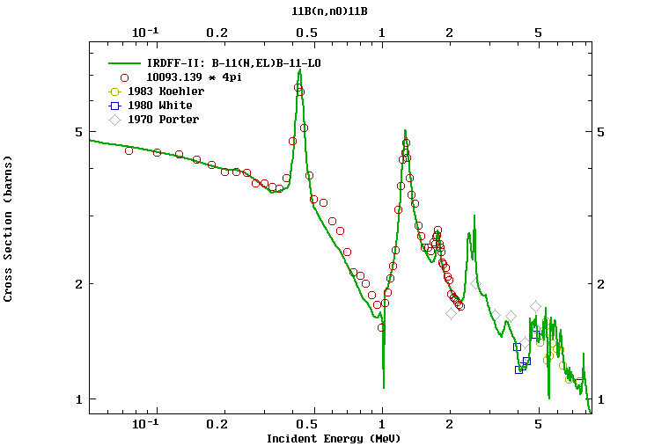
The 0th order coefficients must be more utilized by this way.
In order to make to the 0th order Legendre coefficients more usable for end users (e.g., through conversion to normal cross section in end-user outputs such as C4 and C5), we would like to propose a new quantity code for their compilation separately from higher order coefficients.

Dictionary 34 (Modifiers)
D4PI Divided by 4pi

Dictionary 236 (Quantities)
,SIG,,D4PI Cross section divided by 4pi

Distribution:

a.koning@iaea.org
abhihere@gmail.com
aloks279@gmail.com
bknayak@barc.gov.in
daniela.foligno@oecd-nea.org
dbrown@bnl.gov
draj@barc.gov.in
exfor@oecd-nea.org
franco.michel-sendis@oecd-nea.org
fukahori.tokio@jaea.go.jp
ganesan555@gmail.com
gezg@ciae.ac.cn
iwamoto.osamu@jaea.go.jp
jmwang@ciae.ac.cn
kaltchenko@kinr.kiev.ua
kimdh@kaeri.re.kr
kimura.atsushi04@jaea.go.jp
l.vrapcenjak@iaea.org
manuel.bossant@oecd-nea.org
masaaki@nucl.sci.hokudai.ac.jp
michael.fleming@oecd-nea.org
mmarina@ippe.ru
nicolas.soppera@oecd-nea.org
n.otsuka@iaea.org
nrdc@jcprg.org
odsurenn@gmail.com
ogritzay@ukr.net
ogrudzevich@ippe.ru
otto.schwerer@aon.at
pikulina@expd.vniief.ru
pritychenko@bnl.gov
scyang@kaeri.re.kr
selyankina@expd.vniief.ru
sonzogni@bnl.gov
stakacs@atomki.mta.hu
stanislav.hlavac@savba.sk
sv.dunaeva@gmail.com
tada@nucl.sci.hokudai.ac.jp
taova@expd.vniief.ru
tarkanyi@atomki.hu
vvvarlamov@gmail.com
v.zerkin@iaea.org
vidyathakur@yahoo.co.in
vsemkova@inrne.bas.bg
yolee@kaeri.re.kr
zholdybayev@inp.kz

