Nuclear Data Section
International Atomic Energy Agency
P.O.Box 100, A-1400 Vienna, Austria

Memo CP-D/1026

Date: 6 October 2021
To: Distribution
From: N. Otsuka

Subject: Wrong use of MONIT-ERR

An error budget table of measured cross sections usually summarizes fractional (%) uncertainties of the measured quantity. However, a number of recent activation cross section articles from India give them in the absolute unit (b):

Example: I.Pasha+,J,JRN,320,561,2019 (EXFOR 33129)

The authors used the ¹⁹⁷Au(n,2n)¹⁹⁶Au cross section σ_{M}=2.160±0.0198 b (0.92%).

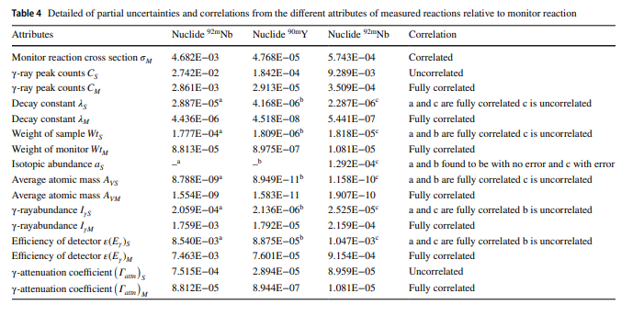
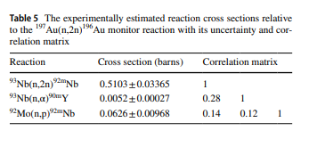
Table 4 does not explain the unit of the uncertainties(!). The ratios of the “Monitor reaction cross section σ_{M}” values to the cross section values in Table 5 are 0.92% for all three reactions (e.g., 4.682E-03/0.5103), and we can infer that the first line of Table 4 is not for the uncertainty in the monitor cross section but for the uncertainty in the measured cross section due to the uncertainty in the monitor cross section.
The uncertainty values in the first line of Table 4were coded under MONIT-ERR in a draft of the EXFOR entry. But this is wrong since this heading is for “Error in normalization value” according to Dictionary 24. (N.B. “error” should read “uncertainty” in the current nomenclature in metrology.). I believe this entry must be revised.
Example
/1/ Current 33129.002 (incorrect):

SUBENT 33129002 20191113
BIB 3 18
REACTION (41-NB-93(N,2N)41-NB-92-M,,SIG)
…
ERR-ANALYS (ERR-T) Total uncertainty
(MONIT-ERR) Uncertainty in monitor cross section
…
COMMON 16 9
MONIT MONIT-ERR
B B
2.160 4.682E-03
ENDCOMMON 9

/2/ /1/ must be corrected to:
SUBENT 33129002 20191113
BIB 3 18
REACTION (41-NB-93(N,2N)41-NB-92-M,,SIG)
…
ERR-ANALYS (ERR-T) Total uncertainty
(MONIT-ERR) Uncertainty in monitor cross section
…
COMMON 16 9
MONIT MONIT-ERR
B B
2.160 0.0198
ENDCOMMON 9

/3/ or alternatively corrected to:
SUBENT 33129002 20191113
BIB 3 18
REACTION (41-NB-93(N,2N)41-NB-92-M,,SIG)
…
ERR-ANALYS (ERR-T) Total uncertainty
(ERR-1) Uncertainty due to monitor cross section
…
COMMON 16 9
MONIT ERR-1
B B
2.160 4.682E-03
ENDCOMMON 9

The partial uncertainty ERR-1 etc. in the absolute unit is unusual, but this is what the authors report.
The monitor value is always proportional to the measured quantity (c.f. LEXFOR Standards). It means the ratio of the absolute MONIT-ERR value (e,g, in barn) to MONIT value always gives the partial uncertainty of the measured quantity in %. In the other words, the absolute MONIT-ERR value gives the information on the uncertainty of the measured quantity only when the MONIT value is coded together. I suggest that the absolute MONIT-ERR value is coded only when the MONIT value is coded together.
I checked the EXFOR entries compiling the activation cross sections from Indian published in 2015 and later. I found the four entries (33114, 33117, 33129, 33141) use MONIT-ERR for the partial uncertainty in the measured cross section wrongly, and proposed corrections are summarized in the appendix of this memo.

Distribution:

a.koning@iaea.org
abhihere@gmail.com
aloks279@gmail.com
bknayak@barc.gov.in
daniela.foligno@oecd-nea.org
dbrown@bnl.gov
draj@barc.gov.in
exfor@oecd-nea.org
fukahori.tokio@jaea.go.jp
ganesan555@gmail.com
gezg@ciae.ac.cn
iwamoto.osamu@jaea.go.jp
jmwang@ciae.ac.cn
kaltchenko@kinr.kiev.ua
kimdh@kaeri.re.kr
kimura.atsushi04@jaea.go.jp
l.vrapcenjak@iaea.org
manuel.bossant@oecd-nea.org
masaaki@nucl.sci.hokudai.ac.jp
michael.fleming@oecd-nea.org
mmarina@ippe.ru
nicolas.soppera@oecd-nea.org
n.otsuka@iaea.org
nrdc@jcprg.org
odsurenn@gmail.com
ogritzay@ukr.net
ogrudzevich@ippe.ru
otto.schwerer@aon.at
pikulina@expd.vniief.ru
pritychenko@bnl.gov
scyang@kaeri.re.kr
selyankina@expd.vniief.ru
sonzogni@bnl.gov
stakacs@atomki.mta.hu
stanislav.hlavac@savba.sk
sv.dunaeva@gmail.com
tada@nucl.sci.hokudai.ac.jp
taova@expd.vniief.ru
tarkanyi@atomki.hu
vvvarlamov@gmail.com
v.zerkin@iaea.org
vidyathakur@yahoo.co.in
vsemkova@inrne.bas.bg
yolee@kaeri.re.kr
zholdybayev@inp.kz

Appendix: Proposed corrections to four EXFOR entries compiling activation cross sections from India

Subentry | EN | DATA | MONIT-ERR  Wrong | (ratio, %) | MONIT | MONIT-ERR  Correct | (ratio, %) | Proposed corrections
 | MEV | B | B |  | B | B
33114.002 | 0.61 | 6.720E-03 | 3.823E-05 | 0.57 | 0.14888 | 0.00085 | 0.57 | Use MONIT(-ERR)=148.88+/-0.85 mb
33114.002 | 1.05 | 7.960E+00 | 4.620E-02 | 0.58 | 0.11272 | 0.00065 | 0.58 | Use MONIT(-ERR)=112.72+/-0.65 mb
33117.002 | 11.98 | 2.358E-01 | 1.870E-02 | 7.93 | 0.153 | 0.0122 | 7.97 | Use MONIT(-ERR)=0.1530+/-0.0122 b
33117.002 | 15.75 | 7.301E-01 | 2.710E-02 | 3.71 | 0.0565 | 0.002 | 3.54 | Use MONIT(-ERR)=0.0565+/-0.002 b
33129.002 | 14.78 | 5.103E-01 | 4.682E-03 | 0.92 | 2.16 | 0.0198 | 0.92 | Use MONIT(-ERR)=2.160+/-0.0198 b
33129.003 | 14.78 | 5.200E-03 | 4.768E-05 | 0.92 | 2.16 | 0.0198 | 0.92 | Use MONIT(-ERR)=2.160+/-0.0198 b
33129.004 | 14.78 | 6.260E-02 | 5.743E-04 | 0.92 | 2.16 | 0.0198 | 0.92 | Use MONIT(-ERR)=2.160+/-0.0198 b
33141.002 | 13.52 | 2.570E-02 | 1.995E-04 | 0.78 | 0.12546 | ? |  | Delete MONIT-ERR (not in the article)
33141.003 | 13.52 | 1.790E-02 | 1.827E-04 | 1.02 | 0.12546 | ? |  | Delete MONIT-ERR (not in the article)

