Nuclear Data Section
International Atomic Energy Agency
P.O.Box 100, A-1400 Vienna, Austria

Memo CP-D/1047

Date: 18 May 2022
To: Distribution
From: R. Shimizu, N. Otsuka

Subject: Threshold calculator and its application to REACTION SF3 checking

We often need to list all contributing target and channels to get a particular product nuclide for comparison of measured production cross sections (e.g, activation cross sections) with model prediction etc. One of us (RS) developed a threshold calculator (C++) to show all contributing target nuclides and channels with AME2020 mass evaluation as the mass table. Below are screenshots of an input and output on a web interface of this calculator (https://www.jcprg.org/tcalc/).

Example of input

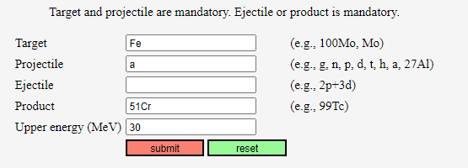

Example of output

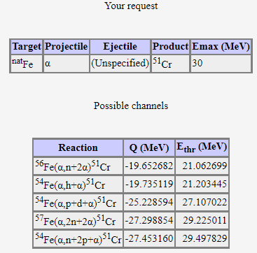

Such a tool is useful to check whether REACTION SF3 follow the following EXFOR compilation rules:

- SF3 should not be X when only one process is possible.
- SF3 should be X when several processes are possible.

Examples
- (79-AU-197(D,P)79-AU-198,,SIG)
rather than
(79-AU-197(D,X)79-AU-198,,SIG)
below the ¹⁹⁷Au(d,nπ⁺)¹⁹⁸Au threshold (~140 MeV).
- (39-Y-89(D,X)38-SR-87,,SIG)
rather than
(39-Y-89(D,A)38-SR-87,,SIG)
above the ⁸⁹Y(d,pt)⁸⁷Sr threshold (~13 MeV).

It is not always trivial to follow these rules for compilers since there exists variety in expressions adopted in the source articles. We implemented checking against the first rule by using the newly developed threshold calculator, and it is added to the JCPRG EXFOR compilation tool (https://www.jcprg.org/exfor/tool/) which now gives an additional output SF3 check output:

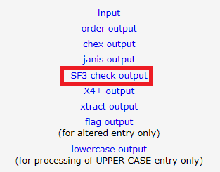

By clicking this link, you can see an output like
SF3=X Checker for ACTIV run on 2022-5-8
-----------------------------------------

Input file: ../exfor/tool/./work/trans-584a.txt

F1456.002: X -> 6N 63-EU-151(A,X)65-TB-149-G,,SIG
F1458.002: X -> N 6-C-12(D,X)7-N-13,,SIG

Program terminated normally

The program currently does not check the energy range, and the message should be utilized with caution when the incident energy is beyond the pion production threshold. We wish this new function is useful for preparation of your future preliminary tapes.

Distribution:

a.koning@iaea.org
abhihere@gmail.com
aloks279@gmail.com
daniela.foligno@oecd-nea.org
dbrown@bnl.gov
draj@barc.gov.in
exfor@oecd-nea.org
fukahori.tokio@jaea.go.jp
ganesan555@gmail.com
gezg@ciae.ac.cn
iwamoto.osamu@jaea.go.jp
jmwang@ciae.ac.cn
kaltchenko@kinr.kiev.ua
kimdh@kaeri.re.kr
kimura.atsushi04@jaea.go.jp
l.vrapcenjak@iaea.org
manuel.bossant@oecd-nea.org
masaaki@nucl.sci.hokudai.ac.jp
marina-03-08@yandex.ru
michael.fleming@oecd-nea.org
mmarina@ippe.ru
nicolas.soppera@oecd-nea.org
n.otsuka@iaea.org
nrdc@jcprg.org
odsurenn@gmail.com
ogritzay@ukr.net
ogrudzevich@ippe.ru
otto.schwerer@aon.at
pikulina@expd.vniief.ru
pritychenko@bnl.gov
s.okumura@iaea.org
scyang@kaeri.re.kr
selyankina@expd.vniief.ru
sonzogni@bnl.gov
stakacs@atomki.mta.hu
stanislav.hlavac@savba.sk
sv.dunaeva@gmail.com
tada@nucl.sci.hokudai.ac.jp
taova@expd.vniief.ru
tarkanyi@atomki.hu
v.devi@iaea.org
v.zerkin@iaea.org
vidyathakur@yahoo.co.in
vsemkova@inrne.bas.bg
vvvarlamov@gmail.com
yolee@kaeri.re.kr
zholdybayev@inp.kz

cc:
shimizu_1515@eis.hokudai.ac.jp

