Nuclear Data Section
International Atomic Energy Agency
P.O.Box 100, A-1400 Vienna, Austria

Memo CP-D/1072

Date: 2023-03-07
To: Distribution
From: N. Otsuka
Subject: 209Bi(p,x)211At cross section? – secondary particle induced reaction
Reference: Memo CP-D/0737
I extracted REACTION codes violating charge or mass conservation in April 2012 and all errors listed in the summary (Memo CP-D/0737) have been fixed. I repeated this checking again by using X4Pro distributed from the NDS website (Ver. 2022-12-22). Charge conservation was checked for datasets below 150 MeV. All cases for corrections without further discussion are summarized in Table 1 appended to this memo.
I found some entries compiling ²⁰⁹Bi(p,x)²¹¹At cross sections. ²⁰⁹Bi(p,π⁻)²¹⁰At, ²⁰⁹Bi(p,π⁻ n)²⁰⁹At etc. are possible at high energy, but ²⁰⁹Bi(p,x)²¹¹At is still impossible. I this has been interpreted as production due to a secondary reaction such as ²⁰⁹Bi(p,α+x) then ²⁰⁹Bi(α,2n)²¹¹At.
The figure in the next page shows the target thickness T dependence of ^{211,210,209,208,206,205}At yields relative to ²⁰⁷At yield at Ep=200 MeV (reproduction of Fig.6 of J.L.Clark et al., Phys.Rev.C26(1982)2073 EXFOR C2113). The authors considered ²⁰⁷At is always produced by ²⁰⁹Bi(p,π⁻ 3n)²⁰⁷At reaction and choose the ²⁰⁷At as a reference. A larger ^{211,210,209}At/²⁰⁷At ratio with a thicker sample is interpreted due to increase of ²⁰⁹Bi(α,xn)^{213-x}At events while constant ^{208,206}At/²⁰⁷At up to a certain thickness.is interpreted due to absence of the secondary α contribution. Namely, they interpret
- ²¹¹At production is always due to ²⁰⁹Bi(α,2n)²¹¹At.
- ^{210,209}At production is due to ²⁰⁹Bi(α,xn) ^{213-x}At and ²⁰⁹Bi(p,π⁻ xn)^{210-x}At.
- ^{208,206}At production is due to ²⁰⁹Bi(p,π⁻ xn)^{210-x}At.
I think
- we should not do compilation for production caused by a secondary particle induced reaction only. (1st case above)
- we may do compilation for production which could be partly due to a secondary particle induced reaction (2nd case above). Information on presence/correction for secondary particle induced reaction is useful.
Cross sections (μb) of each At isotope production (c.f. Tables III and V of Clark’s article)
Thickness | 211 | 210 | 209 | 208 | 207 | 206 | 205
32.77 mg/m2 | 3.8 | 2.4 | 3.0 | 7.4 | 14 | 13 | 9
2.0 mg/cm2 | 1.5 | 1.8 | 3.7 | 8 | 17 | 15 | 16
Corrected | N/A | <1.4 | 3.0 | 7.4 | 14 | 13 | 9
This table shows secondary particle induced reaction effect is large for ²¹⁰At production The last figure shows the ²⁰⁹Bi(p,x)²¹⁰At cross sections in EXFOR other than Clark et al. look ~10 times too high.
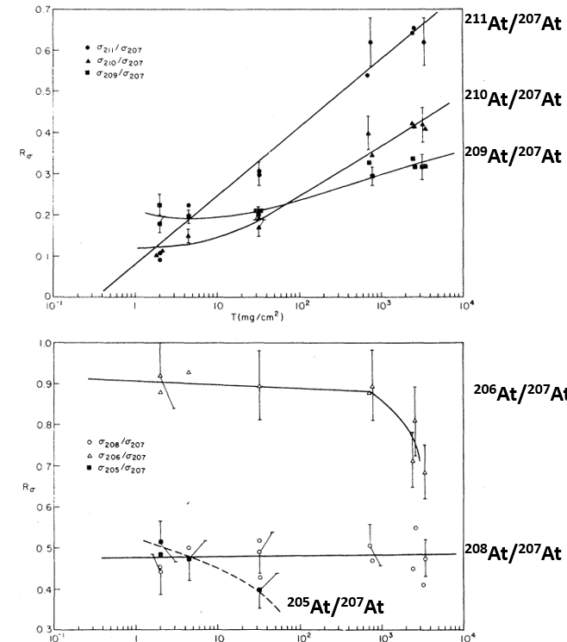
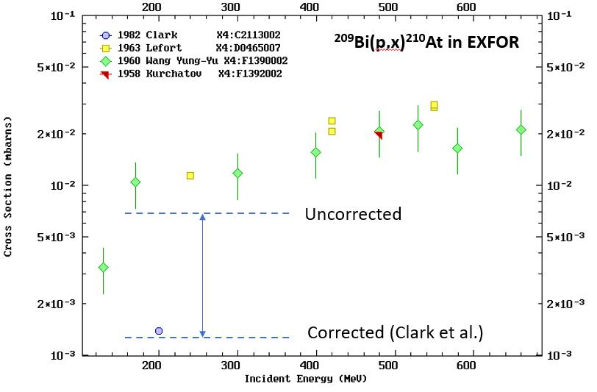
Distribution:

a.koning@iaea.org
abhihere@gmail.com
aloks279@gmail.com
daniela.foligno@oecd-nea.org
dbrown@bnl.gov
draj@barc.gov.in
exfor@oecd-nea.org
fukahori.tokio@jaea.go.jp
ganesan555@gmail.com
gezg@ciae.ac.cn
iwamoto.osamu@jaea.go.jp
jmwang@ciae.ac.cn
kaltchen@ukr.net
kimdh@kaeri.re.kr
kimura.atsushi04@jaea.go.jp
l.vrapcenjak@iaea.org
manuel.bossant@oecd-nea.org
masaaki@nucl.sci.hokudai.ac.jp
marina-03-08@yandex.ru
michael.fleming@oecd-nea.org
mmarina@ippe.ru
nicolas.soppera@oecd-nea.org
n.otsuka@iaea.org
nrdc@jcprg.org
odsurenn@gmail.com
ogritzay@ukr.net
ogrudzevich@ippe.ru
otto.schwerer@aon.at
pikulina@expd.vniief.ru
pritychenko@bnl.gov
scyang@kaeri.re.kr
selyankina@expd.vniief.ru
sonzogni@bnl.gov
stakacs@atomki.mta.hu
stanislav.hlavac@savba.sk
sv.dunaeva@gmail.com
tada@nucl.sci.hokudai.ac.jp
taova@expd.vniief.ru
tarkanyi@atomki.hu
v.devi@iaea.org
v.zerkin@iaea.org
vidyathakur@yahoo.co.in
vsemkova@inrne.bas.bg
vvvarlamov@gmail.com
yolee@kaeri.re.kr
zholdybayev@inp.kz

Table 1: REACTION codes requiring corrections
(Z/A: charge/mass conservation is broken. E/M: ELEM/MASS is coded in SF4)
Dataset # | REACTION | Z/A | E/M | Items | Suggested correction
40299.004 | 55-CS-133(N,X)56-BA-134,,SPC | Z |  | REACTION | ? (I cannot identify the origin of these gamma lines.)
40299.005 | 55-CS-133(N,X)56-BA-134,,SPC | Z |  | REACTION | ? (I cannot identify the origin of these gamma lines.)
C2469.012 | 92-U-235(A,F)126-??-53,IND,FY,,FRC | Z | * | Heading | Swap heading MASS and ELEMENT.
C2469.012 | 92-U-235(A,F)128-??-53,IND,FY,,FRC | Z | * | Heading | Swap heading MASS and ELEMENT.
C2469.012 | 92-U-235(A,F)129-??-54,IND,FY,,FRC | Z | * | Heading | Swap heading MASS and ELEMENT.
C2469.012 | 92-U-235(A,F)130-??-53,IND,FY,,FRC | Z | * | Heading | Swap heading MASS and ELEMENT.
F1217.008 | 83-BI-203(D,X)83-BI-206,CUM,SIG | A | * | REACTION | SF1: 83-BI-203 -> 83-BI-209
M0795.007 | 83-BI-209(G,N)83-BI-203,,INT,,BRS | A | * | REACTION | SF3: N -> X
M0795.007 | 83-BI-209(G,N)83-BI-204,,INT,,BRS | A | * | REACTION | SF3: N -> X
M0795.007 | 83-BI-209(G,N)83-BI-205,,INT,,BRS | A | * | REACTION | SF3: N -> X
M0795.007 | 83-BI-209(G,N)83-BI-206,,INT,,BRS | A | * | REACTION | SF3: N -> X
M0795.007 | 83-BI-209(G,N)83-BI-207,,INT,,BRS | A | * | REACTION | SF3: N -> X
O1508.003 | 30-ZN-64(D,X)30-ZN-69,,TTY,,PHY/MSC | A | * | Data | Impurity in target? Delete this dataset.
O1508.003 | 30-ZN-64(D,X)31-GA-67,,TTY,,PHY/MSC | A | * | Data | Impurity in target? Delete this dataset.
O1665.003.2 | 90-TH-232(P,X)92-U-230,,TTY,,(PHY),DERIV | Z |  | Data | Delete. Decay product - 232Th(p,x)230Pa -> 230U.
O2015.028 | 20-CA-40(P,X)18-AR-42,,SIG | A |  | REACTION | SF1: 20-CA-40 -> 20-CA-0
O2315.018 | 28-NI-0(P,X)30-ZN-62,,SIG | Z |  | REACTION | SF1: 28-NI-0 -> 29-CU-0

Table 2: REACTION codes for production of At from irradiation of Bi or Pb by protons violating mass conservation
(Z/A: charge/mass conservation is broken. E/M: ELEM/MASS is coded in SF4)
Dataset # | REACTION | Z/A | E/M | Items | Suggested correction
C1897.002 | 83-BI-209(P,X)85-AT-211,,SIG | A |  | Data | Delete this dataset.
C1897.003 | 83-BI-209(P,X)85-AT-211,,SIG | A |  | Data | Delete this dataset.
C1897.004 | 83-BI-209(P,X)85-AT-211,,SIG | A |  | Data | Delete this dataset.
C1897.005 | 83-BI-209(P,X)85-AT-211,,SIG | A |  | Data | Delete this dataset.
C1897.006 | 83-BI-209(P,X)85-AT-211,,SIG | A |  | Data | Delete this dataset.
C1897.007 | 83-BI-209(P,X)85-AT-211,,SIG | A |  | Data | Delete this dataset.
C1897.008 | 83-BI-209(P,X)85-AT-211,,SIG | A |  | Data | Delete this dataset.
C1897.009 | 83-BI-209(P,X)85-AT-211,,SIG | A |  | Data | Delete this dataset.
C1897.010 | 83-BI-209(P,X)85-AT-211,,SIG | A |  | Data | Delete this dataset.
D0465.006 | 83-BI-209(P,X)85-AT-211,,SIG | A |  | Data | Delete this dataset.
F1390.002.1 | 83-BI-209(P,X)85-AT-211,,SIG | A |  | Data | Delete this dataset.
F1390.003 | 83-BI-209(P,X)85-AT-211,,SIG | A |  | Data | Delete this dataset.
F1391.002.1 | 82-PB-208(P,X)85-AT-211,,SIG | A |  | Data | Delete this dataset.
F1391.002.2 | 82-PB-208(P,X)85-AT-210,,SIG | A |  | Data | Delete this dataset.
F1391.003 | 82-PB-208(P,X)85-AT-211,,SIG | A |  | Data | Delete this dataset.
F1391.004 | 82-PB-208(P,X)85-AT-210,,SIG,,AV | A |  | Data | Delete this dataset.
F1391.004 | 82-PB-208(P,X)85-AT-211,,SIG,,AV | A |  | Data | Delete this dataset.
F1391.006 | 82-PB-208(D,X)85-AT-211,,SIG | A |  | Data | Delete this dataset.
F1392.002.1 | 83-BI-209(P,X)85-AT-211,,SIG | A |  | Data | Delete this dataset.
F1392.003 | 83-BI-209(P,X)85-AT-211,,SIG | A |  | Data | Delete this dataset.
F1392.004.1 | 83-BI-209(P,X)85-AT-211,,SIG | A |  | Data | Delete this dataset.
F1392.004.2 | 83-BI-209(P,X)85-AT-211,,SIG | A |  | Data | Delete this dataset.
F1427.002 | 83-BI-208(P,X)85-AT-211,,SIG | A |  | Data | Delete this dataset.
F1427.003 | 82-PB-209(P,X)85-AT-211,,SIG | A |  | Data | Delete this dataset.
F1427.004 | 83-BI-208(P,X)85-AT-210,,SIG | A |  | Data | Delete this dataset.
F1427.004 | 83-BI-208(P,X)85-AT-211,,SIG | A |  | Data | Delete this dataset.
F1427.005 | 83-BI-208(P,X)85-AT-211,,SIG | A |  | Data | Delete this dataset.
F1427.006 | 83-BI-208(P,X)85-AT-211,,SIG | A |  | Data | Delete this dataset.
F1427.007 | 83-BI-208(P,X)85-AT-211,,SIG | A |  | Data | Delete this dataset.
F1427.008 | 82-PB-209(P,X)85-AT-211,,SIG | A |  | Data | Delete this dataset.
F1427.009 | 82-PB-209(P,X)85-AT-211,,SIG | A |  | Data | Delete this dataset.
O1906.002 | 83-BI-209(P,X)85-AT-211,,SIG | A | * | Data | Delete the last data line (5+/-0.5 ub for 211At production)

