**Nuclear Data Section**

**International Atomic Energy Agency**

**P.O.Box 100, A-1400 Vienna, Austria**

**Memo CP-D/1126**

**Date:** 25 February 2025

**To:** Distribution

**From:** N. Otsuka

**Subject: Correction of datasets having zero values**

**Reference:** Memo 4C-4/0242

Following the recommendation to NDS from the Vienna EXFOR workshop 2024 “*Register some items in Tables 2 to Table 5 of WS2024-02 to the EXFOR Feedback List.*”, I went through Tables 2 and 3 of the working paper (=Memo 4C-4/0242) and registered selected items in the Feedback List as summarized at the end of this memo.

The scattering cross sections measured with neutrons from the Munich research reactor and published by Koester et al. are often the scattering cross sections at zero energy.

***Example***: Extraction from W. Waschkowski et al., Z. Naturforsch. A 31(1976)115 (EXFOR 20603):

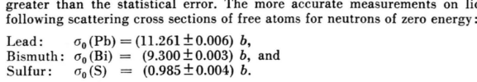

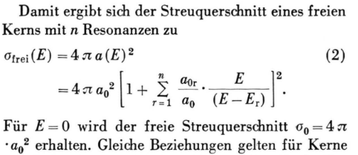

EN=0 is possible for compilation of σ0. The same argument is also applied to EXFOR 23747 (from a J-PARC measurement.)

**Items registered in the EXFOR Feedback List (Italicized items were not registered.)**

Table 2 of Memo 4C-/0424

|  |  |
| --- | --- |
| **Dataset #** | **Registered correction proposal (*or remark if not registered*)** |
| 14709.011.5 | REACTION SF6: PTY -> L (c.f. Table IV) |
| 22602.002.3 | REACTION SF6: PTY -> L? (c.f. Mughabghab's Atlas. Source document kept at NEA DB?) |
| T0246.008.3 | Data: Replace "0" with a blank (c.f. Table I) |

Table 3 of Memo 4C-/0424

|  |  |
| --- | --- |
| **Dataset #** | **Registered correction proposal (*or remark if not registered*)** |
| *11557.003* | (*Is the neutron energy potential scattering cross section?*) |
| *12629.002* | (*Prompt gamma emission probability of thermal neutron capture*) |
| 14239.022, 035,044 | Data: Delete lines filled by zero values at the end of the DATA section. |
| *14316.004-005* | (*Digitized neutron energy from Fig.7 can be zero after rounding.*) |
| 14570.002 | Data: EN=0.0 -> EN-MIN/MAX=0.0/0.5; EN=0.5 -> EN-MIN/MAX=0.5/1.0;...; EN=20.0 -> EN-MIN/MAX=20.0/20.5 (c.f. Fig.7). |
| 14687.003 | Data: EN: Negative energy is impossible from digitization of Fig.11. (N.B. x-axis is not linear of energy) |
| 14688.002 | Data: EN: Negative energy is impossible from digitization of the figure. (N.B. x-axis is not linear of energy) |
| *20603.003, 005,007* | (*from Koester’s group*) |
| *21660.024-027* | (*from Koester’s group*) |
| *21842.024-028* | (*from Koester’s group*) |
| *22104.003,005* | (*from Koester’s group*) |
| *22138.006* | (*from Koester’s group*) |
| *22217.002-003* | (*from Koester’s group*) |
| *23747.002-005* | (*EN=0 agreed with the compiler.*) |
| *40429.002,004* | (*Corrected in TRANS.4217*) |
| A0945.004-005 | REACTION SF9: Add DERIV with an explanation of its derivation under ANALYSIS. |
| A1258.002 | REACTION SF9: Add DERIV with an explanation of its derivation under ANALYSIS. |
| *A1436.002-003* | (*EVALuated datasets*) |
| *A1459.002* | (*CALCulated dataset*) |
| C0174.003 | REACTION SF9: Add DERIV. METHOD -> ANALYSIS. |
| C0720.004,007 | Data: Move EN=0 data point to ADD-RES? No such a point seen in Fig.5 and no description on extrapolation. |
| C1290.002-005 | REACTION: Move free text under ANALYSIS. |
| C2598.006 | REACTION SF9: Add DERIV. |
| D0002.006 | Heading: Swap EN and ANG-CM. |

**Distribution:**

[nrdc.memo-distribution@iaea.org](mailto:nrdc.memo-distribution@iaea.org)