**Nuclear Data Section**

**International Atomic Energy Agency**

**P.O.Box 100, A-1400 Vienna, Austria**

**Memo CP-D/1131**

**Date:** 21 April 2025

**To:** Distribution

**From:** N. Otsuka

**Subject: Use of M+ to short lived ground state production cross sections**

I was asked by an EXFOR user if the REACTION code string

22-TI-0(P,X)21-SC-44-G,M+,SIG

seen in EXFOR C0430.004, D0569.005 and D7033.005 is correct. Use of M+ is indeed questionable since the quantity is cooling time dependent, and does not saturate even after long cooling. Note that the half-life of the metastable state (59 h) is longer than the half-life of the ground state (4 h).

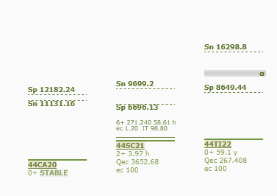

To demonstrate this point schematically, I plotted the cooling time dependence of the cross section derived from the ground state activity after 1 hr irradiation and 1 hr measurement by the conventional activation method assuming 25 mb and 10 mb for the ground state and metastable state production cross sections, respectively (predicted by TALYS).

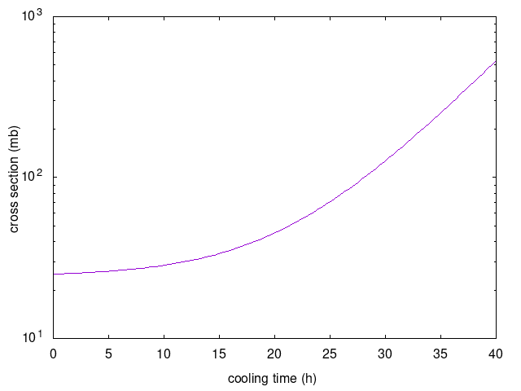

This figure shows the measured cross section is close to the ground state production cross section (25 mb) if the cooling time is very short. Otherwise, the measured cross section monotonically increases as cooling time increases.

Cross sections compiled in EXFOR should not be cooling time dependent, and I think ,SIG,M+ should not be used for an isomer pair which metastable state has longer half-life (i.e., the cross section determined by the ground state activity does not saturate.)

If we meet an article reporting cross sections determined from the activity of a short lived ground state but without declaring it as the ground state production cross section, such cross sections may be compiled with (M),SIG rather than M+,SIG.

(This discussion could be generalized to use of CUM when the precursor has longer half-life.)

**Distribution:**

[nrdc.memo-distribution@iaea.org](mailto:nrdc.memo-distribution@iaea.org)

**cc:**

[alexander.konobeev@kit.edu](mailto:alexander.konobeev@kit.edu)