**Nuclear Data Section**

**International Atomic Energy Agency**

**P.O.Box 100, A-1400 Vienna, Austria**

**Memo CP-D/1139**

**Date:** 21 May 2025

**To:** Distribution

**From:** N. Otsuka

**Subject: Incident energies coded for 238U(n,f) FPY datasets**

I received comments on incident energies coded for 238U(n,f) fission product yields from Andrea Mattera (NNDC) [1]. Below I introduce three typical comments.

**13327.004 (fast reactor spectrum)**

**Current coding:** EN-MEAN=0.4 MeV with SF8=FST.

Sample was irradiated in the Idaho experimental first breeder reactor (EBR-II):

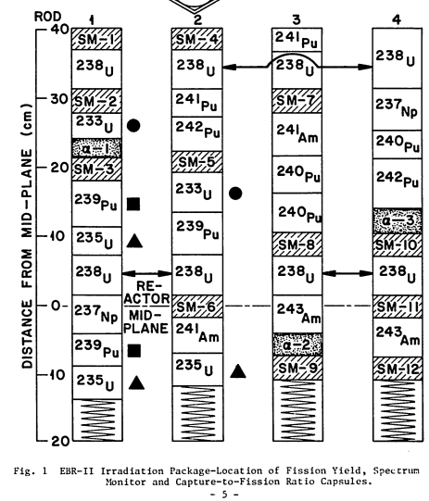

These four sample packages contain 238U capsules and spectrum monitor capsules (“SM”). Based on gamma spectroscopy of these monitor capsules after irradiation, the authors calculated the “mean neutron energy” as well as “mean fission energy” of 238U:

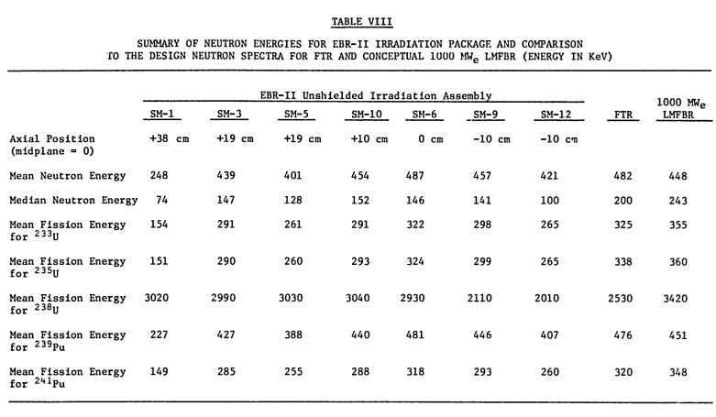

The “mean neutron energy” and “mean fission energy for 238U” correspond to

$$〈E〉={\int{\text{d}E E φ\left(E\right)}}/{\int{\text{d}E φ\left(E\right)}}$$

$${〈E〉=\int{\text{d}E E σ\left(E\right)φ\left(E\right)}}/{\int{\text{d}E σ\left(E\right)φ\left(E\right)}}$$

where φ(E) is the neutron fluence and σ(E) is the 238U(n,f) cross section. This table shows the mean neutron energy (i.e., *first* definition) is about **0.4 MeV** while the 238U mean fission energy (i.e., *second* definition) is about **2.5 MeV**. This difference is due to presence of the 238U(n,f) threshold energy around 1 MeV.

**Question:** Replace EN-MEAN=0.4 MeV (first definition) with EN-MEAN=2.5 MeV (second definition)?

**13379.002 (fission neutron spectrum)**

**Current coding:** EN-DUMMY=1 MeV with SF8=FIS.

Sample was irradiated by neutrons in a uranium rod in an ORNL reactor. The authors say they are nearly unmoderated fission spectrum neutrons and the average neutron energy effecting fission in 238U is estimated to be ~**2.8 MeV**.

**Question:** Adopt KT-DUMMY=1.32 MeV (energy commonly used SF8=FIS for pure 235U prompt fission neutron spectrum) or EN-MEAN=2.8 MeV (second definition)?

**30496.008-009 (thermal neutron spectrum)**

**Current coding:** EN-DUMMY=1 MeV with SF8=SPA.

Sample was irradiated by neutrons for neutrons from the APSARA reactor. The sample is wrapped by a Cd foil. Use of **SF8=EPI and EN-MIN=0.5 MeV** is the current practice by NDPCI for FY measured with a Cd foil in BARC research reactors.

The authors do not provide any representative energy though they give the fractions of fast neutrons for several dosimetry reactions. Andrea Mattea found the spectrum in Fig. 1 of H. Naik+, J,RCA,75,69,1996 (EXFOR 31518), and he estimated the representative neutron energy as **4.2 MeV** according to the *second* definition.

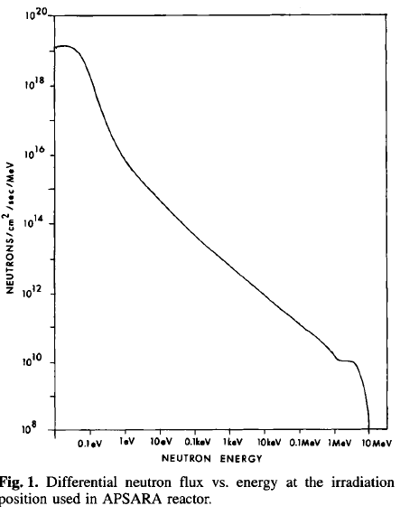

**Question:** Do we use EN-DUMMY=4.2 MeV (mean energy calculated by other than the authors) instead of EN-MIN=0.5 eV?

The original comments are appended to this memo.

**Reference**

[1] A. Mattera et al., “Reviewing incident neutron energy assignments in 238U(n,f) fission yield data”, Report # BNL-228181-2025-INRE, Brookhaven National Laboratory (2025).

**Distribution:**

nrdc.memo-distribution@iaea.org

**cc:**

amattera@bnl.gov

**Appendix**

|  |  |  |  |
| --- | --- | --- | --- |
| **EXFOR #** | **Neutron source** | **Current** | **Comments by Andrea Mattera (2025-03-21)** |
| 13317 | Critical assembly | EN-DUMMY= 1 MeV | EN could probably be changed to 2.9 MeV (as reported in 14584 for the same CRASS) |
| 13327 | Fast reactor | EN-MEAN= 0.4 MeV | Here, I believe that as the EN-MEAN (mean fission energy) one could use the values reported in Table VIII of 1975MAWY. For U-238, this would be 2.903 MeV - 3.020 MeV based on the location of the U-238 irradiated assemblies. |
| 13379 | Reactor core | EN-DUMMY= 1 MeV | EN-DUMMY could be changed to something else. The mean fission energy is ~2.8 MeV, as reported in 1954KE37: "The average neutron energy effecting fission in U-238, [...], is estimated to be approximately 2.8 MeV." |
| 21736 | Reactor core | EN-DUMMY= 1.5 MeV | Spectrum in the thesis [CEA-R 2442 — BRETHE Pierre EXPERIMENTAL MEASUREMENT OF NEUTRON SPECTRUM IN THE REFLECTOR OF A LIGHT WATER REACTOR. at https://inis.iaea.org/records/y0mcb-ark30 ] from which the neutron energy inducing fission can be estimated in 3 +/- 1 MeV |
| 22334 | Fast reactor | EN-DUMMY= 1 MeV | Approximate energy based on [Nilsson, Ragnar, and Erkki Aalto. Tests of Neutron Spectrum Calculations with the Help of Foil Measurements in a D2O and in an H2O-Moderated Reactor and in Reactor Shields of Concrete an Iron. No. AE--155. AB Atomenergi, 1964.]  Possible information on energy spectrum from https://inis.iaea.org/records/9p2k6-mr524 [Etemad, B. Measurement of fast neutron spectrum in fuel irradiation rig in R2 reactor using activation detectors and unfolding techniques. No. STUDSVIK-BR--78-1. Aktiebolaget Atomenergi, 1978.]  Average XS-weighted energy is ~4 +/- 2 MeV |
| 23597 | Reactor core | EN-DUMMY= 0.5 MeV | Fast reactor spectrum given in Fig. 7 of the main reference. Average XS-Weighted energy is ~850 keV +/- 100 keV using data in the plot; it's probably higher, considering that the plot is cut at 1 MeV |
| 23796 | 12C(d,n) at 26 MeV | EN-MEAN= 10 MeV | 26 MeV deuterons delivered to the PARRNe line was fully stopped in a 3 mm thick graphite converter details from [Lau, C., et al. "Production of neutron-rich surface-ionized nuclides at PARRNe." Nuclear Instruments and Methods in Physics Research Section B: Beam Interactions with Materials and Atoms 204 (2003): 257-260.]  Average neutron energy effecting fission (calculated from the spectrum in the reference above): 13.5 +/- 5 MeV |
| 30496 | Thermal reactor +Cd foil | EN-DUMMY= 1 MeV | Fission spectrum for APSARA reactor can be found in [Naik, H., et al. "Absolute Fission Yields in the Fast Neutron Induced Fission of 99.9997 Atom % Pure 238U Using Track Etch-cum Gamma Spectrometric Technique." Radiochimica Acta 75.2 (1996): 69-76.] from which the neutron energy inducing fission can be estimated in 4.2 +/- 2 MeV |
| 30752 | Σ-Σ thermal-fast couple | EN-DUMMY= 450 keV | The energy spectrum of ITN Sigma-Sigma available in [T. Angelescu et al. /Nucl. Instr and Meth. in Phys . Res. A 345 (1994) 303-307] from which the neutron energy inducing fission can be estimated in 3.0 +/- 1.5 MeV |
| 31571 | 7Li(p,n) at 25.5 MeV | EN-MIN/MAX= 1.5/3.5 MeV | From the main reference: "This arrangement produced a beam of neutrons confined within a forward cone of half angle 23◦ and with energies between 1.5 and 3.5 MeV. The average neutron energy was about 2.5 MeV." EN-AVG could better represent this instead of EN-MIN / EN-MAX |
| 32668 | Reactor core | EN-DUMMY= 1 MeV | In the reference (Chung, Chien, and Ming-Yung Woo. "Fission product yields in the fast-neutron fission of 238 U." Journal of Radioanalytical and Nuclear Chemistry 109.1 (1987): 117-131.) the authors report the effective average energy inducing fission. "If one assumes a Watt neutron energy spectrum in a swimming-pool type research reactor such as the THOR facility, the effective average energy of neutrons inducing 238U(n, f) reaction is about 3.2 MeV; the use of neutron shields would also reduce the number of low-energy neutrons such that the effect of average neutron energy would be slightly greater than 3.2 MeV." |
| 33166 | Thermal reactor+ Cd foil | EN-MIN=0.5 MeV | Fission spectrum for CIRUS reactor can be found in [R. H. Iyer, H. Naik, A. K. Pandey, P. C. Kalsi, R. J. Singh, A. Ramaswami & A. G. C. Nair (2000) Measurement of Absolute Fission Yields in the Fast Neutron–Induced Fission of Actinides: 238U, 237Np, 238Pu, 240Pu, 243Am, and 244Cm by Track-Etch-cum-Gamma spectrometry, Nuclear Science and Engineering, 135:3, 227-245, DOI: 10.13182/NSE00-A2136]  from which the neutron energy inducing fission can be estimated in 2.6 +/- 1.1 MeV |
| 40206 | Reactor “active zone” (core?) | EN-DUMMY= 1 MeV | There is a spectrum in [Krezhov, K., et al. "The reference neutron field-a standard neutron source for neutron measurements at the research reactor IRT-2000 in Sofia; Oporno pole-obraztsov iztochnik za neutronni izmervaniya na reaktora IRT-2000 v Sofia." (1993).] -- BUT: the paper is in Russian |
| 40489 | Reactor core | EN-MEAN= 1.3 MeV | There is an unfolded spectrum for BR-1 in [Doroshenko, J. J., et al. "New methods for measuring neutron spectra with energy from 0.4 eV to 10 MeV by track and activation detectors." Nuclear Technology 33.3 (1977): 296-304.]. In [1977GUZJ] there is a reference to another irradiation at BR-1 with Average neutron energy of 1.8 MeV, so that EN-MEAN could be closer to 1.8 MeV than 1.3 MeV |