**China Nuclear Data Centre**

**China Institute of Atomic Energy**

**Beijing 102413, People's Republic of China**

**Memo CP-S/003**

**Date:** 12 September 2019

**To:** Distribution

**From:** Jimin Wang, Tao Xi, N. Otsuka

**Subject:** **EXFOR outliers detected during global optical model analysis**

During global optical model analysis of alpha elastic scattering [1], CNDC found some problems in EXFOR entries.

|  |  |  |  |  |  |  |
| --- | --- | --- | --- | --- | --- | --- |
|  | **Problem** | **Target** | **Energy (MeV)** | **Angle (deg)** | **Entry** | **Note** |
| 1 | Wrong cross sections at some angles | 16O | 104 | 47.9 49.1 50.3 51.5 | D0216.007 |  |
| 24Mg | 172.5 | 23.17 | D0213.003 |  |
| 58Ni | 104 | 36.11 | D0216.010 |  |
| 60Ni | 104 | 16.44 27.08 | D0216.012 |  |
| 172.5 | 6.29 10.56 36.25 | D0256.004 |  |
| 2 | No data in Entry (STATUS=UNOBT) | 27Al |  |  | C0742.003 | 1 |
| 28Si |  |  | O1900.002 | 2 |
|  |  | O1945.002 | 3 |
| 58Ni |  |  | C1025.004 | 4 |
| 3 | Absolute cross sections coded with “RTH” | 90Zr |  | | F0561.004 |  |
| 94Zr | F0561.006 |  |

Note

1. Fig.2 (middle) of J.A.Leavitt+,J,NIM/B,15,296,1986.

2. Fig.1 of T.Lonnroth+,J,JP/G,38,35107,2011. Not suitable for digitization. Angle is not specified on the figure.

3. Figs.4+7 (bottom) of T.Lonnroth+,J,EPJ/A,46,5,2010. Not suitable for digitization.

4. Fig.5 of P.Darriulat+,J,PR,134,B42,1964.

Reference

[1] Z.Zhang, R.R.Xu, Z.Y.Ma, Z.G.Ge, Y.Tian, D.Y.Pang, X.D.Sun, Y.L.Jin, X.Tao, Y.Zhang, J.M.Wang, Nucl. Phys. A **990** (2019) 1.

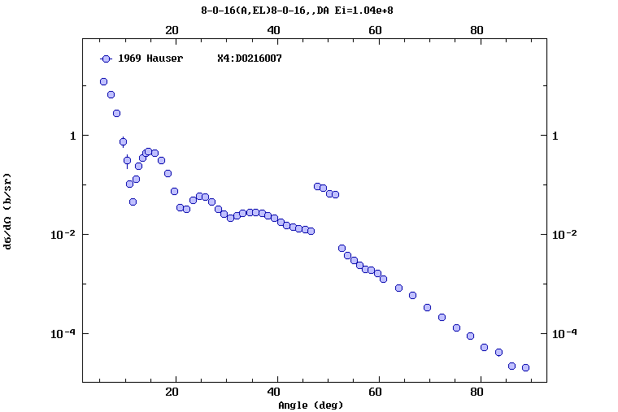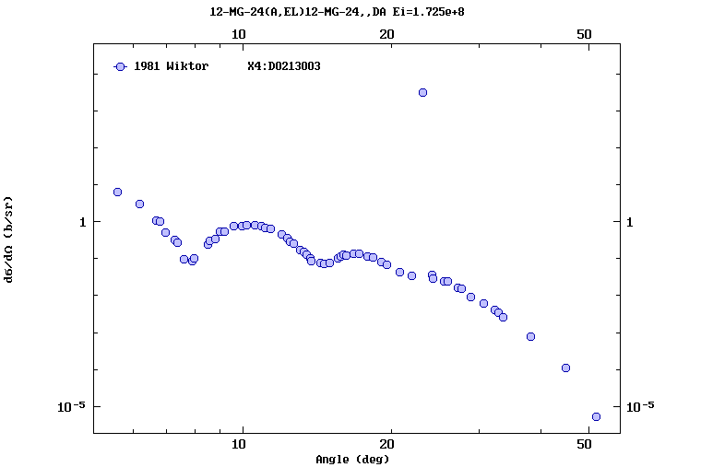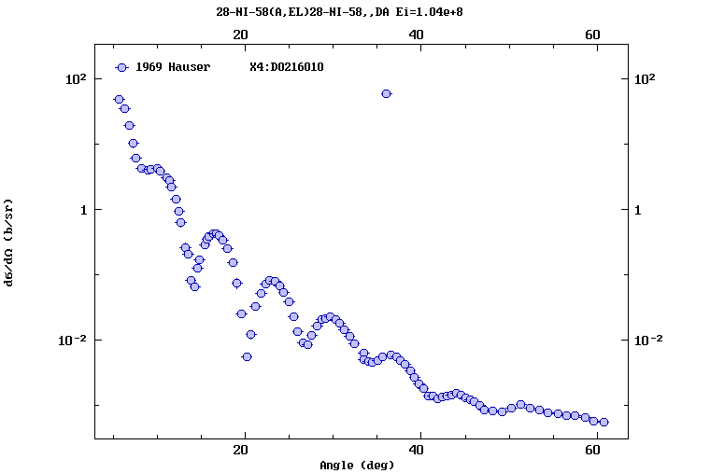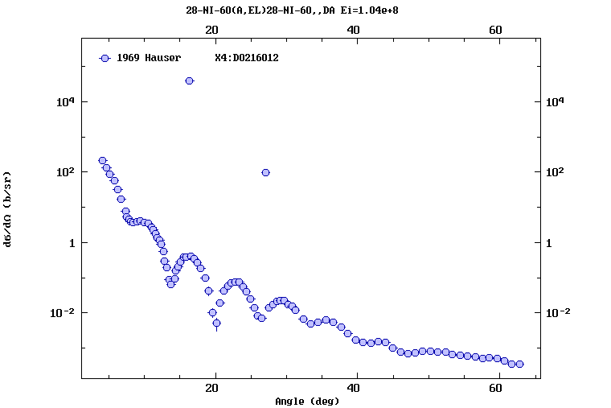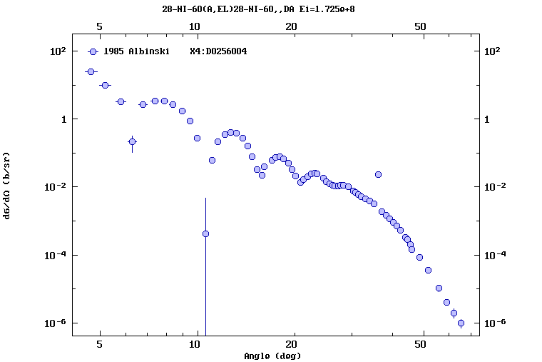

**Distribution:**

[a.koning@iaea.org](mailto:a.koning@iaea.org)

[abhihere@gmail.com](mailto:abhihere@gmail.com)

[aloks279@gmail.com](mailto:aloks279@gmail.com)

[dbrown@bnl.gov](mailto:dbrown@bnl.gov)

[draj@barc.gov.in](mailto:draj@barc.gov.in)

[fukahori.tokio@jaea.go.jp](mailto:fukahori.tokio@jaea.go.jp)

[ganesan555@gmail.com](mailto:ganesan555@gmail.com)

[gezg@ciae.ac.cn](mailto:gezg@ciae.ac.cn)

[iwamoto.osamu@jaea.go.jp](mailto:iwamoto.osamu@jaea.go.jp)

[j.c.sublet@iaea.org](mailto:j.c.sublet@iaea.org)

[jmwang@ciae.ac.cn](mailto:jmwang@ciae.ac.cn)

[kaltchenko@kinr.kiev.ua](mailto:kaltchenko@kinr.kiev.ua)

[kenya.suyama@oecd-nea.org](mailto:kenya.suyama@oecd-nea.org)

[kimura.atsushi04@jaea.go.jp](mailto:kimura.atsushi04@jaea.go.jp)

[l.vrapcenjak@iaea.org](mailto:l.vrapcenjak@iaea.org)

[manuel.bossant@oecd-nea.org](mailto:manuel.bossant@oecd-nea.org)

[masaaki@nucl.sci.hokudai.ac.jp](mailto:masaaki@nucl.sci.hokudai.ac.jp)

[michael.fleming@oecd-nea.org](mailto:michael.fleming@oecd-nea.org)

[mmarina@ippe.ru](mailto:mmarina@ippe.ru)

[nicolas.soppera@oecd-nea.org](mailto:nicolas.soppera@oecd-nea.org)

[n.otsuka@iaea.org](mailto:n.otsuka@iaea.org)

[nrdc@jcprg.org](mailto:nrdc@jcprg.org)

[odsurenn@gmail.com](mailto:odsurenn@gmail.com)

[ogritzay@kinr.kiev.ua](mailto:ogritzay@kinr.kiev.ua)

[ogrudzevich@ippe.ru](mailto:ogrudzevich@ippe.ru)

[otto.schwerer@aon.at](mailto:otto.schwerer@aon.at)

[pikulina@expd.vniief.ru](mailto:pikulina@expd.vniief.ru)

[pritychenko@bnl.gov](mailto:pritychenko@bnl.gov)

[s.okumura@iaea.org](mailto:s.okumura@iaea.org)

[samaev@obninsk.ru](mailto:samaev@obninsk.ru)

[sbabykina@yandex.ru](mailto:sbabykina@yandex.ru)

[scyang@kaeri.re.kr](mailto:scyang@kaeri.re.kr)

[selyankina@expd.vniief.ru](mailto:selyankina@expd.vniief.ru)

[sonzogni@bnl.gov](mailto:sonzogni@bnl.gov)

[stakacs@atomki.mta.hu](mailto:stakacs@atomki.mta.hu)

[stanislav.hlavac@savba.sk](mailto:stanislav.hlavac@savba.sk)

[sv.dunaeva@gmail.com](mailto:sv.dunaeva@gmail.com)

[tada@nucl.sci.hokudai.ac.jp](mailto:tada@nucl.sci.hokudai.ac.jp)

[taova@expd.vniief.ru](mailto:taova@expd.vniief.ru)

[tarkanyi@atomki.hu](mailto:tarkanyi@atomki.hu)

[vvvarlamov@gmail.com](mailto:vvvarlamov@gmail.com)

[v.zerkin@iaea.org](mailto:v.zerkin@iaea.org)

[vidyathakur@yahoo.co.in](mailto:vidyathakur@yahoo.co.in)

[vsemkova@inrne.bas.bg](mailto:vsemkova@inrne.bas.bg)

[yolee@kaeri.re.kr](mailto:yolee@kaeri.re.kr)

[zholdybayev@inp.kz](mailto:zholdybayev@inp.kz)