1974 May
Tenth Four-Centre Meeting
Saclay/Paris

Participants
RUSSIA: Vasili Manokhin
UNITED STATES OF AMERICA: Victoria McLane May, Sol Pearlstein
CCDN: Fritz Fröhner, Luigi Lesca, Anton Schofield, Koichi Okamoto, Hans Potters, Nigel Tubbs, C. Rickeby
IAEA: Hans Lemmel, Joseph Schmidt, Mercury Vlasov
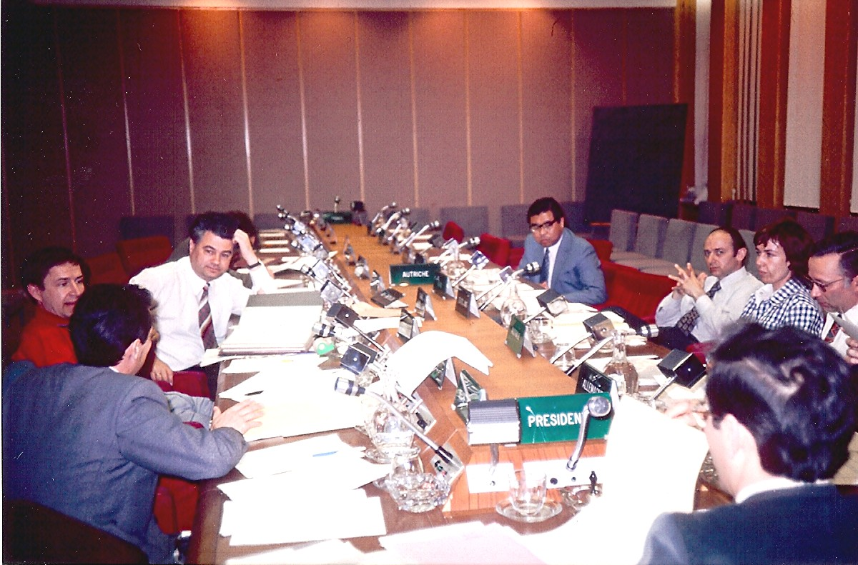

Clockwise from left: Vasili Manokhin, Hans Lemmel, Joe Schmidt, Koichi Okamoto, Sol Pearlstein, Vicki McLane May, Fritz Fröhner, Luigi Lesca

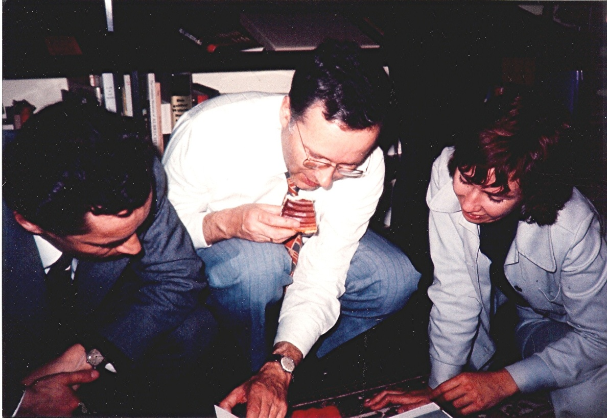

Vasili Manokhin,, Fritz Fröhner, Vicki McLane May

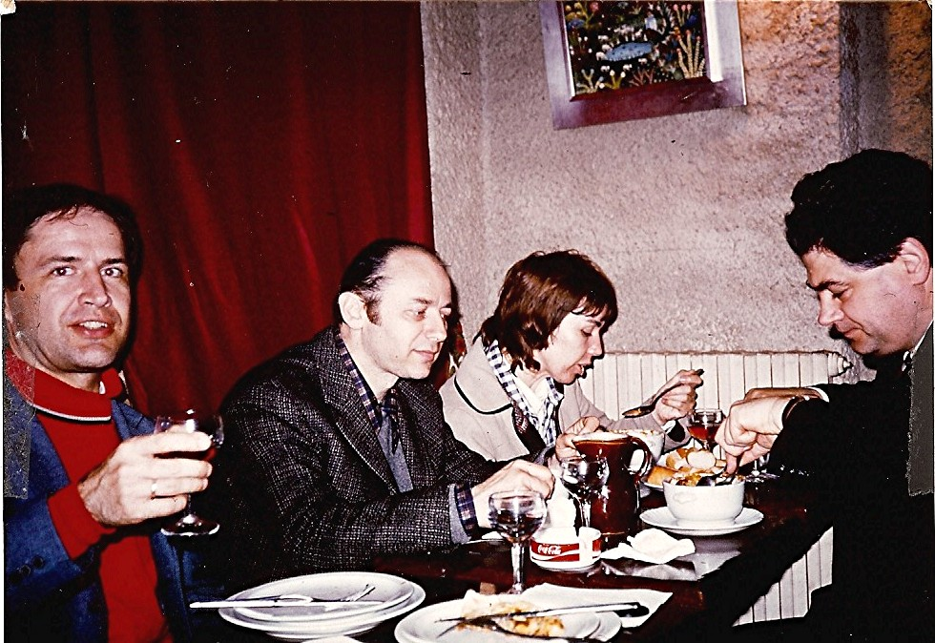

Hans Lemmel, Sol Pearlstein, Vicki McLane May, Joe Schmidt

