1987 October
9th CONSULTANTS MEETING OF
NUCLEAR REACTION DATA CENTRES
Brookhaven National Laboratory, USA

Participants
CHINA: Cai Dunjiu, Zhuang Youxiang
RUSSIA: Vasili Manokhin, Feliks Chukreev
UNITED STATES OF AMERICA: Charles Dunford, Norman Holden, Victoria McLane, Sol Pearlstein, John Hubbell (NBS), Edward Siciliano (LANL), Stephen Warshaw (LLNL), Stanley Whetstone (DOE)
JAPAN: Akira Hashizume
NEA data Bank: Claes Nordborg, Nigel Tubbs
IAEA: Hans Lemmel, Joseph Schmidt
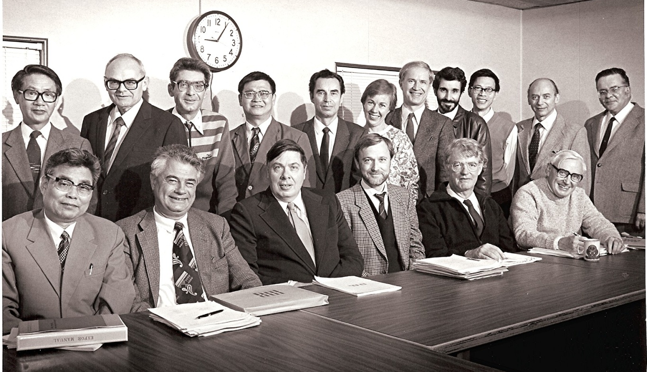
Sitting: Cai Dunjui, Joe Schmidt, Charlie Dunford, Claes Nordborg, Nigel Tubbs, Norman Holden
Standing: Akire Hashizuma, John Hubbell, Feliks Chukreev, Zhuang Youxiang, Vasili Manokhin, Vicki McLane, Hans Lemmel, Ed Siciliano, Wang Gongquing (BNL guest), Sol Pearlstein, Steve Warshaw

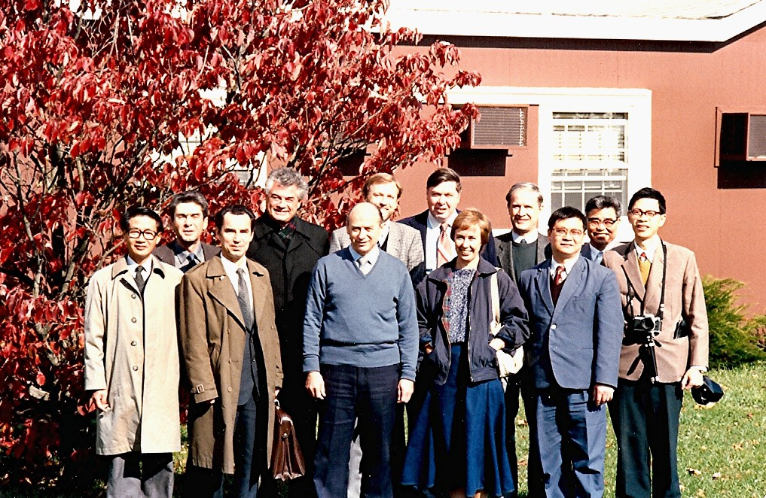

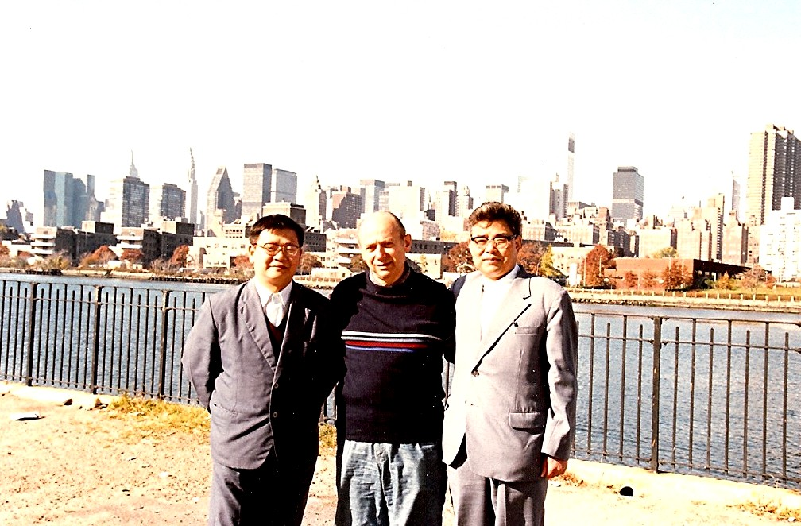
Front: Akire Hashizuma, Vasili Manokhin, Sol Pearlstein, Vicki McLane, Zhuang Youxiang
Back: Feliks Chukreev, Joe Schmidt, Claes Nordborg, Charlie Dunford, Hans Lemmel, Cai Dunjui, Wang Gongquing
Sol Pearlstein, Zhuang Youxiang & Cai Dunjui

