Meeting of the Network of Nuclear Reaction Data Centers, BNL, October 4-7, 2004

National Nuclear Data Center: Status Report

P. Oblozinsky

NNDC, Brookhaven National Laboratory

Personnel

Personnel changes since the last NRDC meeting in May 2002:
- Mike Herman (PhD, nuclear reaction physics) was hired in March 2003. His duties include ENDF database management, maintenance of the reaction code Empire and nuclear reaction cross-section evaluations for ENDF.
- Yako Sanborn retired in October 2003. Boris Pritychenko (PhD, nuclear structure physics) with strong background in computer programming was hired in September 2004. His duties include responsibility for the new NNDC Web site, Linux management and application development.
- Vicki McLane is expected to retire at the beginning of next year. Dimitri Rochman (PhD, nuclear reaction physics) has been hired and is expected to be starting his term in November 2004.

At present, the NNDC staff represents 12.25 FTE (8.0 scientists, 1.75 professionals, and 2.5 support staff).

In the last fiscal year (Oct 2003 – Sep 2004), 13 scientists visited the NNDC at least for 1 week, 53 weeks in total, see Table 1. This represents a considerable increase over the past, dominated by 9 visits devoted to nuclear reaction modeling and cross-section evaluation, followed by nuclear structure evaluation (2 visits), and database development (2 visits).

The list of NNDC visits to other centers is given in Table 2.

Table 1. Summary of Visitors to NNDC (Oct 2003 - Sep 2004)

No. of visits | Duration | Topic
9 | 39 weeks | Nuclear reaction modeling and evaluation
2 | 9 weeks | Nuclear structure evaluation
2 | 5 weeks | Nuclear reaction database migration
Total: 13 | 53 weeks

Table 2. Visits by NNDC Staff to Other Centers (July 2003 - Sep 2004)

Staff Member | Host | Duration | Topic
Alejandro Sonzogni | IAEA/NDS | 1 week | Database migration
Michal Herman | IAEA/NDS | 3 days | ENDF database migration
Victoria McLane | IAEA/NDS | 1 week | EXFOR training session.

Computer Facilities

The NNDC has completed migration from the Compaq Alpha Server to a multi-server Linux system consisting of:
- Three units of dual-processor Intel Xeon Red Hat Advanced Servers (2.8 GHz) functioning as
- working server,
- primary database server, and
- secondary database server.
- Intel Xeon single processor (2.0GHz MP) Web server; owned by us, but operated by the BNL Information Technology Division.

All PCs have been replaced with INTEL Pentium 4 processors running Windows XP and using flat panel monitors.

Bibliographies

The NSR compilation activity has continued. Over 4,200 references were entered in FY2004.

The CINDA compilation activity continues with respect to those references associated with the experimental neutron data compiled at the Center. In the period from July 2003 to September 2004, 3 CINDA transmissions were sent (see Table 3) containing a total of 1,184 records.

Table 3. NNDC CINDA Transmissions (July 2003 – Sep 2004)

Transmissions |  |  | Lines  In database | Blocks in database
Exchange | Date | # lines | Lines  In database | Blocks in database
179 | 20030829 | 681
180 | 20040518 | 226
181 | 20040922 | 277
NNDC Totals |  | 1184 | 91461 | 40531

Experimental Nuclear Reaction Data

The NNDC continues to compile neutron and charged-particle reaction data produced in the U. S. and Canada. In the period from July 2003 through September 2004, 12 final neutron data transmission tapes and 14 charged-particle transmission tapes were sent containing new and corrected entries; 3 preliminary transmissions have been sent (Tab. 4).

Evaluated Nuclear Reaction Data

CSEWG. The NNDC continues to coordinate the work of the Cross Section Evaluation Working Group. CSEWG is focusing on the development of a new version of the ENDF/B library, ENDF/B-VII. The NNDC contributions:
- Preliminary ENDF/B-VII Web page was developed,
- Assembly of ENDF/B-VII and data verification started, and
- ENDF-6.13 Utility Codes were distributed.

Empire. Improved version of the nuclear reaction model code, Empire-2.19, was developed (collaboration with Uni Bucharest, IAEA and JAERI). In particular,
- Fission channel was considerably improved,
- Pre-equilibrium alpha emission was introduced (Iwamoto-Harada), and
- Photon production capabilities were validated.

Evaluations. The NNDC was involved in several cross-section evaluation projects:
- Collaboration with KAERI on neutron cross-section evaluations for 24 selected fission products was completed. In the last year, remaining 5 isotopes of Dy were finalized and submitted to ENDF/B-VII.
- Review of 218 fission products cross was completed as an international project chaired by the NNDC (WPEC Subgroup 21). The project reviewed all evaluations in the fission products region (Z = 31 - 68) and recommended best evaluations.
- Neutron cross-section evaluations for 5 isotopes of Germanium were completed, focusing on photon production. This was in response to the needs of MCNP community.
- Atlas of Neutron Resonances is under preparation by S. Mughabghab. It represents a complete re-evaluation of “BNL-325” published in 1981 and 1984.
- The NNDC continued to cooperate with Russian Nuclear Data Center VNIIEF on “Compilation and Evaluation of Alpha-Induced Nuclear Reaction Cross Sections for Astrophysics” (grant from the Civilian Research and Development Foundation).

Nuclear Structure Data

NNDC continues to publish the Nuclear Data Sheets, with 12 issues per year. As of September 2004, issues through Volume 102, #4 have been sent to Academic Press.

The experimental nuclear structure and decay data database (XUNDL) now contains more than 1,300 data sets, compared to about 1,000 one year ago. The compilation is done in a very efficient way by McMater University, Canada. The NNDC maintains and distributes the database.

Database Migration

The database migration project, conducted in 2000 – 2004, has been essentially completed in April 2004.

The administrative functions for CSISRS (EXFOR), CINDA, ENDF, ENSDF, NUDAT, and NSR have been transferred to the new Linux/Sybase system. This involves installation of new software and modification of legacy codes, where appropriate, to work with the relational database. The VMS-based version of the database has been shut down as of October 1, 2004. The CINDA database will be fully installed by V. Zerkin in November 2004.

Customer Services

As a part of the migration project, the NNDC launched its completely re-designed Web site in April 2004. At the same time, Online Service was shut down.

The number of retrievals continues to increase. There was a large jump in retrievals at the time of the inauguration of the new Web site in April. A figure below shows ratio of monthly retrievals for respective months in 2004 and 2003. It is seen that new Web Portal resulted in almost 100% increase of retrievals. In absolute terms, currently there are about 50,000 retrievals per month.

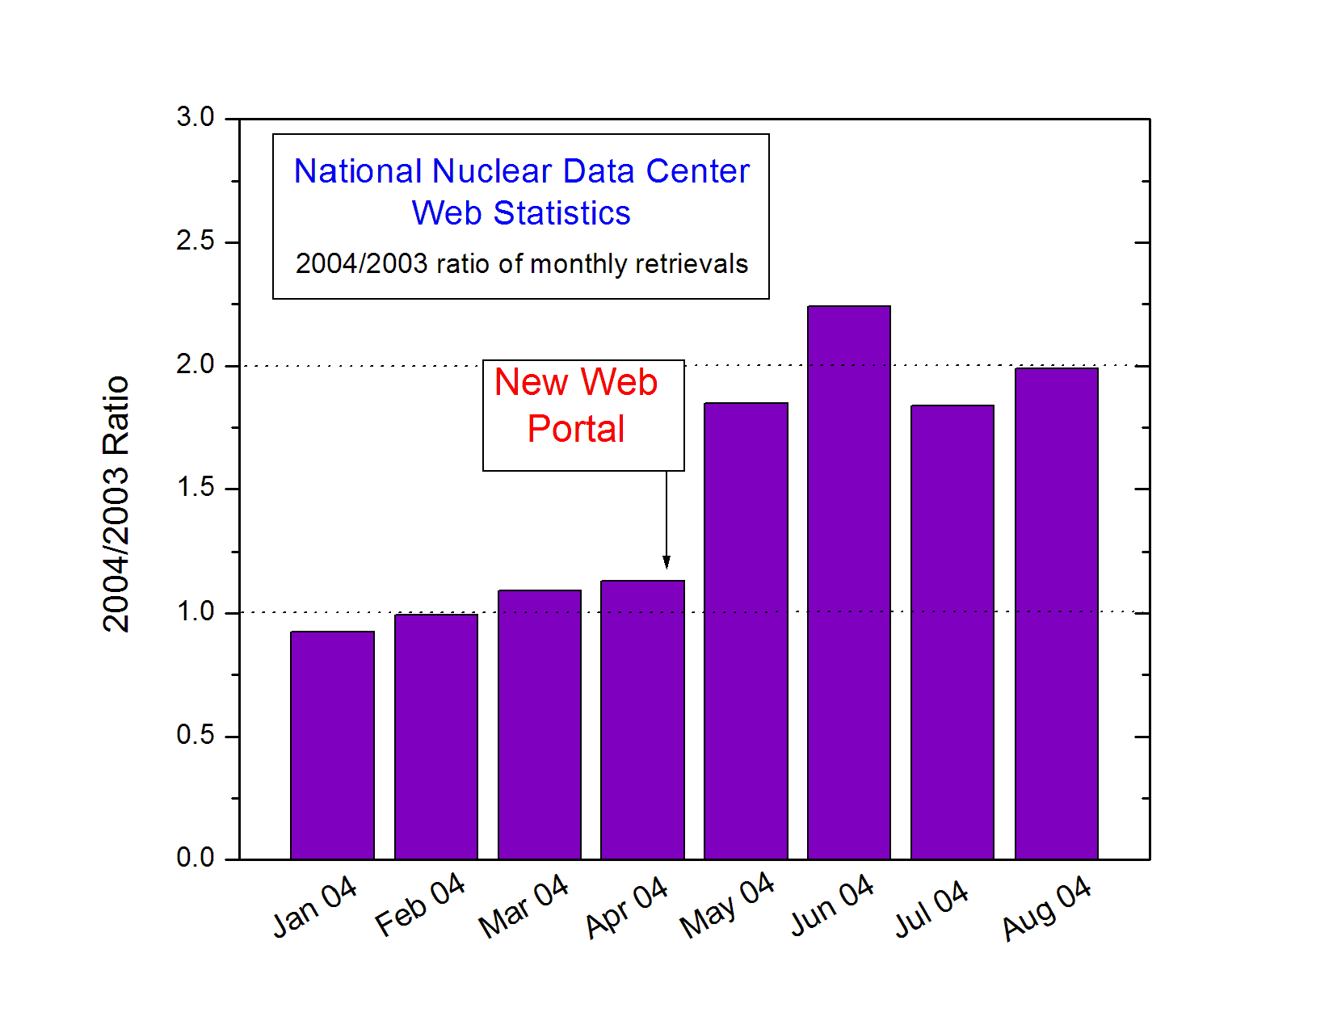

The most popular databases are NuDat, NSR and ENSDF, followed by CSISRS and ENDF. CINDA continues to show fairly low retrieval statistics.

The NNDC continues to host the USNDP Web site and CSEWG Web site.

Table 4. NNDC Transmissions (July 2003 – Sep 2004)

Tape | Preliminary posted | Final |  |  | Change in*
Tape | Preliminary posted | Posted | # data points | # entries | # data points | # subentries
Area 1 (neutron)
1315 | 20030530 | 20030729 | 19,320 | 19 | 7,419 | 3
1316 | 20030910 | 20031023 | 8,001 | 13 | 0 | 0
1317 | 20031105 | 20031219 | 19,288 | 28 | 881 | 5
1318 | 20040115 | 20040406 | 12,666 | 21 | 171 | 1
1319 | 20040426 | 20040514 | 137,863 | 10 | 10,638 | 7
1320 | 20040427 | 20040514 | 241,189 | 1 | 80,012 | 0
1321 | 20040510 | 20040517 | 96,002 | 25 | 80,012 | 0
1322 | 20040512 | 20040517 | 182,329 | 14 | 175,051 | 0
1323 | 20040517 | 20040602 | 18,191 | 23 | 4,741 | 2
1324 | 20040602 | 20040702 | 187,077 | 14 | 176,722 | 2
1325 | 20040702 | 20040722 | 107,443 | 19 | 1342 | 5
1326 | 20040727 | 20040826 | 83,713 | 24 | 55823 | 2
1327 | 20040830
Area 1 Total |  |  | 1,113,083 | 212 | 512,800 | 27
Area C (charged particle_
C057 | 20020827 | 20021018 | 7,919 | 19 | 716 | 11
C058 | 20030225 | 20030328 | 4,924 | 10 | 964 | 7
C059 | 20030605 | 20030729 | 5,965 | 21 | (382) | 3
C060 | 20030819 | 20030919 | 3,515 | 26 | 2,837 | 19
C061 | 20030929 | 20040112 | 6,017 | 28 | 890 | 16
C062 | 20040112 | 20040223 | 4,850 | 20 | 6,549 | 25
C063 | 20040225 | 20040405 | 4,027 | 23 | 23,915 | 26
C064 | 20040406 | 20040510 | 10,497 | 42 | 8,447 | 7
C065 | 20040420 | 20040513 | 27,707 | 26 | 13,376 | 10
C066 | 20040601 | 20040701 | 11,529 | 12 | 716 | 11
C067 | 20040722 | 20040830 | 6,526 | 17 | 964 | 7
C068 | 20040903
Area C Total |  |  | 93,476 | 244 | 57,312 | 142
Area T (charged particle - originally compiled at another center)
T013 | 20030806 | 20030908 | 22,536 | 27 | 18,067 | 18
T014 | 20031009 | 20031218 | 11,172 | 14 | 7,152 | 5
T015 | 20040120 | 20040318 | 43,036 | 14 | 41,478 | 8
T016 | 20040322 | 20040422 | 8,051 | 20 | 5,832 | 14
T017 | 20040625 | 20040730 | 9,007 | 20 | 6,851 | 18
T018 | 20040903
Area T Total |  |  | 93,802 | 95 | 79,380 | 63
NNDC Total |  |  |  |  | 649,492 | 232
* Change takes into account deletions vs. insertions.

