NATIONAL NUCLEAR DATA CENTER
Bldg. 197D
Brookhaven National Laboratory
P. O. Box 5000
Upton, NY 11973-5000 U.S.A.

Telephone: (516)344-5096
FAX: (516)344-2806

Memo CP-C/366.

DATE: October 10, 2005
TO: Distribution
FROM: D. Rochman
SUBJECT: Progress Report

EXFOR Compilation:

Our main effort on compilation was on EXFOR work. The last TRANS file for neutron-induced reaction was 1336 and the last TRANS file for charge-particle induced reaction was C074. Gamma-induced reactions were also compiled with two TRANS files (L007 and L008).
We try to spend the same amount of time on neutron and charge particle –induced reaction. The priorities are driven by the users’ needs that we contact mainly with the EXFOR “Contact area” on the NNDC web site (www.nndc.bnl.gov/exfor). It is important for us to answer as fast as possible to the users’ requests, with the best possible quality.
Another special effort was in the analysis of the EXFOR retrieval system. It is important to understand how people are using the web retrieval system to improve it and to make sure that we answer to the general needs.

CINDA:

It is important for us to provide an up-to-date CINDA database at NNDC. However, no compilations are done at NNDC for CINDA.

STATISTICS:

The number of retrievals for the EXFOR database is increasing over the last few years, as the total number of retrievals from the NNDC web site (see next figure). This is reflecting our new web interface, which has for purpose to make easier the access of the databases.

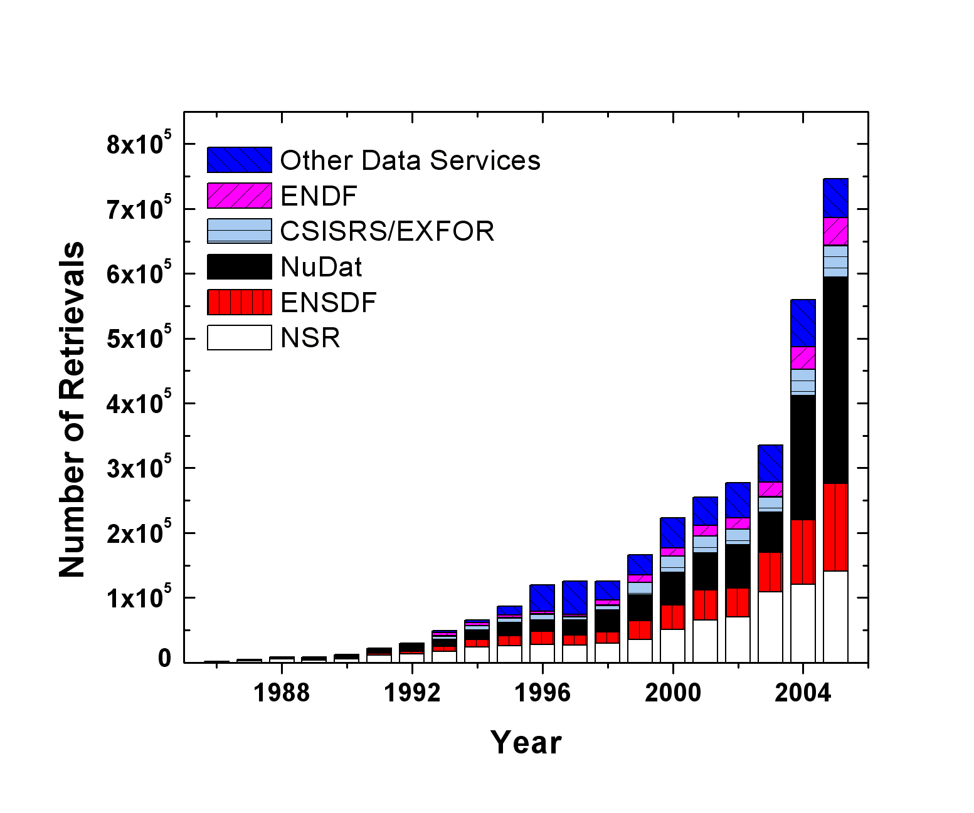

Distribution:

vml@bnl.gov  drochman@bnl.gov  manokhin@ippe.obninsk.ru  maev@ippe.obninsk.ru  may@obninsk.ru  Mmarina@ippe.obninsk.rug  blokhin@ippe.obninsk.ru  feliks@polyn.kiae.su  chukreev@polyn.kiae.su  S.Dunaeva@iaea.org  taova@expd.vniief.ru  varlamov@depni.sinp.msu.ru  kato@nucl.sci.hokudai.ac.jp  ohnishi@nucl.sci.hokudai.ac.jp | gezg@iris.ciae.ac.cn  hongwei@iris.ciae.ac.cn  tarkanyi@atomki.hu  stakacs@atomki.hu  vlasov@kinr.kiev.ua  ogritzay@kinr.kiev.ua  ohtsuka@nucl.sci.hokudai.ac.jp  m.wirtz@iaea.org  m.lammer@iaea.org  v.pronyaev@iaea.org  v.zerkin@iaea.org  henriksson@nea.fr  exfor@nea.fr  schwerer@iaea.or.at

