WP 2005-18
NEA Data Bank
Le Seine St-Germain
12, boulevard des Iles
92130 Issy-les-Moulineaux
FRANCE
Email: exfor@nea.fr | Tel: +33 (0) 1 45 24 10 84
or cinda@nea.fr | Fax: +33 (0) 1 45 24 11 28

MEMO CP-N/36

DATE: 6 Oct 2005
TO: See distribution list below
FROM: H. Henriksson
SUBJECT: Plot possibilities with JANIS for the EXFOR and ENDF formats, in response to Memo CP-C/362 by D. Rochman.

The JANIS data display program has been developed at the NEA for facilitating the visualisation of reaction data in EXFOR and ENDF formats. These formats are convenient for data base storage, but not always useful for researchers and other users who want to compare data sets in the different formats.

The EXFOR and ENDF on-line retrieval pages at the NEA have now the possibility to plot the data points directly in a plot window of JANIS.
For EXFOR: http://www.nea.fr/html/dbdata/x4/x4ret-H2.html
For ENDF data libraries: http://www.nea.fr/html/dbdata/eva/evaret-H2.cgi

The main advantages of directly plotting the retrieved data in JANIS is the possibility to zoom and change scales, store or print results, as well as to compare different sets of EXFOR works. Also, it is possible to plot data from data libraries in ENDF format and compare with EXFOR data, by searching in the data bases available online within JANIS.

Below follows some figures on how the system works. Fig. 1 shows a web retrieval on U-233 in EXFOR, and Fig. 2 shows the JANIS plot window that appears when clicking on the ”Plot in JANIS” button. (Note, that the first EXFOR entry in Fig. 1 (22849, Average kinetic energy of primary fragment) was not possible to plot). Fig. 3 presents the possibility to search data in JANIS, and Fig 4 visualises ENDF/B-VI.8 and JEFF-3.1 data together with EXFOR elastic cross section data.

The on-line version of JANIS is presently a beta-version, and we are happy to receive comments on its use. Please, help us with your feedback in making it more user friendly, in finding errors, and in suggesting improvements.

Best regards,
Hans Henriksson

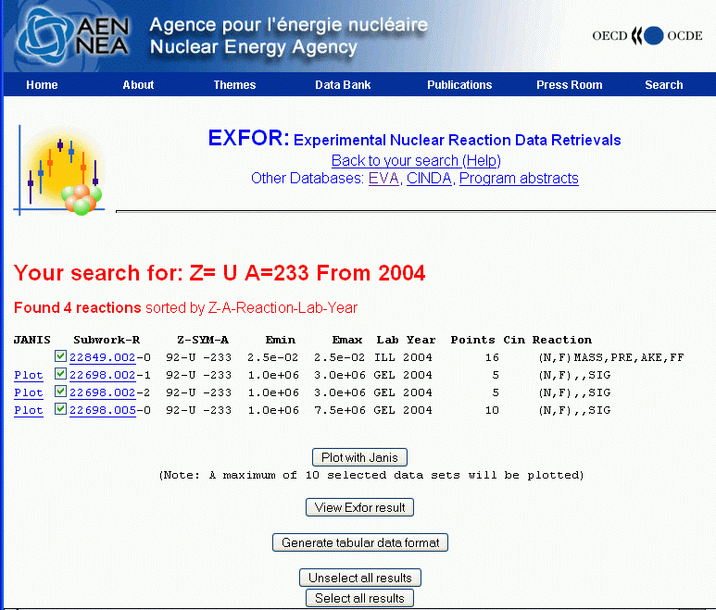
Figure 1, Web retrieval on U-233 from 2004 with the JANIS links on the left of the retrieval line, as well as on the button “Plot with Janis”.

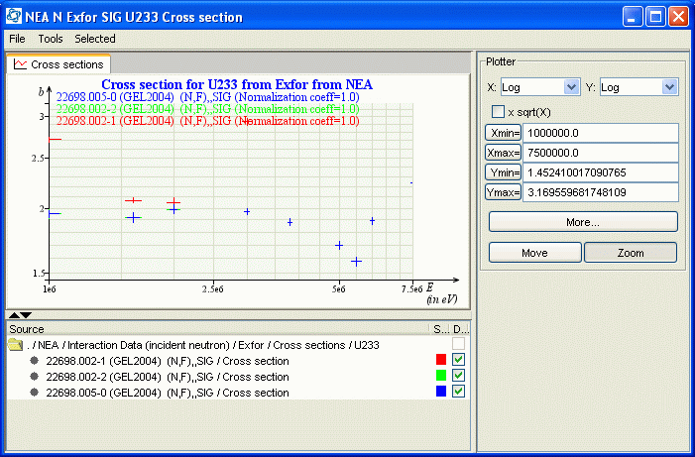
Figure 2, JANIS plot window that appears after clicking on the “Plot with Janis” link.

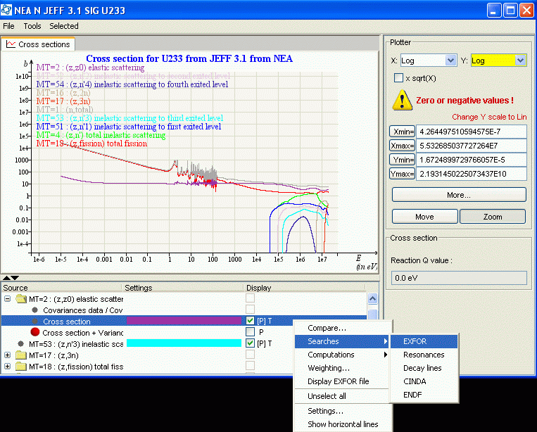
Figure 3, ENDF library plotting with search menu shown

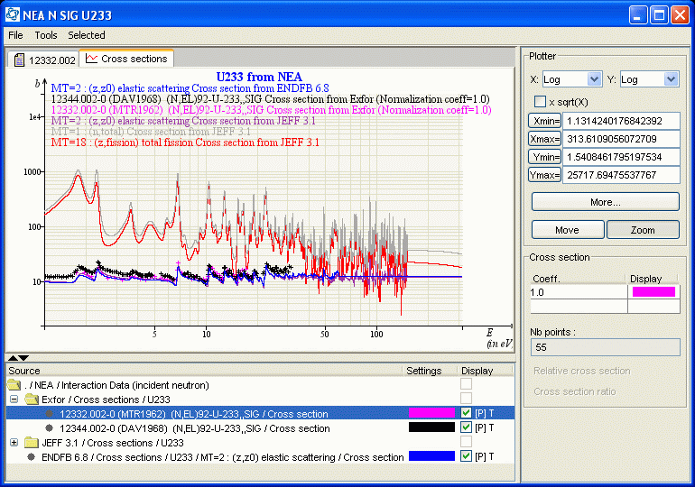
Figure 4, EXFOR data (elastic cross section) compared with JEFF-3.1 and ENDF/B-VI.8 U-233 elastic, fission and total cross sections.

