CINDA-editor
WP 2005-22

V.Zerkin, IAEA-NDS, 06.10.2005

Compiler edits the data in CINDA database performing some operations, like insert/delete/modify blocks/lines and save results in his database. All these changes are accumulated together with actions in the database as temporary. Than Compiler makes TRANS files (Exchange and Reader), dismiss all changes in the database and sends TRANS file to other Nuclear Data Centers. After approval procedure, all TRANS files (including own files) must be applied to the database and became permanent.

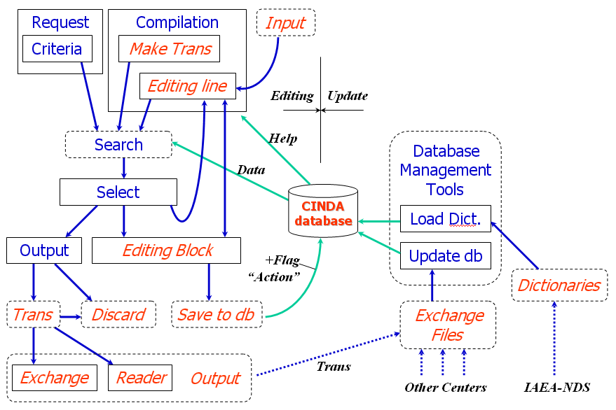
CINDA editor program was built as an extension of Java program used in CD “EXFOR-CINDA for Windows”. Last CD-ROM distribution contains a batch file (ccompil.bat) running program X4java02 in CINDA compilation mode.

Fig.1 CINDA: data editing and database update

Editing process in details.
Editing actions provided by the program are following:
- Create new block and add lines to it
- Add lines to an existing block
- Delete line/block
- Modify line/block
- Attach block to an existing block (move)
- Move line to another block
- Save current editing; continue editing later in another session
- Output TRANS files and clean database

This functionality is implemented in the following way. Two new Tabs are added to existing panel: Compilation–Tab and CC-Help (CINDA Compilation Help). Compilation-Tab has 4 parts (areas):
- Block information: used as search criteria and for input of data of Block
- Line information: used for input/editing of the data of Line
- Edited block: contains Block in CINDA format which is currently edited with special flags for every line showing the status of the line
- Line related information: used for display of database internal information about edited line
Two Tabs existing in CD-ROM retrieval system have an extended functionality:
- Select-Tab: used to define block/line for editing, display flags of lines currently stored in the database, used for calls of editing functions via right-button pull down menu; have a buttons to make TRANS and dismiss accumulated changes in the database
- Output-Tab creates TRANS files in Exchange and Reader formats.

Editing existing data.
Process starts from a search of the data which should be edited. Then on Select-Tab by right-button click using pull-down menu compiler select Block for editing (now selected block appear in Block-edit area). From this menu (as well as from Block-edit area) a line can be copied to Line-edit area: line is disassembled to parts and prepared for editing. Other functions: Move line to edit-block area, Move block (attach) to edit-block area.

Values in Line-edit fields can be manually edited and/or taken from the Help-sytem based on EXFOR-CINDA dictionaries. When line is ready, compiler defines how s/he wants to store this line in Edit-block area: add new line or update edited Line: s/he does this by Edit-line actions at the bottom of Line-edit area. Block-edit area has also pull-down menu working for the actions for every line in the Block (Delete line, Restore line, Mark-up line, Edit line, etc.). On the top of Block-edit area there is a series of buttons for actions with the block when it is ready (Save in database, Restore from database, Restore original values, etc.).

Insert a new data.
Buttons “Block” on Compilation-Tab can be used for search of existing blocks with given BlockNo and Lab-code (compiler should define a BlockNo which is not yet occupied). Then compiler inputs data and codes for Block and Line and use action “New Block” or “Add Line”. Then s/he edits block in the Block-edit area (same as described earlier) and store data in the database.

Make TRANS.
Button “Trans” on Compilation-Tab should be used to prepare a new TRANS: program will search for update Lines accumulated in the database and display them in Selection-Tab. Button “Roll-Back” Selection-Tab allow to dismiss all changes made until now in the database; button “Out Trans” makes two TRANS files (Exchange and Reader). These files can be stored locally and sent to other Centers…

Pictures in Appendix illustrate editing process.

Appendix 1.

Compilation form. Starting point.

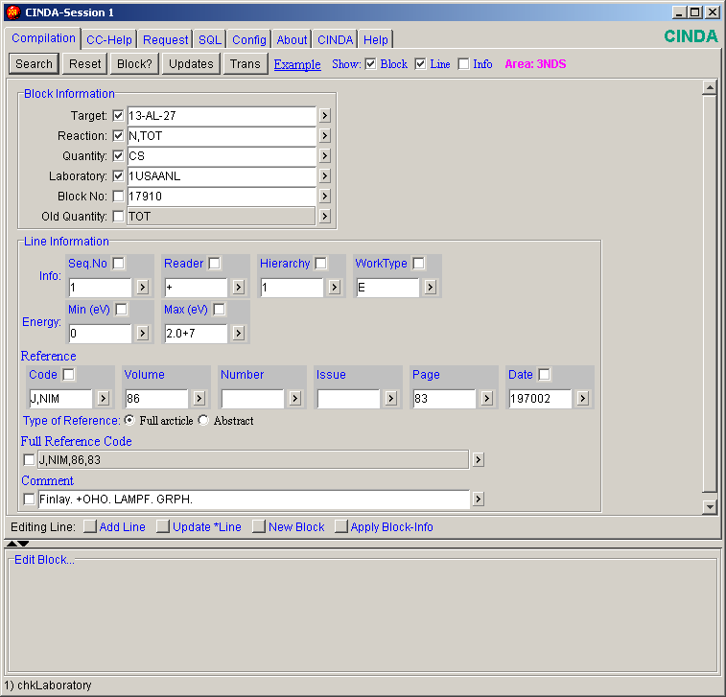
Here you will edit Block data
Here you will edit Line data
Put data to Block-edit area
Block-edit area.
Here you select Lines for editing and apply actions to database

Select form. Actions on the blocks and lines
(pull-down menu is called by mouse right-button click).

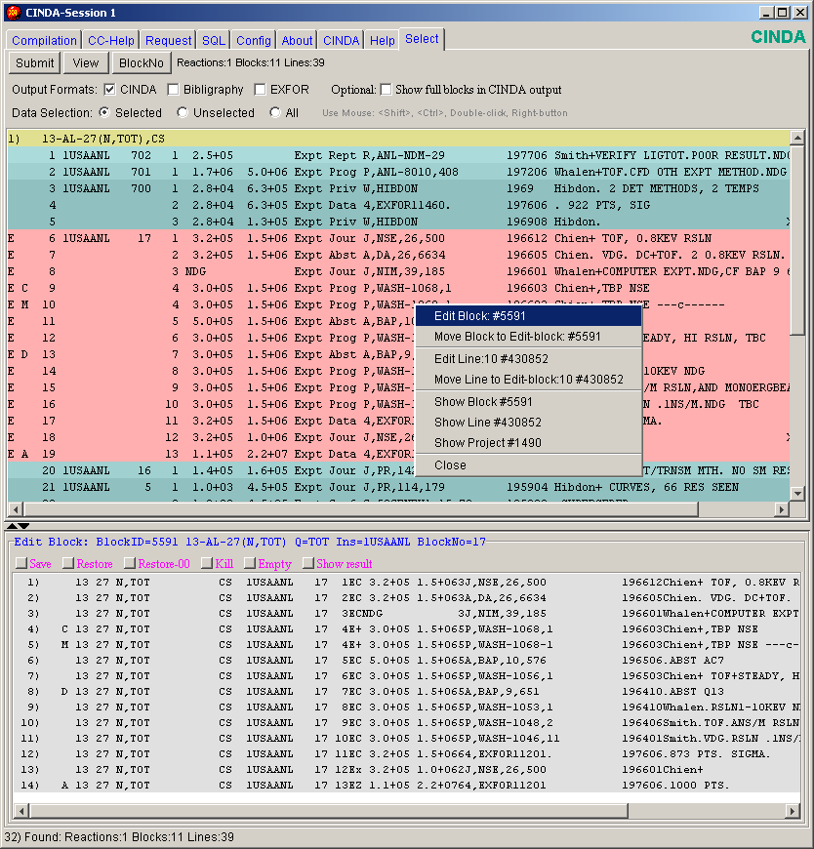
This Block is copied to Block-edit area
Explanation of Action-codes of Lines of the Block-edit area (left side)
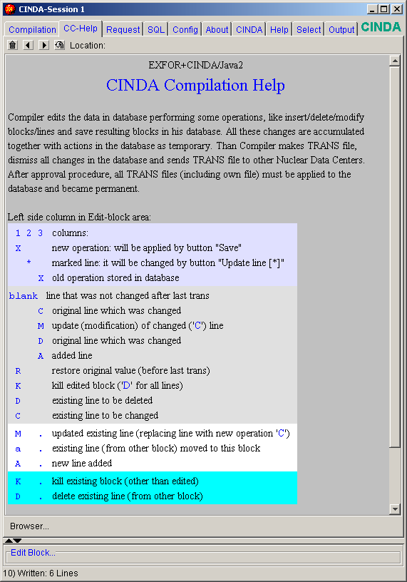
Actions of lines and block, editing line field by field.
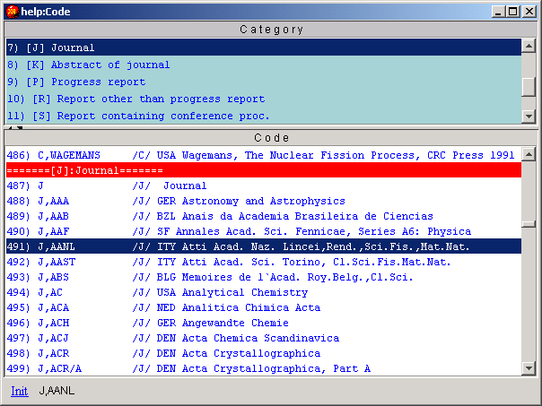
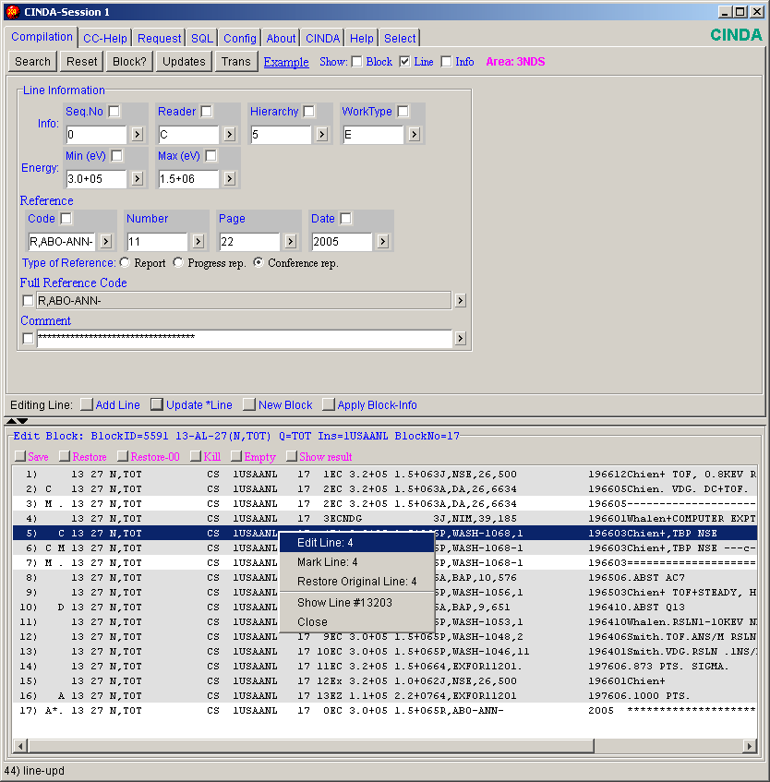

Show result: how block will look after editing.
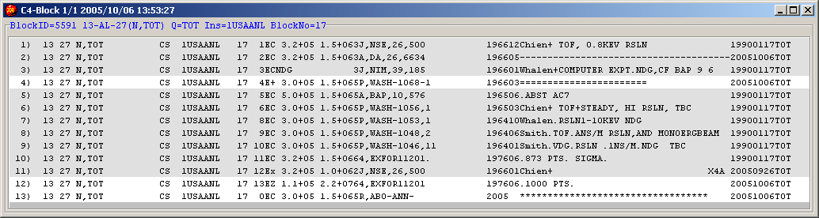
Make TRANS.
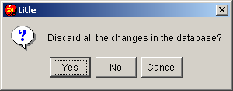
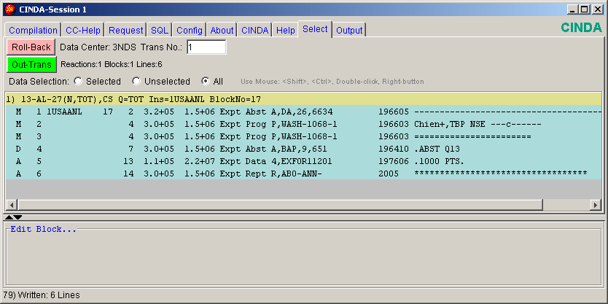

Save Reader and Exchange files.
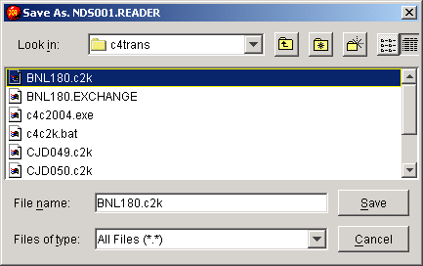
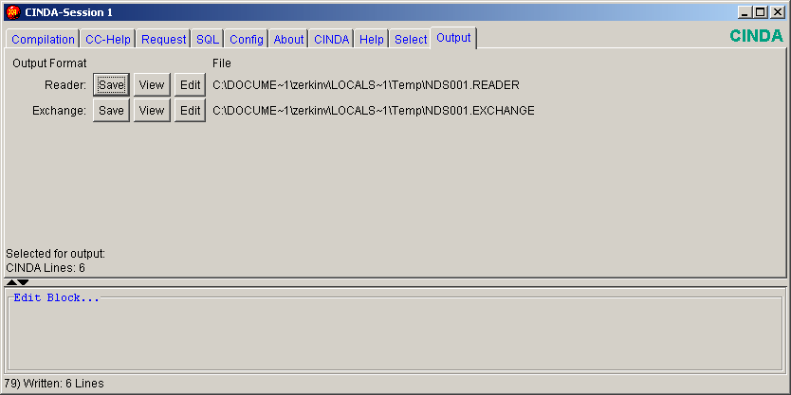

View Reader file of TRANS.
