WP 2005-23
How to plot together
experimental cross sections and evaluated data
using NDS-NNDC EXFOR-ENDF Web-interface.
V.Zerkin, IAEA-NDS, 05.09.2005

I. Start from ENDF Request form.
1) Fill in your request (Target, Reaction, Quantity, etc.)
2) Submit your request.

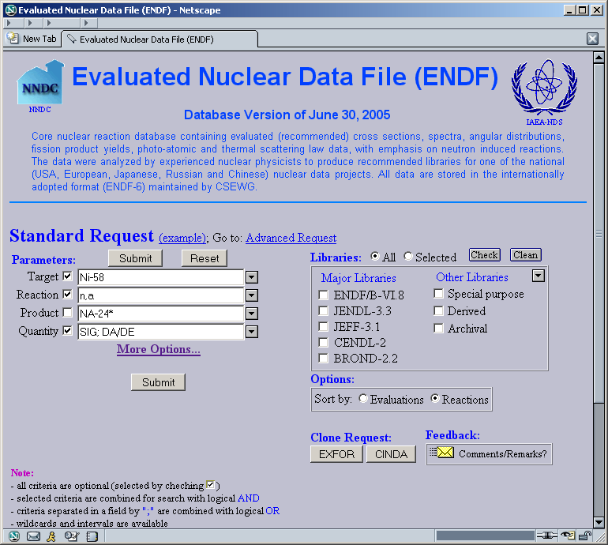
2
2
2
1
1
Use Help

II. You came to Selection-form with results of the search in database.
3) Select data which you age going to plot (optional - default: All)
4) Select option “Quick Plot (MF3)”
5) Submit your selection

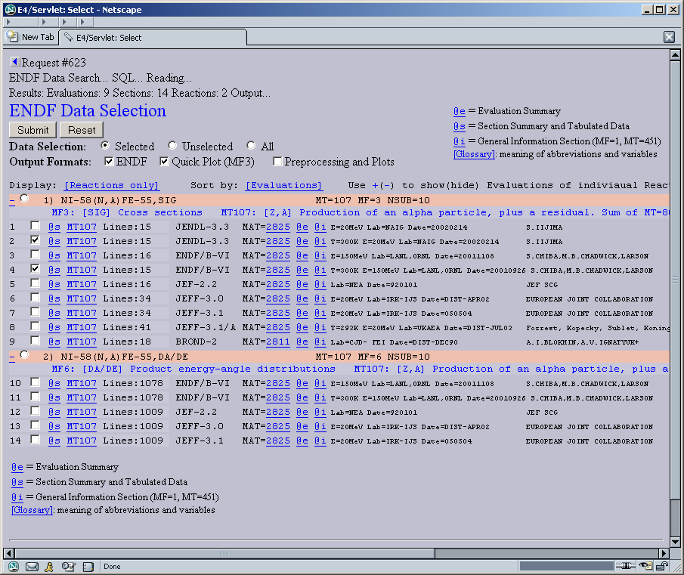
3
4
5

III. You came to Output-form with pointer to ENDF data and plot of selected data.
+) You can change parameters of the plot and repaint picture (bottom).
6) In order to have experimental data on the same plot use EXFOR “Search”

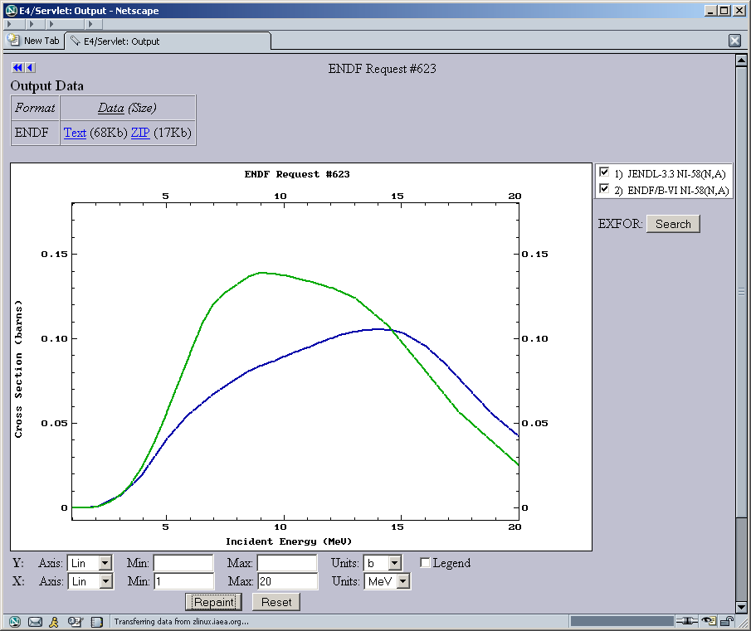
6. Go to EXFOR
6

8+
8+
+

IV. Program opens a new Window and you came to EXFOR Selection-form with experimental datasets found according to evaluated data on the last plot.
7) Select datasets for plot (optional - default: All)
8) Submit

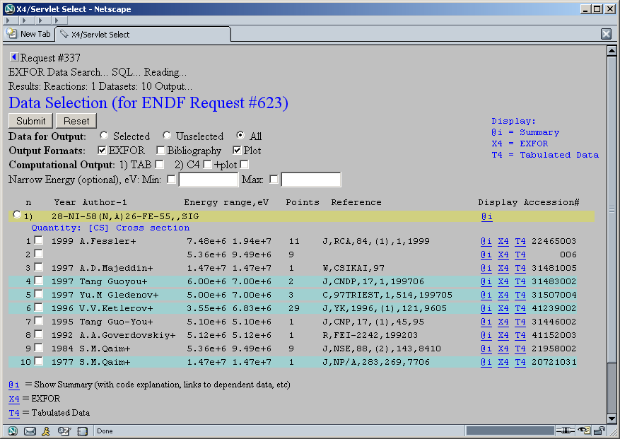
8
7
7

V. You came to EXFOR Output-form with pointer to data and plot of selected experimental data with evaluations.
+) You can change parameters of the plot and repaint picture.
9) You can also go back, select other datasets, submit new request and have another plot.
9

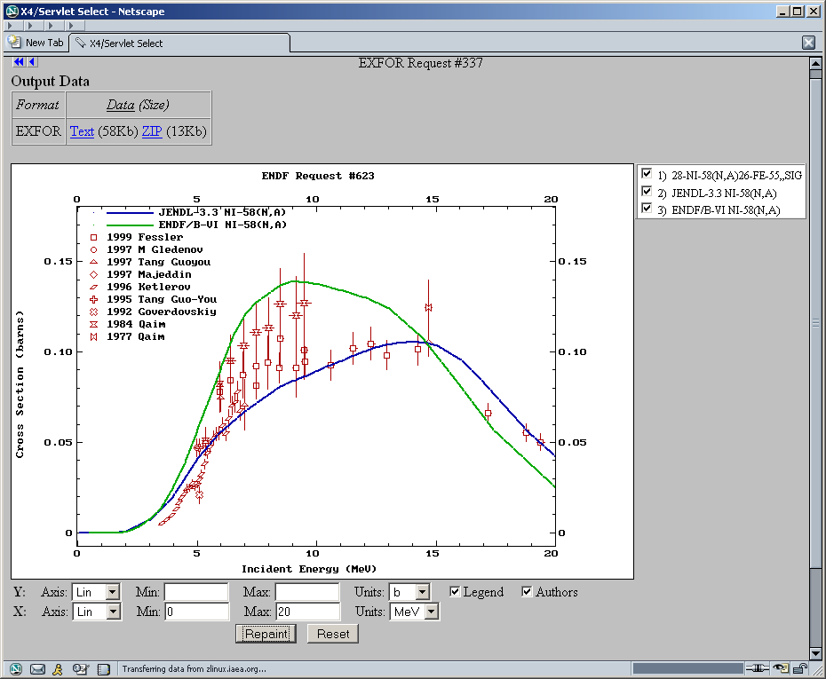
+
8+
8+
+
+

The End

