NEA Data Bank
Le Seine St-Germain
12, boulevard des Iles
92130 Issy-les-Moulineaux
FRANCE
Email: exfor@nea.fr | Tel: +33 (0) 1 45 24 10 84
or cinda@nea.fr | Fax: +33 (0) 1 45 24 11 28

MEMO CP-N/52
DATE: 29 August 2006
TO: See distribution list below
FROM: A. Hasegawa, H. Henriksson
SUBJECT: NEA Progress Report, 2005-2006

Dear colleagues,

The NEA Progress report is attached in this memo to be presented at the NRDC meeting 25-28 September 2006.

Distribution:

s.takacs@atomki.hu
tarkanyi@atomki.hu
chiba@earth.sgu.ac.jp
kato@nucl.sci.hokudai.ac.jp
ohbayasi@meme.hokudai.ac.jp
ohnishi@nucl.sci.hokudai.ac.jp
ohtsuka@nucl.sci.hokudai.ac.jp
hongwei@iris.ciae.ac.cn
gezg@iris.ciae.ac.cn
yxzhuang@iris.ciae.ac.cn
chukreev@polyn.kiae.su
blokhin@ippe.obninsk.ru
feliks@polyn.kiae.su
samaev@obninsk.ru
manokhin@ippe.obninsk.ru
mmarina@ippe.obninsk.ru
taova@expd.vniief.ru
varlamov@depni.sinp.msu.ru
ogritzay@kinr.kiev.ua
kaltchenko@kinr.kiev.ua
oblozinsky@bnl.gov
drochman@bnl.gov
S.Dunaeva@iaea.org
a.l.nichols@iaea.org
schwerer@iaeand.iaea.or.at
v.zerkin@iaea.org
henriksson@nea.fr
hasegawa@nea.fr
claes.nordborg@oecd.org

,

PROGRESS REPORT FROM THE
OECD/NEA DATA BANK
At the NRDC meeting at IAEA, Vienna, Austria
25-28 September 2006
NEA Web page: www.nea.fr
Contact: db@nea.fr

General
The Data Bank’s primary role is to provide scientists in member countries with reliable nuclear data and computer programs for use in different nuclear applications. The services include also thermochemical data for radioactive waste management applications. The Data Bank organises seminars and workshops to present information on computer programs or groups of programs that are considered to be of special interest to users. Training courses on widely used computer programs are organised a few times a year to ensure a correct and effective use of these programs.

The Data Bank member countries are: Austria, Belgium, Czech Republic, Denmark, Finland, France, Germany, Greece, Hungary, Italy, Japan, Republic of Korea, Mexico, Netherlands, Norway, Portugal, Slovak Republic, Spain, Sweden, Switzerland, Turkey, and United Kingdom. Users of the Data Bank services include governmental research institutes, industry and universities.

The NEA Data Bank maintains a close cooperation with the NEA Nuclear Science Section, which provides useful feedback on the performance of computer programs and nuclear data through a number of benchmark studies, especially in the areas of reactor and fuel cycle physics, criticality safety, and radiation shielding.

The annual meeting of the Data Bank management committee (the NEA Nuclear Science Committee Executive Group) was held in May 2006. The two main decisions at this meeting were to actively encourage the release of new computer codes to the Data Bank’s collection and to extend the mandate of the Joint Evaluated Fission and Fusion (JEFF) project for the period 2006–2009.

Organisation
Total number of full time staff in the NEA Data Bank is 15. This is divided into 8 professional staff and 7 support staff. However, only 5 professional and 6 support staff work with the Data Bank services. The remaining staff is allocated to work in other parts of the NEA.

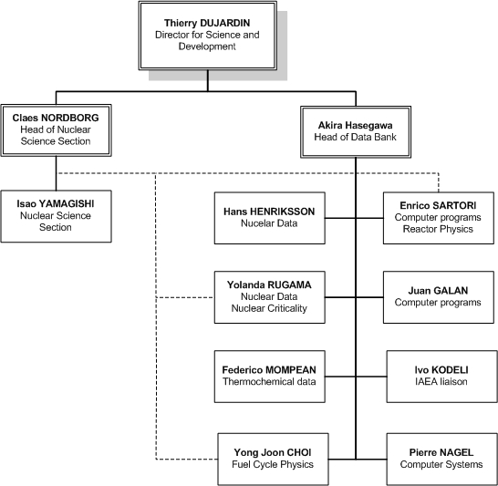
Thierry Dujardin is Director for Science and Development with Claes Nordborg and Akira Hasegawa below him as heads of the Nuclear Science Section and the NEA Data Bank, respectively. Within the Data Bank, Enrico Sartori is responsible for the Computer Program Services (CPS) together with Juan Galan and Ivo Kodeli (employed by the IAEA). Hans Henriksson and Yolanda Rugama are responsible for the Nuclear Data Services (NDS). The in-house computer system is taken care of by Pierre Nagel. Yolanda Rugama, Yong-Joon Choi and Enrico Sartori are also working part-time for the Nuclear Science Section, whereas Federico Mompean work full time for the Thermochemical Database (TDB) project in support of the NEA Radioactive Waste Management division. See Fig. 1 for an overview of the NEA Data Bank professional staff (including the Nuclear Science Section).

Figure 1. NEA Data Bank and the Nuclear Science Section

Nuclear Data Services
The nuclear data services are mainly provided through direct on-line access to the CINDA, EXFOR and EVA databases containing bibliographic, experimental and evaluated nuclear data respectively. Access to all the databases is open and free of charge. The number of retrievals from the NEA Web pages is between 900-1400 requests/month for EXFOR and CINDA, and about the same for evaluated data libraries in the EVA database. See Table 1 for the numbers of retrievals of some services from the web pages during 2004-2005.
Table 1. Web retrievals 2004-2005 from the NEA Data Bank

Service | 2005 | 2004
CINDA | 897 | 873
EVA searches | 13 843 | 8 481
EXFOR searches | 13 368 | 13 105
Janis | 216 520 | 218 811
Web pages NDS | 86 894 | 83 437
CPS | 186 443 | 166 649
TDB | 38 649 | 30 189
other Data Bank pages | 34 166 | 33 107

Lately, the displaying program for experimental and evaluated data, directly obtained from Web retrieval, has been upgraded. This online plotting facility is performed by Janis-2.2.1 (released in October 2005), the software that has been developed at the NEA (see below).

In addition to these on-line services, the Data Bank also answers specific requests from customers. Normally, this concerns requests for very large datasets, which are too large for direct Internet download. The very large datasets are normally distributed on CD-ROM or DVD. Providing advice to nuclear data users is another important part of the nuclear data services.

EXFOR and CINDA compilation
More than 100 new neutron reaction experiments and almost 200 charged particle experiments have been entered by the Data Bank into the EXFOR database since the beginning of 2005 (see Table 2). The database is updated continuously and the delay between article publication and inclusion in EXFOR has been reduced.

Table 2 EXFOR compilations from the NEA (area 2 and O) during 2005 and Jan-July 2006

 |  | AREA 2 |  |  | Trans |  |  | No of works
 |  | 2005 |  |  | 2168 |  |  | 7
 |  |  |  |  | 2169 |  |  | 20
 |  |  |  |  | 2170 |  |  | 8
 |  |  |  |  | 2171 |  |  | 5
 |  |  |  |  | 2172 |  |  | 8
 |  |  |  |  | 2173 |  |  | 7
 |  | 2006 |  |  | 2174 |  |  | 17
 |  |  |  |  | 2175 |  |  | 18
 |  |  |  |  | 2176 |  |  | 11
 |  |  |  |  | 2177 |  |  | 10
 |  |  |  |  | Total |  |  | 111
 | AREA O |  |  | Trans |  |  | No of works
2005 |  |  | o022 |  |  | 34
 |  |  | o023 |  |  | 38
2006 |  |  | o024 |  |  | 9
 |  |  | o025 |  |  | 17
 |  |  | o026 |  |  | 69
 |  |  | Total |  |  | 167

The CINDA database has been subject to a major extension due to the new format, including the insertion of charged particle references from the EXFOR database. The new CINDA database has been tested and adopted at the NEA.

The CINDA database is available on DVD as part of the Janis package, and also on-line through the Web. Due to a certain demand and the extension of CINDA to include charged particle data, the NEA has decided to produce an archive version of the CINDA Book, last issued in 1990. The new archive version is planned to be printed 2006. A draft has already been produced.

Data display tools: Janis
The nuclear data display software, Janis (JAva Nuclear Information System), developed at the NEA Data Bank, has been available for all interested users free of charge since its first release in 2001. Janis accesses locally stored, as well as remote, ENDF formatted evaluated data and experimental data from the EXFOR database. The latest version of Janis (Janis-2.2.1) was released in October 2005.

The program is free of charge and can be downloaded or launched using ‘JAVA Web Start’ from the Janis home page: http://www.nea.fr/janis, where the complete manual can be found as well. Over 25 000 Janis requests per month for data from the NEA databases are registered in the log files. One such request can cover one EXFOR subentry, or a full evaluated library. See Fig. 2 for the evolution of Janis retrievals over time since January 2004.

Figure 2 Janis statistics, January 2004 - August 2006, with the different versions indicated as well. Janis 2.2.1 included the Web retrieval plotting facility.

The Joint Evaluated Fission and Fusion (JEFF) Project and JEFF-3.1
The JEFF-3.1 Nuclear Data Library is the latest version of the Joint Evaluated Fission and Fusion Library. The complete suite of data was released in May 2005, and contains general purpose nuclear data evaluations compiled at the NEA Data Bank in co-operation with several laboratories in the Data Bank member countries. Processed data for Monte Carlo code applications was made available in spring 2006, and the full documentation of JEFF-3.1 is to be published later this year.

The NEA High Priority Request List (HPRL)
The NEA Data Bank is assisting the Nuclear Science section Working Party on international nuclear data Evaluation Cooperation (WPEC) to manage the High Priority Request List (HPRL), which is a compilation of the highest priority nuclear data requirements, primarily for application in the nuclear industry. The purpose of the list is to provide a guide for those planning measurements, exploring nuclear theory, and requesting high precision evaluated data for the projects. The HPRL is a place where data users meet data producers. Three high priority requests have been accepted after peer review by the HPRL reviewing procedure, and one general request was also accepted. All requests need to be tied to a certain project. The list is maintained by the NEA Data Bank and is presented at: http://www.nea.fr/html/dbdata/hprl/

Computer Program Services
The computer program services distribute more than 2000 documented software packages and group cross-section data sets per year. The activity includes collection of programs, compilation and verification, using quality assurance methods, in an appropriate computer environment, and that the computer program package is complete and adequately documented (see www.nea.fr/html/dbprog). The computer program collection covers a wide range of nuclear energy and radiation physics applications.

Data from Integral Experiments
Under the guidance of the NEA Nuclear Science Committee (NSC), the Data Bank preserves data from integral experiments to assist users in having well documented information available for benchmark testing, especially in the context of the development of future nuclear energy systems. Integral experimental data with benchmark quality have been compiled, reviewed and published. The most relevant ones for nuclear data are:
- International Criticality Safety Benchmark Experiments (ICSBEP)
- Radiation Shielding and Dosimetry Benchmark Experiments (SINBAD)
- International Reactor Physics Experiments Evaluations (IRPhE).

Computer program training courses & tutorials 2006
The NEA Data Bank organises and participates in seminars and workshops to present information on computer programs or groups of programs that are considered to be of special interest to users. Training courses on widely used computer programs are organised a few times a year to ensure a correct and effective use of them. A list of recent and planned events is given below.
23 January-10 February 2006, Seminar and Training on Scaling, Uncertainty and 3D Coupled Code Calculations in Nuclear Technology, (3D.S.UNCOP-2005), School of Nuclear Engineering, Barcelona, Spain
7-8 April 2006, Training Course on Neutron Spectra Unfolding, Cape Town, South Africa: UMG software package provided by PTB (UMG: Unfolding with GRAVEL and MAXED)
4-7 July 2006, Electron-Photon Transport Modelling with PENELOPE-2006 - Physics, Code Structure and Operation, University of Barcelona, Barcelona, Spain.
17-21 July 2006, Intermediate Workshop on MCNPX: Monte Carlo N-Particle Transport Code System for Multiparticle and High Energy Applications, ENEA, Bologna, Italy.
10-14 September 2006, PHYSOR-2006-Topical Meeting Advances in Nuclear Analysis and Advances in Nuclear Analysis and Simulation, Hyatt Regency Vancouver
15-17 September 2006, Workshop on Use of Monte Carlo Techniques for Design and Analysis of Radiation Detectors, University of Coimbra, Coimbra, Portugal
25-29 September 2006, 9th Information Exchange Meeting on Actinide and Fission Product Partitioning and Transmutation (co-organised NSC/NDC), Nîmes, France
9-13 October 2006, Training Course on MCNP5 Coupled Neutron, Electron Gamma 3-D Time-Dependent Monte Carlo Transport Calculations, ITN Sacavém, Lisbon, Portugal

Data Bank cooperation with other NEA divisions

Nuclear Science
The collaboration between the NEA Nuclear Science section and Data Bank is mainly in the areas of:
- Reactor and fuel cycle physics, including reactor stability and transient calculations, utilisation of MOX fuel and disposal of weapon-grade Pu, nuclear criticality safety, nuclear waste transmutation studies and radiation shielding.
- Fuel cycle chemistry covering chemical partitioning, fuel cycle flowsheet studies and separation criteria

The Data Bank has also developed a database, called DICE, for the International Handbook of Evaluated Criticality Safety Experiments. The next version of DICE will be released in September 2006. The 2006 version will contain some minor improvements, but may also introduce new data.

Radioactive Waste Management
The Thermochemical Database project is a co-operative effort between the NEA Data Bank and the NEA Radioactive Waste Management Committee to produce internationally recommended chemical thermodynamic data needed for the safety assessment of radioactive waste disposal systems. The Project is currently supported by 17 organisations from 12 OECD member countries.

An update to earlier reviews of thermochemical data for Uranium, Neptunium, Plutonium, Americium, and Technetium was published in 2003. Reviews of data for Zirconium, Selenium, Nickel and selected organic compounds have been published in 2005. A new phase of the project has been started, covering evaluation of inorganic complexes and compounds of Thorium, Iron and Tin. The Thorium review is scheduled for publication early in 2007, followed by the review on Tin. The project has also funded the preparation of guidelines for the evaluation of thermodynamic data for solid solutions in the context of radioactive waste management. The peer review on Iron is scheduled during the first semester of 2007.

Radiation Protection
The Information System on Occupational Exposure (ISOE) is a database managed at the NEA jointly with the IAEA. ISOE provides the world’s largest database on occupational exposure at 478 commercial reactor units in 29 countries, covering some 91% of the world’s operating commercial power reactors. Occupational exposure data collected annually from participants is made available to ISOE members through the database. In addition to the detailed data provided directly by participating utilities, participating authorities also contribute official national data in cases where some of their licensees may not yet be ISOE members. The NEA Data Bank is developing a new Internet-based system for ISOE.

Nuclear Safety
The Data Bank is safeguarding information from a number of projects within the NEA Nuclear Safety division, such as the OECD Piping Failure Data Exchange (OPDE) Project. The goal of this project is to collect and analyse piping failure event data to promote a better understanding of underlying causes, the impact on operations and safety, as well as to generate qualitative insights into the root causes of piping failure events. The OPDE project also aims at establishing a mechanism for efficient feedback of experience gained in connection with piping failure phenomena, including the development of defence against their occurrence.

Data Bank Computer System
An outline of the Data Bank computer system is given in figure 3 below.

The new software system for monitoring the various pieces of equipment and some basic user services (Nagios) has been deployed and is used to detect performance issues as well as for being warned in case of breakdown of some critical piece of hardware.

An upgrade of the Oracle database system to version 10 is underway. This task will resolve some problems encountered with displaying multinational character sets in the framework of the ISOE project. The new version will also allow better handling of the failover between different Oracle databases.

The central file storage system has been upgraded in the spring 2006. The increase in storage space will allow all user and all application files to be consolidated into a single system. The initial capacity will be 1 TeraByte.

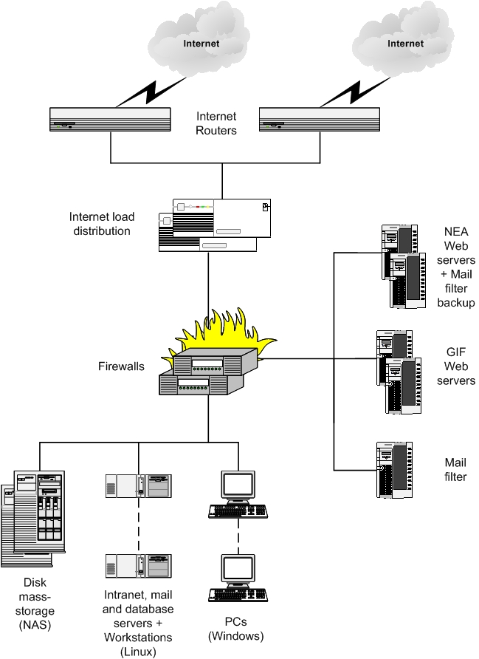
Some improvements in security will be expected from the reorganisation of the subnets into specialised firewall managed .DMZs. The main Internet DMZ will be split into a Windows OS and a Linux OS subnet. In this way, potential weaknesses in the windows OS (in case of attacks) will not affect the Linux servers and vice versa.

Figure 3. Outline of the NEA Data Bank computer configuration.

