

UCRL-TR-228089

POINT 2007:

A Temperature Dependent
ENDF/B-VII.0 Data
Cross Section Library

by
Dermott E. Cullen
University of California
Lawrence Livermore National Laboratory
P.O. Box 808/L-159
Livermore, CA 94550

Tel.: 925-423-7359

E. Mail: cullen1@llnl.gov

February 14, 2007

Approved for public release; further dissemination unlimited.

DISCLAIMER

This document was prepared as an account of work sponsored by an agency of the United States Government. Neither the United States Government nor the University of California nor any of their employees, makes any warranty, express or implied, or assumes any legal liability or responsibility for the accuracy, completeness, or usefulness of any information, apparatus, product, or process disclosed, or represents that its use would not infringe privately owned rights. Reference herein to any specific commercial product, process, or service by trade name, trademark, manufacturer, or otherwise, does not necessarily constitute or imply its endorsement, recommendation, or favoring by the United States Government or the University of California. The views and opinions of authors expressed herein do not necessarily state or reflect those of the United States Government or the University of California, and shall not be used for advertising or product endorsement purposes.

Work performed under the auspices of the U. S. Department of Energy by the University of California Lawrence Livermore National Laboratory under Contract W-7405-Eng-48.

This report has been reproduced
directly from the best available copy.

Available to DOE and DOE contractors from the
Office of Scientific and Technical Information
P.O. Box 62, Oak Ridge, TN 37831
Prices available from (423) 576-8401
http://apollo.osti.gov/bridge/

Available to the public from the
National Technical Information Service
U.S. Department of Commerce
5285 Port Royal Rd.,
Springfield, VA 22161
http://www.ntis.gov/

OR

Lawrence Livermore National Laboratory
Technical Information Department’s Digital Library

http://www.llnl.gov/tid/Library.html

UCRL-TR-228089

POINT 2007:
A Temperature Dependent
ENDF/B-VII.0
Cross Section Library

by
Dermott E. Cullen
University of California
Lawrence Livermore National Laboratory
P.O. Box 808/L-159
Livermore, CA 94550

Tel.: 925-423-7359

E. Mail: cullen1@llnl.gov

February 14, 2007

Overview

This report is one in the series of “POINT” reports that over the years have presented temperature dependent cross sections for the then current version of ENDF/B. In each case I have used publicly available nuclear data (the current ENDF/B data, available on-line at the National Nuclear Data Center, Brookhaven National Laboratory http://www.nndc.bnl.gov/) and publicly available computer codes (the current PREPRO codes, available on-line at the Nuclear Data Section, IAEA, Vienna, Austria http://www-nds.iaea.or.at/ndspub/endf/prepro/). I have used these in combination to produce the temperature dependent cross sections used in applications and presented in this report.

The preceding POINT 2004 report [R1] presented results for the now frozen last version of ENDF/B-VI, Release 8. The current POINT 2007 report is based on data from recently released ENDF/B-VII.0, which is the first release of ENDF/B-VII.

POINT 2007

The preceding version of ENDF/B, namely ENDFV/B-VI, Release 8, contained 328 evaluations [R2]; of the evaluations 13 elemental evaluations are not included in ENDF/B-VII.0 (these have been replaced by isotopic evaluations).

ENDF/B-VII.0 includes 315 evaluations from ENDF/B-VI and 78 evaluations for new isotopes, for a total of 393 evaluations in ENDF/B-VII.0. The contents of ENDF/B-VII.0 are defined in the Appendix A. The appendix includes a variety of what I hope are useful summaries of the VII.0, including,

1) Contents of ENDF/B-VII.0 (78 new + 315 old = 393 total evaluations)
2) Elemental Evaluations Replaced by Isotopic evaluations (16 new, 19 old)
3) New Evaluations for ENDF/B-VII.0 (78 new)
4) Summary of 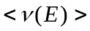 for all 65 fissile/fertile isotopes in ENDF/B-VII.0
5) Completeness of ENDF/B-VII.0 Evaluations
6) Same Evaluations in ENDF/B-VI and VII (315)

Introduction

The ENDF/B data library has recently been updated and is now freely available through the National Nuclear Data Center (NNDC), Brookhaven National Laboratory. This most recent library is identified as ENDF/B-VII.0; this is the first release of ENDF/B-VII. This release completely supersedes all preceding releases of ENDF/B.

As distributed the ENDF/B-VII.0 data includes cross sections represented in the form of a combination of resonance parameters and/or tabulated energy dependent cross sections, nominally at 0 Kelvin temperature.

For use in our applications the ENDF/B-VII.0 library has been processed into cross sections at eight neutron reactor like temperatures, between 0 and 2100 Kelvin, in steps of 300 Kelvin. It has also been processed to five astrophysics like temperatures, 1, 10, 100 eV, 1 and 10 keV. For reference purposes, 300 Kelvin is approximately 1/40 eV, so that 1 eV is approximately 12,000 Kelvin. At each temperature the cross sections are tabulated and linearly interpolable in energy.

All results are in the computer independent ENDF-6 character format [R2], which allows the data to be easily transported between computers. In its processed form the POINT 2007 library is approximately 8.6 gigabyte in size and is distributed on two DVDs.

PREPRO 2007 Codes

In addition to the changes in the ENDF/B-VII.0 evaluations, it should be noted that between the last version of this report, where the PREPRO 2002 codes were used, and the current version, where the PREPRO 2007 codes were used, there have been major improvements in the ENDF/B Pre-processing codes (PREPRO). The major improvements were both in terms of improving the basic methods used by the codes and in terms of incorporating the latest ENDF-6 Formats and Procedures used by the current evaluations. The result is more accurate cross section data throughout the POINT 2007 library.

WARNING – due to recent changes in ENDF-6 Formats and Procedures only the latest version of the ENDF/B Pre-processing codes, namely PREPRO 2007, can be used to accurately process all current ENDF/B-VII evaluations. If you fail to heed this warning and you use any earlier versions of these codes the results will be inaccurate.

The PREPRO 2007 codes run on virtually any computer, and will soon be available FREE on-line from the Nuclear Data Section, IAEA, Vienna, Austria, website at,

http://www-nds.iaea.or.at/ndspub/endf/prepro/

Requesting POINT 2007 Data

Please do not contact the author of this report to request this data; I do not have the resources necessary to directly respond to requests for this data. This data has been distributed and is Internationally available from nuclear data/code centers throughout the World,

- Within the United States: contact the National Nuclear Data Center, Brookhaven National Laboratory, Mike Herman at,
services@bnlnd2.dne.bnl.gov

- Within Western Europe: contact the OECD Nuclear Energy Agency/ Data Bank (NEA/DB), Paris, France, Enrico Sartori at Sartori@nea.fr

- Otherwise: contact the Nuclear Data Section, International Atomic Energy Agency, Vienna, Austria, Alberto Mengoni at,
A.Mengoni@iaea.org

Data Processing

As distributed the original evaluated data includes cross sections represented in the form of a combination of resonance parameters and/or tabulated energy dependent cross sections, nominally at 0 Kelvin temperature. For use in applications, this data has been processed using the 2007 version of the ENDF/B Pre-processing codes (PREPRO 2007) to produce temperature dependent, linearly interpolable in energy, tabulated cross sections, in the ENDF-6 format.

For use in applications this library has been processed into the form of temperature dependent cross sections at eight neutron reactor like temperatures, between 0 and 2100 Kelvin, in steps of 300 Kelvin. It has also been processed to five astrophysics like temperatures, 1, 10, 100 eV, 1 and 10 keV. For reference purposes, 300 Kelvin is approximately 1/40 eV, so that 1 eV is approximately 12,000 Kelvin. At each temperature the cross sections are tabulated and linearly interpolable in energy.

The steps required and codes used to produce room temperature, linearly interpolable tabulated cross sections, in the ENDF-6 format, are described below (the name of each code in given in parenthesis; for details of each code see reference [R3]).

Here are the steps, and PREPRO 2007 codes, used to process the data, in the order in which the codes were used.

1) Linearly interpolable, tabulated cross sections (LINEAR)
2) Including the resonance contribution (RECENT)
3) Doppler broaden all cross sections to temperature (SIGMA1)
4) Check data, define redundant cross sections by summation (FIXUP)
5) Update evaluation dictionary in MF/MT=1/451 (DICTIN)

For the "cold" (0 Kelvin) data steps 1), 2) and 4), 5) were used (no Doppler broadening). For the data at other temperatures, after steps 1) and 2), the data was Doppler broadened to each temperature using step 3), and the results were then made consistent with the ENDF/B formats and conventions using steps 4) and 5), to produce the final distributed data.

The result is linearly interpolable in energy, tabulated, temperature dependent cross sections, in the ENDF-6 format, ready to be used in applications.

Note - this processing only involved the energy dependent neutron cross sections. All other data in the evaluations, e.g., angular and energy distributions, was not affected by this processing, and is identical in all versions of the final results, i.e., it is the same in all of the directories, ORIGINAL, as well as K0 through K2100, and 1ev through 10kev, on the DVD.

Accuracy of Results

Each of the codes described above that was used to process data to obtain tabulated, linearly interpolable in energy cross sections, processed the data to within a user defined accuracy, or allowable uncertainty. The ENDF/B Pre-processing codes (PREPRO 2007) are self-documenting, in the sense that the ENDF/B formatted output data that each code produces includes comments at the beginning of each evaluation defining the accuracy to which the cross sections were calculated. The combination of comments added by all of the codes defines the sequence and accuracy used by all of them. The accuracy is the same for all evaluations. Therefore, for exact details of the accuracy of the data, see the comments at the beginning of any evaluation. For use in Point 2007 all cross sections were reconstructed to within an accuracy of 0.01% in the thermal range, and 0.1 % at all other energies and temperatures; this is beyond the accuracy to which this data in known, so that I assume that the data processing does not add any significant additional error to the inherent error of the data.

Contents of the Library

This library contains all of the evaluations in the ENDF/B-VI.0 general purpose library. A table in the appendix summarizes the contents of the ENDF/B-VII.0 general purpose library. This library contains evaluations for 393 materials (isotopes or naturally occurring elemental mixtures of isotopes).

This library does not contain data from special purpose ENDF/B-VII libraries, such as fission products, thermal scattering, photon interaction data. To obtain any of these special purpose libraries contact the National Nuclear Data Center, Brookhaven National Laboratory,

ENDF@bnlnd2.dne.bnl.gov

In the POINT 2007 library each evaluation is stored as a separate file. The following table defines each material and the corresponding filename. The entire library is in the computer independent ENDF-6 character format, which allows the data to be easily transported between computers. The entire library requires approximately 8.6 gigabyte of storage and is distributed on two DVDs; see below for details of the DVDs.

This library contains data for some metastable materials, which are indicated by an "M" at the end of their descriptions.

The majority of these evaluations are complete, in the sense that they include all cross sections over the energy range 10-5 eV to at least 20 MeV. See the appendix for a list of all evaluations, plus a separate list of incomplete evaluations; there are now only a few.

The DVDs is divided into fifteen (15) directories, across two DVDS,

Part A (first DVD)
DOCUMENT - A copy of this report in MSWord and PDF formats.
ORIGINAL - The original ENDF/B data before it was processed.
K0 - 0 Kelvin cross sections
K300 - 300 Kelvin cross sections
K600 - 600 Kelvin cross sections
K900 - 900 Kelvin cross sections
K1200 - 1200 Kelvin cross sections

Part B (second DVD)
K1500 - 1500 Kelvin cross sections
K1800 - 1800 Kelvin cross sections
K2100 - 2100 Kelvin cross sections
1eV - 1 eV cross sections
10eV - 10 eV cross sections
100eV - 100 eV cross sections
1keV - 1 keV cross sections
10keV - 10 keV cross sections

With the exception of DOCUMENT, each of these directories contains 394 files, one file for each of the 393 evaluation, plus one HTML file to allow interactive data retrieval. Each file is a complete ENDF/B "tape" [R2], including a starting "tape" identification line, and ending with a "tape" end line [R2]. In this form, each file can be used by a wide variety of available computer codes that treat data in the ENDF/B format, e.g., all of the PREPRO codes.

Installation and Use of POINT 2007

I recommend that you create a directory named POINT2007 and copy the entire contents of both DVDs into this directory; this will allow you simple access to the data at all temperatures. These POINT 2007 directories include HTML routines to allow interactive retrieval of the data. The result will be a directory of about 8.6 gigabytes. To put that in perspective, today it costs less than $1 U.S. to purchase, install, and maintain on-line one gigabyte of disk storage. Therefore the cost of maintaining this 8.6 gigabyte library on-line is trivial.

Acknowledgments

I thank Said Mughabghab for his detailed explanation of the use of his newly published resonance parameters [R4] in ENDF/B-VII.0 evaluations. I thank Ramon E. Arcilla, Jr., of the National Nuclear Data Center (NNDC), Brookhaven National Laboratory, for supplying the original ENDF/B-VII.0, used in this project. I thank Kevin McLaughlin and Andre Trkov, of the Nuclear Data Section, International Atomic Energy Agency, for supplying the ENDF/B Pre-processing codes, PREPRO 2007, used in this project. I thank Nancy Larsen, Bob MacFarlane, Maurice Greene, and Mike Dunn, for their intercomparison of their cross section processing codes (SAMMY, NJOY and AMPX) against the PREPRO codes. These comparisons have led to significant improvements in the accuracy and reliability of the results produced by all four codes (SAMMY, NJOY, AMPX, PREPRO). I thank Dave Heinrichs for proofreading the draft of this report and making many helpful corrections and improvements, which I incorporated in the final report.

References

[R1] “POINT 2004: A Temperature Dependent ENDF/B-VI, Release 8 Cross Section Library”, Lawrence Livermore National Laboratory, UCRL-TR-202284, April 2004.

[R2] Data Formats and Procedures for the Evaluated Nuclear Data File ENDF-6, BNL-NCS-44945, Rev. 11/95, edited by V. McLane, et al. National Nuclear Data Center, Brookhaven National Lab. http://www.nndc.bnl.gov/nndcscr/documents/endf/endf102/

[R3] now available, "PREPRO 2004: The 2004 ENDF/B Pre-Processing Codes," by D.E. Cullen, Nuclear Data Section, International Atomic Energy Agency, Vienna, Austria, IAEA-NDS-39, Rev. 12, Nov. 22, 2004; PREPRO 2007 will soon to publicly available. http://www-nds.iaea.or.at/ndspub/endf/prepro/

[R4] “Atlas of Nuclear Resonances”, by S.F. Mughabghab, National Nuclear Data Center, Brookhaven National Laboratory, published by Elsevier, March 2006.

[R5] "Exact Doppler Broadening of Tabulated Cross Sections," by D.E. Cullen and C.R. Weisbin, Nuclear Science and Engineering 60, p. 199 (1975)

[R6] "THERMAL: A Routine Designed to Calculate Neutron Thermal Scattering," by D.E. Cullen, Lawrence Livermore National Laboratory, UCRL-ID-120560-Rev-1, Sept. 1995.
http://home.comcast.net/~redcullen1

[R7] “Verification of High Temperature Free Atom Thermal Scattering in MERCURY Compared to TART”, by D.E. Cullen, Scott McKinley and Christian Hagmann, Lawrence Livermore National Laboratory, UCRL-TR-226340, August 1, 2006.

[R8] “TART2005: A Coupled Neutron-Photon 3-D, Time Dependent, Combinatorial Geometry Monte Carlo Transport Code," by D.E. Cullen, Lawrence Livermore National Laboratory, UCRL-SM-218009, Nov. 22, 2005.

Appendix A: Contents of ENDF/B-VII.0 (78 new + 315 old = 393 total evaluations)

1-H - 1  1-H - 2  1-H - 3  2-He- 3  2-He- 4  3-Li- 6  3-Li- 7  4-Be- 7  4-Be- 9  5-B - 10  5-B - 11  6-C -Nat  7-N - 14  7-N - 15  8-O - 16  8-O - 17  9-F - 19  11-Na- 22  11-Na- 23  12-Mg- 24  12-Mg- 25  12-Mg- 26  13-Al- 27  14-Si- 28  14-Si- 29  14-Si- 30  15-P - 31  16-S - 32  16-S - 33  16-S - 34  16-S - 36  17-Cl- 35  17-Cl- 37  18-Ar- 36  18-Ar- 38  18-Ar- 40  19-K - 39  19-K - 40  19-K - 41  20-Ca- 40  20-Ca- 42  20-Ca- 43  20-Ca- 44  20-Ca- 46  20-Ca- 48  21-Sc- 45  22-Ti- 46  22-Ti- 47  22-Ti- 48  22-Ti- 49  22-Ti- 50  23-V -Nat  24-Cr- 50  24-Cr- 52  24-Cr- 53  24-Cr- 54  25-Mn- 55  26-Fe- 54  26-Fe- 56  26-Fe- 57  26-Fe- 58  27-Co- 58  27-Co- 58M  27-Co- 59  28-Ni- 58  28-Ni- 58M | 28-Ni- 60  28-Ni- 61  28-Ni- 62  28-Ni- 64  29-Cu- 63  29-Cu- 65  30-Zn-Nat  31-Ga- 69  31-Ga- 71  32-Ge- 70  32-Ge- 72  32-Ge- 73  32-Ge- 74  32-Ge- 76  33-As- 74  33-As- 75  34-Se- 74  34-Se- 76  34-Se- 77  34-Se- 78  34-Se- 79  34-Se- 80  34-Se- 82  35-Br- 79  35-Br- 81  36-Kr- 78  36-Kr- 80  36-Kr- 82  36-Kr- 83  36-Kr- 84  36-Kr- 85  36-Kr- 86  37-Rb- 85  37-Rb- 86  37-Rb- 87  38-Sr- 84  38-Sr- 86  38-Sr- 87  38-Sr- 88  38-Sr- 89  38-Sr- 90  39-Y - 89  39-Y - 90  39-Y - 91  40-Zr- 90  40-Zr- 91  40-Zr- 92  40-Zr- 93  40-Zr- 94  40-Zr- 95  40-Zr- 96  41-Nb- 93  41-Nb- 94  41-Nb- 95  42-Mo- 92  42-Mo- 94  42-Mo- 95  42-Mo- 96  42-Mo- 97  42-Mo- 98  42-Mo- 99  42-Mo-100  43-Tc- 99  44-Ru- 96  44-Ru- 98  44-Ru- 99 | 44-Ru-100  44-Ru-101  44-Ru-102  44-Ru-103  44-Ru-104  44-Ru-105  44-Ru-106  45-Rh-103  45-Rh-105  46-Pd-102  46-Pd-104  46-Pd-105  46-Pd-106  46-Pd-107  46-Pd-108  46-Pd-110  47-Ag-107  47-Ag-109  47-Ag-110M  47-Ag-111  48-Cd-106  48-Cd-108  48-Cd-110  48-Cd-111  48-Cd-112  48-Cd-113  48-Cd-114  48-Cd-115M  48-Cd-116  49-In-113  49-In-115  50-Sn-112  50-Sn-113  50-Sn-114  50-Sn-115  50-Sn-116  50-Sn-117  50-Sn-118  50-Sn-119  50-Sn-120  50-Sn-122  50-Sn-123  50-Sn-124  50-Sn-125  50-Sn-126  51-Sb-121  51-Sb-123  51-Sb-124  51-Sb-125  51-Sb-126  52-Te-120  52-Te-122  52-Te-123  52-Te-124  52-Te-125  52-Te-126  52-Te-127M  52-Te-128  52-Te-129M  52-Te-130  52-Te-132  53-I -127  53-I -129  53-I -130  53-I -131  53-I -135 | 54-Xe-123  54-Xe-124  54-Xe-126  54-Xe-128  54-Xe-129  54-Xe-130  54-Xe-131  54-Xe-132  54-Xe-133  54-Xe-134  54-Xe-135  54-Xe-136  55-Cs-133  55-Cs-134  55-Cs-135  55-Cs-136  55-Cs-137  56-Ba-130  56-Ba-132  56-Ba-133  56-Ba-134  56-Ba-135  56-Ba-136  56-Ba-137  56-Ba-138  56-Ba-140  57-La-138  57-La-139  57-La-140  58-Ce-136  58-Ce-138  58-Ce-139  58-Ce-140  58-Ce-141  58-Ce-142  58-Ce-143  58-Ce-144  59-Pr-141  59-Pr-142  59-Pr-143  60-Nd-142  60-Nd-143  60-Nd-144  60-Nd-145  60-Nd-146  60-Nd-147  60-Nd-148M  60-Nd-150  61-Pm-147  61-Pm-148  61-Pm-148  61-Pm-149  61-Pm-151  62-Sm-144  62-Sm-147  62-Sm-148  62-Sm-149  62-Sm-150  62-Sm-151  62-Sm-152  62-Sm-153  62-Sm-154  63-Eu-151  63-Eu-152  63-Eu-153  63-Eu-154 | 63-Eu-155  63-Eu-156  63-Eu-157  64-Gd-152  64-Gd-153  64-Gd-154  64-Gd-155  64-Gd-156  64-Gd-157  64-Gd-158  64-Gd-160  65-Tb-159  65-Tb-160  66-Dy-156  66-Dy-158  66-Dy-160  66-Dy-161  66-Dy-162  66-Dy-163  66-Dy-164  67-Ho-165  67-Ho-166M  68-Er-162  68-Er-164  68-Er-166  68-Er-167  68-Er-168  68-Er-170  71-Lu-175  71-Lu-176  72-Hf-174  72-Hf-176  72-Hf-177  72-Hf-178  72-Hf-179  72-Hf-180  73-Ta-181  73-Ta-182  74-W -182  74-W -183  74-W -184  74-W -186  75-Re-185  75-Re-187  77-Ir-191  77-Ir-193  79-Au-197  80-Hg-196  80-Hg-198  80-Hg-199  80-Hg-200  80-Hg-201  80-Hg-202  80-Hg-204  82-Pb-204  82-Pb-206  82-Pb-207  82-Pb-208  83-Bi-209  88-Ra-223  88-Ra-224  88-Ra-225  88-Ra-226  89-Ac-225  89-Ac-226  89-Ac-227 | 90-Th-227  90-Th-228  90-Th-229  90-Th-230  90-Th-232  90-Th-233  90-Th-234  91-Pa-231  91-Pa-232  91-Pa-233  92-U -232  92-U -233  92-U -234  92-U -235  92-U -236  92-U -237  92-U -238  92-U -239  92-U -240  92-U -241  93-Np-235  93-Np-236  93-Np-237  93-Np-238  93-Np-239  94-Pu-236  94-Pu-237  94-Pu-238  94-Pu-239  94-Pu-240  94-Pu-241  94-Pu-242  94-Pu-243  94-Pu-244  94-Pu-246  95-Am-241  95-Am-242  95-Am-242M  95-Am-243  95-Am-244  95-Am-244M  96-Cm-241  96-Cm-242  96-Cm-243  96-Cm-244  96-Cm-245  96-Cm-246  96-Cm-247  96-Cm-248  96-Cm-249  96-Cm-250  97-Bk-249  97-Bk-250  98-Cf-249  98-Cf-250  98-Cf-251  98-Cf-252  98-Cf-253  98-Cf-254  99-Es-253  99-Es-254  99-Es-255  100-Fm-255

Elemental vs. Isotopic Evaluations

Successive versions of ENDF/B have replaced elemental evaluations by isotopic evaluations. Between ENDF/B-VI and VII 13 elemental evaluations were deleted (included in ENDF/B-VI, but not included in ENDF/B-VII); the below table summarizes the elemental evaluations deleted and the isotopic evaluations designed to replace them. The only remaining elemental evaluations in ENDF/B-VII are:
6-C–Nat 6-C-12 98.93%/ 6-C-13 1.07% missing
23-V –Nat 23-V-50 99.75%/ 23-V-51 0.25% missing
30-Zn-Nat 5 isotopes, all missing

All of these isotopes in VII.0 are complete, in the sense that they include major cross sections (elastic, capture, inelastic) over the energy range 10⁻⁵ eV up to at least 20 MeV. However, be aware that evaluating isotopes is difficult and the quality of minor isotopes may be poor. To my knowledge as yet the summing these isotopes to define equivalent elemental evaluations has not been verified against experimental measurements.

Elemental Evaluations Replaced by Isotopic evaluations (16 new, 19 old)
Element Isotope | Element Isotope | Element Isotope
12-Mg-Nat 12-Mg- 24  12-Mg- 25  12-Mg- 26  14-Si-Nat 14-Si- 28  14-Si- 29  14-Si- 30  16-S -Nat 16-S - 32  16-S - 33  16-S - 34  16-S - 36  17-Cl-Nat 17-Cl- 35  17-Cl- 37  19-K -Nat 19-K - 39  19-K - 40  19-K - 41  20-Ca-Nat 20-Ca- 40  20-Ca- 42  20-Ca- 43  20-Ca- 44  20-Ca- 46  20-Ca- 48 | 22-Ti-Nat 22-Ti- 46  22-Ti- 47  22-Ti- 48  22-Ti- 49  22-Ti- 50  31-Ga-Nat 31-Ga- 69  31-Ga- 71  40-Zr-Nat 40-Zr- 90  40-Zr- 91  40-Zr- 92  40-Zr- 93  40-Zr- 94  40-Zr- 95  40-Zr- 96 | 42-Mo-Nat 42-Mo- 92  42-Mo- 94  42-Mo- 95  42-Mo- 96  42-Mo- 97  42-Mo- 98  42-Mo- 99  42-Mo-100  49-In-Nat 49-In-113  49-In-115  72-Hf-Nat 72-Hf-174  72-Hf-176  72-Hf-177  72-Hf-178  72-Hf-179  72-Hf-180  74-W -Nat 74-W -182  74-W -183  74-W -184  74-W -186
New Evaluations for ENDF/B-VII.0 (78 new)

After six versions of ENDF/B over almost 40 years, most of the important isotopes have already been evaluated and included in earlier versions of ENDF/B. The new ENDF/B-VII evaluations were difficult to do, since usually there is little experimental data for rarer isotopes. Most of the new evaluations are complete in the sense that they include major cross sections from 10⁻⁵ eV to 20 MeV. The except is 4-Be-7 which only extends up to 8.1 MeV, and only includes elastic and charged particle reactions; this is a theoretical evaluation that should not have been included in ENDF/B-VII.0. Many of the other evaluations are pretty bad; better than nothing, but crude, so CAVEAT EMPTOR!

The below table includes a list of all 78 new evaluations. If there are no comments, I judge the evaluation to be o.k.

78 New Evaluations
Material Comments  4-Be- 7 Useless partial  11-Na- 22 Crude  12-Mg- 25  12-Mg- 26  16-S - 33  16-S - 34  16-S - 36 Crude  18-Ar- 36 Crude  18-Ar- 38 Crude  19-K - 39  19-K - 40 Very crude  20-Ca- 40 o.k. to 20 MeV  20-Ca- 42 “  20-Ca- 43 “  20-Ca- 44 “  20-Ca- 46 Very crude  20-Ca- 48 o.k. to 20 MeV  22-Ti- 49  27-Co- 58 Very crude  27-Co- 58M Very crude  30-Zn-Nat Check (n,alpha)  31-Ga- 69  31-Ga- 71  32-Ge- 70  33-As- 74  34-Se- 79 Crude  47-Ag-110M (n,n') down to 3 eV?  50-Sn-113 Resonance gap  54-Xe-123 Very crude  56-Ba-130  56-Ba-132 Crude  56-Ba-133  57-La-138  58-Ce-136  58-Ce-138  58-Ce-139  64-Gd-153  66-Dy-156  66-Dy-158 | Material Comments  67-Ho-166M Crude  68-Er-162  68-Er-164  68-Er-168  68-Er-170  80-Hg-196 Crude  80-Hg-198 Crude, check capture  80-Hg-199  80-Hg-200  80-Hg-201  80-Hg-202 Crude, check capture  80-Hg-204 Very crude  82-Pb-204  88-Ra-223 Very crude  88-Ra-224 Very crude  88-Ra-225 Very crude  88-Ra-226  89-Ac-225 Very crude  89-Ac-226 Very crude  89-Ac-227 Very crude  90-Th-227 Very crude  90-Th-228 Rubbish  90-Th-229 (n,n’) down to 100 eV  90-Th-233 Very crude  90-Th-234 Rubbish  92-U -239 Weird resonances  92-U -240  92-U -241 Weird resonances  93-Np-235 Very crude  94-Pu-246 Very crude  95-Am-244 Very crude  95-Am-244M Very crude  96-Cm-249  96-Cm-250 Crude  97-Bk-250 Weird resonances  98-Cf-254 Very crude  99-Es-254 Very crude  99-Es-255 Very crude  100-Fm-255 Very crude

Summary of for all 65 fissile/fertile isotopes in ENDF/B-VII.0

For applications I require both prompt and delayed neutrons per fission. In the ENDF/B format the evaluator can optionally include: Total (T), Delayed (D) and/or Prompt (P). Below is a summary of all fissile/fertile materials in ENDF/B-VII.0, indicating the neutrons per fission data included for each isotope. In all cases the Total (T) is included, however in some cases no other data is included, so that we cannot define either Prompt (P) or Delayed (D). I will have to add the missing data before I can use these isotopes in my applications.

Summary of all 65 fissile/fertile isotopes in ENDF/B-VII.0
Isotope <nu> Comments  ZA088223 T No Delayed  ZA088226 T No Delayed  ZA089227 T No Delayed  ZA090227 T D P  ZA090228 T D P  ZA090229 T D P  ZA090230 T No Delayed  ZA090232 T D P  ZA090233 T D P  ZA090234 T D P  ZA091231 T D P  ZA091232 T D P  ZA091233 T D P  ZA092232 T D P  ZA092233 T D P  ZA092234 T D P  ZA092235 T D P  ZA092236 T D P  ZA092237 T D P  ZA092238 T D P  ZA092239 T D P  ZA092240 T D P  ZA092241 T D P  ZA093235 T D P  ZA093236 T D P  ZA093237 T D P  ZA093238 T D P  ZA093239 T No Delayed  ZA094236 T D P  ZA094237 T No Delayed  ZA094238 T D P  ZA094239 T D P  ZA094240 T D P | Isotope <nu> Comments  ZA094241 T D P  ZA094242 T D P  ZA094243 T No Delayed  ZA094244 T No Delayed  ZA094246 T D P  ZA095241 T D P  ZA095242 T D P  ZA095242.M T D P  ZA095243 T D P  ZA095244 T D P  ZA095244.M T D P  ZA096241 T No Delayed  ZA096242 T D P  ZA096243 T D P  ZA096244 T D P  ZA096245 T D P  ZA096246 T D P  ZA096247 T D P  ZA096248 T No Delayed  ZA096249 T D P  ZA096250 T D P  ZA097249 T D P  ZA097250 T D P  ZA098249 T D P  ZA098250 T No Delayed  ZA098251 T D P  ZA098252 T No Delayed  ZA098253 T No Delayed  ZA098254 T D P  ZA099254 T D P  ZA099255 T D P  ZA100255 T D P

Completeness of ENDF/B-VII.0 Evaluations

For ENDF/B-VI.8, I judged that only about half of the 328 evaluations were complete and physically acceptable enough to be used in neutron transport calculations. In contrast in ENDF/B-VII.0, only a few evaluations are incomplete (10⁻⁵ eV to 20 MeV) or physically unacceptable (negative cross sections). Below is a summary (no comment = o.k.)

Material Comments
ZA001001 mt= 50 no inelastic
ZA001002 mt= 50 no inelastic
ZA001003 mt= 102 no capture
ZA001003 mt= 50 no inelastic
ZA002003 mt= 50 no inelastic
ZA002004 mt= 102 no capture
ZA002004 mt= 50 no inelastic
ZA004007 mt= 2 cross section ends 8.1000D+06 eV Incomplete only elastic
ZA004007 mt= 1 no total up to 8.1 MeV
ZA004007 mt= 102 no capture
ZA004007 mt= 50 no inelastic
ZA004009 mt= 50 no inelastic
ZA005010 mt= 102 cross section ends 5.0000D+05 eV
ZA017035 mt= 2 cross section start 1.4519D-05 eV Negative elastic
ZA018040 mt= 2 cross section <=0 9.7825D+05 eV Negative elastic
ZA020040 mt= 2 cross section <=0 5.0000D+05 eV Negative elastic
ZA021045 mt= 102 cross section ends 5.0000D+06 eV
ZA026056 mt= 2 cross section <=0 1.1971D+06 eV Negative elastic
ZA027058 mt= 102 cross section <=0 8.4925D+00 eV Negative capture
ZA027058.M mt= 51 level energy > 0 2.4900D+04 eV
ZA028059 mt= 50 no inelastic Incomplete
ZA028061 mt= 2 cross section <=0 7.4355D+05 eV Negative elastic
ZA041093 mt= 2 cross section <=0 2.3344D+03 eV Negative elastic
ZA047110.M mt= 51 level energy > 0 1.1760D+05 eV
ZA047110.M mt= 52 level energy > 0 1.0660D+05 eV
ZA048108 mt= 102 cross section ends 1.0000D+07 eV
ZA048110 mt= 102 cross section ends 1.0000D+07 eV
ZA048112 mt= 102 cross section ends 1.0000D+07 eV
ZA048115.M mt= 51 level energy > 0 1.8100D+05 eV
ZA048116 mt= 102 cross section ends 1.0000D+07 eV
ZA052127.M mt= 51 level energy > 0 8.8260D+04 eV
ZA052127.M mt= 52 level energy > 0 2.7140D+04 eV
ZA052129.M mt= 51 level energy > 0 1.0550D+05 eV
ZA054130 mt= 102 cross section ends 1.0000D+07 eV
ZA061148.M mt= 51 level energy > 0 1.3790D+05 eV
ZA061148.M mt= 52 level energy > 0 6.2200D+04 eV
ZA064152 mt= 2 cross section <=0 3.3186D+01 eV Negative elastic
ZA066160 mt= 2 cross section <=0 3.3293D+02 eV Negative elastic
ZA067166.M mt= 51 level energy > 0 5.9850D+03 eV
ZA082207 mt= 2 cross section <=0 4.7500D+05 eV Negative elastic
ZA090228 mt= 18 cross section <=0 3.0000D+03 eV
ZA090230 mt= 2 cross section <=0 1.2856D+00 eV Negative elastic
ZA092240 mt= 2 cross section <=0 2.2262D+00 eV Negative elastic
ZA094238 mt= 2 cross section <=0 5.9743D+01 eV Negative elastic
ZA094242 mt= 2 cross section <=0 2.2348D+00 eV Negative elastic
ZA094244 mt= 2 cross section <=0 2.0770D+01 eV Negative elastic
ZA095242.M mt= 51 level energy > 0 4.8600D+04 eV
ZA095242.M mt= 52 level energy > 0 4.5000D+03 eV
ZA095244.M mt= 51 level energy > 0 8.8000D+04 eV
ZA096241 mt= 102 cross section ends 4.0000D+06 eV
ZA096242 mt= 2 cross section <=0 1.3448D+01 eV Negative elastic
ZA096242 mt= 18 cross section <=0 2.7600D+02 eV
ZA096248 mt= 2 cross section <=0 6.8142D+00 eV Negative elastic
ZA098250 mt= 2 cross section <=0 1.4329D+01 eV Negative elastic
ZA098252 mt= 2 cross section <=0 1.6674D+01 eV Negative elastic
ZA098253 mt= 18 cross section ends 1.1000D+04 eV Incomplete only to 11 keV
ZA098253 mt= 102 cross section ends 1.1000D+04 eV
ZA098253 mt= 50 no inelastic
ZA099253 mt= 102 cross section ends 1.1000D+04 eV Incomplete only to 11 keV
ZA099253 mt= 50 no inelastic

Same Evaluations in ENDF/B-VI and VII (315)

Above I stated that ENDF/B-VII.0 includes 315 evaluations from ENDF/B-VI. By this I mean that there are evaluations for the same 315 elements or isotopes in both VI and VII. The contents of these evaluations may be identical to ENDF/B-VI, or completely different. Below I provide a brief, one line summary comparing the contents of ENDF/B-VII.0 to VI.8. These summaries are based only on my comparing major cross sections (total, elastic, capture and fission) for the 315 same evaluations. For more details of any given evaluation the reader can use the COMPLOT code [R3] to “see” comparisons.

The intent here is to hopefully save users time and effort by telling them which evaluations have or have not changed. For example, many metals and fissile isotopes have not changed. There are also materials where the cross sections are what I call “similar”, but which I mean similar resonance structure, but actual cross section values may be quite different.

- Many single level Breit-Wigner (SLBW) resonances have been changed to multi-level (MLBW). In many case this eliminates negative elastic cross sections, and results in what I identify in the following table as “similar”. WARNING – because of the use of non-physical average J values, switching from SLBW to MLBW does not always eliminate negative cross sections. WARNING – “similar” here means similar resonance structure; the actual energy dependent cross sections may be very different.
- Many incomplete ENDF/B-VI evaluations have now been extended up to 20 MeV and are now complete in VII.0. Also the high energy range of many other evaluations were re-done using nuclear model code calculations; this has changed some high energy cross sections by 10 to 20%.
- Many evaluations now include resonance parameters from the latest 2006 version of the atlas of nuclear resonances, BNL-325 [R4]; this has allowed many resonance regions to be extended to higher energies. However, in many cases no additional evaluation was performed to eliminate resonance gaps in the experimentally measured resonance parameters, and many isotopes do not included an unresolved resonance energy range.
- I try to identify evaluations where the major cross sections differ substantially; roughly speaking my criteria was differences of at least ~ 1% .
- I also compared <nu>, where smaller differences can be important. For the major fuel, U-233, U-235, and Pu-235, there have been minor ~ 0.5% changes in <nu> which may be reflected in calculated integral parameters, such as K-eff. Some minor fissile/fertile have changes in <nu> of 5 to 10%

315 Same Materials (1-H - 1 to 44-Ru- 99)
1-H - 1 Elastic 0.3% lower < 10 keV  1-H - 2 Same  1-H - 3 Elastic 30% higher < 1 MeV  2-He- 3 Same  2-He- 4 Same  3-Li- 6 Elastic 7% higher < 0.1 eV  3-Li- 7 Same  4-Be- 9 Elastic 10% different > 10 eV  5-B – 10 Elastic 8% higher ~ 100 keV  5-B – 11 Same  6-C –Nat Same  7-N – 14 Same  7-N – 15 Same  8-O – 16 Elastic 7% higher 4 to 9 MeV  8-O – 17 Same  9-F – 19 Different resonances < 1 MeV  11-Na- 23 Same  12-Mg- 24 Same  13-Al- 27 Different resonances < 1 MeV  14-Si- 28 Same  14-Si- 29 Same  14-Si- 30 Same  15-P – 31 Same  16-S – 32 Different resonances  17-Cl- 35 Different – resonances > 200 keV  17-Cl- 37 Different – resonances > 200 keV  18-Ar- 40 Completely different  19-K – 41 Same  21-Sc- 45 Same  22-Ti- 46 Same  22-Ti- 47 Same  22-Ti- 48 Same  22-Ti- 50 Same  23-V –Nat Same  24-Cr- 50 Same  24-Cr- 52 Same  24-Cr- 53 Same  24-Cr- 54 Same  25-Mn- 55 Same  26-Fe- 54 Same  26-Fe- 56 Same  26-Fe- 57 Same  26-Fe- 58 Same  27-Co- 59 Same  28-Ni- 58 Same  28-Ni- 59 Very narrow resonance differences  28-Ni- 60 Same  28-Ni- 61 Same  28-Ni- 62 Same  28-Ni- 64 Same  29-Cu- 63 Same  29-Cu- 65 Same  32-Ge- 72 New - completely different | 32-Ge- 73 New - completely different  32-Ge- 74 New - completely different  32-Ge- 76 New - completely different  33-As- 75 New - resonances > 2 keV  34-Se- 74 Different  34-Se- 76 Different  34-Se- 77 Different  34-Se- 78 Different  34-Se- 80 Different  34-Se- 82 Different  35-Br- 79 Different  35-Br- 81 Different  36-Kr- 78 Different  36-Kr- 80 Different  36-Kr- 82 Different  36-Kr- 83 Different  36-Kr- 84 Different  36-Kr- 85 Different  36-Kr- 86 Different  37-Rb- 85 Different - fewer resonances  37-Rb- 86 Different  37-Rb- 87 Different - fewer resonances  38-Sr- 84 Different  38-Sr- 86 Different  38-Sr- 87 Different  38-Sr- 88 Different  38-Sr- 89 Different - both rubbish  38-Sr- 90 Different - both rubbish  39-Y – 89 Different  39-Y – 90 Different – old rubbish  39-Y – 91 Different - both rubbish  40-Zr- 90 Different – fewer resonances  40-Zr- 91 Different - similar resonances  40-Zr- 92 Different – fewer resonances  40-Zr- 93 Different – old rubbish  40-Zr- 94 Similar  40-Zr- 95 Different - both rubbish  40-Zr- 96 Similar  41-Nb- 93 Same  41-Nb- 94 Different - both rubbish  41-Nb- 95 Different - both rubbish  42-Mo- 92 Very different > 20 keV  42-Mo- 94 Very different > 6 keV  42-Mo- 95 Same < 2 keV – 40% higher energy  42-Mo- 96 Very different > 4 keV  42-Mo- 97 Different  42-Mo- 98 Different – old rubbish  42-Mo- 99 Different - both rubbish  42-Mo-100 Very different > 4 keV  43-Tc- 99 Very different > 1 keV  44-Ru- 96 Different - both rubbish  44-Ru- 98 Different - both rubbish  44-Ru- 99 Different > 100 eV

315 Same Materials (44-Ru- 100 to 61-Pm-148)
44-Ru-100 Old Rubbish – new poor  44-Ru-101 50% higher < 10 eV  44-Ru-102 Similar  44-Ru-103 Old Rubbish – new poor  44-Ru-104 Different > 1 keV  44-Ru-105 Similar - both rubbish  44-Ru-106 Similar - both rubbish  45-Rh-103 Same < 4 keV – 40% higher energy  45-Rh-105 Different - both rubbish  46-Pd-102 Old rubbish – new poor  46-Pd-104 Different – old rubbish  46-Pd-105 Same < 2 keV – 20% higher energy  46-Pd-106 Different – old rubbish  46-Pd-107 Very similar  46-Pd-108 Different – old poor  46-Pd-110 Different - old rubbish  47-Ag-107 Different > 3 keV  47-Ag-109 Similar < 5 keV - 7% > 100 keV  47-Ag-111 New - old rubbish  48-Cd-106 No resonances 600 eV - 3 keV  48-Cd-108 No resonances 350 eV – 2.6 keV  48-Cd-110 Similar  48-Cd-111 Different < 1 eV 60% lower  48-Cd-112 Similar < 2 keV  48-Cd-113 Similar < 2 keV  48-Cd-114 Same  48-Cd-115M New - old rubbish  48-Cd-116 Similar  49-In-113 New resonances > 50 eV  49-In-115 Very different > 1 keV  50-Sn-112 Similar  50-Sn-114 Different - more resonances  50-Sn-115 Different – both poor  50-Sn-116 New resonances > 2 keV  50-Sn-117 Different  50-Sn-118 Similar  50-Sn-119 Different  50-Sn-120 New resonances > 15 keV  50-Sn-122 New resonances > 900 eV  50-Sn-123 Different - both rubbish  50-Sn-124 New resonances > 700 eV  50-Sn-125 New - old rubbish  50-Sn-126 Different - both rubbish  51-Sb-121 More resonances > 2.5 keV  51-Sb-123 More resonances > 2.5 keV  51-Sb-124 Different - both rubbish  51-Sb-125 Different - both rubbish  51-Sb-126 Different - old rubbish  52-Te-120 Different - both rubbish  52-Te-122 More resonances > 4 keV  52-Te-123 More resonances > 500 eV  52-Te-124 More resonances > 6 keV  52-Te-125 More resonances > 1 keV | 52-Te-126 More resonances > 6 keV  52-Te-127M Different - both rubbish  52-Te-128 More resonances > 3.5 keV  52-Te-129M Different - both rubbish  52-Te-130 Different  52-Te-132 Different - old rubbish  53-I -127 More resonances > 1 keV  53-I -129 More resonances > 150 eV  53-I -130 Different - old rubbish  53-I -131 Different - both rubbish  53-I -135 Different - both rubbish  54-Xe-124 Similar  54-Xe-126 Different resonances  54-Xe-128 Similar  54-Xe-129 Similar  54-Xe-130 Similar  54-Xe-131 Same  54-Xe-132 Different  54-Xe-133 Different - both rubbish  54-Xe-134 Different  54-Xe-135 Same - both rubbish > 10 eV  54-Xe-136 New - old rubbish  55-Cs-133 Same - 14% > 100 keV  55-Cs-134 Similar  55-Cs-135 Similar  55-Cs-136 Different - new rubbish  55-Cs-137 Similar - both rubbish  56-Ba-134 Similar < 10 keV  56-Ba-135 Similar < 1 keV  56-Ba-136 Different  56-Ba-137 Different  56-Ba-138 Similar  56-Ba-140 Different – old rubbish  57-La-139 Different  57-La-140 Different - old rubbish  58-Ce-140 Different - old rubbish  58-Ce-141 Different - old rubbish  58-Ce-142 Different - old rubbish  58-Ce-143 Different - old rubbish  58-Ce-144 Different - both rubbish  59-Pr-141 Similar  59-Pr-142 Different - old rubbish  59-Pr-143 Different - old rubbish  60-Nd-142 Different  60-Nd-143 Similar - 4% > 100 keV  60-Nd-144 Different  60-Nd-145 Similar - 5% > 100 keV  60-Nd-146 Different  60-Nd-147 Different > 30 eV  60-Nd-148 Different  60-Nd-150 Different  61-Pm-147 No resonances > 100 eV  61-Pm-148 Different - both rubbish

315 Same Materials (61-Pm-148M to 99-Es-293)
61-Pm-148M Similar - not great  61-Pm-149 Different - both rubbish  61-Pm-151 Different - old rubbish  62-Sm-144 Similar  62-Sm-147 Similar > 10 eV  62-Sm-148 Different - old rubbish  62-Sm-149 Very similar  62-Sm-150 Very similar  62-Sm-151 Same - 15% > 10 keV  62-Sm-152 Similar  62-Sm-153 Different - old rubbish  62-Sm-154 Different  63-Eu-151 Very similar  63-Eu-152 Same - 30% > 100 eV  63-Eu-153 Same - 16% > 100 eV  63-Eu-154 Different  63-Eu-155 Very similar  63-Eu-156 Different - both rubbish  63-Eu-157 Different - old rubbish  64-Gd-152 Different < 10 eV  64-Gd-154 Similar  64-Gd-155 Same - 20% > 200 eV  64-Gd-156 Different  64-Gd-157 Similar, same < 400 eV  64-Gd-158 Different  64-Gd-160 Different  65-Tb-159 Different > 100 eV  65-Tb-160 Different - old rubbish  66-Dy-160 Very similar  66-Dy-161 Similar  66-Dy-162 Similar < 5 keV  66-Dy-163 Similar  66-Dy-164 Similar < 7 keV  67-Ho-165 Different  68-Er-166 Similar < 2 keV  68-Er-167 Similar < 500 eV  71-Lu-175 Same  71-Lu-176 Same  72-Hf-174 Same  72-Hf-176 Same  72-Hf-177 Same  72-Hf-178 Same  72-Hf-179 Same  72-Hf-180 Same  73-Ta-181 Same  73-Ta-182 Same  74-W -182 Same  74-W -183 Same  74-W -184 Same  74-W -186 Same  75-Re-185 Same  75-Re-187 Same | 77-Ir-191 Very similar  77-Ir-193 Similar  79-Au-197 Similar  82-Pb-206 Very similar  82-Pb-207 Very similar, 3% ~ 10 MeV  82-Pb-208 Very similar  83-Bi-209 Same  90-Th-230 Same  90-Th-232 Different resonances  91-Pa-231 Similar < 15 eV  91-Pa-232 Similar  91-Pa-233 Similar < 40 eV  92-U -232 Same < 200 eV  92-U -233 Similar to 60 eV  92-U -234 Similar  92-U -235 Same - 1% ~ 20 MeV  92-U -236 Same - 6% ~ 500 keV  92-U -237 Similar – weird resonances  92-U -238 Similar < 10 keV  93-Np-236 Same  93-Np-237 Similar < 150 eV  93-Np-238 Different - both rubbish  93-Np-239 Same - both rubbish  94-Pu-236 Same  94-Pu-237 Same  94-Pu-238 Same  94-Pu-239 Same  94-Pu-240 Same  94-Pu-241 Same  94-Pu-242 Same  94-Pu-243 Same  94-Pu-244 Same  95-Am-241 Same  95-Am-242 Different - old bad  95-Am-242M Similar - 30% > 3.5 eV  95-Am-243 Same  96-Cm-241 Same  96-Cm-242 Same  96-Cm-243 Same  96-Cm-244 Similar < 500 eV  96-Cm-245 Same  96-Cm-246 Same  96-Cm-247 Different  96-Cm-248 Same – negative elastic  97-Bk-249 Same  98-Cf-249 Same  98-Cf-250 Same  98-Cf-251 Same  98-Cf-252 Same  98-Cf-253 Same – partial to 11 keV  99-Es-253 Same – partial to 11 keV

Appendix B: The Effects of Temperature and Doppler Broadening

For those readers who are not familiar with the effects of temperature and Doppler broadening on neutron cross sections and transport, for details I suggest that you read references [R5] and [R6], listed below. Here I will give a brief description of these effects. Users of neutron cross sections should be aware that there are several important effects of temperature and Doppler broadening,

1) There is the well known effect in the neutron resonance region, where as the temperature increases resonances become broader, hence the name Doppler broadening. Figure 1 below illustrates the effect of temperature on the U238 capture cross section for neutron reactor like temperatures, and figure 2 illustrates this effect for astrophysical like temperatures. These figures each contain four sub-figures, with each sub-figure comparing cross sections at two progressively higher temperatures. In both figure 1 and 2 each sub-figure shows exactly the same energy and cross section range. From these figures we can see that as temperature increases the peaks of the resonances become lower, and the minima between resonances become higher. At extremely high temperature the entire resonance structure disappears and the cross section approaches a simple 1/v shape (where v is the neutron speed). This temperature effect will have a very important effect on resonance self-shielding in any neutron transport calculation. You should note from these figures that due to the large resonance spacing in U²³⁸ the resonance structure can still be seen up to very high temperatures.

To understand the importance of considering temperature we should consider reaction rates, such as captures/second, in various systems. In optically thin systems (few mean free paths dimensions) the flux will be unshielded, and our reaction rates will be defined by a simple cross section average,

Unshielded Capture = 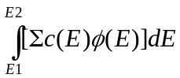 = capture cross section times neutron flux

In optically thick systems (many mean free paths dimensions) the flux will be shielded (the flux is suppressed by the total cross section) and our reaction rates must include the effect of self-shielding on the cross section average,

Shielded Capture = 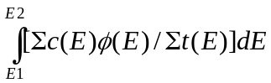 = including one over total cross section

Consider for example the U238 capture cross section between 1 and 10 keV as shown in fig. 1 and 2. If we calculate the unshielded and shielded average capture cross section for the energy interval over the range of temperatures shown in figs. 1 and 2, we obtain the results shown below in table 1.

What we see from these results is that the unshielded average capture cross section is virtually independent of temperature, being about 1 barn over the entire temperature range. In contrast the shielded average cross section varying by over a factor of three between the 0 K average (0.293 barns) and the 10 keV average (0.939 barns). The point to learn from this is that without including the effect of self-shielding in multi-group calculations, temperature has very little effect on the average cross sections, which is quite simply wrong for optically thick systems.

Table 1: Effect of Temperature on Average Cross Sections

Temp. Unshielded Shielded
(barns) (barns)
0 K 0.996 0.293
300 K 0.966 0.526
600 K 0.996 0.576
1,200 K 0.996 0.630
12,000 K (1 eV) 0.996 0.799
10 eV 0.998 0.905
100 eV 1.000 0.933
1 keV 1.004 0.935
10 keV 1.007 0.939

2) Another, less well known, effect of Doppler broadening is at lower energies where as temperature increases the low energy constant scattering cross section increases and at very low energies approaches a simple 1/v shape (where v is the neutron speed); this effect is explained in detail in ref [R5]. Figure 3 illustrates the effect of temperature on the hydrogen total cross section. From this figure we can see that starting from a “cold” (0 Kelvin) cross section that is constant at about 20 barns, as temperature increases the cross section increases. Compared to the “cold” 20 barn cross section, at thermal energy the Doppler broadened cross section is about 30 barns, i.e., 50 % higher. Note also from this figure that this effect extends well above thermal energy. For example, at 300 Kelvin the thermal energy is 0.0253 eV, but we can see this effect up to about 1 eV; a factor of 400 higher in energy. From the lower half of figure 2 we can see that at very low energy the cross section approaches a simple 1/v shape (where v is the neutron speed) and the cross sections at various temperatures become proportional to one another. This effect on the cross sections at low energy is very important for thermal and low energy neutron systems.

3) Yet another important effect of temperature is that at lower energies neutrons do not slow down in energy as quickly and neutron scatter can even result in the upscatter of neutrons, i.e., when neutrons scatter they can gain, rather than lose, energy. This is a well known effect at low energies, where thermal scattering law data or a free gas model is used to model the interaction of neutrons with target atoms that are moving about with thermal motion. Figure 4 illustrates the effect of temperature on the neutron spectrum over a wide range of temperatures [R7]. This effect can also be important at higher energies, particularly near narrow resonances, where thermal motion of the target atoms can cause neutrons to slightly upscatter, but even slight upscatter can cause a neutron to scatter from below to above the energy of a very narrow resonance. See reference [R6], below for a routine designed to be used in conjunction with the SIGMA1 method of Doppler broadening [R5], to handle neutron thermal scattering. This routine [R6] is completely compatible for use with the cross sections included here, since these cross sections were Doppler broadened using the SIGMA1 method [R5]. The combination of SIGMA1 [R5] Doppler broadened cross sections and THERMAL [R6] to handle thermal scattering, is currently used in the TART Monte Carlo transport code [R8].

Fig.1: Effect of Doppler Broadening on Resonance Cross Sections

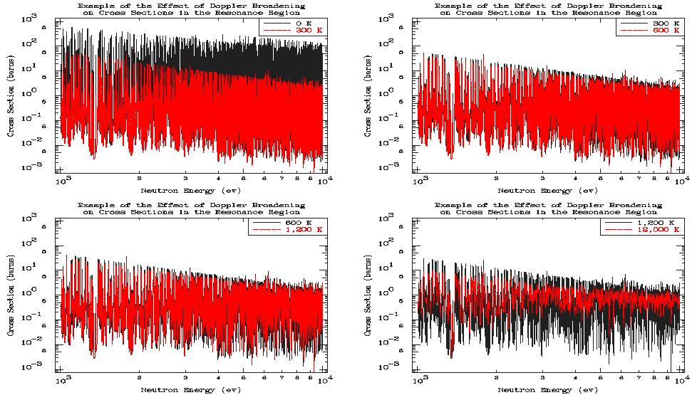

Fig.2: Effect of Doppler Broadening on Resonance Cross Sections

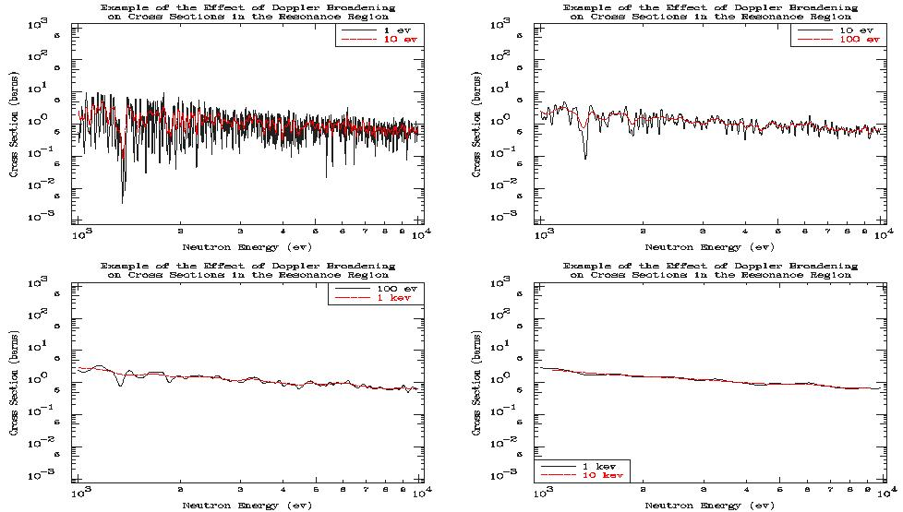

Fig.3: Effect of Doppler Broadening on Low Energy Cross Sections
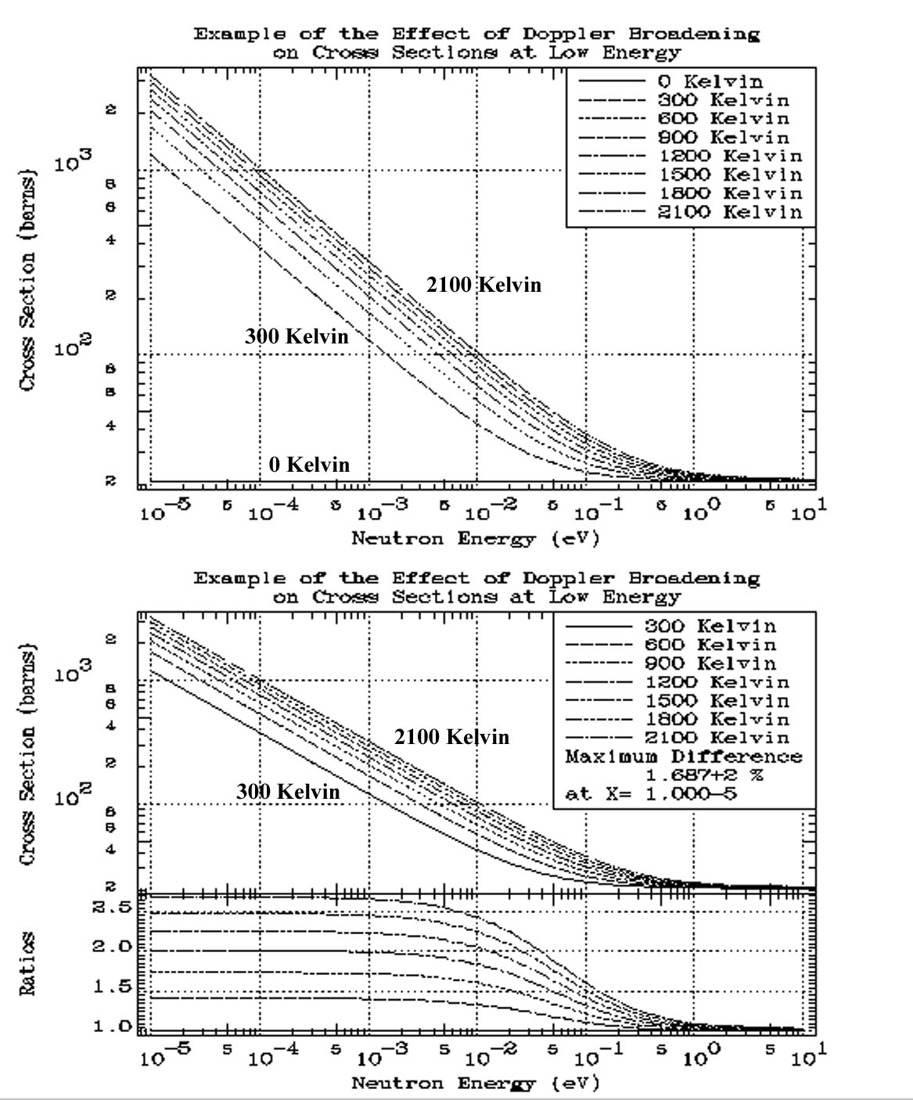

Fig.4: Effect of Doppler Broadening on Neutron Spectrum


