Toward a new nuclear data evaluation of ⁵⁵Mn by the EMPIRE code
Alberto Milocco, Andrej Trkov
Jožef Stefan Institute
Jamova cesta 39, SI-1000 Ljubljana, Slovenia
Alberto.Milocco@ijs.si, Andrej.Trkov@ijs.si
Roberto Capote
NAPC-International Atomic Energy Agency, Nuclear Data Section
Vienna International Centre, A-1400 Vienna, Austria
R.CapoteNoy@iaea.org
ABSTRACT
Manganese is one of the constituents of alloys for structural components of fission and fusion devices and a well known neutron dosimeter; however, existing ENDF-B/VII.0 Mn-55 evaluation was produced by Shibata et al. in 1988. This work is an attempt to re-evaluate neutron-induced cross sections on ⁵⁵Mn using the latest release of the EMPIRE code. Sensitivity studies on the physical and fitting parameters are presented, with special emphasis on the capture and neutron inelastic cross sections. A calculated nuclear data file in ENDF-6 format of the neutron interaction cross sections is produced. It extends up to 150 MeV, which is of interest for fusion and accelerator driven system applications. This evaluation is compared with the ENDF-B/VII.0 evaluation and with a selection of experimental microscopic cross sections. The evaluation is tested using integral data: the OKTAVIAN integral experiment on a manganese shell, and an FNG experiment with manganese activation foils. Benchmark results provide needed feedback for the refinement of the physics parameters.

INTRODUCTION
Manganese is a constituent of stainless steel alloys for structural components of fission and fusion reactors, and also serves as a neutron dosimeter. Therefore ⁵⁵Mn nuclear data is important to optimize a design of nuclear devices. The current ENDF/B-VII.0 evaluation for ⁵⁵Mn neutron induced reactions dates back to 1988 [1]. A new updated evaluation is needed for inclusion in the FENDL-3 nuclear data library. This paper is an attempt to evaluate the neutron-induced ⁵⁵Mn cross sections with the code EMPIRE [2]. In this work a major attention is paid to the study of capture and inelastic cross sections, which are the dominant channels below a few MeV of incident neutron energy. Covariance data production and least square fitting of experimental data will be added at a later stage.
EMPIRE is a complex nuclear reaction modelling system including various nuclear models. A consistent selection of them is required; a brief description of selected options is given in Section 2. They represent the physics core of the system, which allows the calculation of the whole and consistent set of cross sections using a well established and consistent set of nuclear reaction models.
The IAEA coordinated project RIPL produced a comprehensive and consistent database that provides inputs for nuclear reaction modelling and nuclear data evaluation [3]. A set of default input values from RIPL is available for evaluations using the EMPIRE code. To produce a good evaluation the parameters usually need to be refined; sensitivity studies on their impact on benchmark studies are presented in Section 3. They concern mainly the level density parameters for the most important residual nuclei and the choice of the gamma-ray strength function affecting the capture cross sections. Additional non-physical parameters are also available in EMPIRE to fit measured data compensating for nuclear model deficiencies, their sensitivities on benchmarks were also assessed.
In Section 4, the comparisons are presented between the results from the EMPIRE calculations, the ENDF/B-VII.0 evaluation and selected experimental data. Recent (n,2n) cross-section evaluation [4] is also included in the comparison. The microscopic experimental data are retrieved from the EXFOR database [5]. No additional corrections were applied to experimental data; those corrections will be a subject of additional investigation. The proposed calculated nuclear data file is tested with integral measurements in Section 5 to provide a feedback for further improvement of physical parameters. Integral experimental data are those from the OKTAVIAN experiment on the Mn spherical shell [6] and from the FNG experiment with the Mn activation foils undertaken at the ITER Blanket Bulk Shield experiment [7].
The conclusions and the future activities are drawn in the Section 6.

COMPUTATIONAL METHOD
EMPIRE is a very general and flexible code developed by an international collaboration coordinated by M. Herman [2]; the code uses state-of-the-art nuclear reaction models to describe the direct, pre-equilibrium and compound nucleus reaction mechanisms relevant to the studied energy range. We use the latest available version - EMPIRE 3. A careful and physically sound selection of the physics models must be made by a suitable choice of input options.
The direct interaction cross sections and the transmission coefficients for the incident neutron channel were calculated within coupled-channel (CC) formalism, while the particle transmission coefficients for the emerging channels were calculated considering a spherical optical model (DIRECT=1 option in EMPIRE input terminology). Additionally, the direct neutron scattering on non-coupled levels was considered by a Distorted Wave Born Approximation (DWBA) with dynamic deformations selected to describe available neutron emission spectra. All the optical model calculations were performed with the ECIS06 code [8] incorporated into the EMPIRE system.
Pre-equilibrium emission was taken into account by the module PCROSS based on the one-component exciton model [9] with gamma, nucleon and cluster emissions as described in Ref. [2]. While the EMPIRE features advanced quantum-statistical pre-equilibrium models, those models are not suitable for calculation above 30 MeV of neutron incident energy; therefore a simple but very successful Griffin exciton model should be used in high energy evaluations.
After a direct or pre–equilibrium emission take place, the system reaches statistical equilibrium. The emission from the system in equilibrium follows Bohr hypothesis and is well described in EMPIRE by an advanced implementation of the Hauser–Feshbach theory with γ-cascade and width fluctuations. The full γ-cascade in the residual nuclei is considered. The γ emission involves E1, E2 and M1 transitions. To account for the correlation between incident and exit channels in elastic scattering (width fluctuations) EMPIRE code uses the model proposed by Hofmann, Richert, Tepel and Weidenmuller [10] (HRTW). The exact angular momentum and parity coupling is observed using l-dependent transmission coefficients. The emission of neutrons, protons, α-particles, deuterons, tritium and He-3 is taken into account. Angular distributions of particles emitted from the compound nucleus are assumed to be isotropic. For the radiative-strength function, the Modified Lorenzian (MLO1) expression from the RIPL library [3] proposed by Plujko was used, which usually provides a best description of the experimental neutron capture database.
Particular attention is dedicated to the determination of the level densities, which can be calculated in a nonadiabatic approach allowing for the rotational and vibrational enhancements. The RIPL Enhanced Generalized Superfluid Model [3] includes a more accurate treatment of high angular momenta. The properly parametrized EGSM (including adjustment to discrete levels) is the default level density formulation in the EMPIRE code [2] for calculations of nucleon induced reactions at fairly low energies; therefore, it is also referred to as “EMPIRE-specific level densities”. The EGSM level density model is used in our calculations. Enhancement compared to GSM relates to the treatment of the spin distribution in the Fermi gas model. The formalism, inspired by the GSM, uses the superfluid model below the critical excitation energy U_{c} [3], and the Fermi gas model above.
In the unresolved energy range above 100 keV, EMPIRE calculations provide the average value of the cross sections. Neutron resonances are subsequently included by retrieving the resonance parameter data. Neutron resonance parameters of ⁵⁵Mn obtained by Derrien et al [11] from a Reich-Moore analysis of recent experimental neutron transmission and capture cross sections are used in our updated nuclear data file.

selection OF tHE PHYSICAL PARAMETERS
An accurate theoretical modelling requires, beside the quality of the nuclear models, an appropriate set of input parameters. A comprehensive library of input parameters covers nuclear masses, optical model parameters, ground state deformations, discrete levels and decay schemes, level densities, fission barriers, moments of inertia and γ-ray strength functions. The starting model parameters were retrieved from the RIPL database [3].
Input parameters may be adjusted within their estimated uncertainties in the evaluation process to describe simultaneously all the observables. This experience allowed us to choose for the most important parameters and models those with the best predictive power. The following subsections address major physical issues, which require detailed consideration.

Optical model
The backbone of a successful nuclear data evaluation is a proper selection or derivation of the optical model parameter set which better describes available scattering data in the energy range of interest. ⁵⁵Mn is usually considered a spherical nucleus, however there is a well defined rotational band on the ground state which can be used to build a deformed coupled-channel potential. A coupled-channel approach is very valuable in evaluations as the prediction of the inelastic neutron scattering to low lying energy levels is much improved compared to the use of spherical optical models.
For this work we selected a recently derived optical model potential (OMP) of Capote et al (RIPL 1484, see table 6, p. 3137 of Ref. [3]). This is a dispersive and coupled-channel OMP reproducing all available nucleon scattering data on ⁵⁵Mn nucleus from 100 keV up to 150 MeV, including also low-energy observables like the neutron strength functions and the scattering radius. The agreement of the selected OMP with available total cross sections measurements is outstanding as can be seen in Fig.1.
Particularly nice features of dispersive potentials are the reduced number of potential parameters, the energy-independent geometry and specially a reliable extrapolation to the low-energy region, which is important for a proper calculation of cross sections below 1 MeV of incident neutron energy. It should be noted that there is a 2007 OMP proposed by Avrigeanu et al [12] based on modifications to Koning-Delaroche potential [13]. However, this is not a dispersive potential and modifications to original parameters were derived by fitting the total cross section data, and not doing a full least-square fit of all observables.

The RIPL 1484 OMP couples the 0, 0.279, 0.547, and 0.855 MeV levels of the 3/2+ ground-state rotational band of ⁵⁵Mn. At higher excitation energies, the DWBA approach is adopted based on the same OMP to consider collective excitations of discrete (and quasi-discrete) levels. DWBA dynamic deformations are derived from a fit to the observed strength in neutron emission spectra. A neutron continuum starts above 3 MeV. Dummy collective levels in the continuum are also included to simulate MSD contribution [14]. The inclusion of the collective levels above the four coupled levels modifies the 14.1 MeV angle–integrated neutron emission spectra between ~7 and ~12.5 MeV of emission energy as seen in Fig. 2.
 | 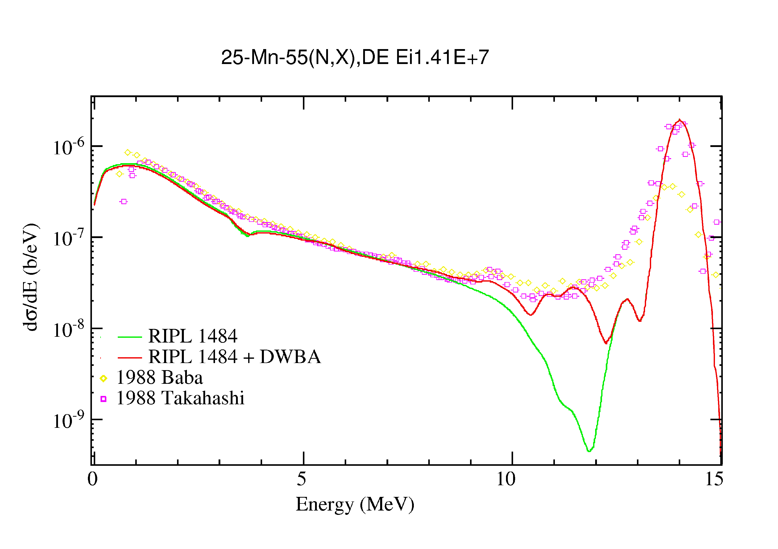
Fig. 1: Experimental total cross sections vs calculations with rotational dispersive CC neutron OMP (RIPL 1484). | Fig. 2: Effect on the 14.1 MeV neutron emission spectrum of the inclusion of collective excitations to the discrete levels and continuum treated with the DWBA.
⁵⁵Mn(n,tot) & ⁵⁵Mn(n,el)
⁵⁵Mn neutron emission spectra

Level density
As mentioned the Enhanced Generalized Superfluid Model [3] is the default level density formulation in the EMPIRE code. The properly parametrized EGSM requires adjustment to discrete levels; therefore calculated level density below the binding energy is sensitive to the energy cut-off (level number Nmax) defining the start of the continuum (or the last discrete level). The consistency of the EGSM parameterisation with the experimental discrete levels retrieved from the RIPL database can be checked in EMPIRE by plotting the cumulative number of levels for each nucleus. Graphical representation helps to identify the level at which the cumulative plot starts to bend because the discrete levels, which are not detected experimentally, are missing from the spectrum and the high–energy end of the experimental cumulative plot is too low compared to EGSM calculations. The experimental levels lying above this point should be excluded from consideration. This is usually done by changing the Nmax parameter. Three examples of level density fit for different Nmax values are shown in Fig.3 for ⁵⁶Mn. Systematics indicates that missing levels occur at lower energy in odd-odd and odd nuclei. The fitting with only 5 discrete levels is not very reliable because the statistical level density models do not describe the first low–lying levels. The Nmax parameter for ⁵⁶Mn is set to 17 discrete levels. However, the Nmax parameter for ⁵⁵Mn is set to 39 discrete levels so the continuum starts above 3 MeV. Usually the target nucleus should include as many discrete levels as available to improve the reliability of the calculated neutron inelastic cross sections.
In EMPIRE code there is additional tuning parameter ATILNO that allows changing the EGSM asymptotic level density parameter by a factor equal to ATILNO (ATILNO=1 means no change). The estimated uncertainty of the RIPL asymptotic level density parameter can reach up to 20% depending on the availability of neutron resonance measurements for the relevant nucleus; therefore ATILNO is expected to vary from 0.80 up to 1.20.
The level density parameter ATILNO is first calculated from systematics and then renormalized with the experimental values at the binding energy, when available. The choice of Nmax and any change in ATILNO have a big impact on calculated cross sections through a change in the corresponding level density. However, the energy region affected is different; ATILNO usually affects the level density calculated above the binding energy, while Nmax affects the level density normalization below the binding energy. A typical impact of ATILNO change on the calculated capture cross section is seen in Fig.4. The modification of the level density of the ⁵⁵Mn continuum affects the capture cross section above ~3 MeV.
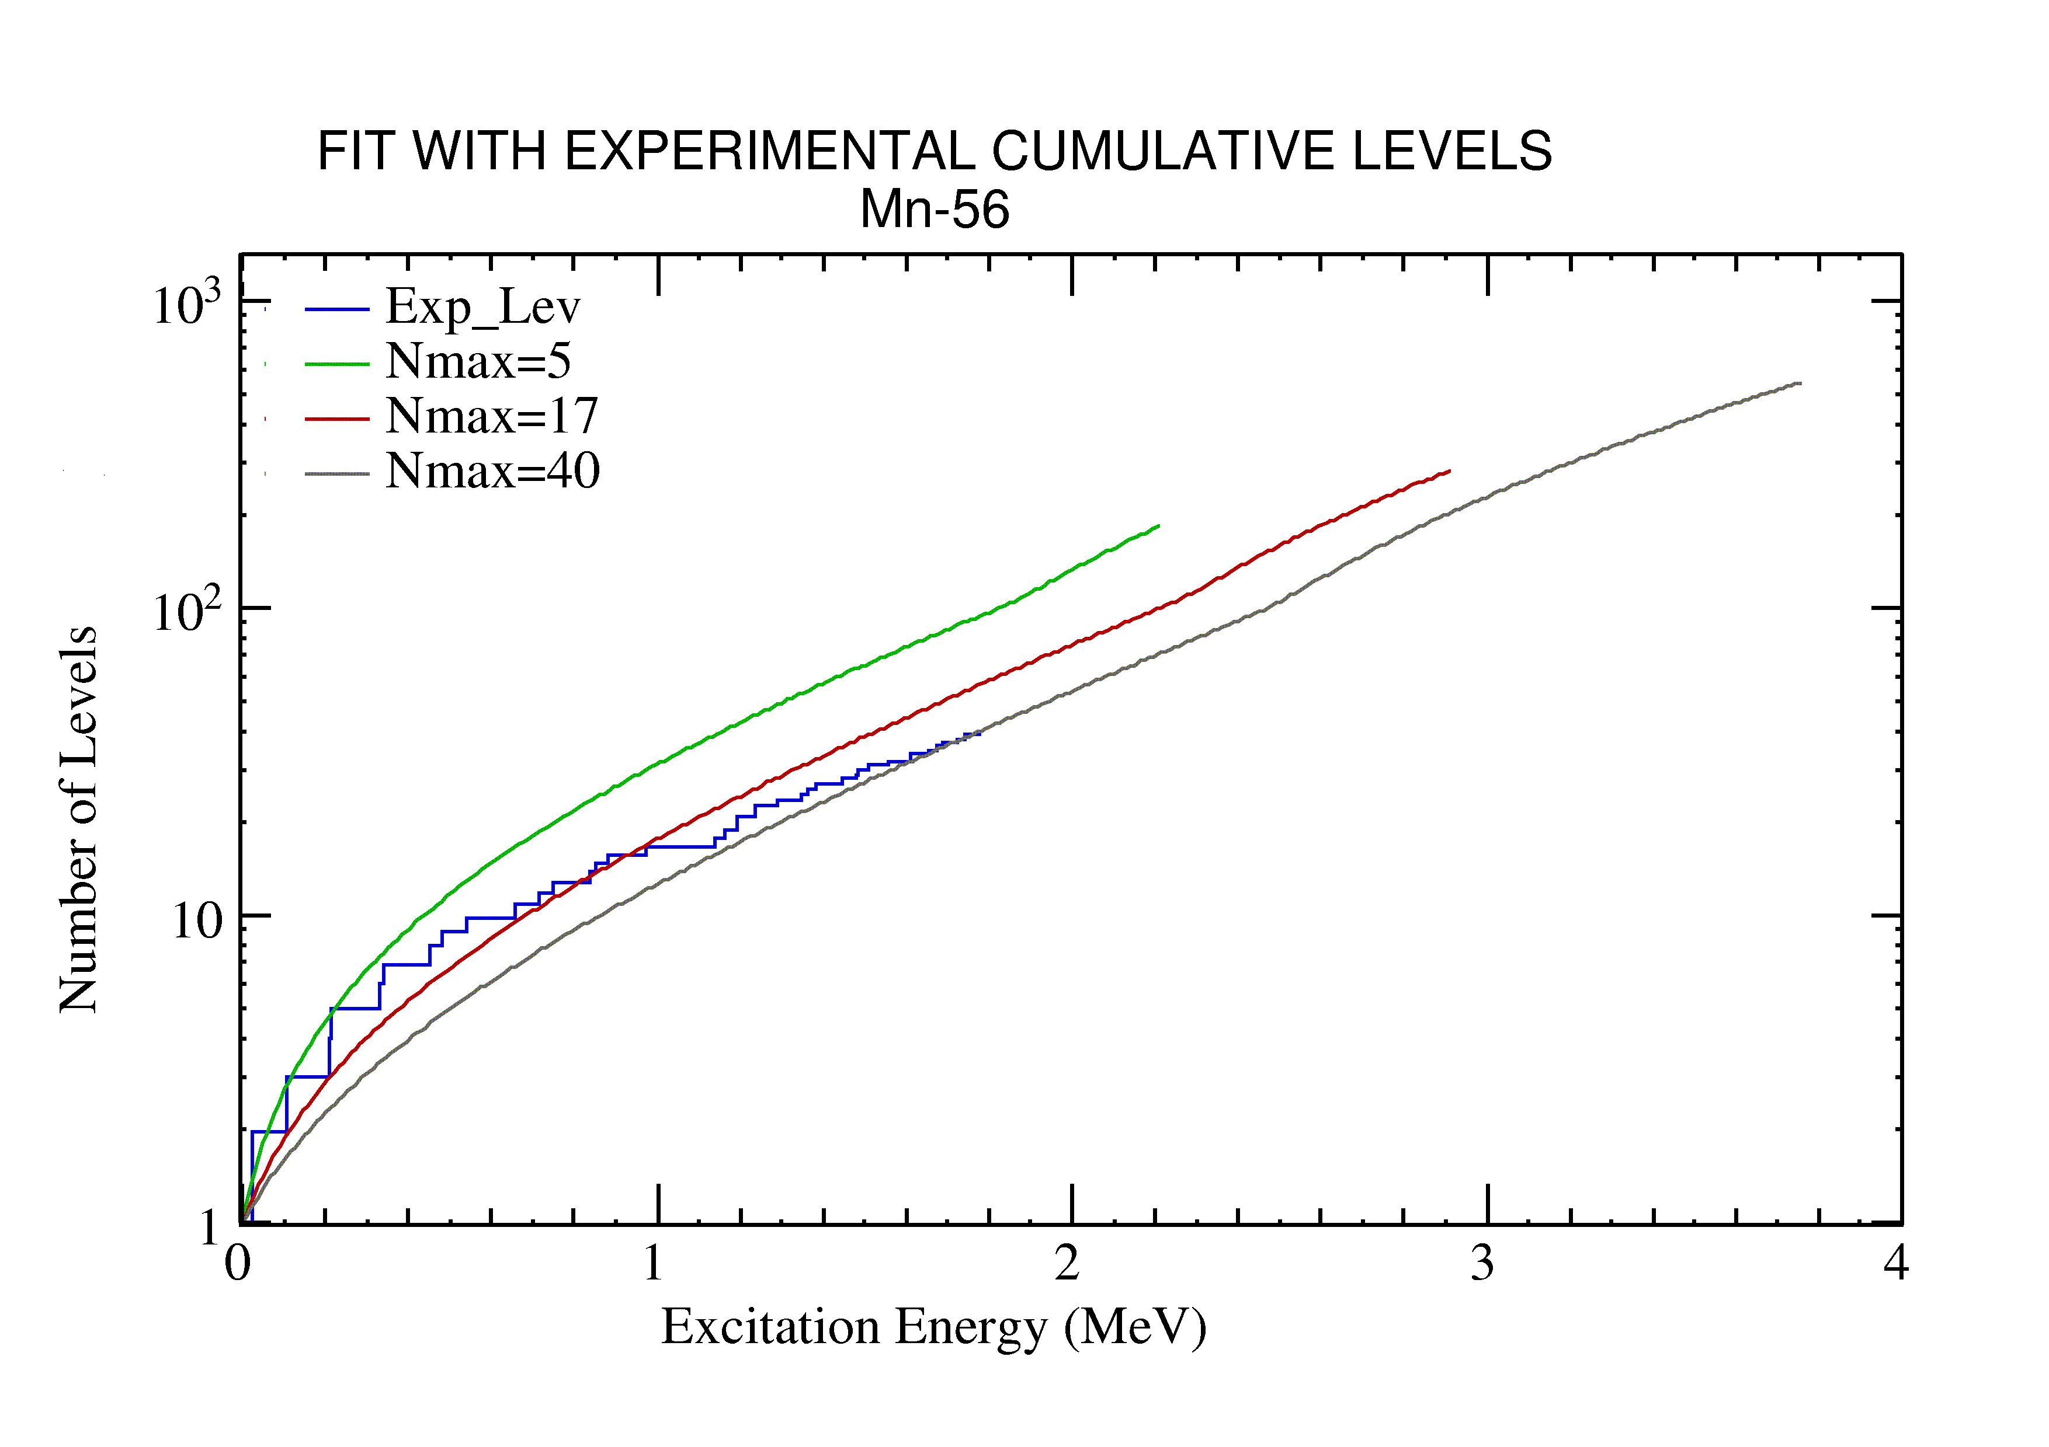 | 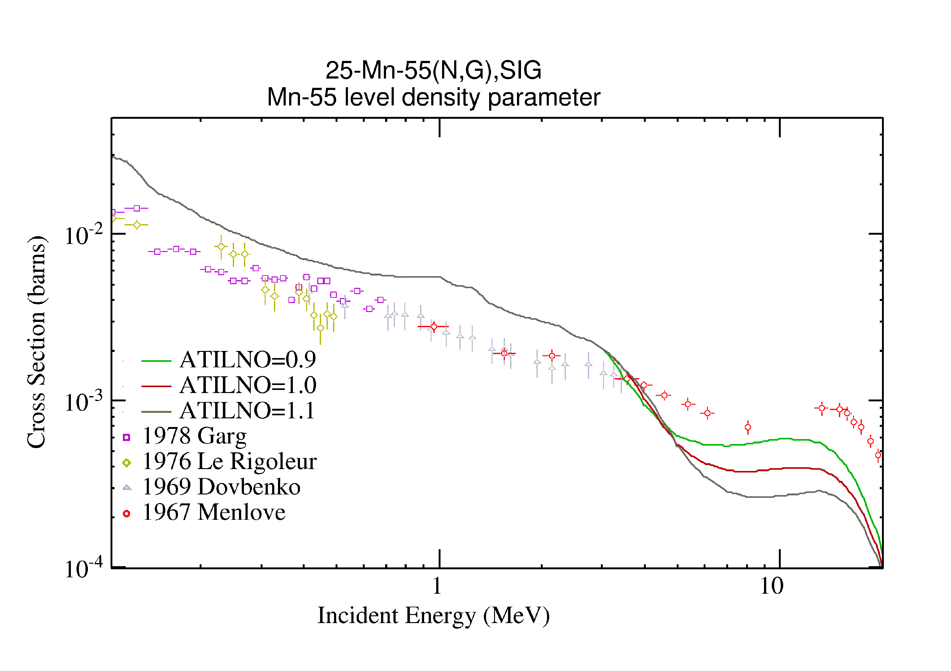
Fig. 3: Cumulative plot for the ⁵⁶Mn level density with increasing energy cut-off of the discrete levels Nmax=5, Nmax=17 and Nmax=40. | Fig. 4: Effect of ATILNO for the ⁵⁵Mn level density on the capture cross section.
Based on previous considerations, the Nmax and ATILNO settings for relevant nuclei below 20 MeV of incident energy are listed in Table 1.

Table1: Discrete level cut-off number Nmax and level density tuning parameter ATILNO for nuclei contributing to scattering cross sections below 20 MeV of incident neutron energy.
nucleus | ⁵⁶Mn | ⁵⁵Mn | ⁵⁴Mn | ⁵³Mn | ⁵⁵Cr | ⁵⁴Cr | ⁵²V | ⁵¹V
Nmax | 17 | 36 | 35 | 29 | 27 | 30 | 10 | 39
ATILNO | 1.05 | 1.02 | 0.85 | 1 | 0.87 | 1 | 0.73 | 1

Gamma strength function (GSF)
The RIPL-3 provides a set of E1 γ–ray strength functions [3]. Altogether, six different formulations of the γ–ray strength function can be selected. Depending on the formalism chosen, the shape changes especially at the low γ–emission energies. We show a comparison of three different radiative strength functions: GFL is the Generalised Fermi Liquid Model, EGLO is the Enhanced Generalised Lorentzian and MLO1 is the Modified Lorentzian, version 1. The choice of the γ–ray strength function influences the calculated double differential gamma emission cross section, as can be seen from Fig. 5. Experimental gamma emission cross sections are measured at 125 degrees for 11 MeV of incident neutron energy. The MLO1 radiative strength function is preferable in this case, especially at high emission energies above 6 MeV (corresponding to low excitation energy of the compound nucleus).
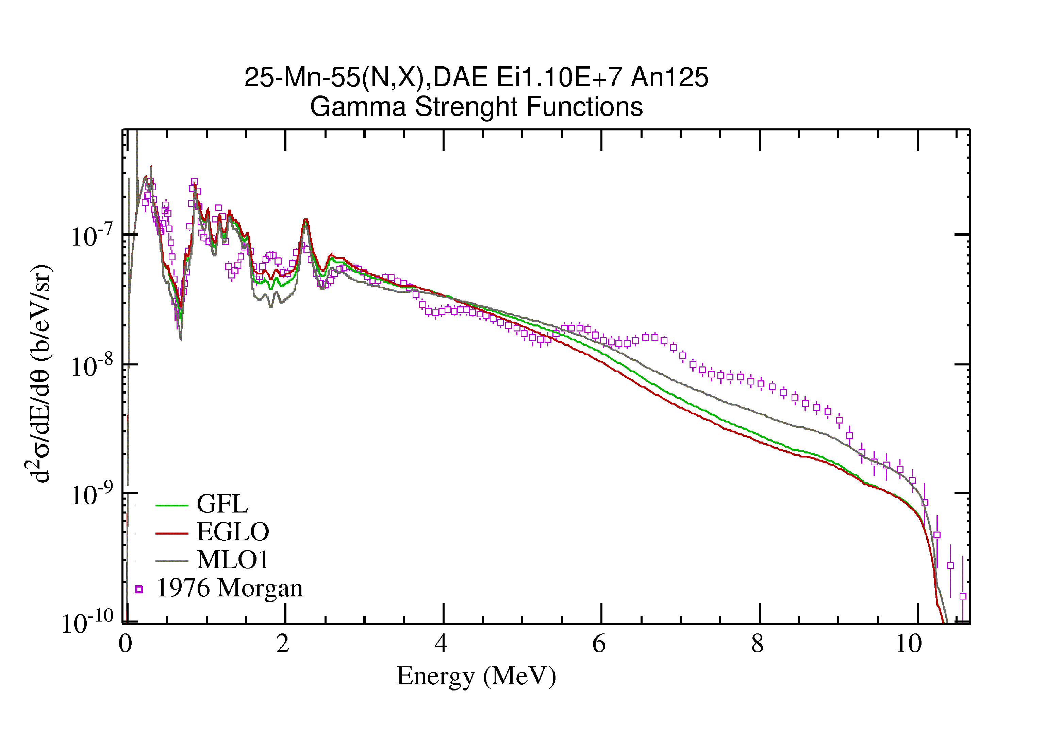
Fig. 5: Effect of selected GSF on calculated γ-emission spectrum at 125° for the 11 MeV incident neutron.

Non-physical parameters
For a real evaluation we need first to carry out theoretical calculations to derive global average cross sections with broad uncertainties. Then we use selected and corrected experimental data to undertake a Generalized Least Squares (GLSQ) fit based on a Bayesian approach using a theoretical calculation including covariance matrix as a prior for a GLSQ fit. Such approach is statistically sound and provides both the best average value and corresponding uncertainties and correlations. Moreover, it combines both the best available experimental data with strong correlations arising from nuclear reaction model calculations. However, we did not pursue correlations in our evaluation yet, so we rely on an approximate approach where we introduce non-physical (tuning) parameters to get calculated results as close as possible to selected experimental data. Our approach allows understanding model or experimental data discrepancies as well as supplying for model deficiencies.
Two of available tuning parameters are factors multiplying the γ-emission width corresponding to the pre–equilibrium and the equilibrium populations. The pre–equilibrium component is adjusted by a TUNEPE parameter; the equilibrium gamma - by a TUNE parameter, correspondingly. Both parameters should be defined for each nucleus and they may be energy dependent. Of course they are intended to be used only as a replacement of a proper GLSQ fit.
The TUNEPE parameter for the γ-emission width is useful to adjust the pre-equilibrium emission featuring a maximum around 14 MeV of incident neutron energy. Its impact on other cross sections is minimal as the capture cross section at 14 MeV is 1 mbarn or less, almost negligible if compared with total cross section of a few barns. Sensitivity to the TUNEPE parameter is shown in Fig. 6. We selected a value of 2.5, however, there is a big discrepancy of available experimental data, especially between those measured after and before 1970. It is a well established fact that capture measurements at 14 MeV before 1970 has a systematic overestimation of measured cross section, therefore we normalized data measured by Menlove [5] to the average of remaining measurements at 14 MeV. Even so the agreement with Menlove from 5 to 10 MeV is poor. Considering that the capture those cross section is small compared to the neutron inelastic in that energy region, we introduced energy dependent TUNE parameters from 5 to 10 MeV to reproduce Menlove data, simulating a GLS fit. However, we may decide to drop Menlove data at a later stage, unless we can properly correct it. Right now Menlove data shape is not consistent with theoretical expectations. The combined effect of TUNE and TUNEPE tuning is to fit the capture channel with Menlove experimental data between 3 and 16 MeV as seen in Fig. 7.
We also used two other tuning parameters FUSRED and TOTRED that modify the reaction and total cross sections, respectively. These parameters are designed to correct small deviations of model calculations (optical model) from experimental data. IF GLS fit is done, we usually do not need to use TOTRED. For the FUSRED parameter the situation is worse; usually there is no reliable experimental data for the reaction cross section. One notable exception are measurements of (n,nγ) cross section for the first excited level of the compound nucleus. If we undertake the GLSQ fit, then we should be able to reproduce measured (n,nγ) cross section below 1 MeV. We changed parameter FUSRED allowing for a 10% variation that reflects our estimates of the uncertainty of the neutron inelastic scattering. FUSRED adjustments allow better fitting with the experimental data of the inelastic cross section below 1 MeV, which is especially clear for the first level (MT=51 in Fig. 8). We also reduced the total inelastic cross section from 1 to 4 MeV to reduce the neutron removal, therefore improving results of integral tests.
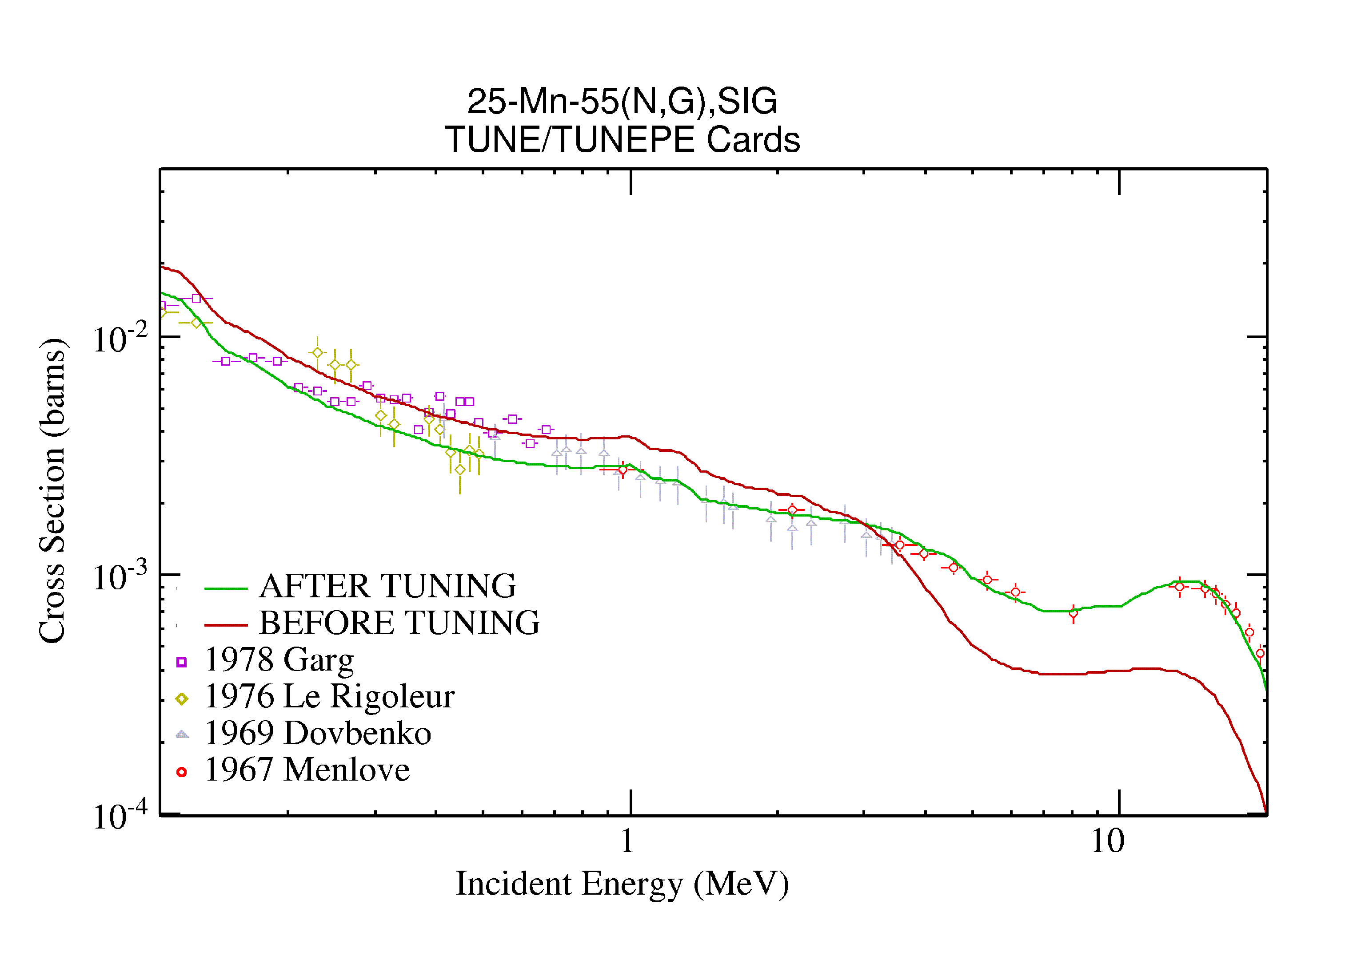 | 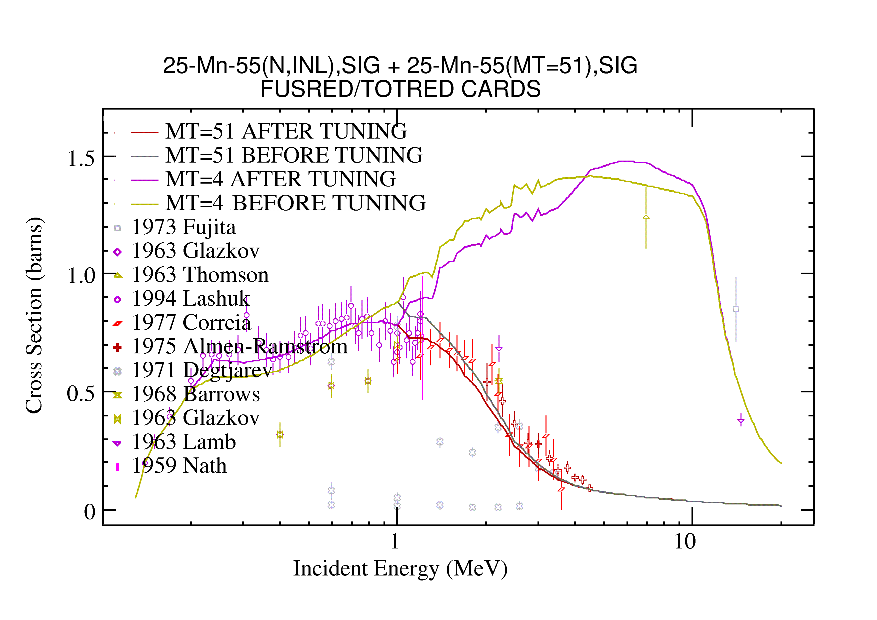
Fig. 7. Effect of the TUNE and TUNEPE cards on the capture cross section | Fig. 8: Effect of the FUSRED and TOTRED non-physical tuning parameters on the total inelastic cross section (MT=4) and the direct inelastic scattering to the first excited level at 0.126 MeV (MT=51).

COMPARISON WITH OTHER EVALUATIONS AND EXPERIMENTAL DATA

Differential data
For the proper comparison with other evaluations and with the experimental data, the resonance parameters from Derrien et al. evaluation [11] are used to reconstruct the resolved resonance region up to 100 KeV. The present evaluation of the ⁵⁵Mn neutron interaction cross sections is labelled as IB-8. The differences with the ENDF/B-VII evaluation of the capture cross section between 100 eV and 20 MeV can be seen from Figure 9. The dosimetry file IRDF-2002 for the ⁵⁵Mn(n, γ) reaction has adopted the ENDF/B-VII data. Around 1 MeV, the IB-8 cross sections do not present the fluctuations of the ENDF/B-VII nuclear data since the latter were obtained by fitting measurements in this energy range both for the capture and total cross sections (see also Fig. 10). The IB-8 (n,2n) evaluation is compared also with the recent evaluation by Zolotarev; good agreement between the two is observed, except for the ~10% difference between the maxima around 18 MeV (Figure 11). The results of the IB-8 calculation ob the 14.1 MeV neutron emission spectra at 60 degrees are in general within the uncertainties of the microscopic experimental data as seen in Fig. 12.

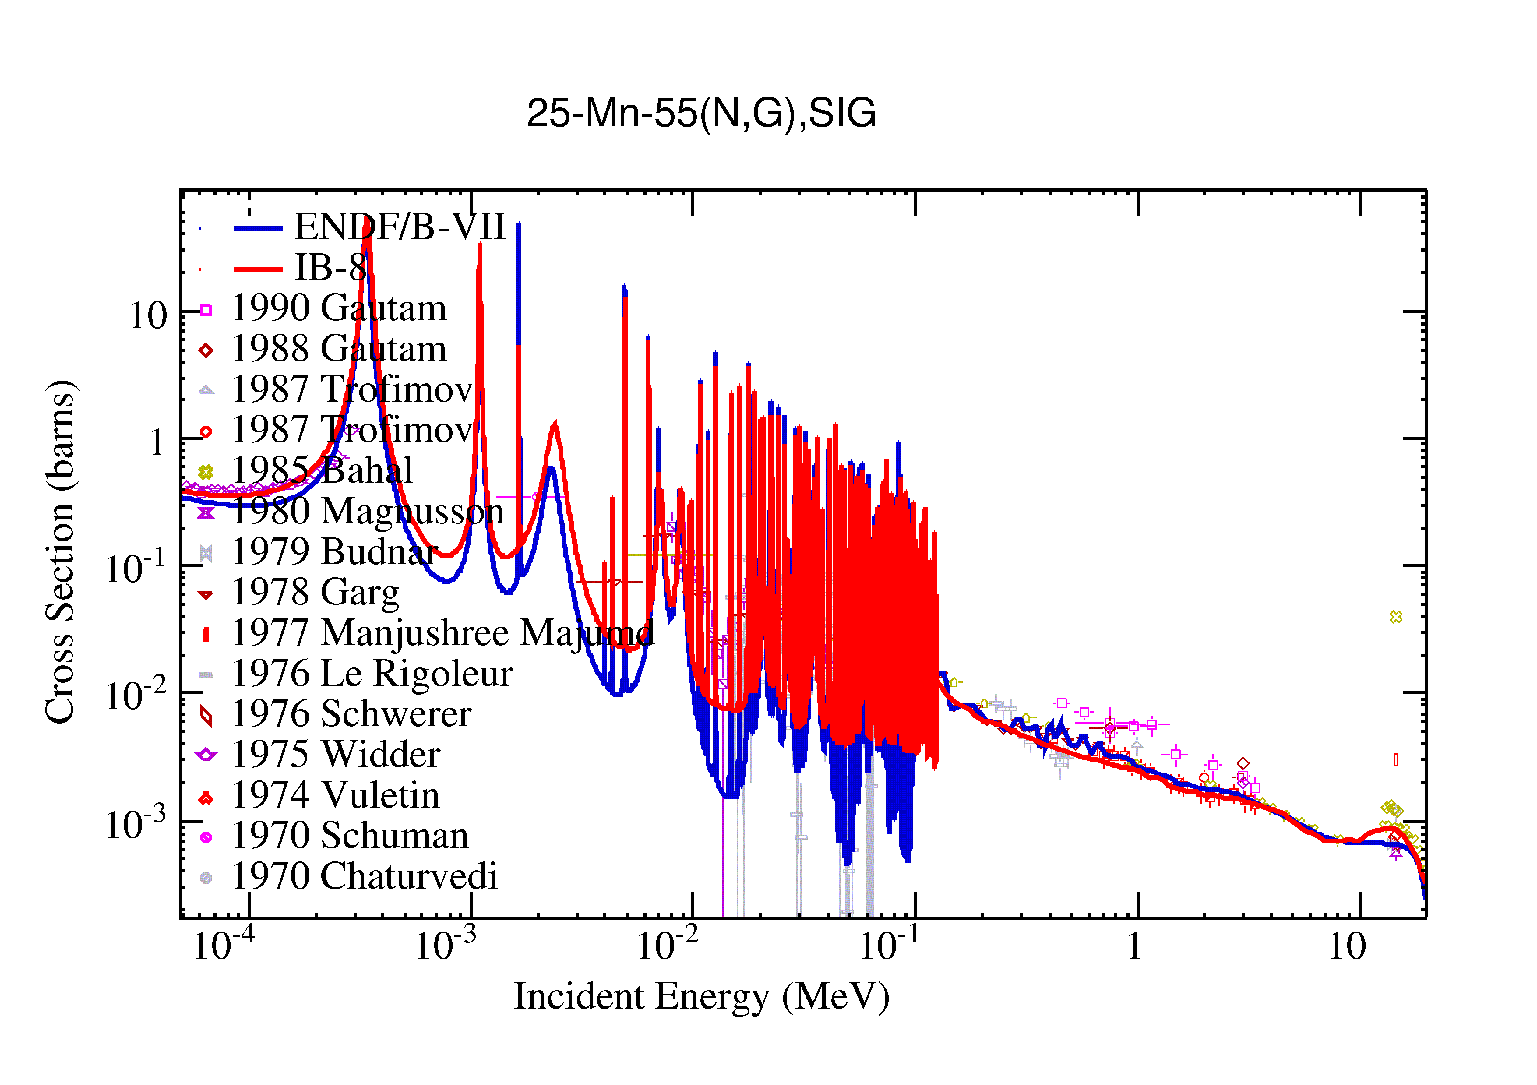 | 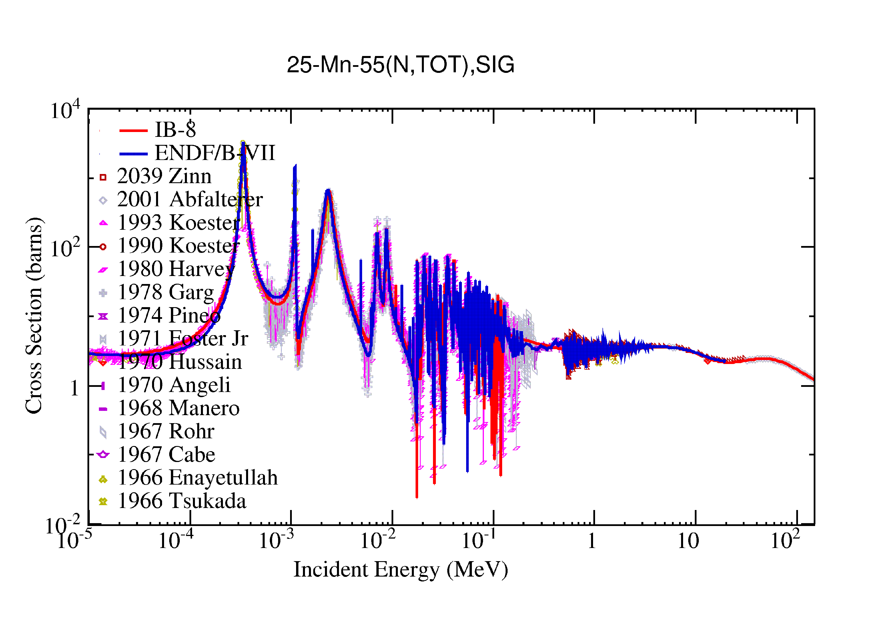
Figure 9: Capture cross section: IB-8, ENDF/B-VII evaluations and selection of EXFOR data | Figure 10: Total cross section: IB-8, ENDF/B-VII evaluations and selection of EXFOR data
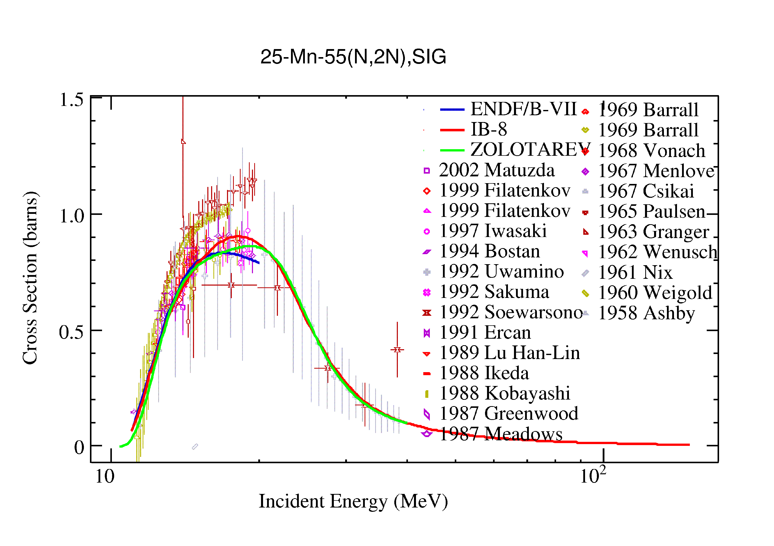 | 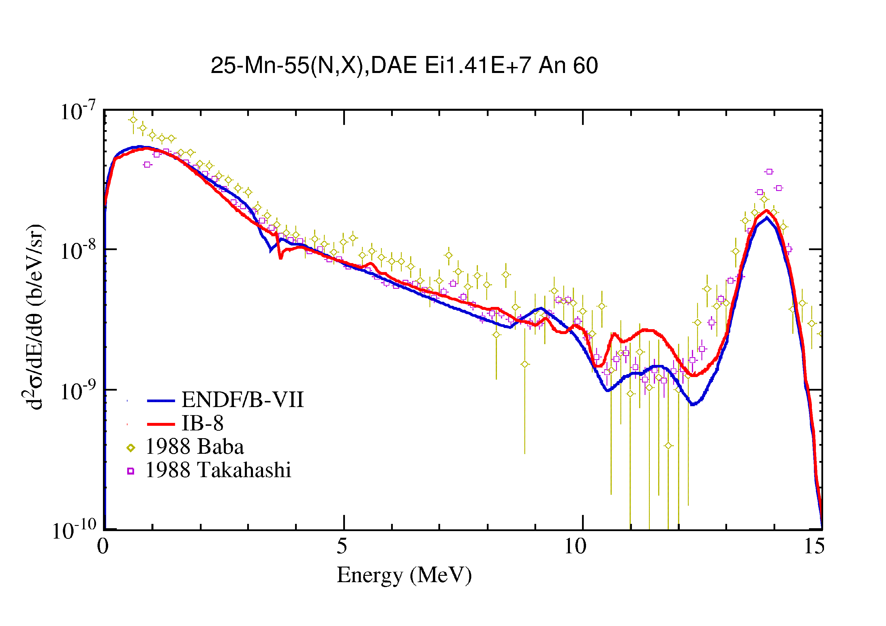
Figure 11: (n,2n) cross section: IB-8, ENDF/B-VII, Zolotarev evaluations and EXFOR data | Figure 12: Double differentia cross section at 60 degrees with neutron incident energy of 14.1 MeV: comparison between IB-8 and ENDF/B-VII evaluations

INTEGRAL EXPERIMENTS
On the other hand, in the simulation of integral experiments any error in the evaluated cross sections would propagate trough the bulk material up to large discrepancies with the measurements. The FENDL-2 Benchmarks Sublibrary (http://www-nds.iaea.org/fendl/fen-bench.htm ) provides with the spectrum measurement of neutrons leaking from a Mn 60–cm diameter shell, irradiated at the OKTAVIAN facility with 14 MeV neutrons in the centre.
The results of the MCNP5 simulation with the IB-8 and ENDF/B-VII nuclear data are illustrated in Figure 13. The ENDF/B-VII performs very well in this benchmark experiment. The IB-8 evaluation shows some problems with discrepancies up to ~20 % around 2 and 7 MeV. The MCNP5 model of the OKTAVIAN experiment have some approximations, but an experienced estimate would suggest these not to be responsible for more then 10% of the discrepancy at those energies. Between 0.1 and 1 MeV, the structure of the experimental data cannot be reproduced with the IB-8 because the resonances are still unresolved.
The validation of the (n, γ) cross section needs integral measurements that are sensitive to the low energies were the neutron capture becomes large. An interesting case is represented by the Mn foils activation performed at FNG in the framework of the neutronics experiment on the ITER Blanket Bulk Shield. A realistic MCNP5 model of the experiment is used for the simulation of the ⁵⁵Mn(n,γ)⁵⁶Mn activation rates with both the IB-8 and IRDF-2002 evaluations of the (n, γ) cross section. The ~14 MeV source neutrons are produced in front of the assembly. The monitors are placed at increasing depth inside the sample. Figure 14 presents the results in terms of the relative % error between calculations and experimental values. In this case, the IB-8 evaluation of the (n, γ) cross section performs slightly better then the IRDF-2002 evaluation. The discrepancy found between the experimental data and the activation rates calculated with the IB-8 evaluation is consistent with the preliminary results on the gold activation foils. Anyway, a statement on the quality of the benchmark experiment is advisable before definitively assessing the performances of the benchmark model.
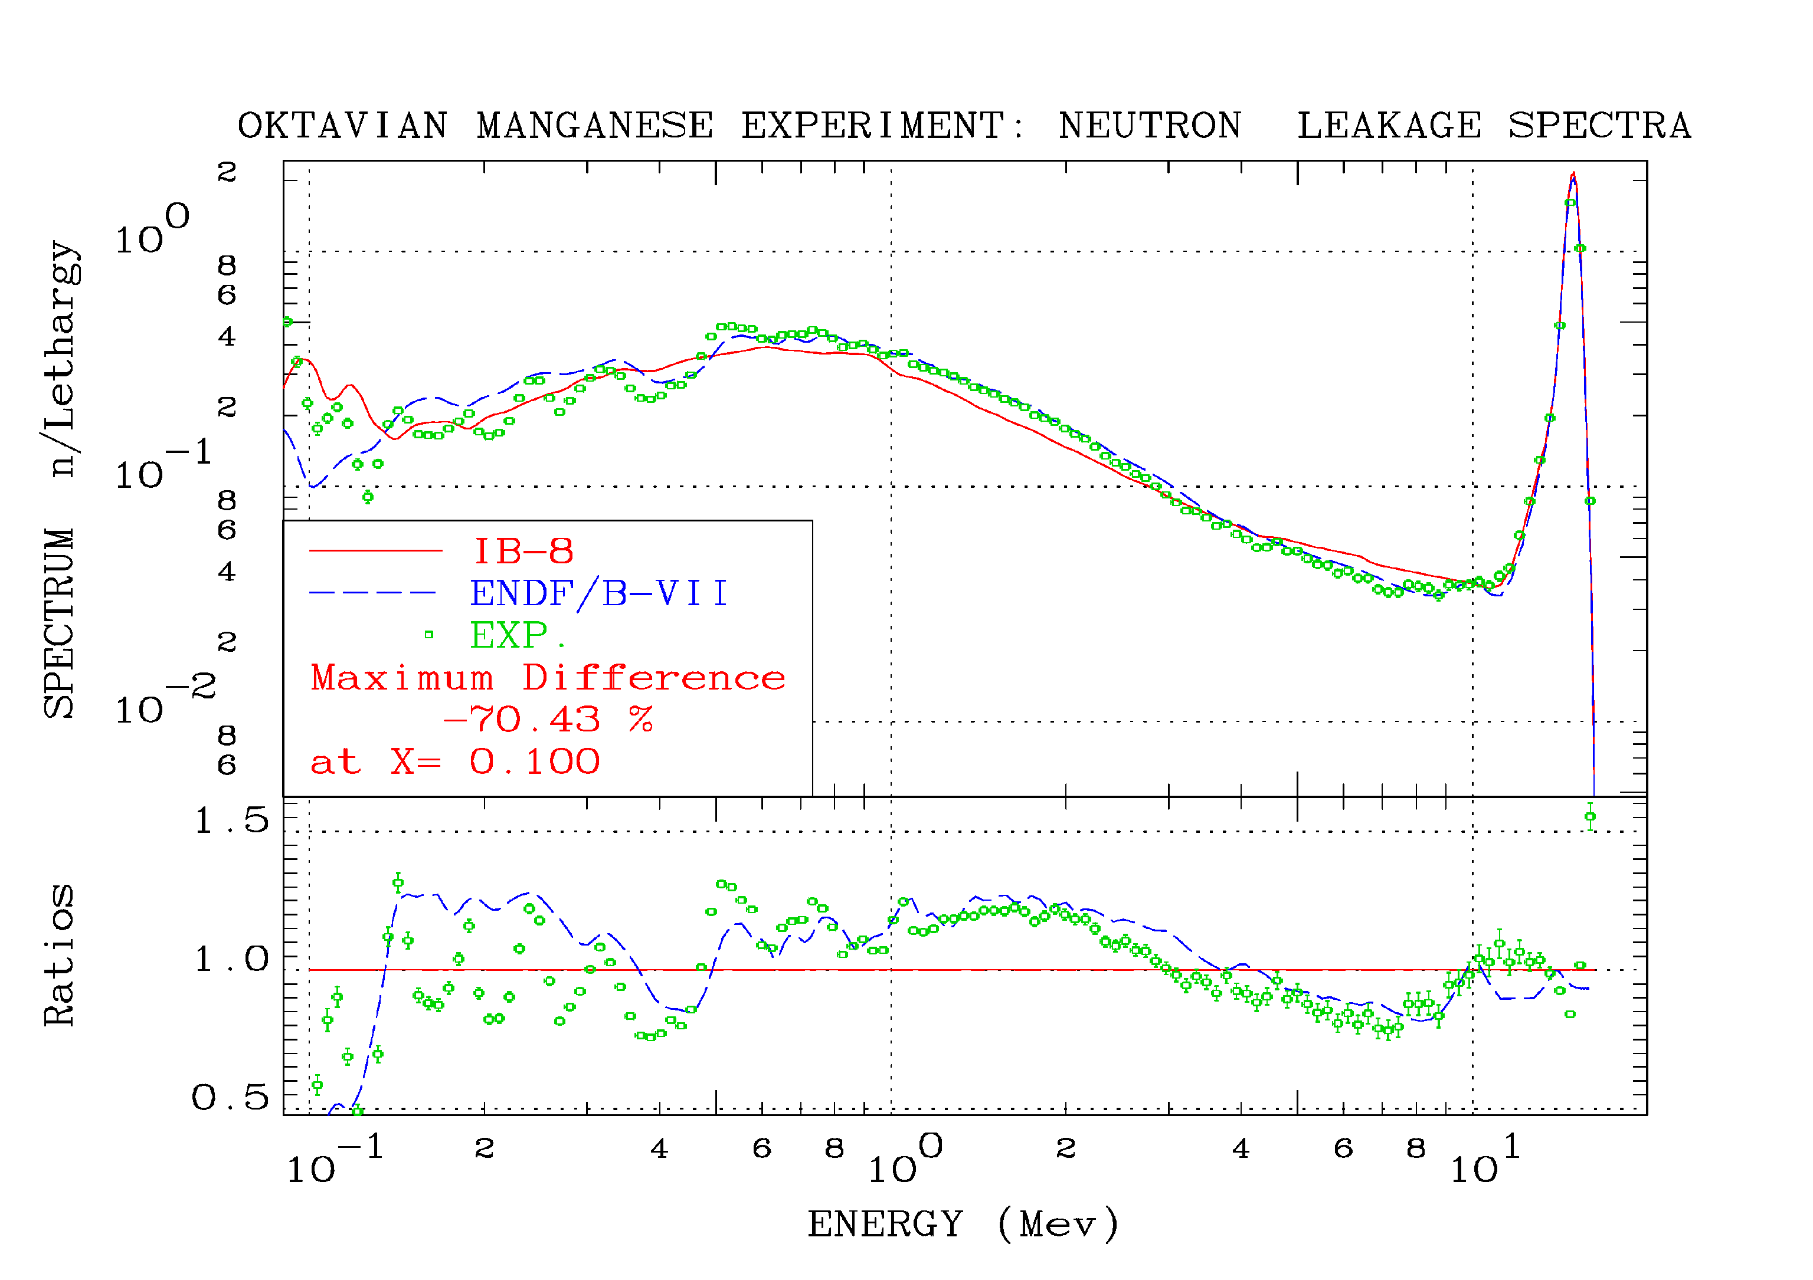
Figure 13. Neutron leakage spectra for the OKTAVIAN Mn experiment calculated with the current nuclear data file (IB8) and ENDF/B-VII.0 evaluations | Figure 14. ⁵⁵Mn(n,γ)⁵⁶Mn activation rates for the FNG-BLANKET SHIELD experiment calculated with the IB8 and ENDF/B-VII.0 (which coincide with the IRDF-2002) neutron capture evaluations

CONCLUSIONS
A new ⁵⁵Mn nuclear data evaluation was started, which relied on the EMPIRE system. The major features of the code were presented, together with the sensitivity studies on the physical and fitting parameters. It is worthwhile to notice that this work represented also a test case for the capabilities of the EMPIRE code, whose improvement is constantly under way. Major attention was addressed to the neutron capture and inelastic cross sections. The availability of the nuclear data up to 150 MeV makes current evaluation of interest for fusion applications. The validation stage with the integral OKTAVIAN experiment spotted out possible problems with the inelastic cross section and the region of resolved resonances. Concerning the FNG-BLANKET SHIELD experiment, the behaviour of the present file containing resonances as calculated from Derrien’s parameters [11] seem promising to improve the current dosimetry file IRDF-2002.
Future planned activities involve a further refinement of the physical parameters, a GLSQ fit using the GANDR system to obtain covariances properly combining experimental data and modelling results, and subsequent validation of the final evaluation with integral experiments.
REFERENCES
[1] K. Shibata, "Calculation of Neutron-Induced Reaction Cross Section of Manganese-55", J. Nucl. Sc. & Tech. (Japan) 26 (1989) 955-965.
[2] M. Herman, R. Capote, B.V. Carlson, P. Obložinský, M. Sin, A. Trkov, H. Wienke and V. Zerkin, “EMPIRE: Nuclear Reaction Model Code System for Data Evaluation”, Nucl. Data Sheets 108 (2007) 2655-2715.
[3] R. Capote, M. Herman, P. Obložinský, P.G. Young, S. Goriely, T. Belgya, A.V. Ignatyuk, A.J. Koning, S. Hilaire, V.A. Plujko, M. Avrigeanu, O. Bersillon, M.B. Chadwick, T. Fukahori, Zhigang Ge, Yinlu Han, S. Kailas, J. Kopecky, V.M. Maslov, G. Reffo, M. Sin, E.Sh. Soukhovitskii and P. Talou, “RIPL – Reference Input Parameter Library for Calculation of Nuclear Reactions and Nuclear Data Evaluations”, Nucl. Data Sheets 110 (2009) 3107-3214.
[4] K.I. Zolotarev, “Evaluation of Cross-section Data from Threshold to 40-60 MeV for Specific Neutron Reactions Important for Neutron Dosimetry Applications: ²⁷Al(n,α)²⁴Na, ⁵⁵Mn(n,2n)⁵⁴Mn, ⁵⁹Co(n,p)⁵⁹Fe, ⁵⁹Co(n,2n)^{58m+g}Co and ⁹⁰Zr(n,2n)^{89m+g}Zr reactions”, Technical report INDC(NDS)-0546, Vienna, Austria, 2009.

[5] EXFOR database is compiled by the International Network of Nuclear Reaction Data Centres (NRDC). Available online at http://www-nds.iaea.org/exfor/exfor.htm.
[6] F. Maekawa et al., "Collection of Experimental Data for Fusion Neutronics Benchmark”, Technical report JAERI-M-94-014, Japan, 1994.
[7] P. Batistoni et al., " Neutronics experiment on a mock-up of the ITER shielding blanket at the Frascati Neutron Generator", Fusion Engineering and Design, 47 (1999) 25-60.
[8] J. Raynal, ECIS06 code is distributed by the NEA DATA Bank, Paris, France; ECIS72 described in “Optical model and coupled-channels calculations in nuclear physics,” in Computing as a language of physics. ICTP International Seminar Course, Trieste, Italy, Aug.2-10, 1971, (IAEA, 1972), p. 281.
[9] J. J. Griffin, “Statistical model of intermediate structure,” Phys. Rev. Lett. 17 (1966) 478–481.
[10] H. M. Hofmann, J. Richert, J. W. Tepel, and H. A. Weidenmuller, “Direct reactions and Hauser-Feshbach theory”, Annals of Physics 90 (1975) 403.
[11] H. Derrien, L. C. Leal, N. M. Larson, K. Guber, D. Wiarda and G. Arbanas, Neutron resonance parameters of ⁵⁵Mn from Reich-Moore analysis of recent experimental neutron transmission and capture cross sections, Proceedings, International Conference on the Physics of Reactors, PHYSOR 2008, Interlaken, Switzerland, September 14-19, 2008, ISBN 978-3-9521409-5-6.
[12] V. Avrigeanu et al., "Fast-Neutron Induced Pre-equilibrium Reactions on ⁵⁵Mn and ^{63,65}Cu at Energies up to 40 MeV", Nuclear Physics A, 806, 2008, pp. 15–39.
[13] A. J. Koning and J. P. Delaroche, "Local and Global Nucleon Optical Models from 1 KeV to 200 MeV", Nuclear Physics A 713 (2003) 231–310.
[14] H. Wienke, R. Capote, M. Herman and M. Sin, “Deformation-dependent Tamura-Udagawa-Lenske multistep direct model”, Phys. Rev. C 78 (2008) 064611.

